Customizing ArcGIS Explorer - Creating Your Tools in ArcGIS Explorer

You will learn
- What is ArcGIS Explorer (AGX)?
- The installation of AGX
- How to navigate the AGX interface?
- How to add and work with layers in AGX?
- What is ArcGIS Explorer SDK?
- The installation of AGX-SDK
- How to create your own add-in?
- Programming example in AGX-SDK
- How to deploy your own add-in?

What is ArcGIS explorer (agx)
ESRI tries to make ArcGIS Explorer (AGX) as “GIS for Everyone.” The following description is copied from ESRI online training course directly.
- AGX is a free of charge, lightweight GIS browser which can work with a variety of GIS data that created by ArcGIS Desktop.
- AGX enables users to deliver GIS data to a broad audience
  - Within and between departments
  - Throughout your organization and with other organizations
  - To geographic information users everywhere
- AGX makes it easy to integrate other data such as KML from Google Earth and the GPS inputs information geographically
- AGX provides an easy way to explore, visualize, share, and present geographic information
Some key features of AGX:
- Intuitive and easy to use
- Integrated 2D/3D display
- Basemap gallery
- Enhanced and extended data support
- Presentations
- ArcGIS Online (Sharing) / Localization
- Customization (via application configurations)
- SDK (Visual Studio .NET)

the installation of agx
The download of AGX is free from ESRI website
http://resources.arcgis.com/content/arcgis-explorer/1500/download
http://wikis.esri.com/wiki/display/agxpsr/ArcGIS+Explorer+System+Requirements
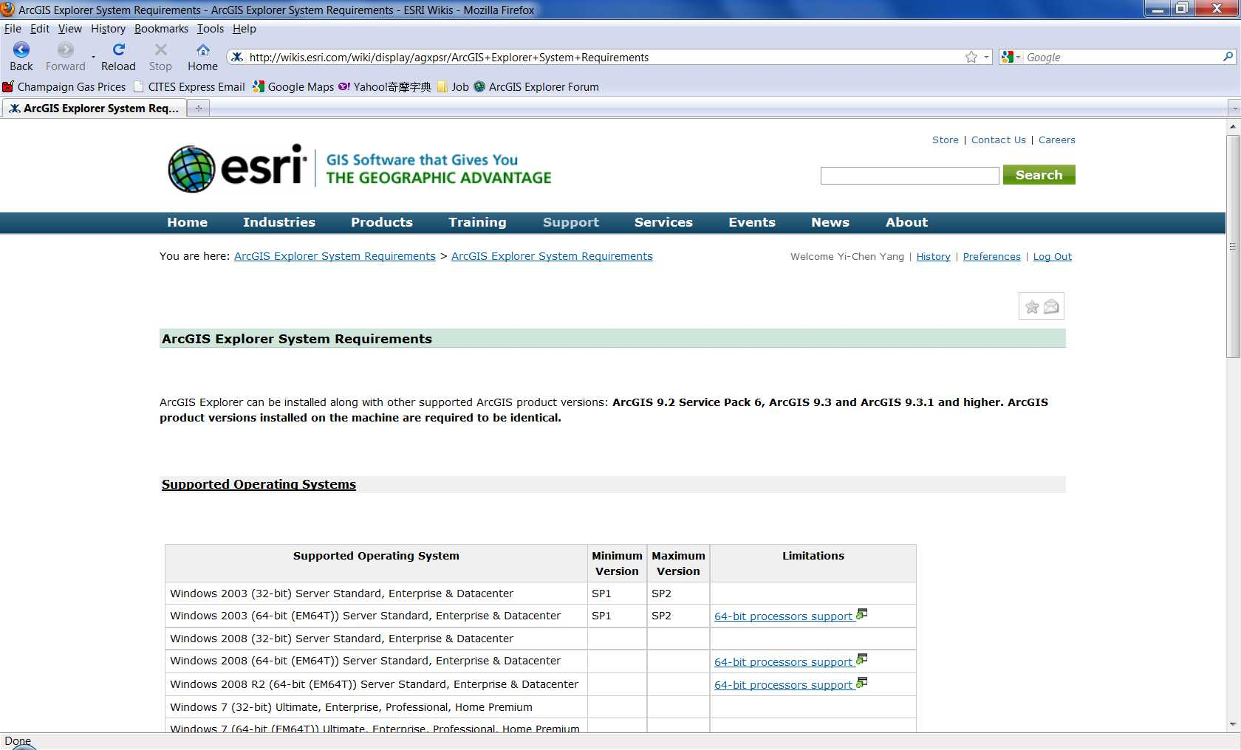
But before you download it, go to “Check your computer's ability to run ArcGIS Explorer” to check if your computer can run AGX. You have to use Internet Explorer to open the above link.
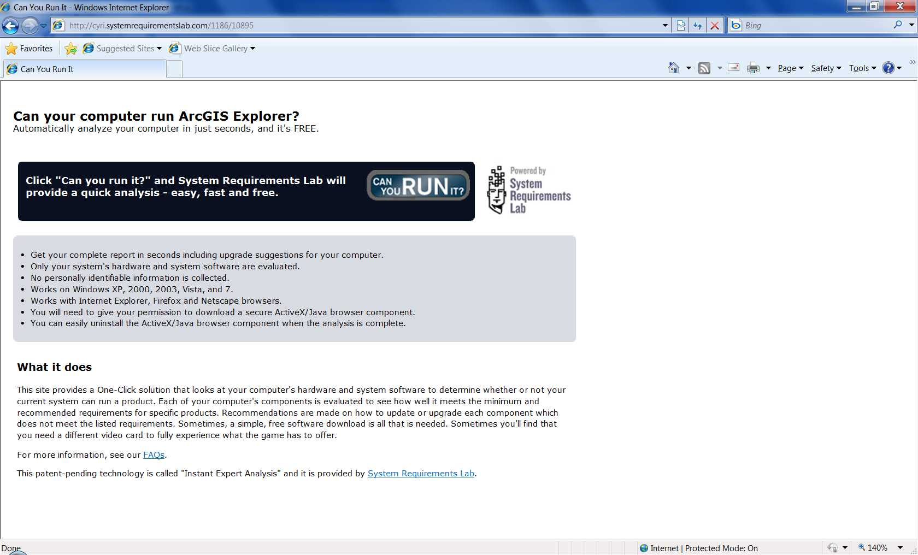
This website will tell you whether your computer can run AGX or not. If your computer failed the test, the website will also tell you which part you need to fix.
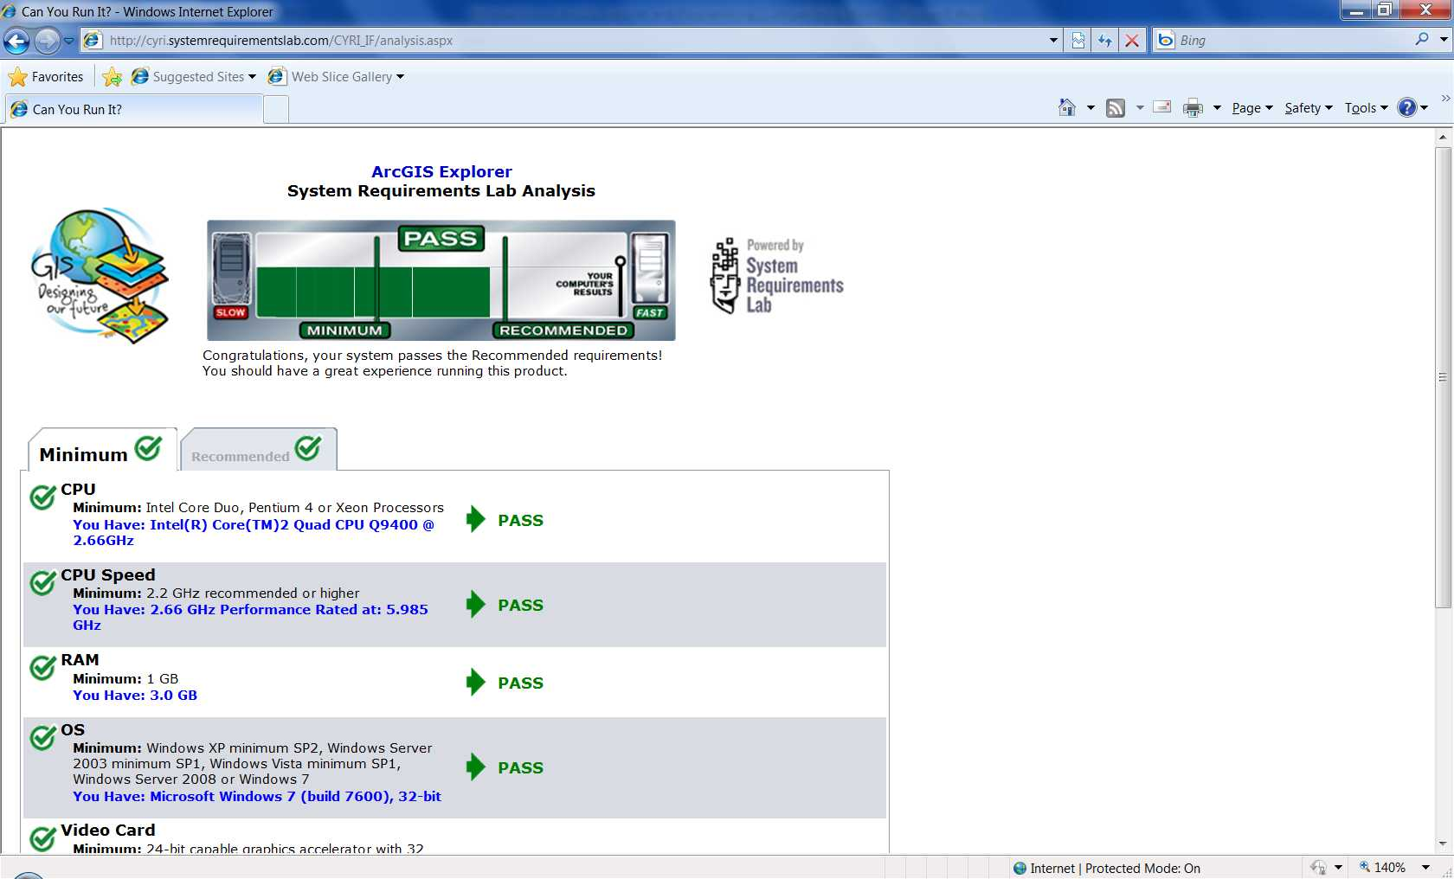
After the check, you can just download AGX and install it follow the instruction.

How to navigate the AGX interface
Double-click the AGX icon on desktop to open the software. The following view is the default setting for the first launch of AGX. There are six basic components in AGX that users can use: Tabs, Controls, Ribbons, Map, Contents and Navigator.
At the top of the application are the “Tabs.” There are only two tabs in default setting: “Home” and “Display.” More tabs will shows up when additional contents are added. This part will be discussed latter. In each tab, there will be several “Ribbons.” And in each ribbon, some “Controls” buttons are organized in “Group.” To the left, it is the “Table of Contents (TOC)” and it is similar to the one we have in ArcMap. TOC will display all user added contents and allow users to manage them. In the middle, the basic “Map” shows in 3D mode in default but users can switch between 2D and 3D whichever mode works best for them. And in the lower left corner, there is a “Navigator.” Users can use it to zoom in and zoom out from the map or drag and rotate the map in any way they want.
Users can always click the blue question make located at the upper right hand corner of the application to open the Help document. In the Help, there are some chapters that provide introduction and how to get started with AGX. The Help is also integrated into the Map (Controls) Tips. Therefore, when users hover over a tool, they can see a description of the control and also a little F1 capability, which enable users to get more information by pressing F1 key.
One more thing about the setting is users can dock windows in a variety of different ways. Just drag the window off the application, and little blue arrows will shown which enable users to position the window in various locations.

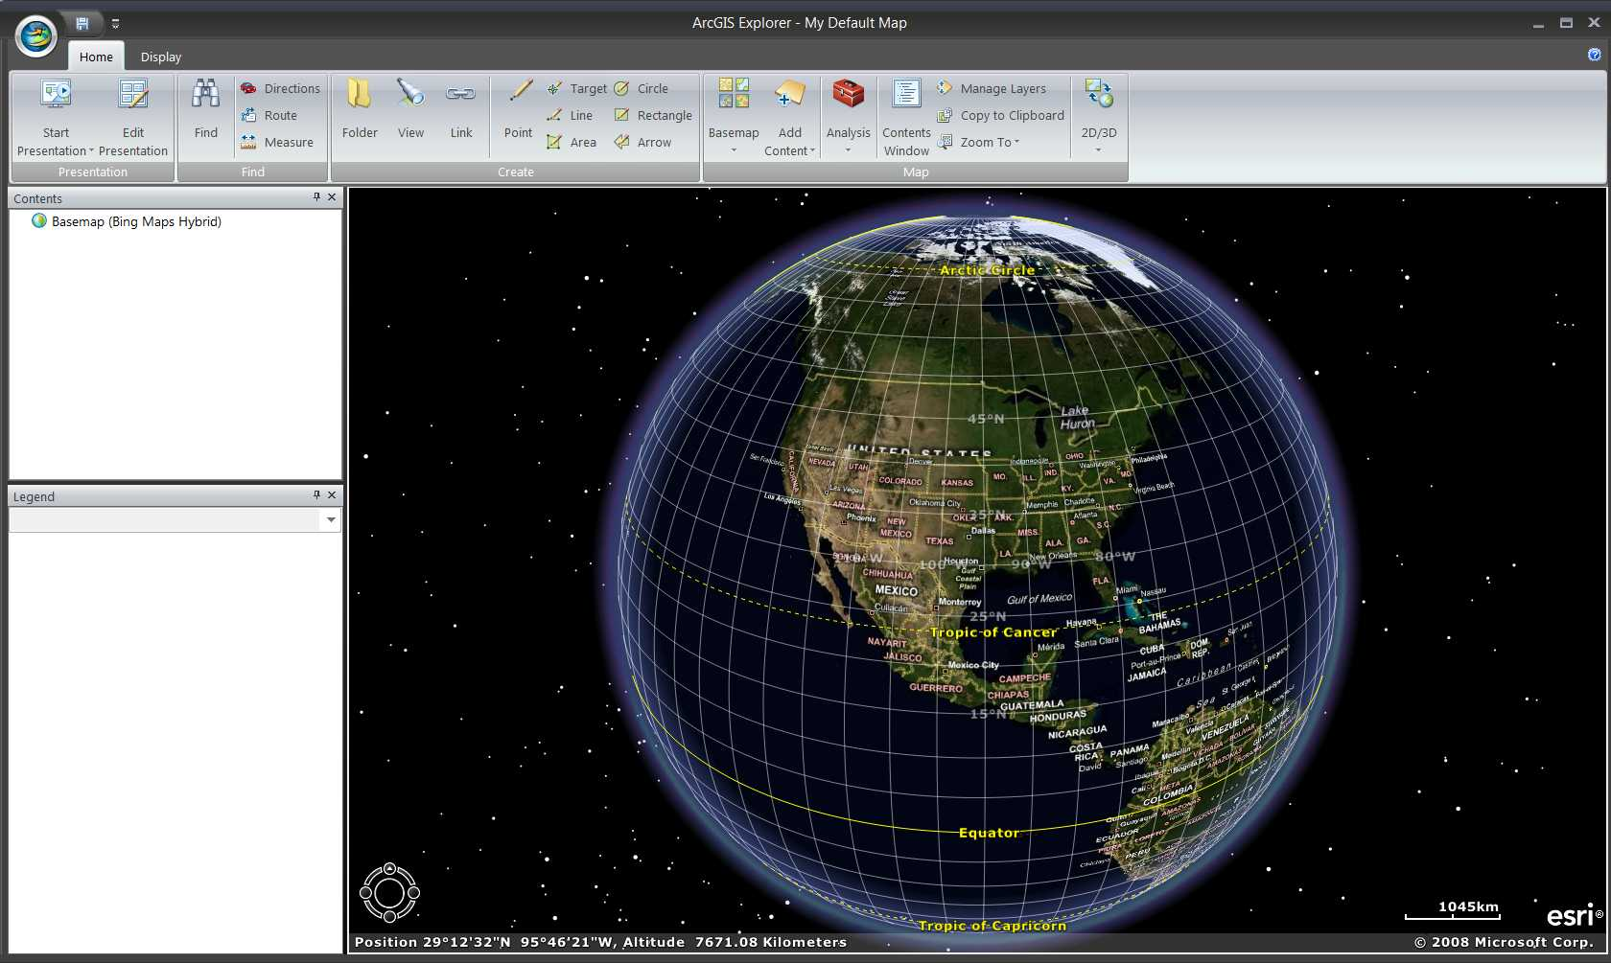
Tabs
Controls
Ribbons
Map
Navigator
Table of Contents (TOC)
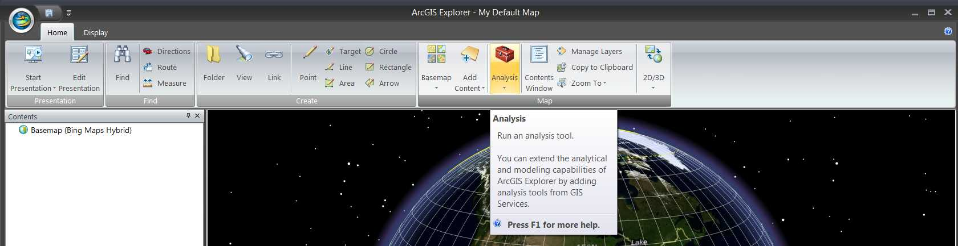
Help
Controls Tips
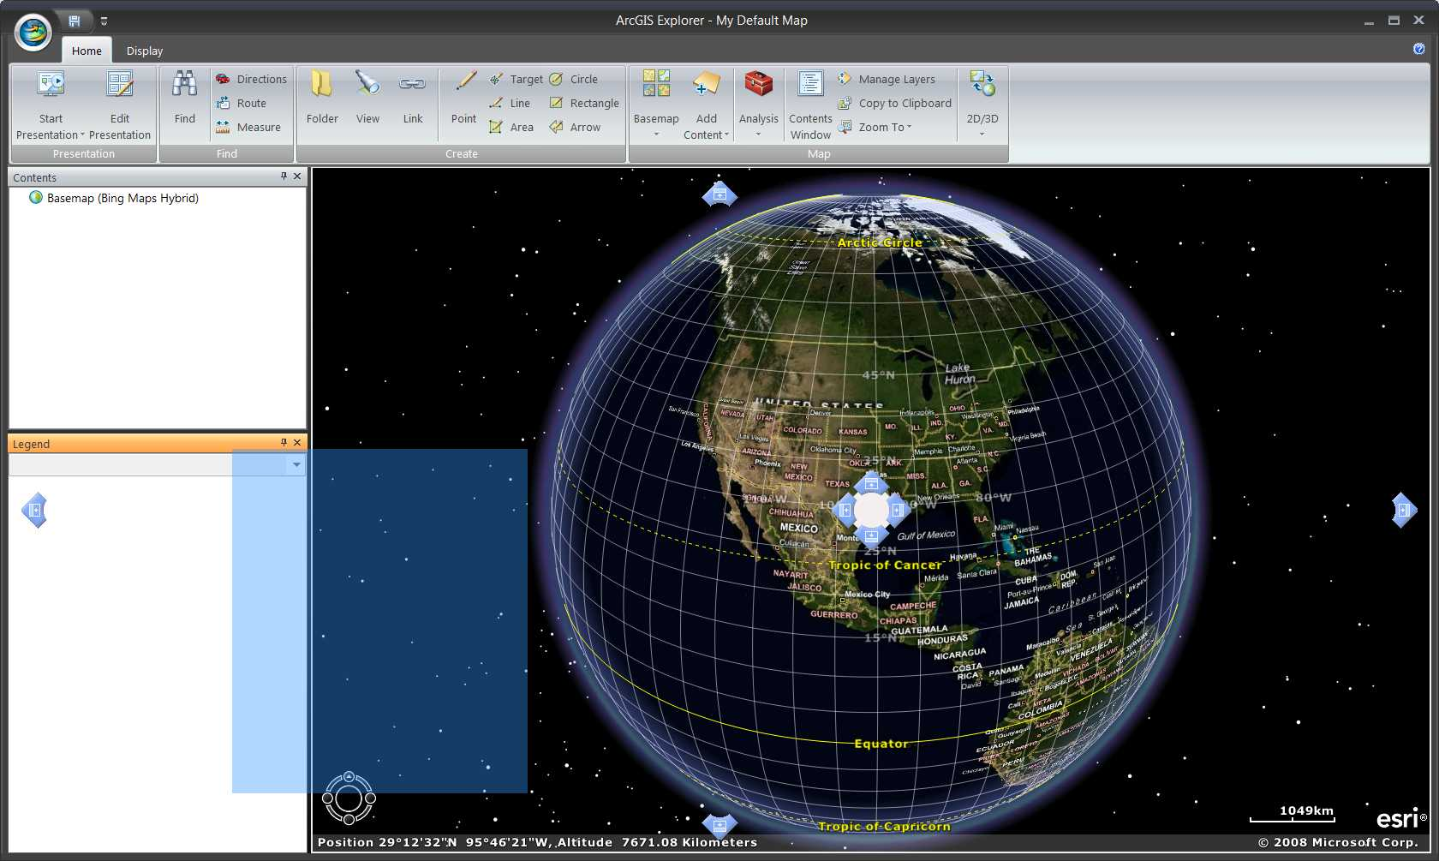
Dock Window

How to add and work with layers in AGX
Navigation
Three different ways can be used to navigate the map: 1) using the navigator; 2) using the mouse; 3) using the keyboard. The usage of navigator and mouse is straightforward and the keyboard shortcut can be found in the Help.

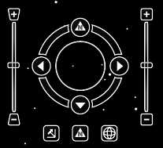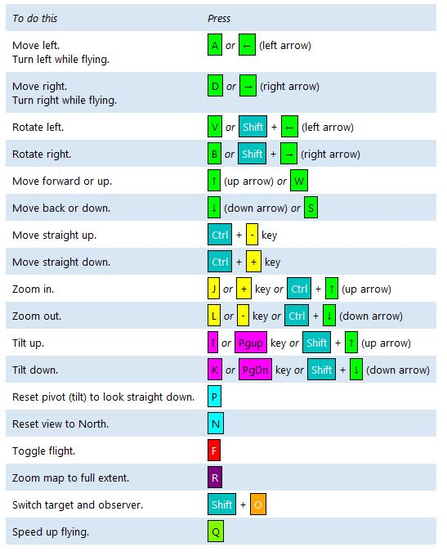
Next, we will learn how to add files into AGX, there are several different formats that can be display on the platform.
Adding shapefiles
Shapefile is one the most common data format for GIS data that created by ESRI. AGX can easily add shapefile into the application. The map view will automatically zoom to the added data when the adding process is finished. AGX only provides limit options for the display purpose. For example it does not provide the “Quantities display” for different characteristics that stored in the shapefile. In other words, only one color is allowed. There are several ways to hand this issue which will be discussed in the later section. Here we used the census data from McHenry County, Illinois as an example. We can add the census block into AGX and as default it will only show in single color. We can use the “Appearance” tab in the Layer Tab Controls to change the color of the outline which can make it more easily to see.
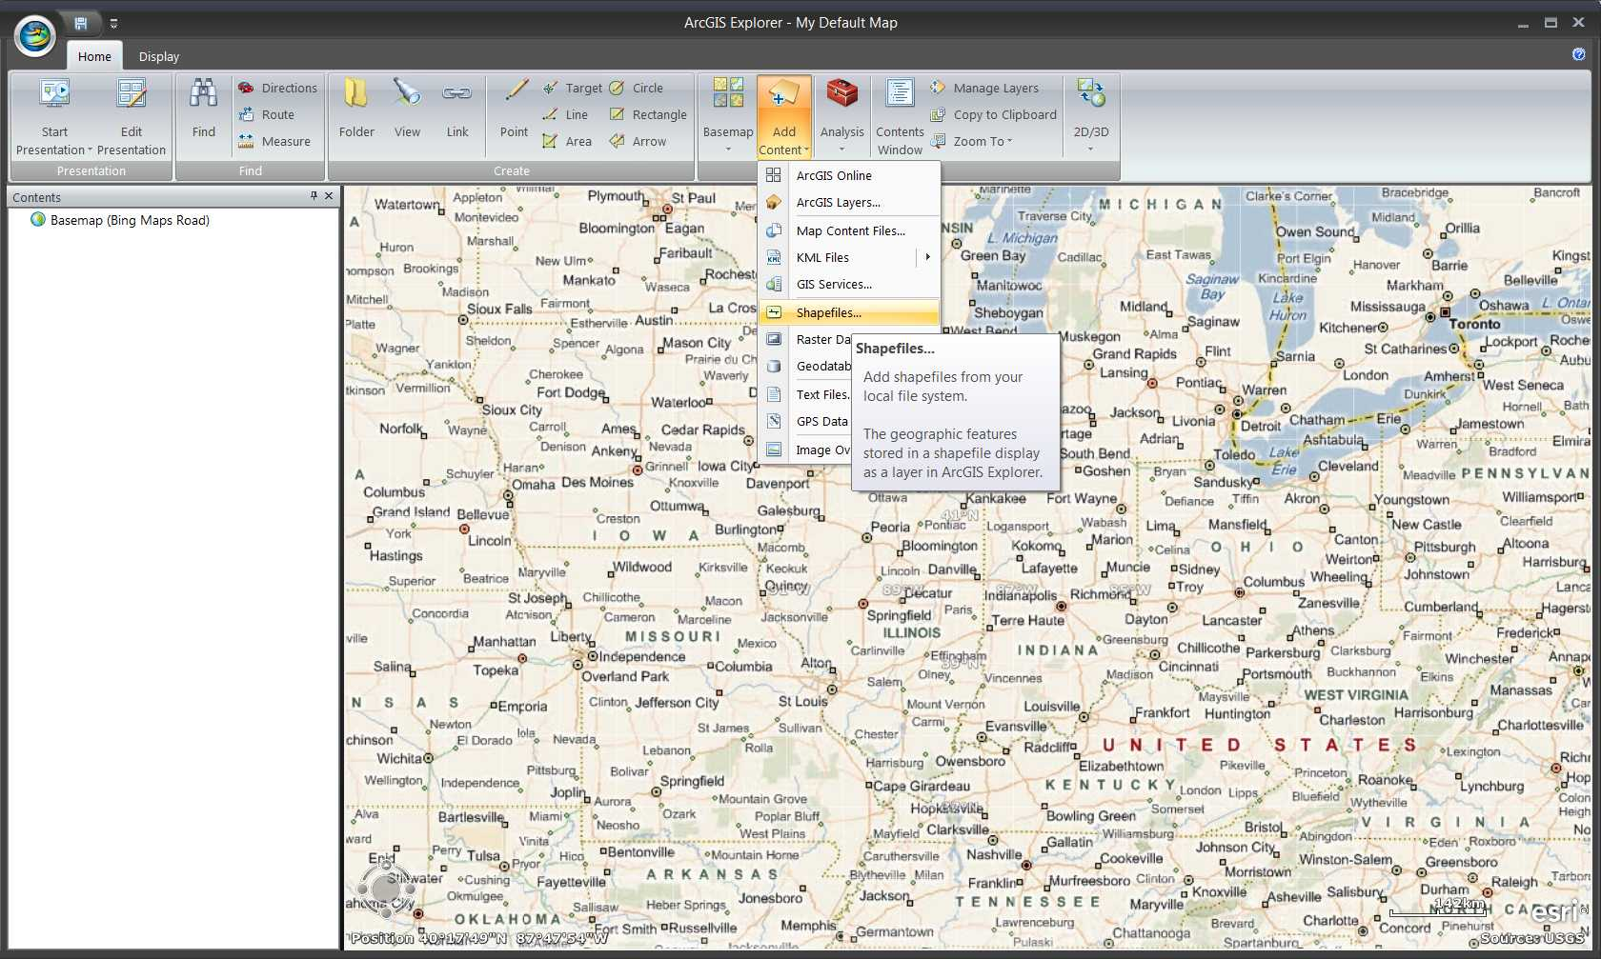
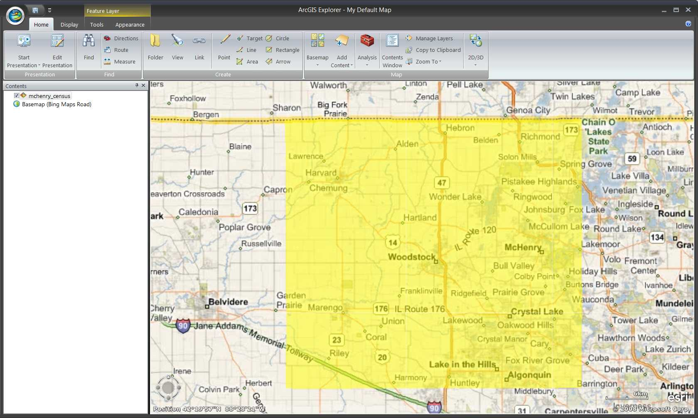
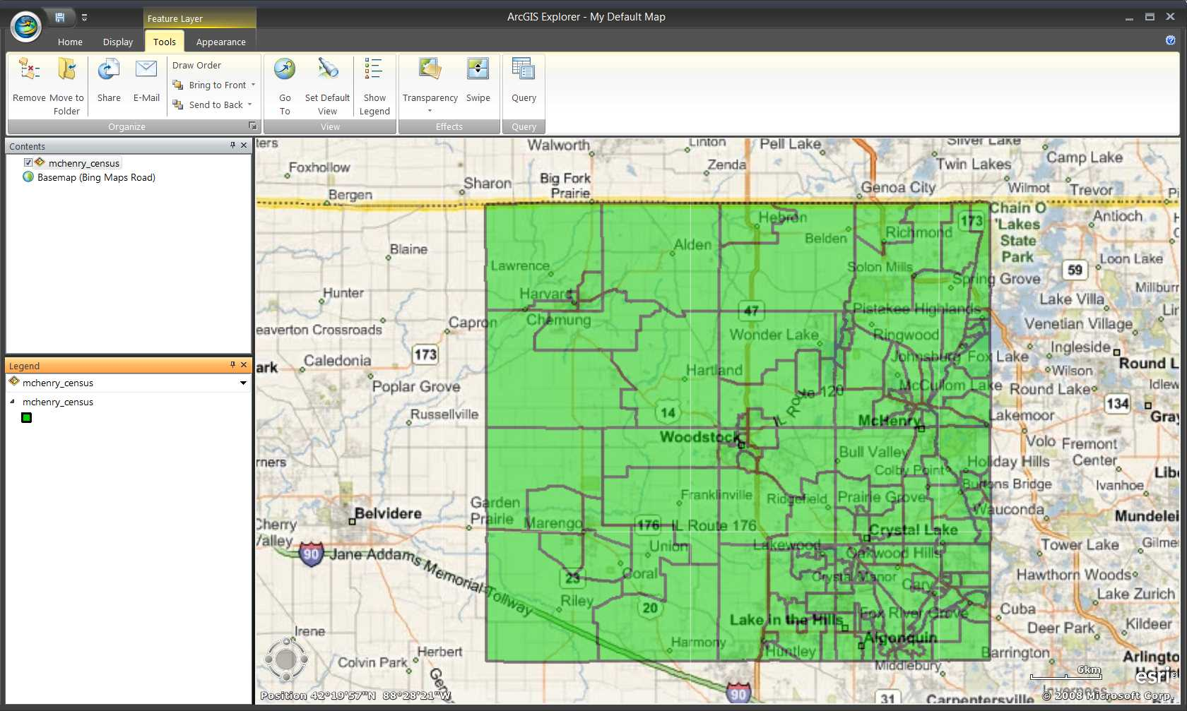
Adding ArcGIS layers (or layer packages)
If the shapefile has been saved in layer or layer package (by ArcMap), AGX can also add in this kinds of files. Since the “Quantities display” is stored I the data, AGX can also be shown different color in the platform. The following example is still the census block of McHenry County but we saved it into layer package with ArcMap. And we also set up the “Quantities display” to show the result of “Urban_population/Total population.” AGX can display all these information using the legend.
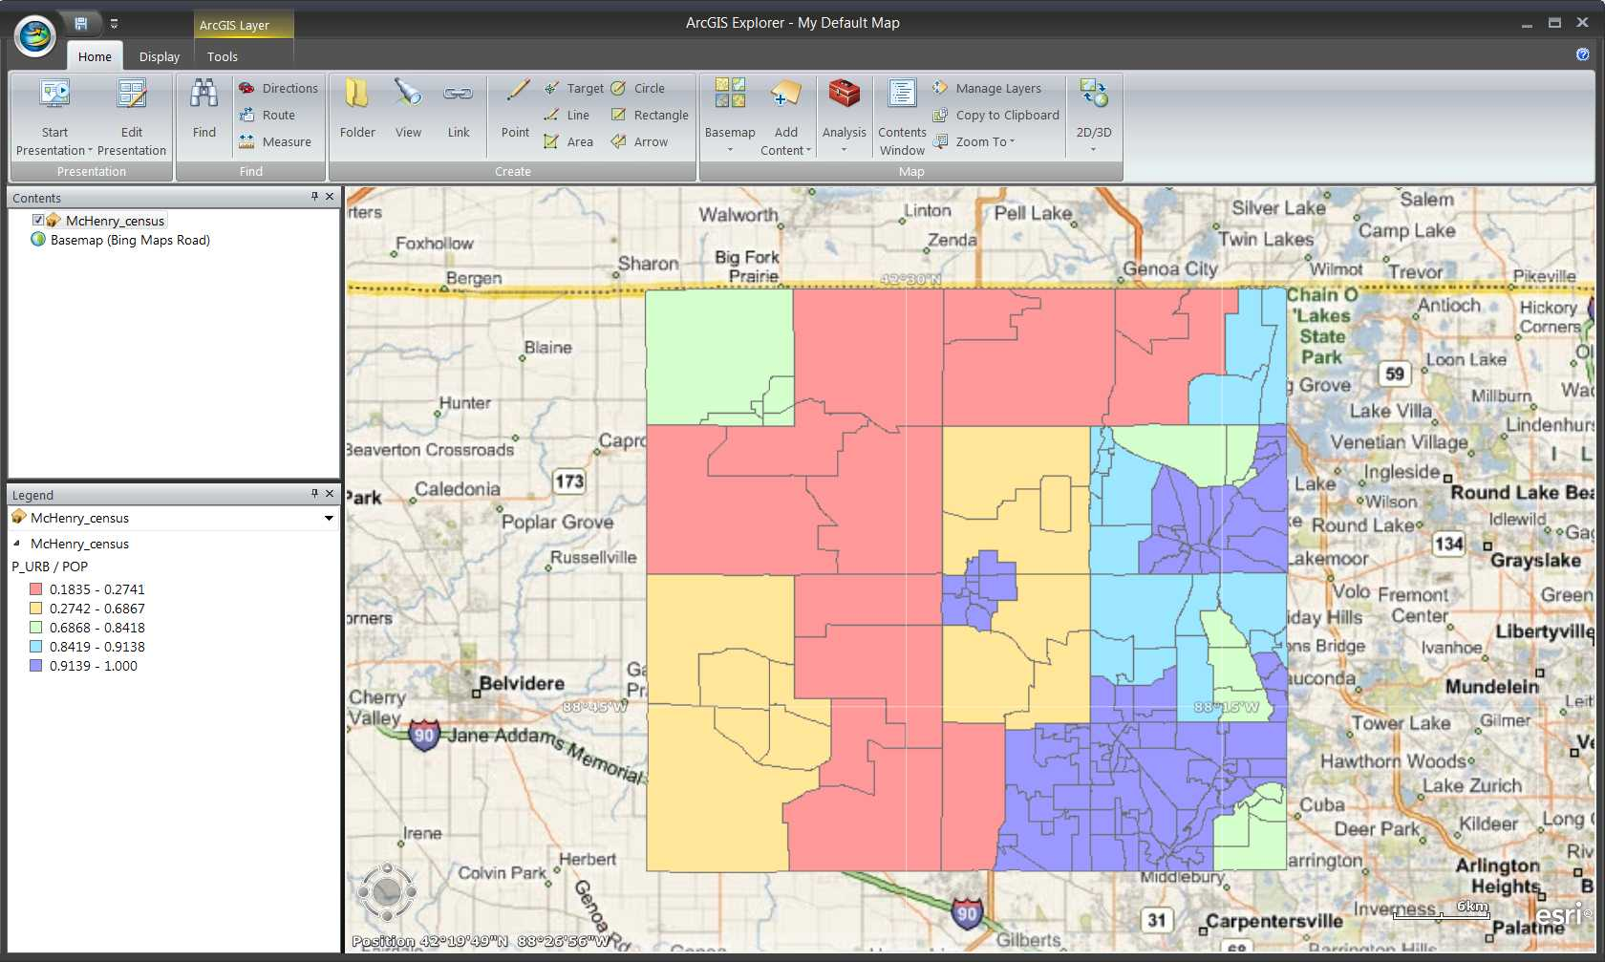
Adding Map Content files
Map content files (.nmc) are those AGX specific file format. It is also the default output format of AGX. Users can safe anything (shapefile, raster file, folder of notes, etc.) in AGX into Map content files and add into AGX later. Right-click on the files that users want to save and choose “Share…” the AGX will allows users to select which format they want. It can be chosen from Map Content files, ArcGIS Layer Package and Google Earth KML files. And the dialog window will indicate users to select the location for the output files.
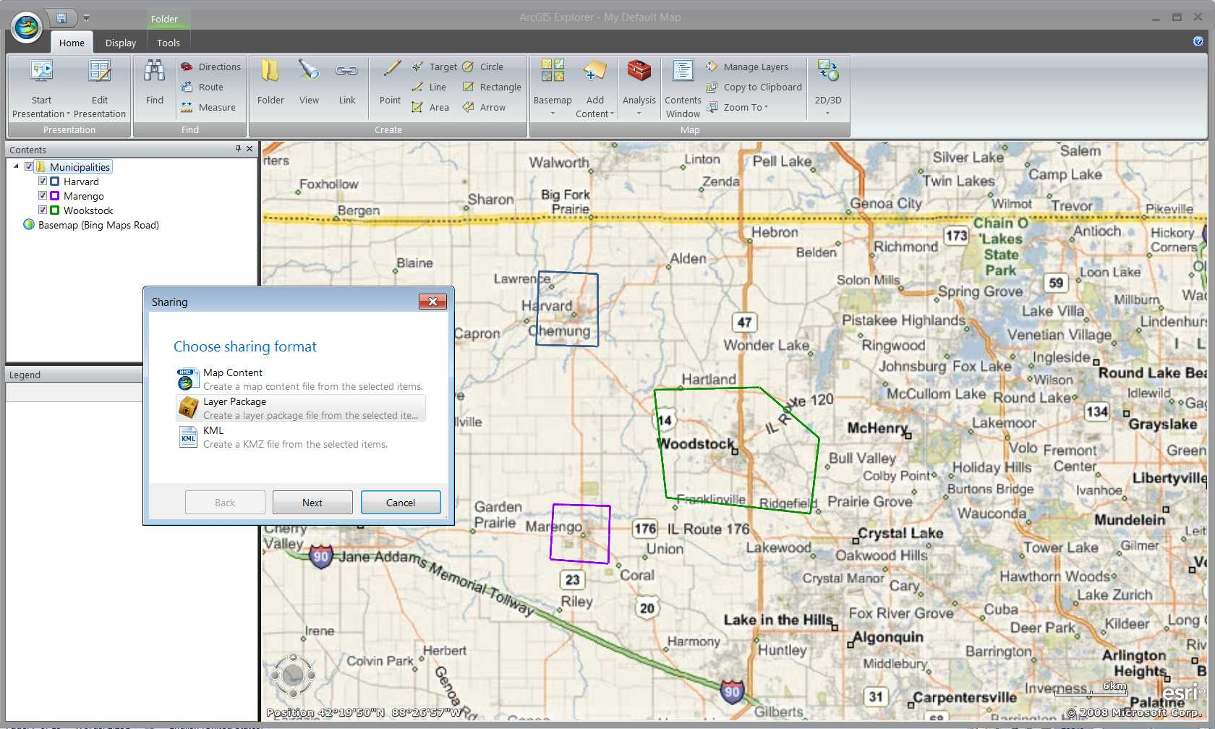
Adding KML files
The KML file used in Google Earth can also be added into AGX. Simply add KML files as other data format from button. All information that stored in the file will be display in AGX.
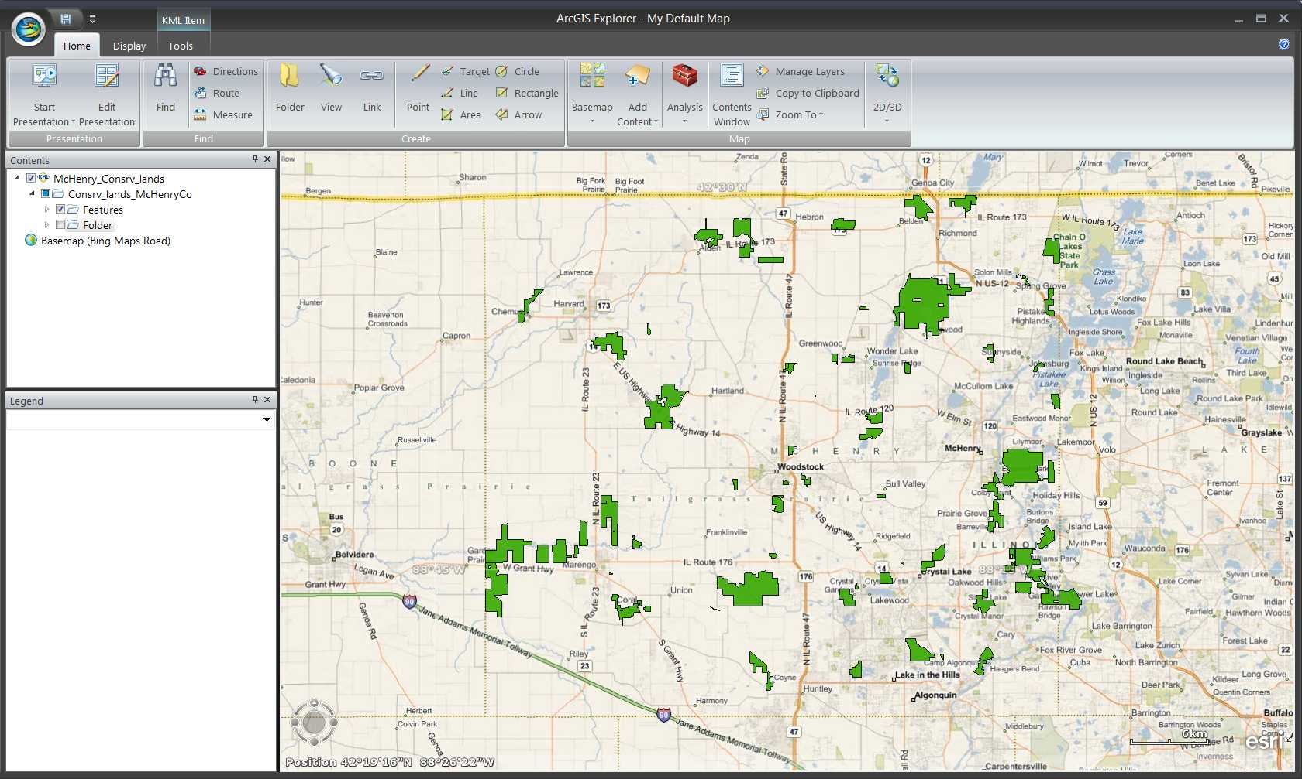
Adding files from GIS server
AGX can work within an environment without internet connection. However, it is designed to have best performance when internet connection is available. When the computer is connected to internet, AGX can add GIS data from any GIS server. ESRI provides a public GIS server with various GIS data. Click on “GIS services” button, and type in the web address of the ESRI GIS server: http://services.arcgisonline.com/arcgis/services, AGX will connect to ESRI GIS server automatically. And users can then choose any GIS data that provided by this server. For example, The “USA_1990-2000_Population_Change” in Demographics is added into AGX.
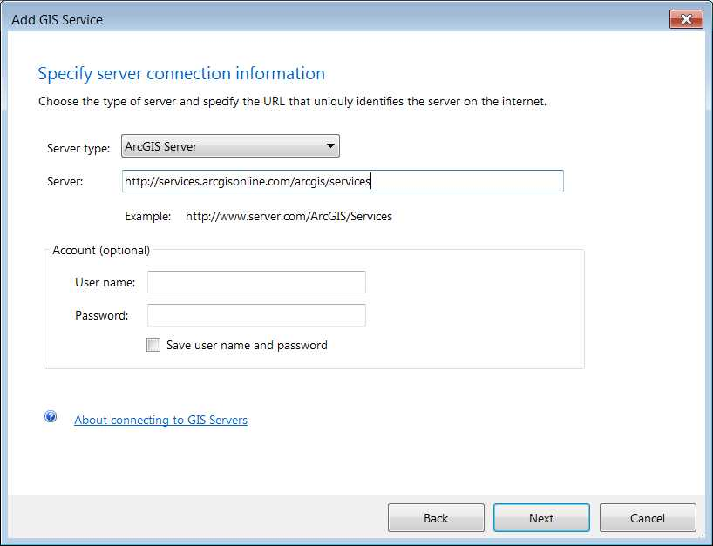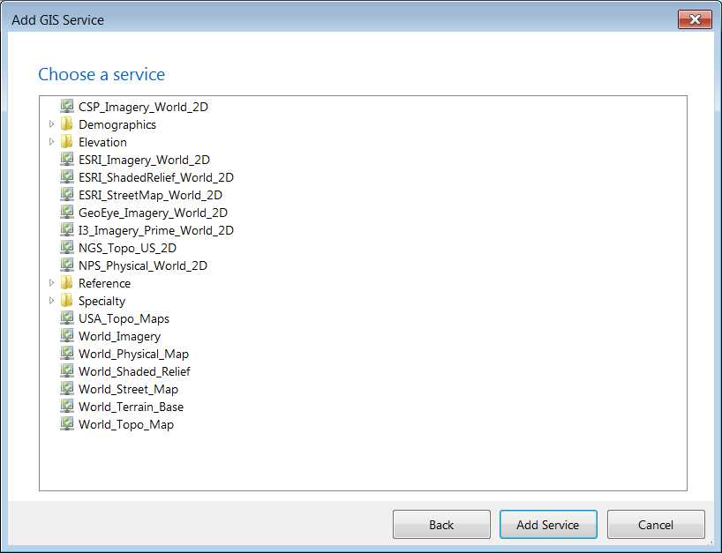
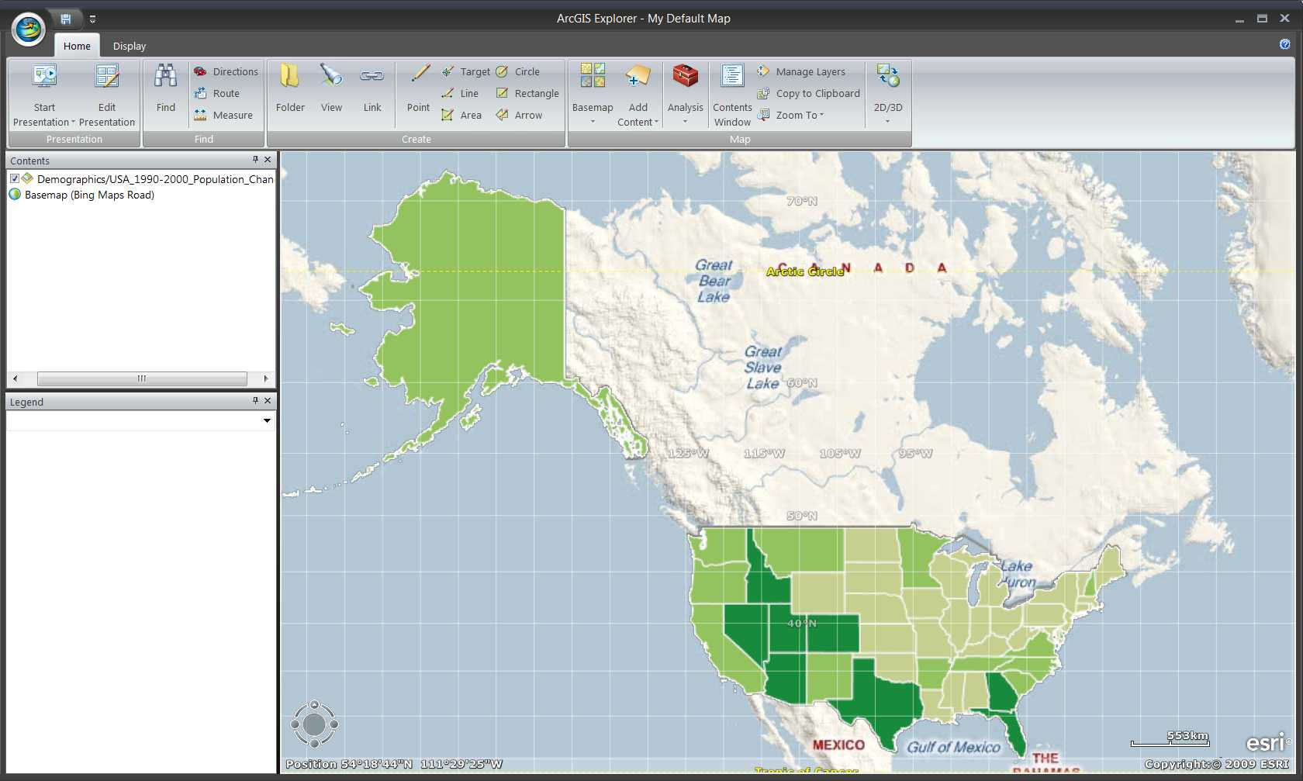
Adding raster data
Raster data such as GeoTIFF can also be added into AGX. The legend of the raster data will also be displayed in the Legend dockable window. The example here is the land cover data for McHenry County in 1992.
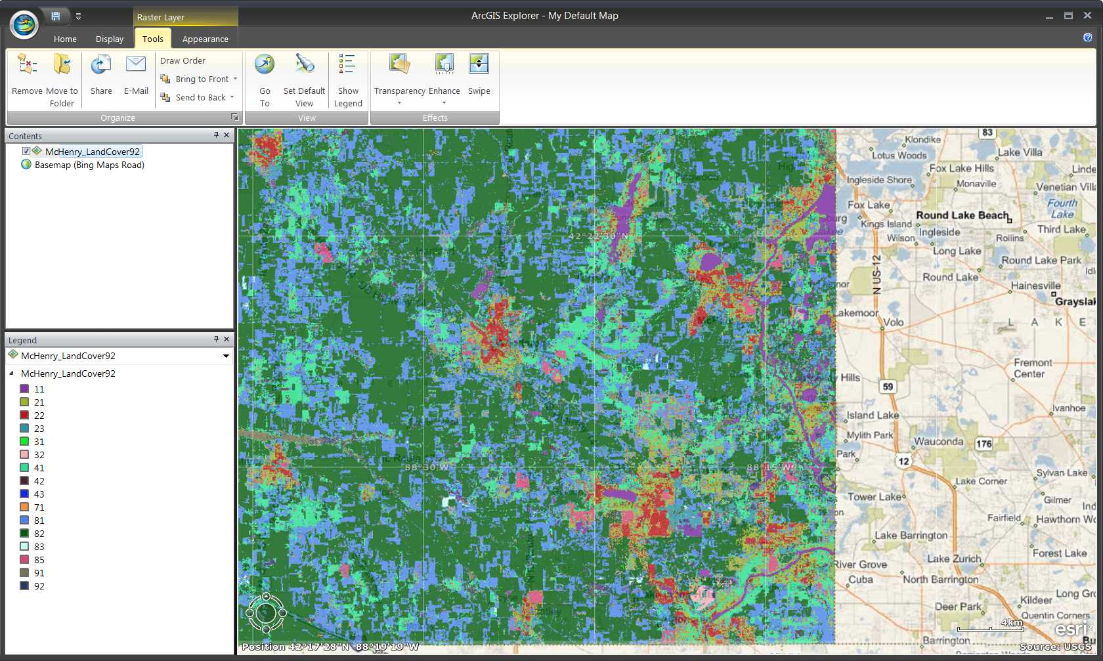
Adding text data
Text data such as “.xls,” “.txt,” and “.csv” with coordinate information can be imported into AGX. The example here is the towns in McHenry County save in .xls format. Users first have to choose which sheet contains the data. The next step is choosing the separates and text qualifier. For .xls format, using Comma and “”. Users then have to select the column with X and Y coordinates information, meanwhile, the title and description can also be selected. Finally, the text file will be added as Point Note in AGX.
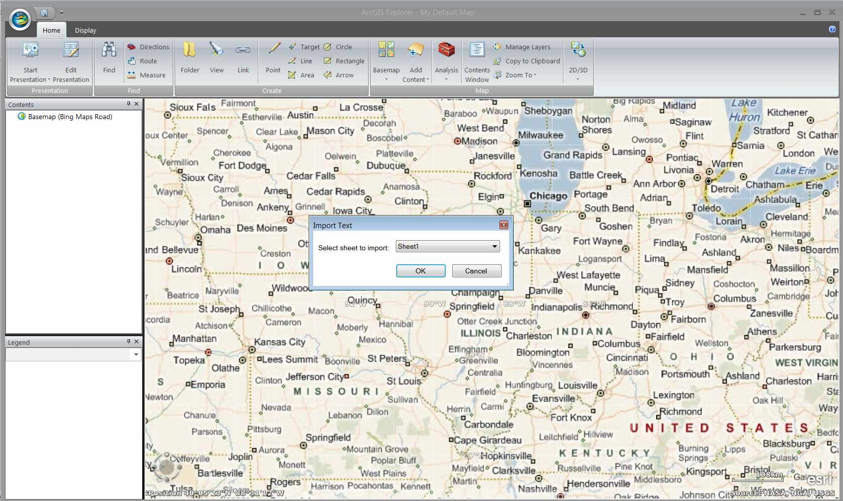
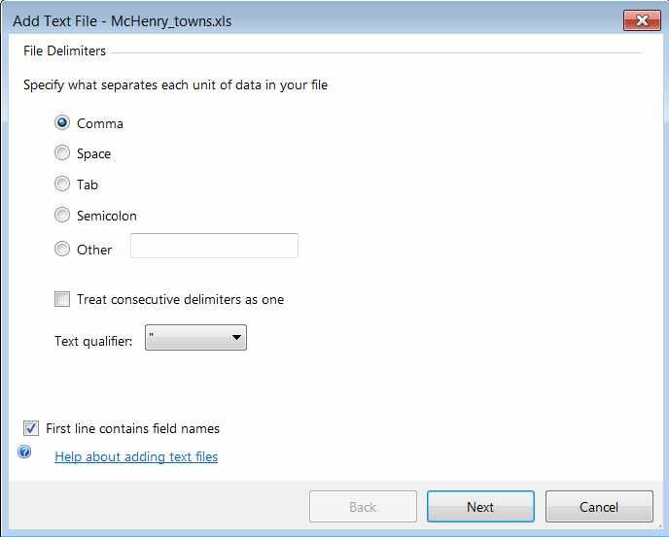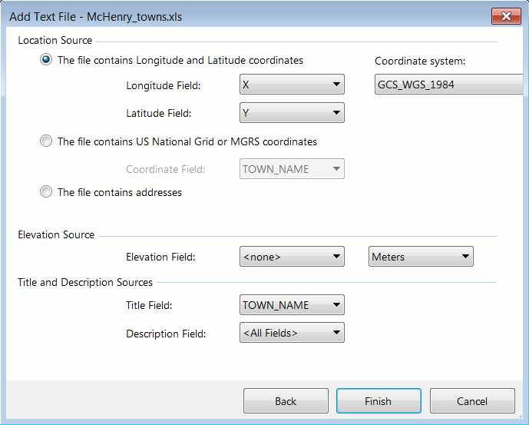
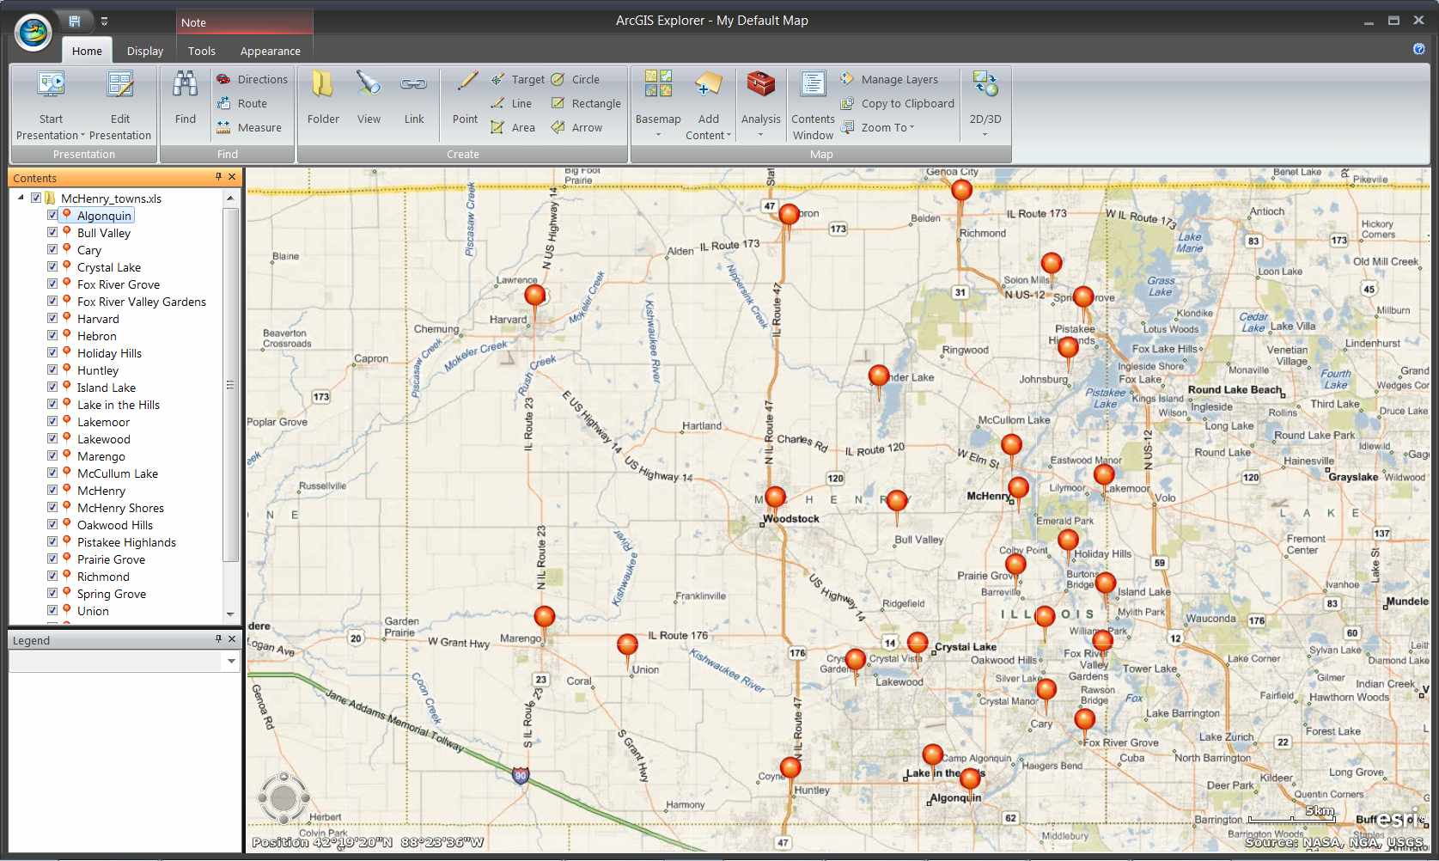
Next, we will use the Tab Controls to modify the data we added.
Home Tab Controls
The Home Tab control is one of two main tabs in AGX. It allows users to change basemap, add in data, search address and create their own notes. Presentation Group allows users to view or to create a presentation slide using AGX. Find Group works on the basemap and has similar function as Google Map which can identify specific address and get direction between two locations. Create Group lets users to create their own notes in AGX. Map Group allows users to change the basemap, add in all the data we mentioned above, open/close windows and change the view between 2D and 3D.
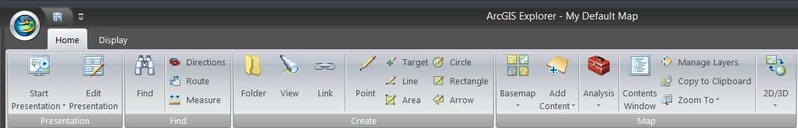
Display Tab Controls
Display Tab control is also the main tab of AGX. It allows users to change some display setting in the platform and alter the special effect in 3D display. Options Group can change the position of navigator and open/close the position information. Units Group allows users to select the coordinate system and the scalebar. 3D Environment Group can change the visualized setting in 3D display.
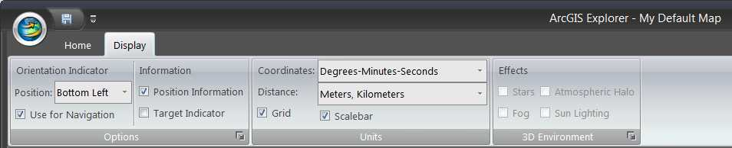
Layer Tab Controls
Layer Tab control is not always display in the tab bar. It will appear when a layer has been selected in the Table of Contents. Based on the selected layer, different type of layer tabs will show up. When a layer is selected by users, two layer tabs: Tools and Appearance are ready for users to use. Tool Tab allows users to organize and set the view of layer. Organize Group allows users to remove, move, share and change order of the layer that selected. View Group can zoom to the selected layer and open/close the legend. Effect Group can change some visualized effect of the layer. Query Group, a new function in build 1500, provides a basic attribute query function (on feature layer only). Appearance Tab allows users to change the details of the layer, such as color and size of the symbol. Popup Group can change the display content of Popup window. Symbols Group changes the size, color and transparency of layer symbols. Display Range Group set up the display range of this layer.
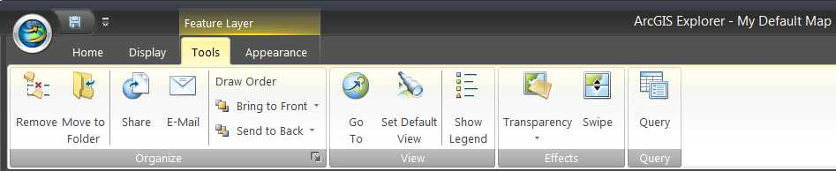
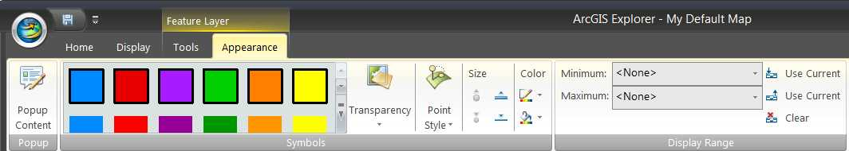

What is ArcGIS explorer SDK
ArcGIS Explorer SDK is the software developer kit for users who wish to create their own “Add-ins” in AGX. One of the parts of the SDK is the documentation which is the developer helps that users can get from the AGX-SDK. This SDK help contain object model diagrams which shows all the properties and methods that certain class has.
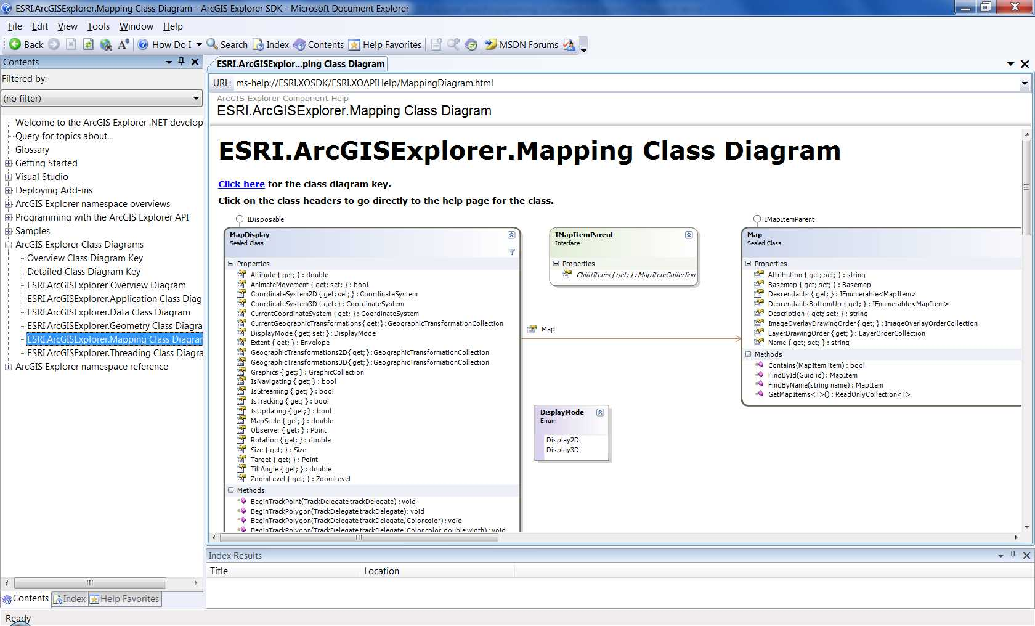
Meanwhile, some sample codes are also included in the documentation. Most importantly, SDK will create snippets and templates users’ Microsoft Visual Studio 2008. Snippets are like samples; they are little blocks of codes that users can just right-click and put them into their own codes. Templates are the starting point to create Add-Ins.
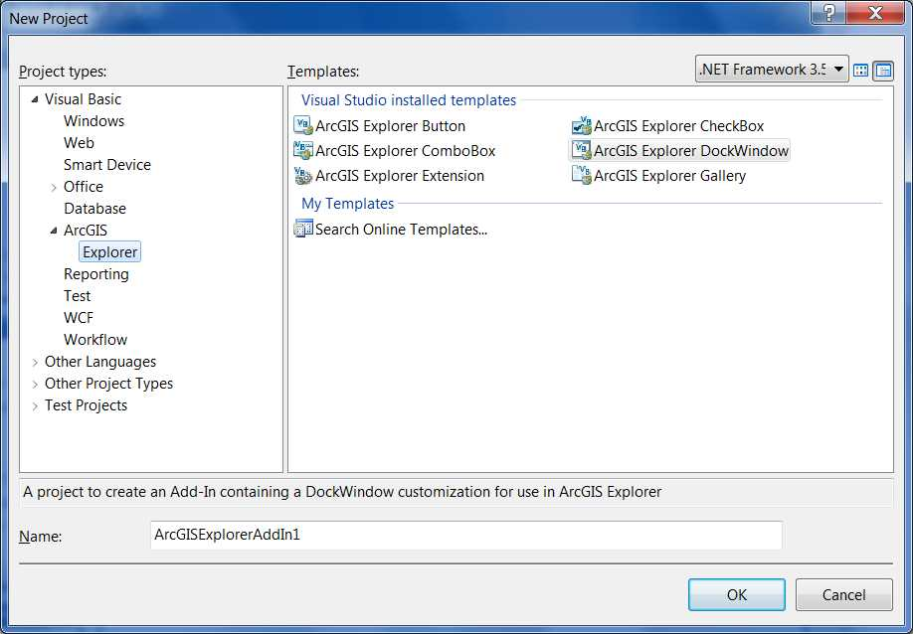

The installation of AGX-SDK
Like AGX, the download of ArcGIS Explorer SDK is free from ESRI website
http://resources.arcgis.com/content/arcgis-explorer/1500/download
Make sure to read through the installation guide before install AGX-SDK. The most important requirement is the pre-installation of Microsoft Visual Studio 2008 or higher and .NET Framework 3.5.
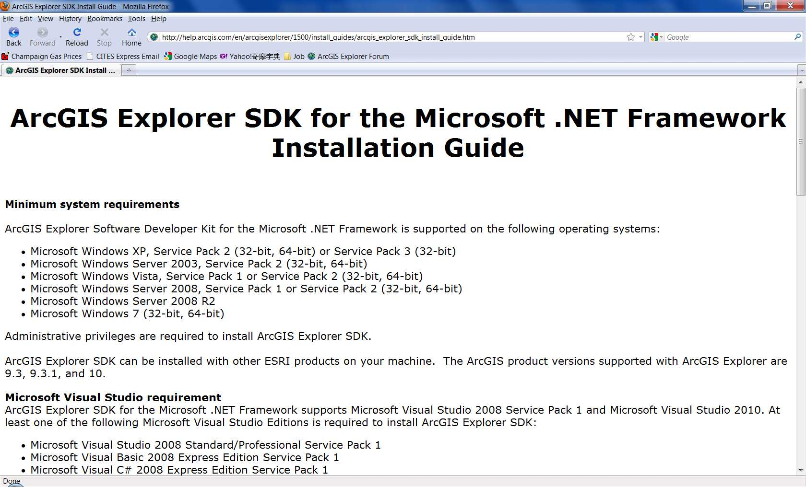

How to create your own add-in
Add-Ins is the function that users can build in their own logic and purpose into a button or a platform to customized AGX. There are six different Add-Ins in AGX: Buttons, Dockable Windows, CheckBox, ComboBox, Gallery and Extensions. This workshop will only focus on the first two Add-Ins since they are the most common two. ESRI marks base classes and provides six templates for these six Add-Ins in Visual Studio. Users will create their own class which inherits from one of these six base classes.
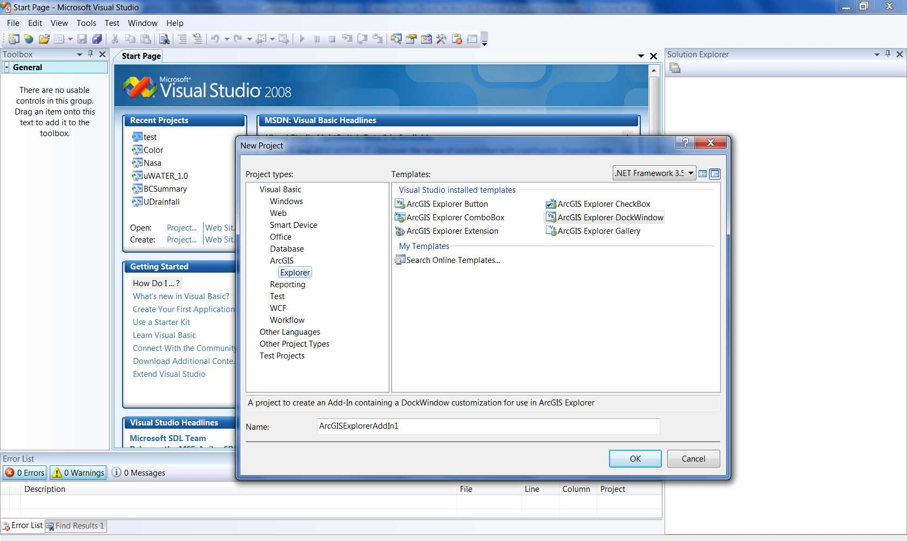
Users have to initial a new project in Visual Studio first, and then choose a base class (Add-Ins) from the ESRI templates. After that, users need to put in their own logic and compile the program. Finally they can test and deploy their program.

Programming examples in AGX-SDK
We need to create a project for examples. The project is named “AGXDemo.” in Visual Basic 2008. When the project name has been input, the setting dialog for the project will show up. The Display Name is set the same as the project name. It is also the name of the “Add-ins” file (.eaz files, will discuss in detailed in next section). The developer can type in some description about the project in Description. The Group Caption will be displayed in the Group section and the Publisher is the developer’s name.
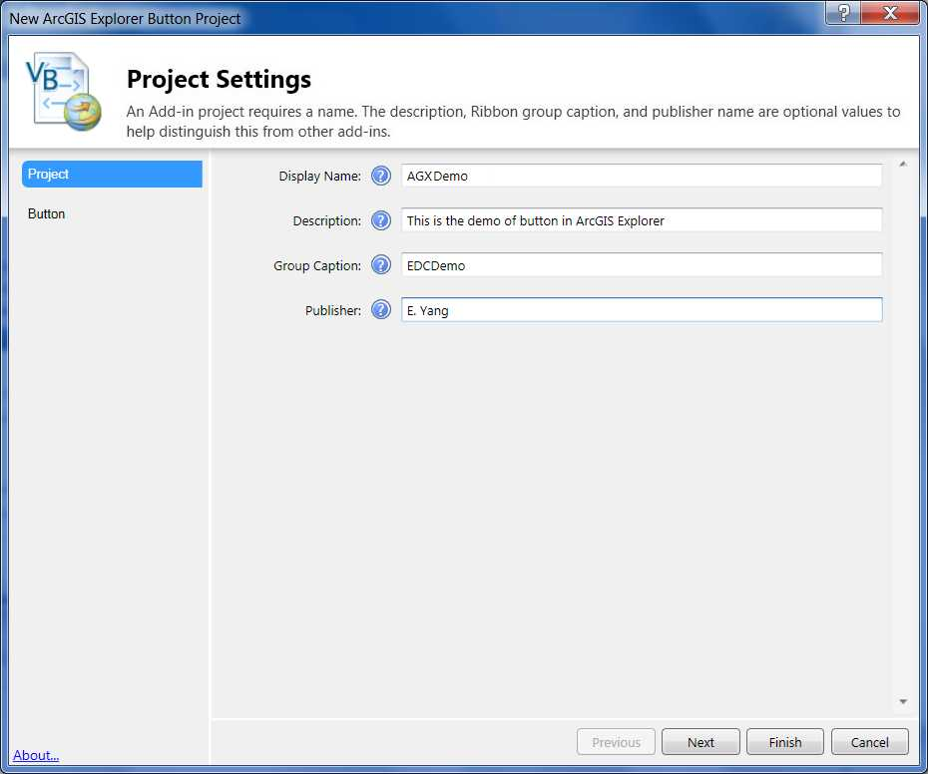
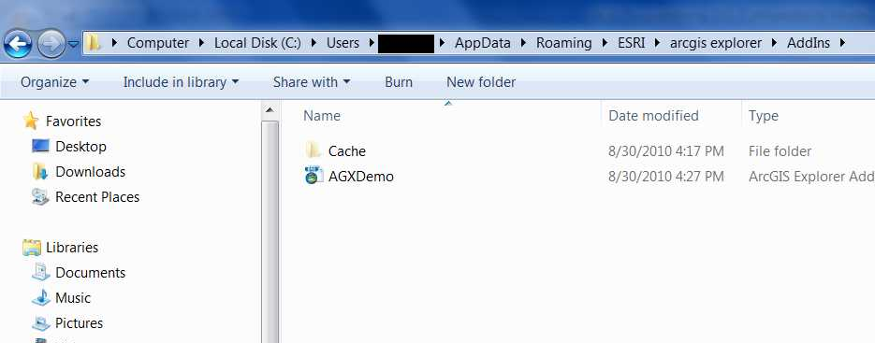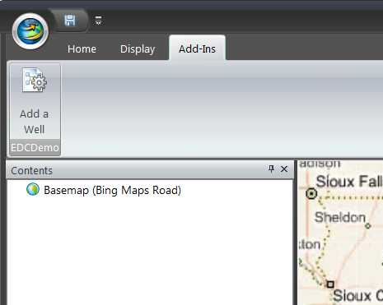

First, a Button is created in the project and the Button Settings dialog will show up once we finish the project settings. The Class Name shows the type of class. The Caption is the name of the Button that will appear in AGX. The ToolTip is the description of this Button and will show up when user move their curser above the Button.
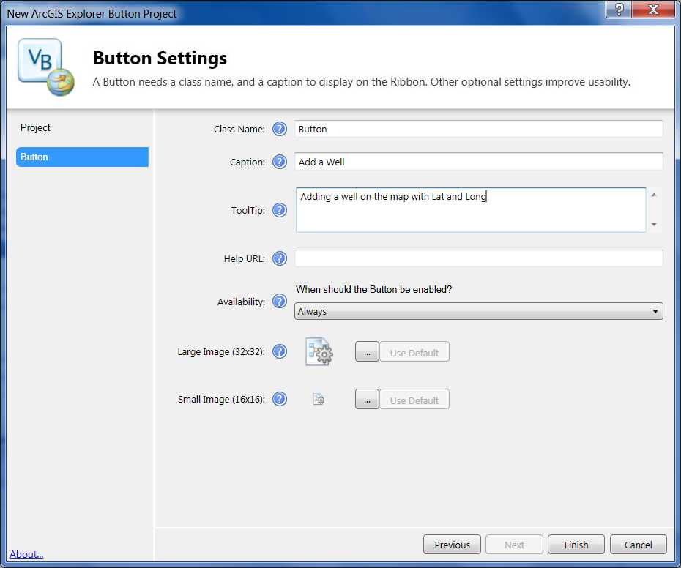
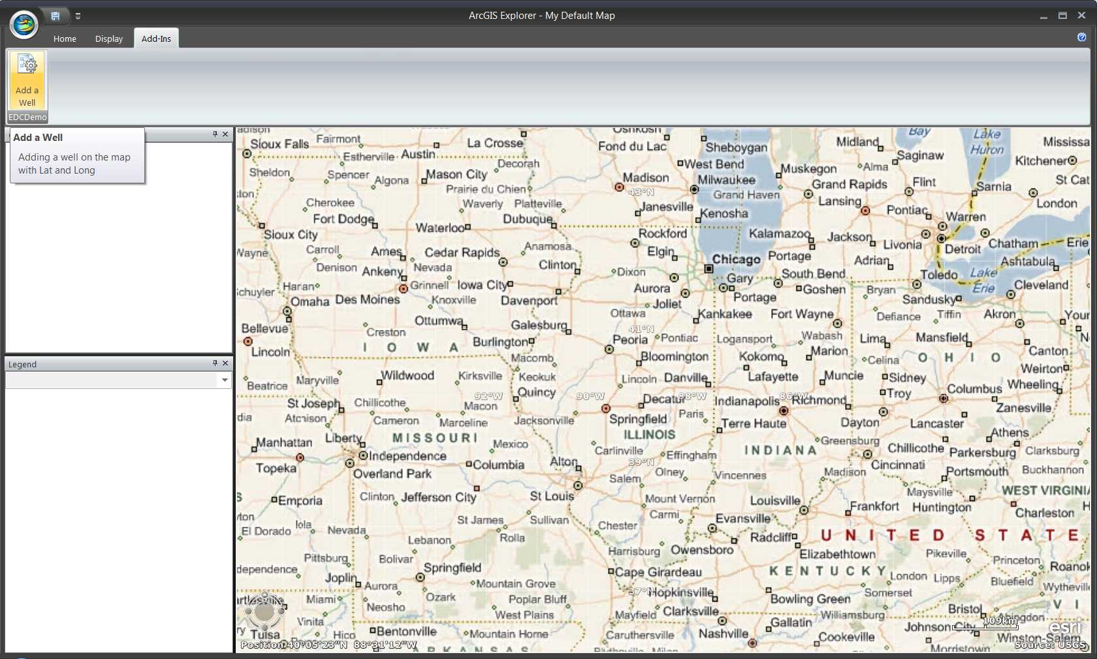

Second, we can add another class into the project by using “Add New Item.” in Visual Basic 2008. This time we will add a Dockable Window. Once we done with the item selection, the setting dialog for Dockable Window will show up. All settings are similar as Button. However, we can change the Availability which control when this function can be used in AGX. For this example, we want this function only available when a single feature layer is selected.
The above are the basic settings of the project and the classes we will use. The following section will demonstrate how to create our own logic in these classes.
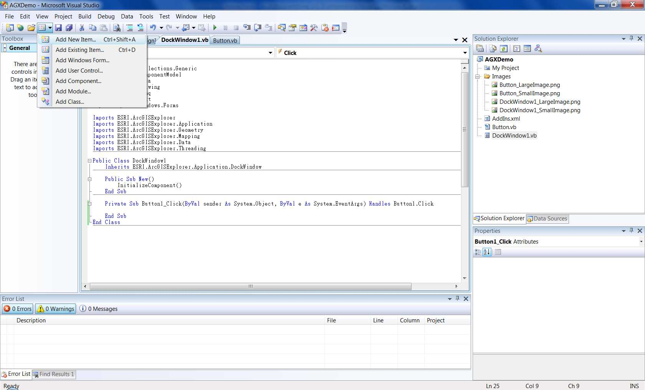
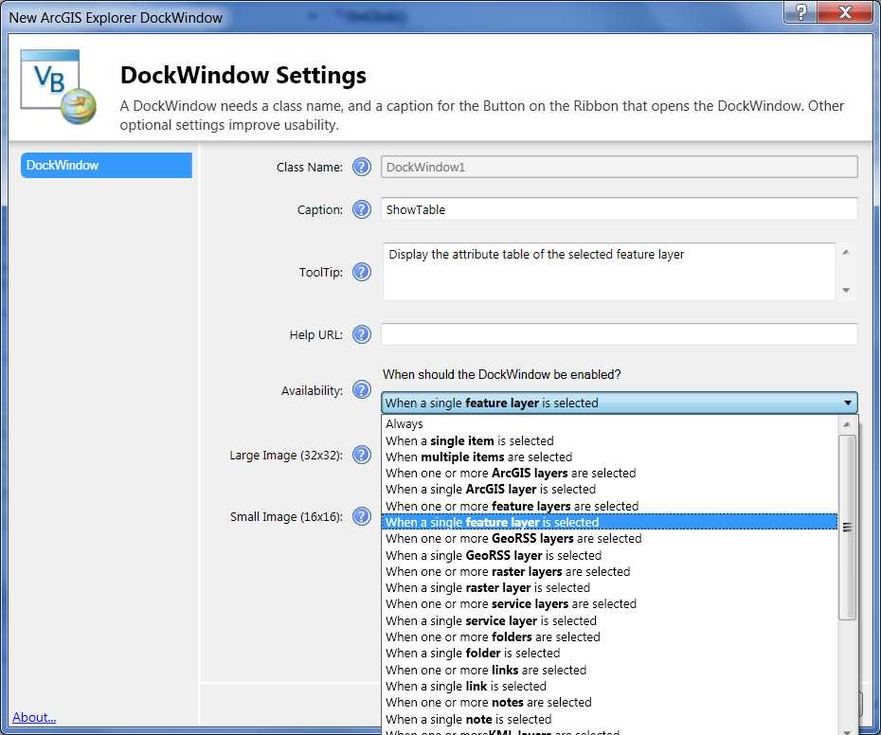
Button Demonstration
In this example, we want to create a Button which allows users to put an oil well on the map by click on it. The following code is the exact code that needed to be written.
***Code**********************************************************************************
' set the active display
Dim disp As ESRI.ArcGISExplorer.Mapping.MapDisplay = ESRI.ArcGISExplorer.Application.Application.ActiveMapDisplay
' get the point where user clicked
Dim pt As ESRI.ArcGISExplorer.Geometry.Point
pt = ESRI.ArcGISExplorer.Application.Application.ActiveMapDisplay.TrackPoint()
' define a note to record the well
Dim WellNote As Note
' create the note using the name “Well,” location and the graphic of pt
WellNote = New Note("Well " & "Lat: " & pt.GetLatitude.ToString & " Long: " & pt.GetLongitude.ToString, pt)
' set the symbol of created note as “Oilwell”
WellNote.Graphic.Symbol = Symbol.Marker.PointsOfInterest.OilWell
' add not to the active display
disp.Map.ChildItems.Add(WellNote)
*****************************************************************************************
Dockable Window Demostration
In this example, we want to create a Dockable Window which can display the attribute table of selected featurelayer. First go to the designer interface and create the Dockable Window interface as following. The Selected Feature Layer is a Label in VB 2008. The Display the attribute table is a Button in VB 2008. We also need a DataGridView class to show the attribute table.

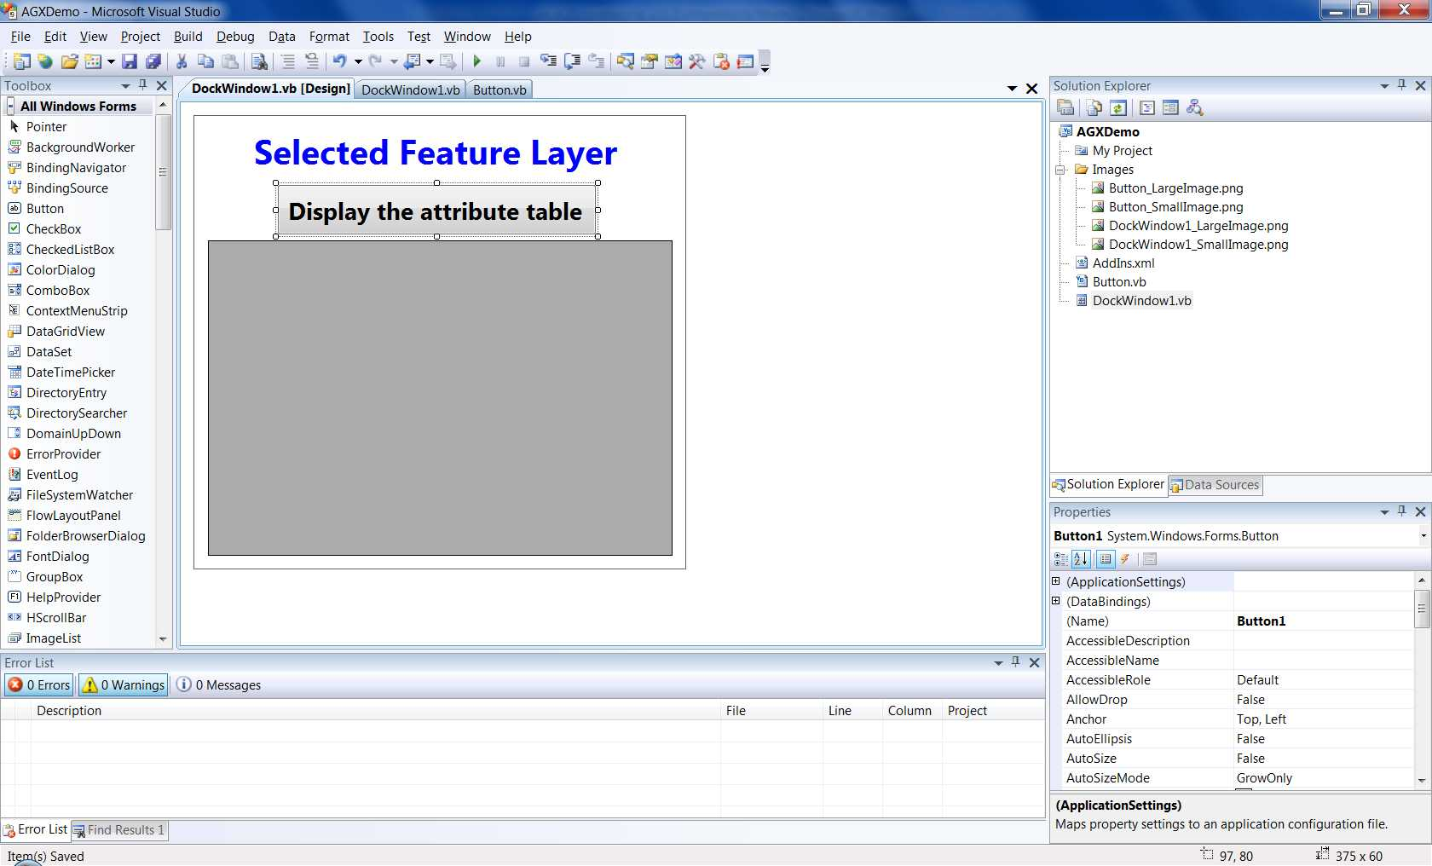
The following code is the exact code that needed to be written.
***Code**********************************************************************************
' set the active display
Dim disp As ESRI.ArcGISExplorer.Mapping.MapDisplay = ESRI.ArcGISExplorer.Application.Application.ActiveMapDisplay

' define the item that selected by user
Dim SelItem As ESRI.ArcGISExplorer.Application.SelectedItemsCollection = ESRI.ArcGISExplorer.Application.Application.SelectedItems

' define the name of selected item
Dim SIName As String

' define a featurelayer for selected item
Dim FLitem As FeatureLayer

' get the name of user selected item
SIName = SelItem.Item(0).ToString()

'display the name on the label
Label1.Text = SIName

' find the featurelayer that has the name which equals to the one user selected
FLitem = disp.Map.FindByName(SIName)

' create a new bindtable and fill it with featurelayer's table
Dim FLbind As TableBindingAdapter
FLbind = New TableBindingAdapter(FLitem.Table)
FLbind.Fill()

' using the datagridview to show the bindtable which is the selected rows
DataGridView1.DataSource = FLbind
*****************************************************************************************

How to deploy your own add-in
EAZ files
When users finish the programming process and after the test and compile, AGX-SDK will automatically create an .eaz file in the “addins” folder. The location of “addins” folder depended on the operation system of users’ computers. For Window XP user, the “addins” folder is located at:
C:\Documents and Setting\user\Application Data\ESRI\ArcGIS Explorer\Addins
For Window Vista or Window 7 users, the “addins” folder is located at:
C:\Users\user\AppData\Roaming\ESRI\ArcGIS Explorer\Addins
The .eaz file is the Add-Ins that developer just created. They can send this .eaz file to other developers for testing purpose.
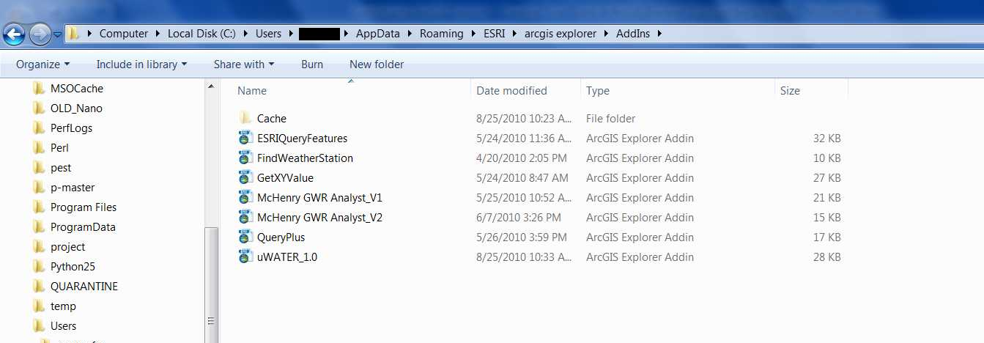
Some sample .eaz file can be downloaded from ESRI website.
http://www.esri.com/software/mapping_for_everyone/explorer/add-ins.html

NCFG file
Usually, .eaz file and the “Add-ins” will not show up on end users’ platform. The developer needs to create an application configuration file: .ncfg file for the end users. Users who open this .ncfg file will see the custom configuration that design by the developer. Application Configuration Manager is the necessary tool to create .ncfg file. The developer can change the configuration setting such as using their own basemap, enable or disable several default functions in AGX and incorporated the .eaz files.

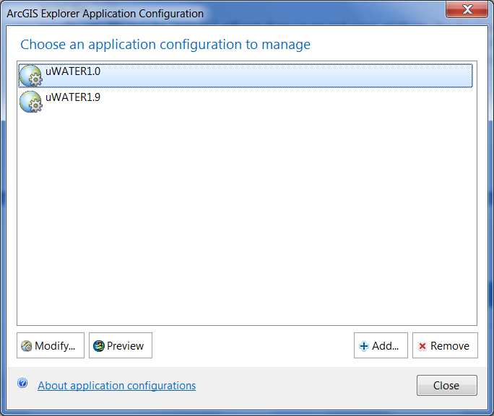
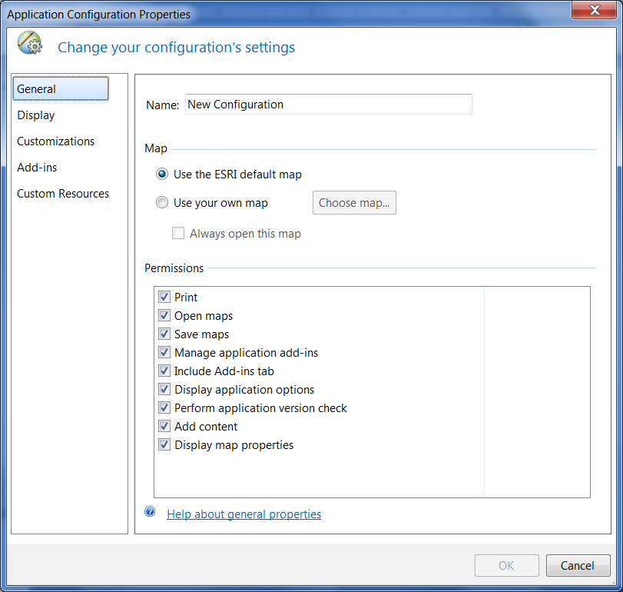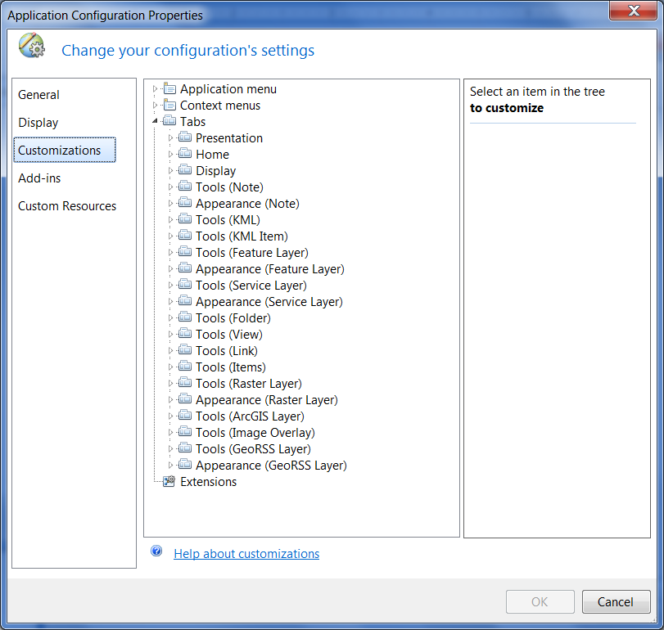

More information

GIS HELPS
ArcGIS Explorer Blog http://blogs.esri.com/Info/blogs/arcgisexplorerblog/default.aspx
ArcGIS Explorer Forum http://forums.arcgis.com/forums/25-ArcGIS-Explorer
ArcGIS Explorer Online Help http://webhelp.esri.com/arcgisexplorer/1200/en/index.html#welcome_page.htm
ESRI Training: http://training.esri.com/gateway/index.cfm (Virtual Campus courses are freely available to University faculty, staff, and students through WebStore (https://elms.e-academy.com/uiuc/index.cfm?loc=estore/soft_browse/listing&store=3&name=ESRI%20Virtual%20Training&parentID=217)

Getting Data
Illinois Geospatial Clearinghouse: http://www.isgs.illinois.edu/nsdihome/
National Atlas: http://nationalatlas.gov/
National Elevation Dataset: http://ned.usgs.gov/
National Hydrography Dataset: http://nhd.usgs.gov/
Soils, average temp/precip, watershed boundaries, and more: http://datagateway.nrcs.usda.gov/

Reference
ESRI Training presentation: ArcGIS Explorer Quick Start Tutorial: ArcGIS Explorer
ESRI Training presentation: Extending ArcGIS Explorer for Developers

