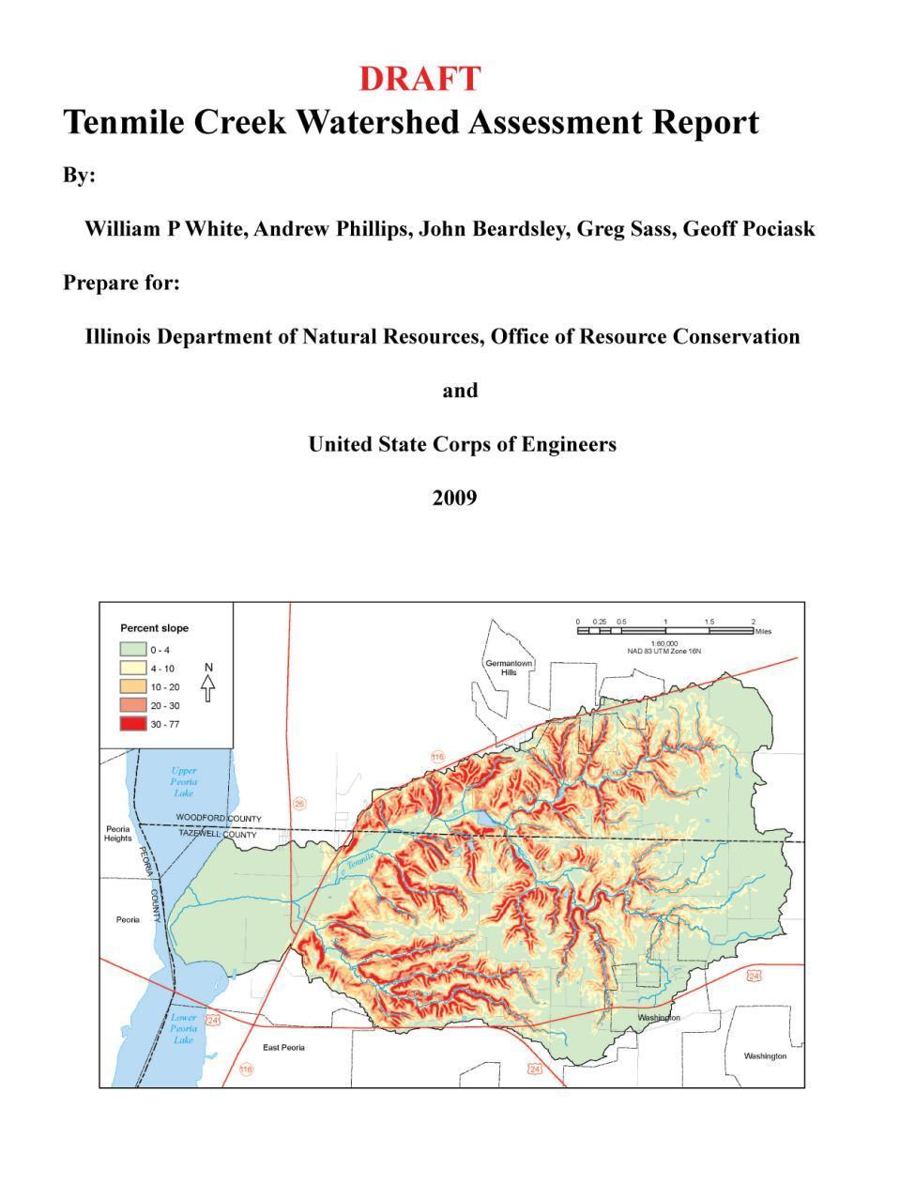

Tenmile Creek Watershed
Assessment Report

Prepared By:

William P. White¹, John Beardsley¹, Andrew Phillips², Geoff Pociask³, Greg Sass⁴

¹ Institute of Natural Resource Sustainability University of Illinois at Urbana-Champaign, Illinois State Water Survey, Center for Watershed Science, P.O. Box 697, Peoria, IL 61652-0697; PH (309) 671-3196; FAX (309) 671-3106; email: bwhite1@uiuc.edu, beardsly@sws.uiuc.edu,

² Institute of Natural Resource Sustainability University of Illinois at Urbana-Champaign, Illinois State Geological Survey, Geologic Mapping and Hydrogeology Center, 615 East Peabody Drive, Champaign, IL; PH (217) 333-2513; FAX (217) 333-2830 email: phillips@isgs.illinois.edu

³ Institute of Natural Resource Sustainability University of Illinois at Urbana-Champaign, Illinois State Geological Survey, Transportation and Environmental Center, 615 East Peabody Drive, Champaign, IL; PH (217) 265-8212; FAX (217) 265-8214 email: pociask@isgs.illinois.edu

⁴ Institute of Natural Resource Sustainability University of Illinois at Urbana-Champaign, Illinois Natural History Survey, Illinois River Biological Station, 704 N Schrader Ave., Havana, IL; PH (309) 543-6000; FAX (309) 543-2105 email: ggsass@illinois.edu

Prepared for:

Illinois Department of Natural Resources, Office of Resource Conservation
One Natural Resources Way, Springfield, IL, 62702-1271

And

United States Army Corps of Engineers
Rock Island District,Clock Tower Building
P.O. Box 2004, Rock Island IL, 61204-2004

TABLE OF CONTENTS

- STUDY AUTHORITY 3
- Authority, Section 519 3
- Proposed Sponsors 3
  - STUDY FRAMEWORK AND PURPOSE 3
  - PROJECT LOCATION 5
- Location 5
- Study Area Congressional District 5
- PRIOR STUDIES, REPORTS, AND EXISTING PROJECTS 6
- Assessment Goals 6
- Tenmile Creek Watershed Restoration Plan, a Preliminary Investigation Report 8
C. Lake Front and River Development Plan 10
D. Related Efforts of Significance to Forest Management in the Tenmile Creek
Watershed…………………………………………………………………………….10
  - PLAN FORMULATION 10
- Watershed Condition 10
- General Geomorphic Setting and Recent Geologic History 11
- Native Landscape and Pre-European Land Cover: Influences from Soil
Geomorphology and Slope 12
- Cultural Setting 15
  - Population 15
  - Political Boundaries 15
  - Non- Governmental Organizations …………………………………………..15
  - Other Stakeholders 15
- Current Land Cover, Land Use, and Other Existing Conditions 15
  - Current Land Cover 15
  - Current Land Use 16
    - Agriculture 16
    - Industry 16
    - Transportation 17
    - Urban Areas and Impervious Surfaces 17
    - Zoning 17
    - Prime Farmland 17
    - Public Lands with Ecological Designations 17
- Study Methods 18
- Abiotic Environment
  - Geologic Setting 18
    - Bedrock Geology 18
    - Surficial Geology 19
  - Hydrogeomorphic Setting 20
    - Aerial Reconnaissance 20
    - Channel Morphology 21
    - Channel Gradient and Channel Bed Texture 24
    - Mass Wasting 26
    - Hydrological and Sedimentological Conditions 29
    - Stream Dynamics Assessment: 1939 and 1998 Comparison 30
    - Channel Stability and Habitat Integrity
    - Water Quality 35
- Biotic Environment 36
  - Terrestrial Habitat 36
  - Wetlands 36
  - Aquatic Habitat 37
- Prioritization Screening Criteria 39
- Expected Future without Project Conditions of Watershed 39
- Prioritization Screening Criteria 39
- Future Geomorphology and Hydrology 40
- Future Biology 42
- Problems and Opportunities 42
- Significance 43
- Technical Significance 43
- Institutional Significance 45
- Public Significance 45
- Goals and Objectives 46
- Preliminary Evaluation of Alternatives 48
- Tenmile Creek Mainstem 48
- Spring Creek 50
- Spring Creek Tributary Creek 50
- Wolf Creek 50
- Forestland 50
- Agricultural Land 50
- Lake Front and River Development Plans
- Proposed Methods for Benefit Assessment 50
- FEDERAL INTEREST 50
- RECOMMENDATIONS 50
- ACKNOWLEDGEMENTS…………………………………………………………......54
- DISCLAIMER………………………………………………………………………...55
- REFERENCES CITED 53

LIST OF FIGURES

Figure 1: Location of Tenmile Creek Watershed

Figure 2: Ten subbasins bordering the Illinois River north of Peoria comprise the Illinois River Bluffs Assessment Area (IDNR, 1998a-d)) and are designated as a Resource Rich Area (Suloway et al. 1996)

Figure 3: Location of grade control structures in the Tenmile Creek Watershed

Figure 4: Landscape of Tenmile Creek watershed

Figure 5: Slope of Tenmile Creek watershed, based on USGS 10m DEM

Figure 6: The Natural Divisions of Illinois (Schwegman, 1973) in the Illinois River Bluff Assessment Area, including Tenmile Creek watershed

Figure 7: Early Europeon Settlement land cover reported by General Land Office surveyors in the early 19th Century. Data from Szafoni et al. (1998)

Figure 8: Soils-based land cover in the Tenmile Creek watershed, compiled using color as described in the Key to Illinois Soils (Windhorn, 2005)

Figure 9: Population density in Tenmile Creek watershed

Figure 10: Land Cover of Tenmile Watershed. Data from the Illinois GAP Analysis Program (http://www.agr.state.il.us/gis/pass/gapdata/).

Figure 11: Land Cover of HUC 071300011705 of the Tenmile Creek watershed extracted from the Illinois GAP Analysis Program, Land cover classification database (http://www.agr.state.il.us/gis/pass/gapdata/)

Figure 14: Industry?

Figure 15: Transportation?

Figure 16: (Public) managed lands (Eliminate DOQ as Base) Creek watershed showing a single T & E species (Softleaf Arrowwood: Viburnum molle) at two Natural Areas, Dams, channelized segments, wetlands, HUC 12 units, Marshall State Fish & Wildlife Conservation Area, Leigh Woods Natural Area, Hatcher Woods Natural Area, Root Cemetery (not show—scale limited), and county boundaries (Illinois Geospatial Data Clearinghouse, 1998-1999)

Figure 17: Biological Stream Characterization: ?

Figure 18: Locations of field and geomorphic channel surveys by ISWS (DATES?)

Figure 19: Soils parent material in the Tenmile Creek watershed. Compiled from USDA NRCS soil surveys for Marshall (NRCS 2002), Peoria (NRCS 1992) and Stark (NRCS 1996) Counties. Bedrock valley (ISGS) and ISGS field observation sites [add ISGS field locations? Strike of Wyoming valley?]

Figure 20: Occurrence of Jules and Paxico soils indicating recent floodplain deposition

Figure 21: Aerial Locations?

Figure 22: Illustration of the six stages of channel evolution following disturbance from Simon (1989, Figure 5; see also USACOE, 1990). “Construction Stage” can be generalized to “Disturbance Stage”

Figure 23: CEM Spatial Distribution

Figure 24: Gradients of Tenmile Creek and its tributaries. (Revised Version Coming)

Figure 25: Percent slope in Tenmile Creek watershed

Figure 26: Bed materials and channel gradient along Tenmile Creek

Figure 27: Exposed active gas (None)

Figure 28: Exposed abandoned gas pipeline (None)

Figure 29: Sites with large scale mass wasting in the Tenmile Creek Watershed. Sites A-C are referenced in the text?

Figure 30: Discharge measurements at Benedict Bridge?

Figure 31: Estimated Annual Sediment Yield and Water Discharge

Figure 32: Reaches, in red, showing significant differences in planform position between 1939 and 1998

Figure 33: Meanders changed their position throughout this reach between 1939-1998. Red polygons indicate the affected areas

Figure 34: The dominant cause of stream planform change in HUC 401 between 1939 and 1998 was channelization

Figure 36: Stream rankings in Tenmile Creek watershed

Figure 37: Rankings of Channel Stability (red) and Biologic/Habitat Integrity (blue) for Tenmile Creek mainstem. Labels are field station numbers.

Figure 38: Rankings of Channel Stability (red) and Biologic/Habitat Integrity (blue) for Spring Creek. Labels are field station numbers.

Figure 40: Rankings of Channel Stability (red) and Biologic/Habitat Integrity (blue) for Spring Creek tributary. Labels are field station numbers.

Figure 41: Rankings of Channel Stability (red) and Biologic/Habitat Integrity (blue) for Wolf Creek. Labels are field station numbers.

Figure 42: Estimated Phosphorous yield in Tenmile Creek watershed (Illinois EPA, 1999)

Figure 43: Estimated Nitrate Yield in Tenmile Creek watershed (Illinois EPA, 1999)

Figure 44: Species richness of mammals in GAP model (IL-GAP, 2004)

Figure 45: Species richness of amphibians in GAP model (IL-GAP, 2004)

Figure 46: Species richness of reptiles in GAP model (IL-GAP, 2004)

Figure 47: Species richness of birds in GAP model (IL-GAP, 2004)

Figure 48: Potential Habitats in the Tenmile Creek watershed

Figure 49: Areas of Soils Considered 100% Hydric (Soil Survey Staff, 2005a). To prioritize sites for potential wetland restoration or recreation, polygons were ranked by proximity to major streams in the watershed and occurrence of existing wetlands

Figure 50: (A) Portion of July 30, 1939 airphoto of the confluence (insert Tenmile photo)

Figure 51: Reaches identified for possible ecosystem restoration activities

LIST OF TABLES

Table 1. Basin, Watershed, and Project Prioritization Process

Table 2. Land Cover Statistics of Tenmile Watershed

Table 3. Potential Project Sites Identified During Aerial Reconnaissance

Table 4. Six Stages of Simon’s (1989) Channel Evolution Model (Simon and Hupp, 1987).

Table 5. Results of CEM stage and Habitat analysis

Table 6: Spatial distribution of CEM stages based on 2005-2006 field data collection?

Table 7: Tenmile Creek Watershed stream slope data sorted by % gradient

Table 8. Discharge and Sediment Yield for Tenmile Creek (from Demissie et al. 2004) ? does this exist

Table 9. Dynamic Classes of Planform Change in HUC , 1939-1998.

Table 10. Dynamic Classes of Planform Change in HUC 402, 1939-1998.

Table 11. Dynamic Classes of Planform Change in HUC 403, 1939-1998.

Table 13. Biological Stream Characterization

Table 12. Prioritization of Potential Wetland Projects

Table 14. Fish collected by electric seine from Tenmile Creek

Table 15. Fish species records from the Tenmile Creek Drainage, Woodford and Tazewell counties, Illinois. INHS denotes records from the Illinois Natural History Survey Fish Collection Database. IDNR denotes records from the Illinois Department of Natural Resources, Division of Fisheries Database. (check Greg’s table)

Table 16. Agency Roles: Governmental and Non-governmental Agents in Watershed Restoration?

Table 17. Goals and Objectives of Ecosystem Restoration

Table 18. Potential Project Features

Glossary

Name Acronym

Best Management Practices ….. BMPs
Biological Habitat Index…. BHI
Biological Stream Characterization… BSC
Channel Evolution Model… CEM
Channel Stability Index…. CSI
Clean Water Act… CWA
Conservation Reserve Enhancement Program… CREP
Conservation Reserve Program… CRP
Conservation Practices Program…. CPP
Crititcal Trends Assessment Program ….. CTAP
Cubic feet per second… cfs
Digital Elevation Model… DEM
Digital Orthophotographic Quadrangles… DOQs
Environmental Quality Incentives Program… EQIP
General Land Office… GLO
Global Positioning System… GPS
Historical Aerial Photographs… HAPs
Hydrologic Unit Code…. HUC
Illinois Department of Natural Resources…. IDNR
Illinois Department of Transportation … IDOT
Illinois Environmental Protection Agency… IEPA
Illinois Natural History Survey… INHS
Illinois State Geological Survey ISGS
Illinois State Water Survey… ISWS
Illinois River Basin…. ILRB
Illinois River Bluffs Assessment Area… IRBAA
Illinois River Soil Conservation Task Force… IRSCTF
Illinois River Valley Council of Governments… IRVCG
Index of Biotic Integrity… IBI
Land Use and Evaluation and Impact Assessment
Large woody debris… LWD
Model…. LEAM
Macroinvertebrate Biotic Index… MBI
National Wetlands Inventory… NWI
Natural Resources Conservations Service…... USDA/NRCS
Non-Government Organizations… NGOs
Non-Point Source… NPS
Ohio Environmental Protection Agency… OEPA
Quality Habitat Evaluation Index… QHEI
Ravine Overlay District…. R.O.D.
Resource Rich Area RRA
Tenmile Creek Watershed Assessment… TCWA
Tenmile Creek Watershed Committee... TCWC
Soil and Water Conservation Districts… SWCDs
Special Area Management Plans… SAMPs
United States Army Corp of Engineers… USACE
United States Department of Agriculture

Name Acronym

USDA/Soil Conservations Service… SCS
United States Environmental Protection Agency… USEPA
Watershed Land Treatment Program… WLTP
Water and Sediment Control Basins… WASCOBs

Draft
TENMILE Creek Watershed Assessment

I. STUDY AUTHORITY

A. Authority, Section 519
Authority for the Tenmile Creek watershed assessment comes from Section 519 of the Water Resources Development Act (WRDA) of 2000. The primary purpose of Section 519 funding currently used in Illinois is for planning, conservation, evaluation, and construction of measures for fish and wildlife habitat conservation and rehabilitation, and stabilization and enhancement of land and water resources in the Illinois River basin (ILRB).

B. Proposed Sponsors
Proposed sponsors include the U.S. Army Corps of Engineers (USACE) Rock Island District serving as federal sponsor and the State of Illinois as local sponsor. The Illinois Department of Natural Resources (IDNR) serves as primary coordinator and facilitator for the local sponsor.

II. STUDY FRAMEWORK AND PURPOSE

This Tenmile Creek watershed assessment (TCWA) documents past and current watershed conditions to identify potential restoration needs and locations. Both historical and new data were analyzed. Assessment data are being used specifically to understand past and current conditions and generally document previous conservation practices. The TCWA also was conducted to help locate, characterize, and prioritize potential conservation and restoration practices. Information provided in the TCWA eventually will be used to guide project considerations, including siting feasibility study projects, and design/construction of multi-objective restoration projects. Projects will be selected that reduce erosion, restore habitat, and protect overall ecosystem health to meet goals and objectives of the ILRB Comprehensive Plan (USACE, 2007). Those objectives include: 1) implementing projects that produce independent, immediate, and sustainable restoration; 2) implement multi-goal projects with systemic impacts; 3) evaluating alternatives that address common system problems; and 4) using adaptive management concepts while being responsive to long-term management and maintenance needs (USACE, 2007).

The assessment provides scientific guidance for the planning process and is essential for determining whether more detailed reconnaissance studies should begin and, if so, where. Those decisions will be based on preliminary appraisal of federal interest, estimated costs, potential benefits, and possible environmental impacts of various alternatives. This assessment also matches potential projects with appropriate federal agencies for further evaluation and/or implementation.

A framework to assess areas and select potential targets for critical restoration is required to implement a comprehensive plan for restoring ILRB ecosystem functions efficiently and effectively (White et al., 2005). Watersheds within the ILRB were prioritized for assessment of ecosystem restoration potential using criteria developed and applied by an IDNR-USACE system team, with input from regional teams and other study committees (Table 1, USACE; White et al., 2005). Assessment protocols used rapidly identified and described significant erosion problem areas within the ILRB as erosion and sedimentation were identified as two of the most important problems in the Integrated Management Plan (State of Illinois, 1997) and the Comprehensive Plan (USACE, 2007). Sediment delivery and biological conditions were major criteria, but other criteria also were used to select initial assessment areas from broad areas of interest within the entire basin (White et al., 2005). These criteria include:

Basin location (primarily sub-basins, watersheds, and sub-watersheds draining directly into Peoria Pool, areas upstream, and Alton and LaGrange Pools).

Sediment budget information for the ILRB (assess watersheds with the most potential to value sediment delivery to the Illinois River).

Potential to reduce sediment delivery to the Illinois River.

Increase base flows and/or decrease peak flows. Increased base flows ensure sufficient flow and depth for aquatic organisms during periods of low precipitation while decreased peak flows reduce occurrences of flash floods.

Threats to ecological quality or system integrity (increased or changed population rate, rate of change in impervious surface rate, water quality impairment, etc.).

Biologically significant areas and ecosystem partnership concerns (Biologically Significant Streams, Resource Rich Areas, regionally significant species and areas, etc.).
- Potential to improve, protect, and expand habitat for regionally significant species, patch size and spacing.
- Potential to be self-sustaining.

Level of local, state, and federal support, including recommendations from agencies, non-government organizations (NGOs), the ILRB Ecosystem Restoration Project regional teams, Conservation 2000 Ecosystem Partnerships (now called Partners in Conservation), regional planning commissions, watershed planning and technical advisory groups, and other local coordination groups.

Economic limitations and opportunities.

Tenmile Creek was one of several watersheds, all direct tributaries to Peoria Pool, given highest priority by an IDNR-USACE system team and recommended for reconnaissance-level watershed assessment because of criteria listed above and similarly outlined in Table 1. It was also necessary to develop additional criteria for targeting and prioritizing potential individual restoration sites within each watershed. These additional criteria are similar to those used to select the initial list of watersheds for assessment but with more detail on individual project concerns (White et al., 2005). Recommended criteria for selecting individual project sites include but are not limited to:

- Sediment contributions from the watershed and particularly the site in question.
- Availability of a watershed plan and progress with planning and implementation.
- Landowner willingness to participate.
- Availability of access.
- Future potential damages if a project is not implemented.
- Federal, state, and local ability to improve the area.
- Economic opportunities or limitations influencing project success.

Table 1. Basin, Watershed, and Project Prioritization Process

Criteria Description | Basin Screening | Watershed Assessment
Location in IL River basin | Priority/greater initial weighting will be placed on watersheds draining into Peoria Pool and upstream, then Alton & LaGrange pools
Reduce sediment delivery to Illinois River | Existing data from past reports and system study on delivery. | Verification of Basin Screening factors. Field investigation of geomorphological attributes—i.e., locating headcuts and monitoring erosion of banks.
Improve quality and/or increase area/connectivity of Biologically Significant Areas (BSA)/Resource Rich Areas (RRA) | Office assessment of existing biological and GIS data from Corps, DNR, TNC, EPA. Contiguous habitat. | Verification of Basin Screening factors. Field investigation of biological attributes (ability to meet system patch size, spacing, connectivity, etc. goals).
Improve, protect and expand habitat for regionally significant species (including T & E), patch size and spacing | Number of Threatened and Endangered species. | Identification of specific species and potential to benefit.
Increase base flows and /or decrease peak flows | Preliminary Assessment | More detailed analysis
Threats to Ecological Quality/Integrity | Consider population density, pop. Growth rates, percent impervious cover, and water quality (303d) | Verification of Basin Screening factors. Land use changes, increased isolation, invasive species
Other Agency Efforts | Identify known areas of other agency restoration activity | Identify specific other agency actions and potential to collaboratively address problems.
Public support | Existence of local plan or ecosystem partnership group | Identified support in progress and landowner interest
Sustainability |  | Assessment of potential to be self sustaining/add to system self sustaining.

III. PROJECT LOCATION

A. Location
Tenmile Creek watershed is located in the ILRB middle sub-basin and within Woodford County and Tazewell County (Figure 1). The 11,027-acre or 17.2-square-mile watershed (NRCS, 2002) drains directly into Upper Peoria Lake in Peoria Pool, one of the largest riverine lakes on the Illinois River. One hydrologic units comprise the watershed, as defined by the hydrologic unit code 071300011705 (NRCS, 2002). Tenmile Creek originates in Washington Township, Tazewell County then flows approximately 10 miles to its confluence with the Illinois River at the Narrows of Peoria Lake near Peoria Heights. Spring Creek and Wolf Creek are larger tributaries of Tenmile Creek.

B. Study Area Congressional District
The study area is located in the State of Illinois 18th Congressional District represented by Congressman Aaron Schock (Figure 2). The 18th Congressional District of Illinois contains all or parts of 20 counties in Central and Western Illinois. The district is a mixture of urban (Peoria, Springfield and rural areas. The district contains some of the most productive farmland in the world as well as maintaining a strong manufacturing base. Several historic and scenic rivers flow through the farm fields, small towns, and large cities of the district, The counties in the 18th District are: Adams, Brown, Bureau, Cass, Knox, Macon, Marshall, Mason, Menard, Morgan, Peoria, Pike, Putnam, Sangamon, Schuyler, Scott, Stark, Tazewell, and Woodford. The 18th District also contains all 11 of the counties that Abraham Lincoln represented during his one year term (1847-1849) in Congress.

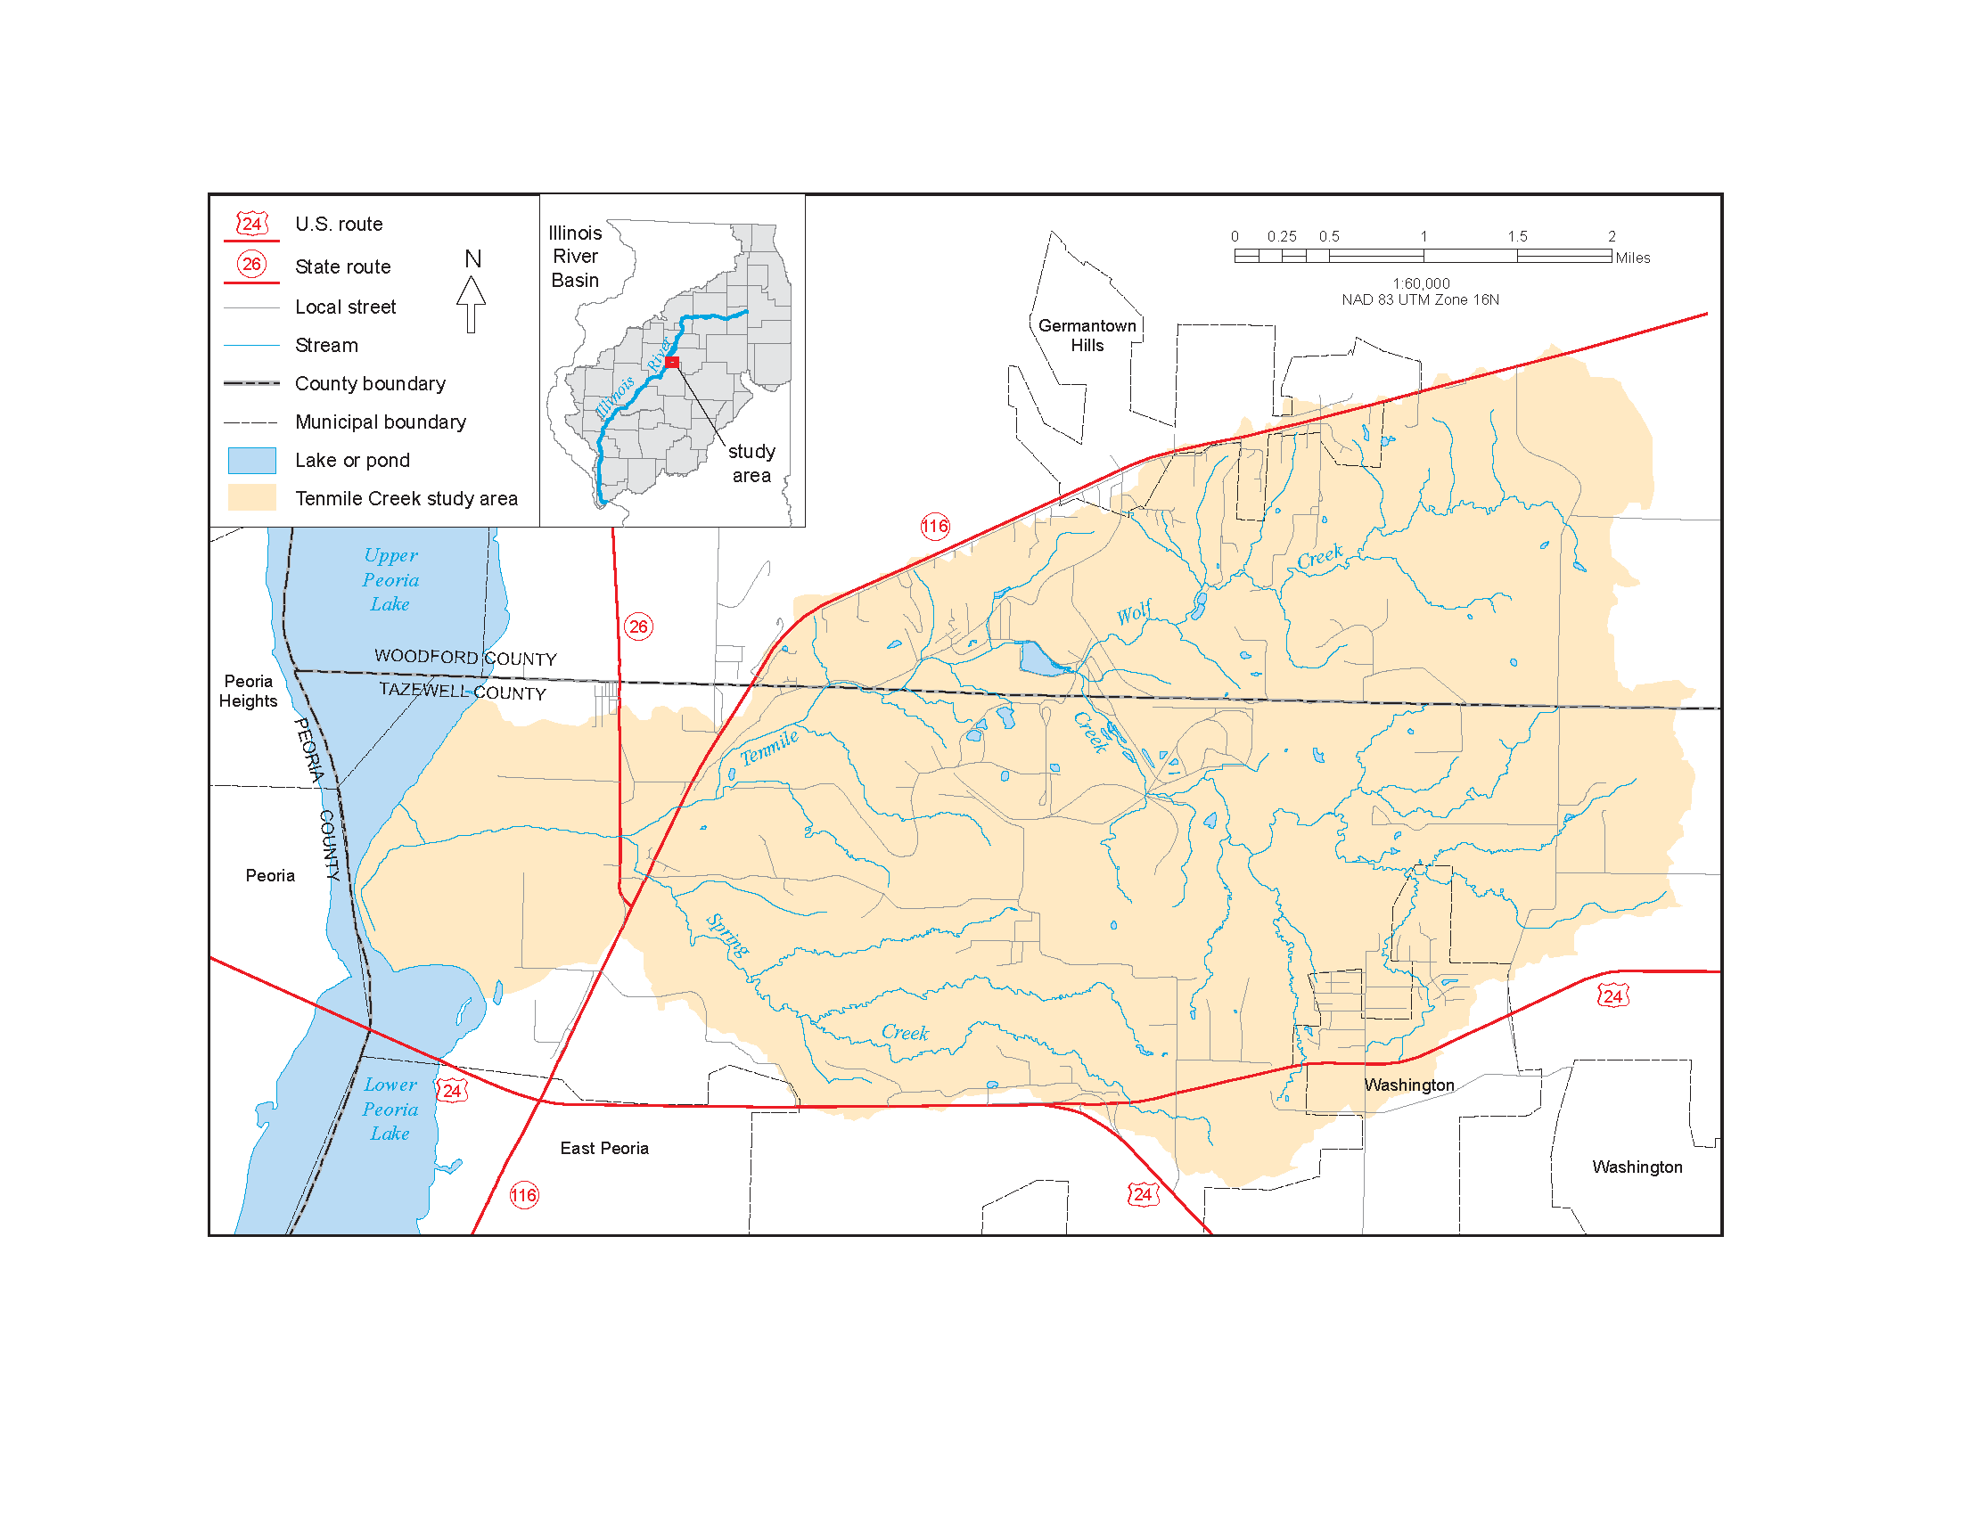

Figure 1. Location of Tenmile Creek in Woodford and Tazewell Counties. The Ten Mile Creek watershed flows into the Illinois River on the eastern shore of Peoria Lake near the Tazewell and Woodford County boundaries

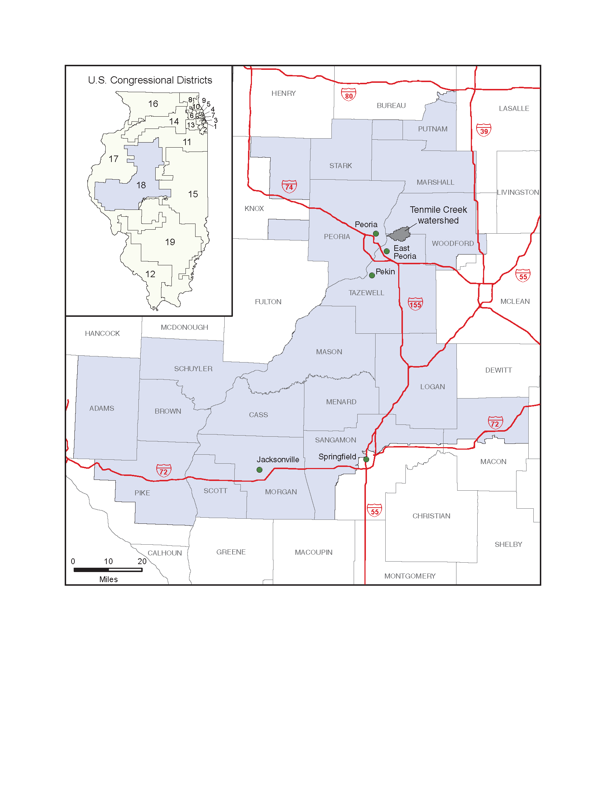

Figure 2. The 18th Illinois Congressional District encompasses much of the middle Illinois River valley, including Ten Mile Creek.

IV. PRIOR STUDIES, REPORTS, AND EXISTING PROJECTS
There may have been work done by the Illinois River Soil Conservation Task Force
This section briefly discusses prior studies, reports, existing documents, and other activities pertinent to this study. Planning and implementation of erosion control and water management projects have occurred in the Tenmile Creek watershed in the past.

A. Assessment Goals
Tenmile Creek is in the Illinois River Bluffs Ecosystem Partnership Area in the portion designated as the Peoria Wilds Resource Rich Area (or the Peoria Wilds RRA) (Figure 3). These areas were identified under the IDNR Critical Trends Assessment Program (CTAP) and the IDNR Ecosystems Program. Regional analyses of Partnership Areas using existing statewide data were completed in the 1990s. The goal of those assessments was to provide baseline data to help set priorities and develop management plans. Reports for the Illinois River Bluffs Ecosystem Partnership comprise four volumes covering area geology (IDNR, 1998a); water resources (IDNR, 1998b); living resources (IDNR, 1998c); and the socio-economic profile, environmental quality, and archaeological resources (IDNR 1998d). Although the CTAP assessments were comprehensive, scale of existing data was too coarse for adequate assessment of past and current conditions of the watershed and fluvial systems for use in suggesting project implementation priorities.

The TCWA is part of a long-term project to provide watershed-specific information at a scale more appropriate for ecosystem restoration recommendations than the CTAP and other previous assessments. This study also addresses some directives of the Integrated Management Plan for the Illinois River Watershed (State of Illinois, 1997), including generating site-specific data to understand causes of tributary stream instability and evaluate public lands for wetland and surface water restoration. Finally, this study partly fulfills four of the five goals of watershed assessment recommended by Holtrop and Pegg (2004):

- Identify defining physical limits of the watershed.
- Document past and current watershed conditions.
- Identify practices and processes with watershed impacts.
- Recommend restoration projects based on identified cause and effect relationships.
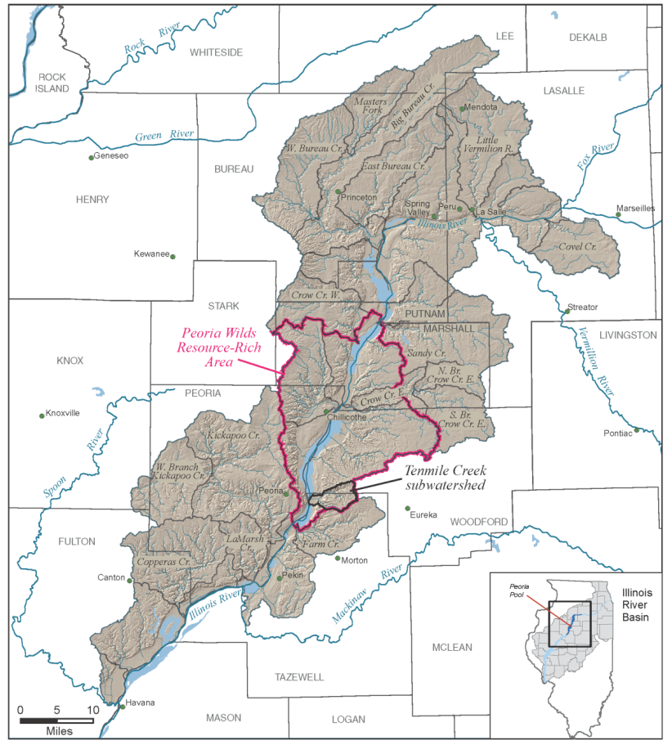

Figure 3. Ten Mile Creek lies within the IDNR-designated Peoria Wilds Resource Rich Area of the middle Illinois River valley. The Peoria Wilds is a biologically diverse area of dissected bluffs surrounding the Illinois River floodplain (IDNR 1996).

It does not include a reference watershed in its scope as recommended by Holtrop and Pegg (2004), however.

Various intrinsic (land use, land cover, and geology) and extrinsic (climate change) forcings have caused disturbances in stream systems throughout the ILRB (IDNR, 1998b). For example, rapid conversion of native prairie to agriculture in the past marked extreme changes in land use and water use that may have triggered erosion and deposition cycles that remain detrimental to native habitats, soils, and property. To mitigate disturbances to the landscape and stream systems, traditional water management and erosion control projects (e.g., grassed waterways, terraces, ponds, water and sediment control basins or WASCOBs, etc.) have been implemented outside the channel in the Tenmile Creek watershed. Such projects may alter water and sediment loadings to the Tenmile Creek mainstem or have either positive or negative effects immediately after construction. For example, without compensating for flow regime changes or channel slope adjustments, sediment detention in upland areas can result in channel migration and/or channel incision, which would induce channel erosion and change channel morphology (White et al., 2007). By contrast, coordinated implementation of best management practices (BMPs) in and beyond the channel should reduce peak discharge, increase base flow, and establish a more balanced sediment regime.

Therefore, the TCWA intends to build on lessons from past BMP implementation to guide future projects. Further, a central focus of recommended treatments will be to coordinate upland and in-channel projects to enhance the ecological system by naturalizing or optimizing hydrologic, hydraulic, and sediment regimes. Treatments could focus on channel bed grade control, streambank stabilization, hydrologic and hydraulic optimization, wetland and riparian habitat restoration, or combinations thereof. Potential projects include riffle and pool structures for multiple benefits, such as channel bed control and oxygenation of water, lunker structures for bank protection and fish habitat, bioengineering techniques for bank stabilization and native plant diversity, improved stream connectivity for fish passage, improved riparian connectivity for nutrient filtering and terrestrial habitat, or channel re-meandering to reconnect channel-floodplain systems for naturalizing hydraulic and sediment conditions and enhanced habitat.

Potential to improve, protect and expand habitat for regionally significant species, vegetated patch size and spacing for habitat also will be important and, as with stream and riparian management, will be outlined and pursued as opportunities arise. More details on biological conditions and possibilities (i.e., forest management) will be discussed later in this document.

Earlier reports describe previous planning and implementation efforts. They are described below in Sections IV B-D. The locally guided committee became inactive after these projects were completed, but it being re-established as a result of this SCWA effort (Josh Joseph, Peoria County Soil and Water Conservation District (SWCD), Personal Communication, 2006).

B. Draft Preliminary Investigation Report: Tenmile Creek Watershed, Woodford
and Tazewell Counties, Illinois

E. Related Efforts of Significance to Forest Management
in the Tenmile Creek Watershed
The Tri-County area has strong local, state, and federal commitments towards ongoing preservation and rehabilitation of the Illinois River, Peoria lakes, and the region’s abundant natural areas. Numerous completed or nearly completed projects strongly support preservation of these valuable assets. The Tri-County Regional Planning Commission created the Mossville Bluffs Master Plan in 2002, with funding made available through the IDNR Conservation 2000 program. While this plan was for an area west of Tenmile Creek watershed, it is very pertinent in that it made several important recommendations about erosion and sediment control, rural and urban forest management, stormwater management, and habitat enhancement. The Mossville Bluffs Watershed Restoration Master Plan identified an opportunity to create a ravine overlay district (R.O.D.) to be used as a mechanism to continue the ongoing preservation and rehabilitation of Peoria lakes and the Illinois River valley. After verbal encouragement from the Illinois River Valley Council of Governments (IRVCG), (an association of local municipal representatives), it became a priority to investigate the opportunity for developing a regional R.O.D.
The R.O.D. was created as a model for a zoning district to protect rapidly eroding bluff and wooded areas (particularly those areas under pressure from land development). Recent analyses completed using the Land Use and Evaluation and Impact Assessment Model (LEAM) predict that encroaching development will consume approximately 8,500 acres (9.5%) of Peoria area forests over the next 30 years. The LEAM is a tool for predicting regional growth patterns and analyzing subsequent results of those patterns. It was created at the University of Illinois at Urbana-Champaign and brought to Peoria as a demonstration project. Several groups made the LEAM project possible: IDNR, the Illinois Department of Transportation (IDOT), the Illinois Department of Agriculture, the Tri-County Regional Planning Commission, and the Governor’s Sub-Cabinet on Balanced Growth. The model would help R.O.D. development by identifying threatened natural areas, gathering anecdotal information from local landowners, and analyzing potential impacts of growth on natural areas. Results of the LEAM modeling system identify the possibility of preserving a substantial portion of sensitive areas via tools such as the proposed R.O.D. Design of the R.O.D. model ordinance will allow wide use and adoption by entities both inside and outside the Tri-County area.
Currently in the Tenmile Creek watershed the ISWS has introduced the benefits of a forestry plan to Caterpillar Inc. and they have met with IDNR regional forester and have obtained contacts of local contractors to develop a forestry plan covering xxx acres.
F. Lake Front and River Development Plan

The ISWS and Heartland Water Resources Council (HWRC) are refining a plan for the conservation and protection of Peoria Lakes. Currently the plan is divided into 3 segments; one detailing conservation areas in Upper Peoria Lake, a second segment outlining a transitional management strategy for the lower area of Upper Peoria Lake, and a third plan for Lower Peoria Lake which concentrates on a side conservation channel with islands and beneficial use of dredged materials. Research needs are being outlined and currently recommend a study of the hydrology and hydraulics to aide in design and construction of islands and a conservation channel among other conservation and development measures. Funding is being sought for the Hydrology and Hydraulics efforts to initiate this strategy.

Plans are already underway to revitalize one section of the riverfront. The City of Peoria’s Department of Economic Development is developing landscape design ideas for the southern gateway to the City of Peoria which is now primarily an obsolete industrial development. The City of Peoria is considering major reinvestment opportunities by intensively redeveloping the conservation amenities along Peoria’s riverfront. One component of a plan under consideration is to develop a public “green edge” or linear park along the river from Water Street to War Memorial Drive. Over time the existing river edge could be converted to parks with a scenic riverfront drive, quality mixed use development with some new residential homes, beautification of the area and streets, enhanced connectivity between the downtown and riverfront areas, and enhancement of the natural environment.
Additional plans include setting sediment traps within Tenmile and Blue Creek to reduce the flow of sediment into Peoria Lake and constructing an island just downstream of the Blue Creek delta. Trapping the coarse and finer sediment would prevent it from flowing into Peoria Lake and forming deltas. In addition, it would provide the sediment resource necessary to build the island, cutting down on the need of sediment transported in from other areas. Additionally, other islands with secondary channels would be created. The building of islands with secondary channels would provide diversity and habitat and create recreational benefits by helping combat some of the problems caused by sedimentation.

V. PLAN FORMULATION

A. Watershed Conditions

1. General Geomorphic Setting and Recent Geologic History
The Creek watershed developed in a valley between two glacial moraines deposited during the most recent glaciation (Figure 4). The glacier flowed over the Illinois River valley from the east, scraping pre-existing sedimentary cover down to bedrock and leaving subglacial and proglacial deposits upon retreat. This was followed by deposition of a blanket of wind-blown dust (loess) over the region, and erosion and re-sedimentation of existing deposits as the drainage network continued to develop. Prairie grasses and forests became established over lower and steeper slopes, respectively. Thus, the upper portion of the watershed is a composite of deposits from downwasting ice, till, debris flow, and stratified sediments (Ablation Plain), outwash streams (stratified sediments along Creek valley) and ice-marginal lakes (Glacial Lake Plain). The lowermost part of the valley cuts through the Illinois River bluff and flows over a terrace left from outwash deposits of the last glaciation. Tributaries to Creek are mainly incised into the till plain.

The present-day watershed has gently sloping areas on the flanks of moraines in the upper watershed, more steeply sloping valley areas along middle reaches of the Creeks, and lower relief areas on the Illinois River terrace and floodplain between the bluff at North Hampton and the Illinois River (Figure 5). Upstream of, the Creek valley is 1-1.25 miles wide.

Three reaches of Creek can be distinguished based upon planform configuration. In the upper reach, (approximately the upstream half of hydrologic unit code 401 (HUC 401)), the gently meandering stream is partly channelized, with an average 2-3% valley slope within 1000 feet of channel (Figure 5). Headwaters are incised into the Providence Moraine, whose crest forms the western watershed divide, while the lower part flows over the Glacial Lake Plain. Lineback (1979) interpreted the Glacial Lake Plain based upon the relatively low slope (~1%). The total elevation drop from headwaters to the lakeplain is 90 feet (~800-710 feet above mean sea level, (ft-msl)), whereas the elevation drop across the lake plain is only about 20 feet (710-690 ft-msl). The plain has a gently undulating surface that likely reflects interfingering fluvial and lacustrine environments.
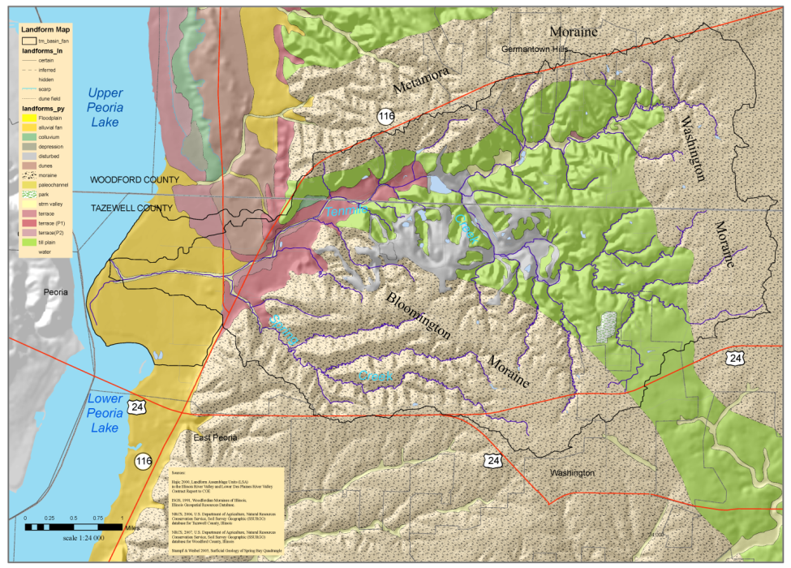
Figure 4. Map showing the landforms of Tenmile Creek watershed

The Middle valley begins where the stream exits the Glacial Lake Plain and flows through the Ablation Plain (Figure 4) formed by downwasting of ice that created the Providence Moraine and by meltwater streams flowing off the glacier terminus at the Eureka Moraine. The present channel along this reach moderately meanders and increases in sinuosity downstream. The valley slope is ~13% within 1000 feet of the channel, steepens abruptly where the stream cuts through Illinois River bluffs, then shallows to ~3% below the confluence of Little Creek (Figure 5; note that the valley slopes differ from the channel slopes, discussed below). The Middle valley thus includes the lower portion of HUC 401, all of HUC 402, and the upper portion of HUC 403.
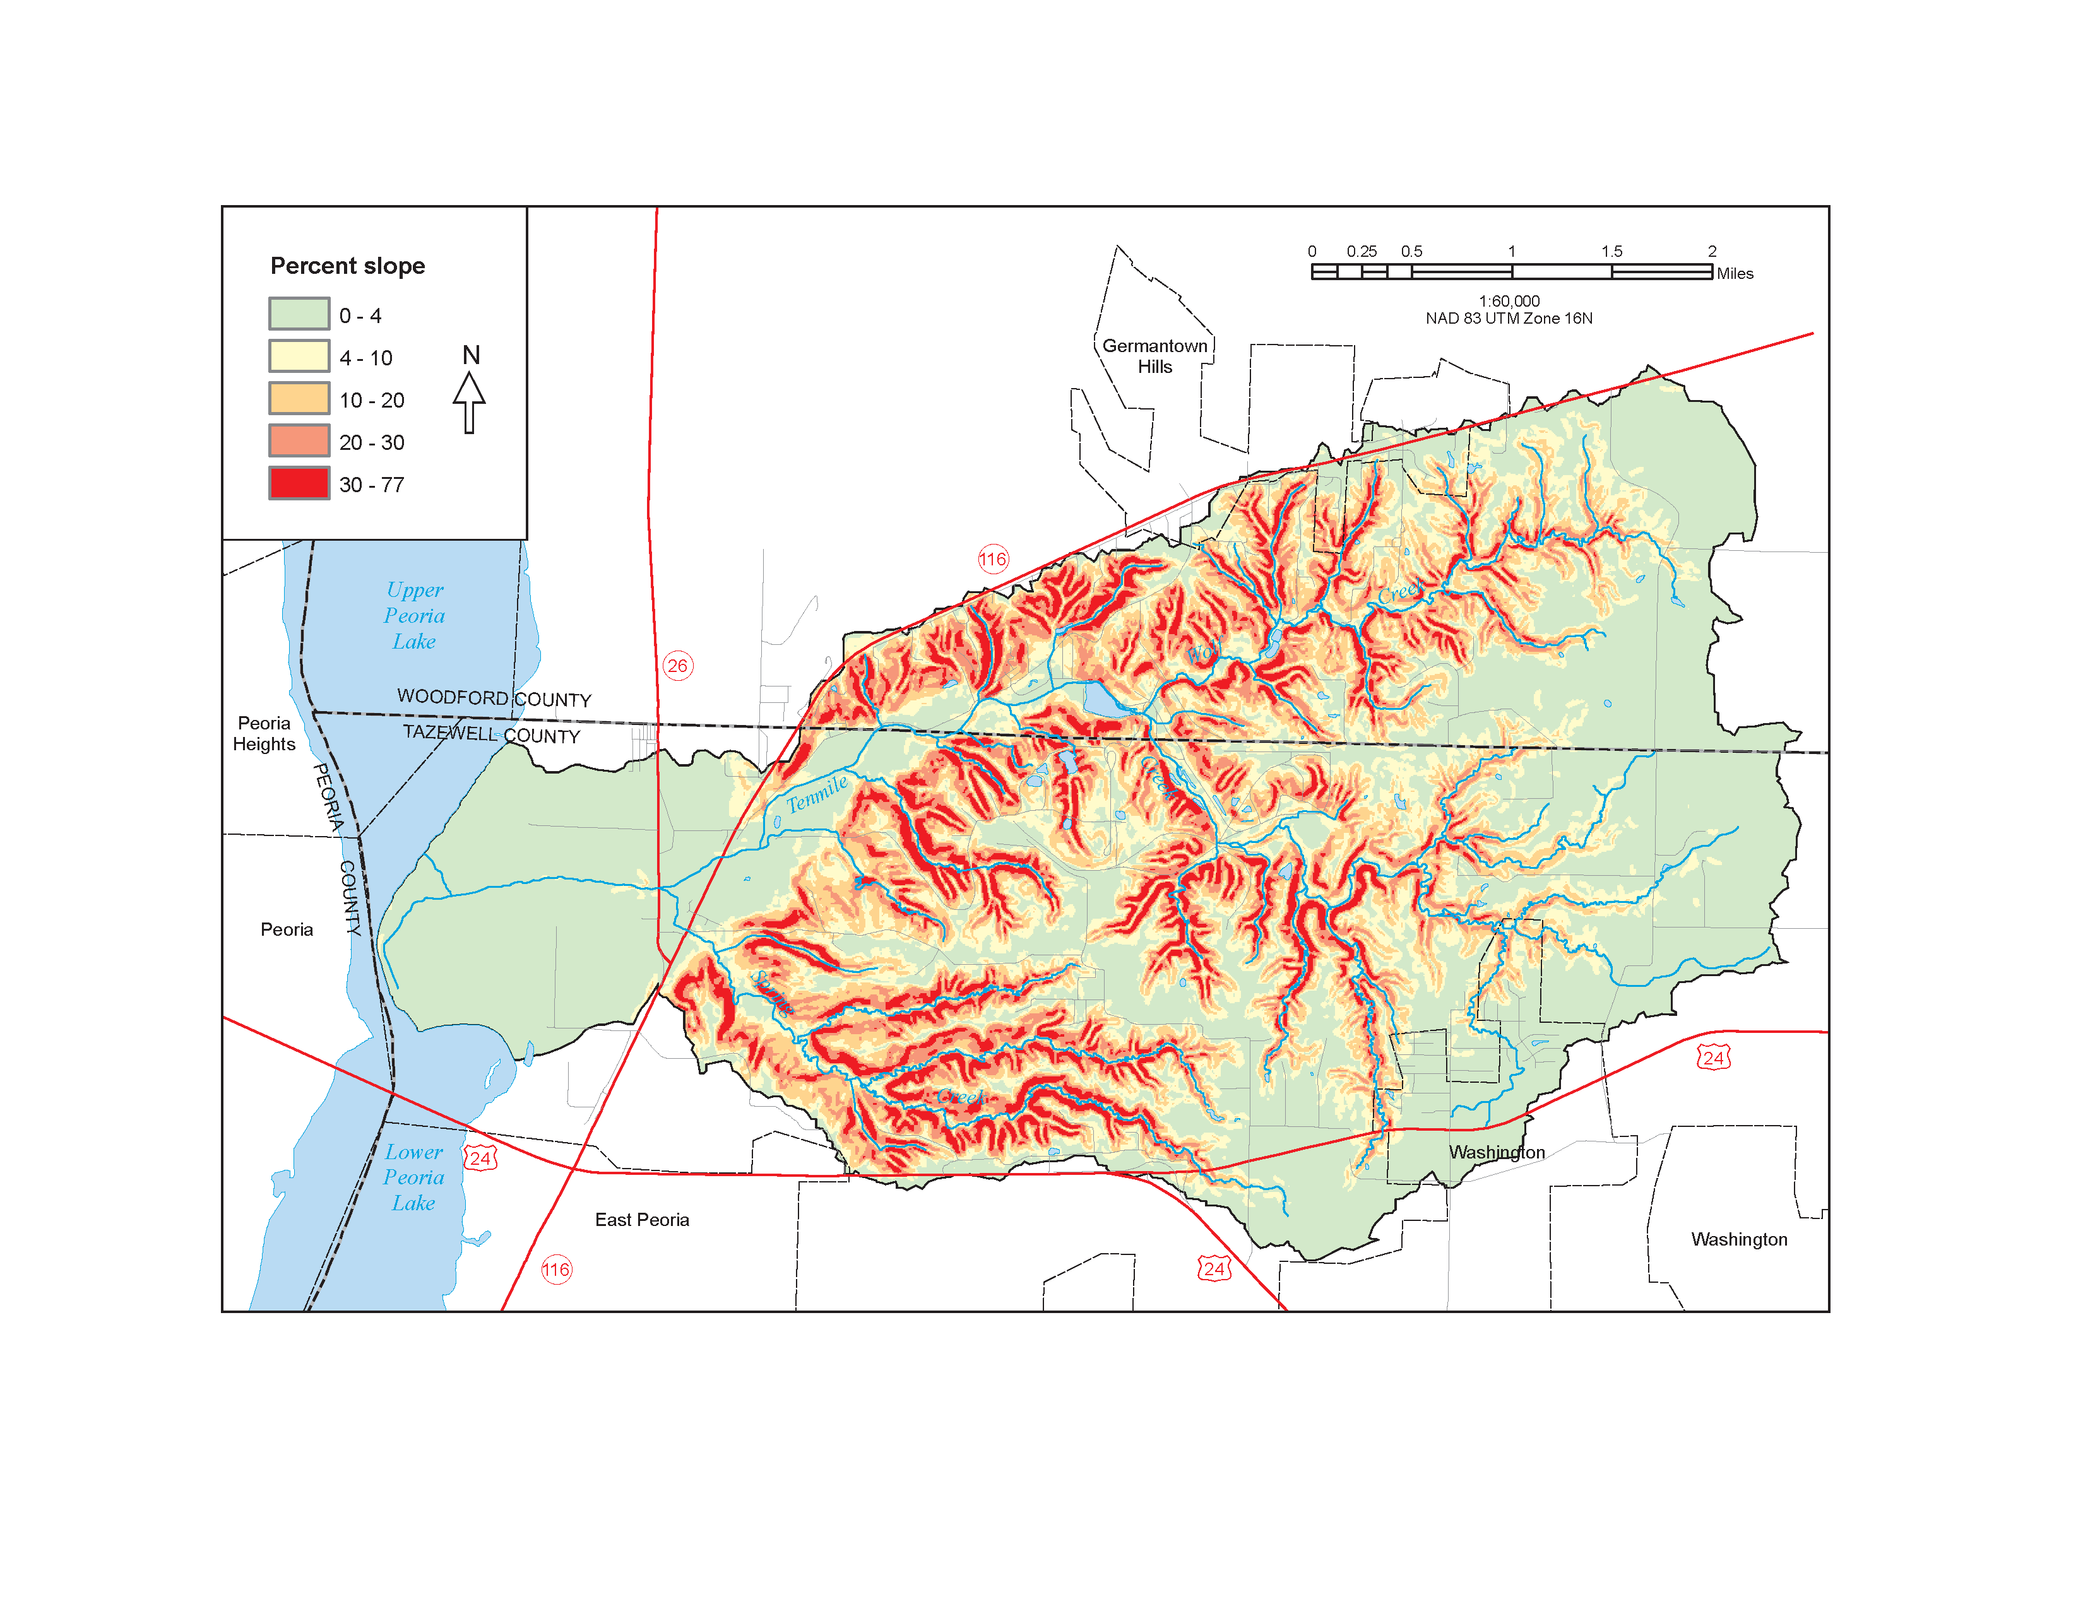

Figure 5. Slope of the land surface and stream channels in Ten Mile Creek watershed. Land surface slope categories adopted from NRCS (1996); channel slope categories based upon distribution within watershed.

In the lower reach on the Ancient Mississippi floodplain, the channel again gently meanders and has significant modified subreaches (Figure 4). The gentle valley slope drops only 20 feet over 3 miles (~0.1%) down to the Illinois River (Figure 5). East of Illinois Route 29, the channel has been straightened and maintained since before 1939. The Woerman maps of 1902-1904 (ref-ask Bill) show two outlets for Creek: Spring Branch and the present outlet (Bhowmik et al., 1993). By 1939, Spring Branch no longer received flow and appeared to be cut off or abandoned. There is no distinct delta at the stream mouth, because either the Illinois River either transports sediment rapidly downstream or partly deposits it in streamwise-oriented sediment bars, islands, or both. Channel constriction and navigation channel and bridge maintenance activities also may influence morphology at the stream mouth.

2. Native Landscape and Pre-European Land Cover:
Influences from Soil Geomorphology and Slope

Settlers of the Creek watershed found a landscape characterized by a mix of oak woodlands and prairie in the early 1800s (Suloway et al., 1996). Schwegman (1973) classed natural environments and biotic communities in Illinois based primarily on topography, soils, bedrock, glacial history, and distribution of plants and animals (Figure 6). The Creek watershed is located primarily in the Grand Prairie Section of the Grand Prairie Division but also includes the Illinois River Section of the Upper Mississippi River and Illinois River Bottomlands Division, and a very small area in the Illinois River and Mississippi River Sand Areas Division. The following descriptions of the natural divisions in the Creek watershed are paraphrased, in part, from Schwegman (1973).

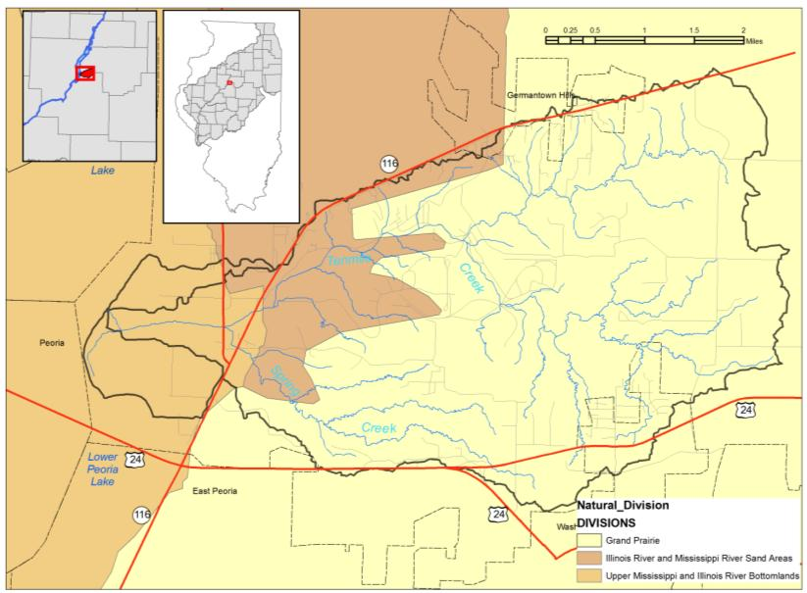

Figure 6. The Natural Divisions of Illinois (Schwegman, 1973) in the Illinois River Bluffs Assessment Area and the Tenmile Creek watershed.

(DREW insert)
Pre-European Land Cover
Information about the landscape in Tenmile Creek watershed before it was settled by Europeans was obtained from the United States General Land Office (GLO ) records (Figure GLO). From 1804 to 1843, the GLO surveyed the land of Illinois and recorded information on its vegetation and features. Maps of the original surveys have been digitized by the Illinois Natural History Survey (Illinois Natural History Survey 2003a). Presettlement land cover also can be inferred from surface soil color data as reported on NRCS soil maps (Figure Soils LC, Illinois NRCS 2005). In Illinois dark soils formed under prairies (mollisols) and light soils under forests (alfisols). The soils in riparian corridors are also dark in color, though they may not have formed under prairies. In general the soils-derived land cover map is similar to GLO-derived map, confirming that forests dominated the land surface in pre-settlement times, with some prairie in the eastern part of the watershed. The area shown as wetland is relatively small and is not the same for both data sources.

Ecoregions
Tenmile Creek lies within 3 distinct Level IV Ecoregions, the descriptions of which are excerpted and summarized here from Woods et al. (2006; Fig_x_ ecorgions). Ecoregions denote areas of general similarity in ecosystems and in the type, quality, and quantity of environmental resources (Omernik 1995). They are useful for structuring and implementing ecosystem management strategies across political boundaries and across agencies. Ecoregions stratify the environment according to its probable response to disturbance and recognize the spatial differences in the capacities and potentials of ecosystems. The Illinois ecoregion delineations are based on several criteria: (1) physiography, (2) natural vegetation, (3) soil, (4) surficial and bedrock geology, (5) climate, (6) land use and land cover, and (7) regional biogeography. A critical component is the recognition of the pervasive effects of people in the landscape, unlike the Natural Divisions of Illinois, which are focussed on pre-settlement conditions (Omernik 1995).

Upper Mississippi Alluvial Plain This ecoregion occurs in the western part of Tenmile Creek watershed, near Tenmile Creek’s confluence with the Illinois River (Fig_x_ ecorgions). It includes the lower portion of the Ten Mile alluvial fan (Fig. landforms). The ecoregion encompasses the broad floodplains and low river terraces of the Mississippi River and its major tributaries above the Mississippi’s confluence with the Missouri River, including much of the Illinois River. Levees, oxbow lakes, islands, and scattered sand sheets and dunes occur. Soils were mostly derived from thick silty and clayey alluvium, and are usually poorly drained. Others soils developed from sandy outwash. Both the alluvial plain and the river channel have been heavily modified in the last 100 years. Prior to the 19th century, bottomland forests, prairies, and marshes were common. Bottomland forests were adapted to prolonged flooding, and dominated by silver maple, American elm, and green ash; fewer tree species occurred than in the bottomlands downstream from the Mississippi’s confluence with the Missouri River. Mesic and wet prairies occurred on wide bottomlands, and dry prairie grew on the sand sheets. Today, the natural vegetation has largely been replaced by agriculture, with corn and soybeans as the major crops.

River Hills Most of Tenmile Creek lies within the River Hills ecoregion (Fig_x_ ecorgions). The dissected and forested hills, bluffs, cliffs, and ravines of this ecoregion flank the floodplains of the Mississippi, Illinois, and lower Sangamon rivers in west central Illinois. This ecoregion is characteristically underlain by limestone and sandstone, and is deeply covered by loess. Most of the area was glaciated by pre-Wisconsinan ice. Areas of karst occur where limestone is near the surface. Sugar maple, basswood, and red oak are common on mesic sites, whereas black and white oaks occur on drier sites, and post oak is found near ridge tops. Floodplain forests grow on bottomlands, and are dominated by silver maple, cottonwood, hickories, and sycamore. The River Hills ecoregion is part of an extensively forested habitat corridor along the Mississippi River. Wooded valleys in this ecoregion are important nighttime roosting areas for wintering bald eagles. Modern land use in the ecoregion is a mixture of cropland, pastureland, and forest. Forests are now most commonly found on steeper slopes. Patterns of land use are more varied than in adjacent ecoregions

Illinois and Indiana Prairies constitute a relatively small area in the eastern part of Tenmile Creek watershed. This ecoregion is characterized by vast, glaciated, flat to rolling plains and by dark, very fertile soils that developed under tall-grass prairie. Marshes and wet prairies naturally occurred in poorly drained areas, and forests grew on concentric moraines and floodplains. Overall, at the time of settlement, trees were less common than in neighboring ecoregions, and native vegetation was distinct from the hardwood forests that covered the drift plains of Indiana. The soils of the Illinois/Indiana Prairies are typically rich in organic material and developed from loess, glacial drift, or lacustrine sediments.

In the 19th century, to make the land more suitable for cropland and settlement, extensive parts of the till plains were tiled, ditched, and tied into existing drainage systems. In so doing, once abundant aquatic habitats have been modified, reduced in size, or eliminated, and nearly all of the original prairies have been replaced by agriculture. Main crops are corn and soybeans. Agriculture has affected stream chemistry, turbidity, and habitat. Streams in the loess-mantled western part of this ecoregion (which includes Tenmile Creek) are more turbid and have less fish species diversity, than eastern areas.

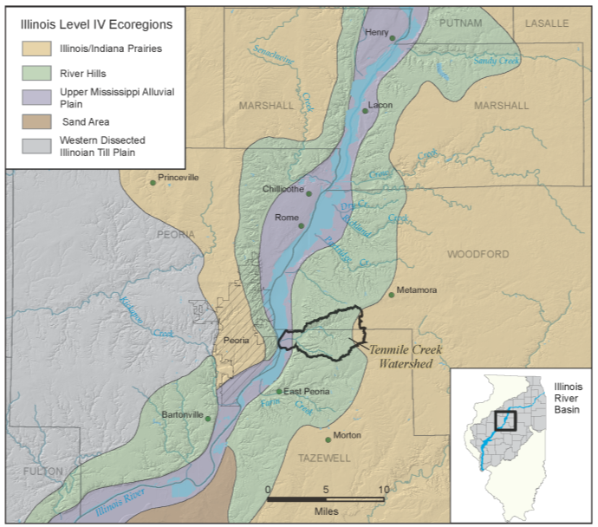
Figure 6. Ecoregions of the of the Illinois River valley within the Upper and Lower Peoria Lake.

(end DREW insert)

The Grand Prairie Section is a vast plain outside the Northeastern Morainal Division that was covered by the Wisconsinan stage of Pleistocene glaciation (Schwegman, 1973). These generally very fertile soils developed from recently deposited loess, glacial lakebed, and outwash sediments. Poor natural drainage resulted in many marshes and prairie potholes. Prairie grasses were the predominant vegetation. Forest bordered rivers and streams, as still can be found in lower segments of Creek and its tributaries (Figure 6). There were occasional groves of trees on moraines, such as what is now Camp Grove; a small town in headwaters of the Creek watershed. Prairie potholes, rivers, and creeks were the main aquatic habitats.

Tallgrass prairie probably covered much of the upland landscape and was once home to bison and great numbers of waterfowl that occupied marshes, potholes, and larger river floodplains. Most bison were hunted out by 1814. Invention and implementation of the steel plow by the mid-1800s brought about rapid conversion of prairies to farms. By the 1870s, construction of ditches and tile drainage systems created with steam shovels and drag lines drained almost all marshes and potholes, displacing large numbers of waterfowl. The prairie is now one of the rarest plant communities in Illinois. Nearly 90% of native wetlands were degraded or destroyed, although they hold most of the rare and endangered plants in Illinois.

Headwaters of Creek were generally a poorly drained plain of glacial drift, as discussed above. The Illinois Section of the Grand Prairie Division is generally relatively level but less level in transitional microenvironments within and along the flanks of end moraines, ground moraines, dissected till plains, and outwash plains as in the area encompassing the Creek watershed.

Forests of the Grand Prairie Section generally are associated with stream valleys and crests of moraines (Schwegman, 1973). Forests on dry sites are dominantly white oak, black oak, shagbark hickory, and often shingle oak and bur oak. Basswood, sugar maple, slippery elm, American elm, hackberry, red oak, white ash, black walnut and butternut hickory are dominant on mesic sites, and bigtooth aspen are common in the northern part. Floodplain forests are of the silver maple-American elm-ash type. Recurrent fires influenced development of prairie groves, such as Camp Grove near headwaters of Creek Mainstem, of burr oak and American elm and hackberry.

A small portion of the lower end of the Creek watershed occurs in the Illinois River Section of the Upper Mississippi and Illinois River Bottomlands Division (Schwegman, 1973; Figure 6). This section encompasses, among other things, bottomlands and associated backwater lakes of the Illinois River and its major tributaries south of LaSalle. Much of the section originally was forested, but prairie marsh also occurred. The lower segment of Creek Mainstem flows through bottomlands of the Illinois River valley, which are subject to backwater effects from the Illinois River mainstem and characterized by broad floodplain features and sand-and-gravel terraces formed by glacial outwash. Soils formed in this glacial outwash and recent alluvium drain poorly, are alkaline to slightly acidic, and vary from sandy to clayey in texture. Springs often associated with gravel terraces along the Illinois River occur near

The Illinois River Section of the Illinois River and Mississippi River Sand Areas Division encompasses sand areas and dunes in bottomlands of both rivers. A minor part of lower Creek Mainstem lies within the Illinois River and Mississippi River Sand Areas Division (Figure 6). Natural vegetation of this section includes scrub oak forest and dry, mesic, and wet sand prairies and marsh. Several plant species here are more typical of the short-grass prairies west of Illinois. Several relic western amphibians and reptiles are known only from these sand areas. Dunes and blowouts are common topographical features in this Section, and various plant associations related to unstabilized sand are located here.

The Schwegman (1973) analysis was at a regional scale. Using township maps, better suited to the size of the Creek watershed, from United States General Land Office (GLO) records, Greer et al. (2002) developed a map of pre- to early Euro-settlement land cover (Figure 7). The GLO data are based on observations by surveyors in the watershed in the early 1800s. Independent interpretation of pre-settlement land cover can be obtained from surface soil color data reported on NRCS soil maps (Figure 8). In Illinois, dark soils formed under prairie (mollisols) and light soils under forested areas (alfisols). Analysis of soils helps characterize early ecosystems, and set the framework for understanding later patterns of natural and anthropomorphic disturbances.

The GLO observations closely reflect soil morphology data confirming that prairie and forests dominated the land surface since the last glacial episode. At higher elevations in the watershed (cf. Figure 4), GLO surveyors described nearly level to gently sloping prairie dominated by grasses such as big bluestem and many species of wildflowers (Figure 7). Hardwood forests dominated by oak, hickory, and maple covered steep uplands and much of the lower elevation floodplains of Creek and its tributaries in the southern portion of the watershed.
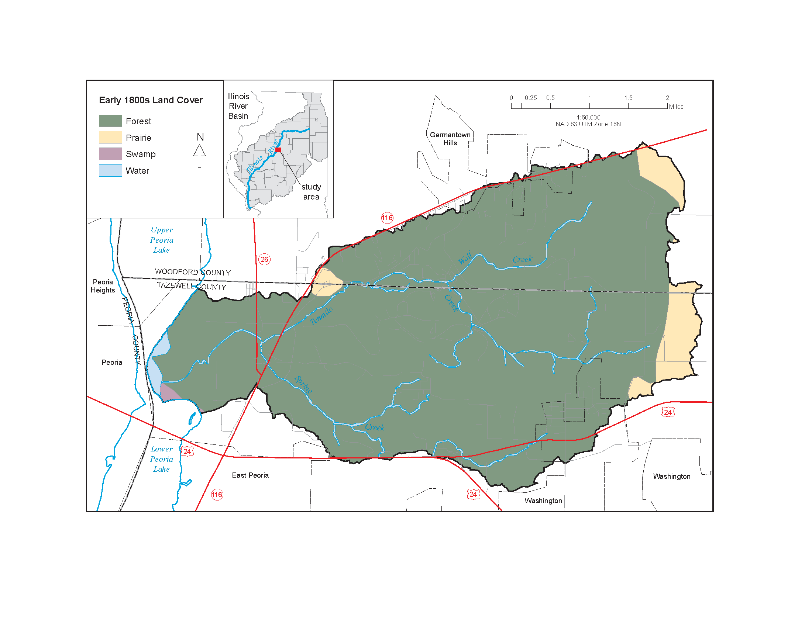

Figure 7. The landscape was dominated by oak forest when first surveyed in the early 1800s by the U.S. Government Land Office (Greer et al. 2002).

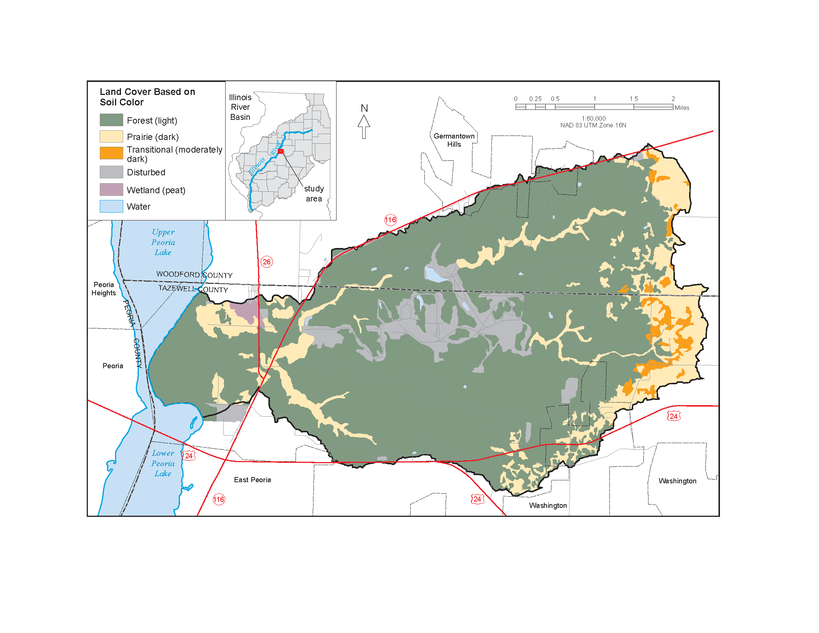

Figure 8. The color of the soil A horizons is distinctive of the long term landcover under which they developed. This map supports the landcover analysis from Government Land Office data (Greer et al. 2002), and may give a better appreciation of the distribution of the small but significant prairie openings..

3. Cultural Setting
a. Population
Early settlement was sparse. Joliet and Marquette documented an Algonquian Indian settlement on the banks of Upper Peoria Lake in 1673. When people first began to form settlements in Woodford County, it was inhabited by the Pottawotamies. Other tribes, including the Foxes and the Sacs, were known to inhabit this region earlier on. In June of 1790, Woodford county was included in Knox County along with other central and northeastern parts of the state, and all of Indiana. Subsequent divisions occurred for political reasons. Woodford County was originally a part of Tazewell County, named after Governor Lyttleton W. Tazewell, and created in 1827. In February, 1841 Woodford separated from Tazewell. (Moore, Roy)

Today, Tenmile Creek watershed is mainly rural. Urban development is limited to the suburbs of Peoria, the largest of which is Pekin (population ~ 33,857).Tazewell County’s total population as of the 2000 Census was 128,485. Nearby Woodford County’s population has grown 70% since World War II, but overall, the area has grown at half the rate as the state as a whole since 1870 (IDNR, 1998). As of 2000, the population was 35,469. The Illinois River Bluff Assessment Area, including Tenmile Creek watershed, is part of the Tri-County Peoria metropolitan area. Suburban development is occurring in these uplands (Figure 9) as population expands beyond Peoria.
(DREW insert)
Population
Most of Tenmile Creek Watershed is rural, located in unincorporated areas of Woodford and Tazewell Counties. However, 136 acres in the northern part are within the Village of Germantown Hills, and 415 acres in the southwest are within the City of Washington (Figure 1, TCRPC 2004a). Germantown Hills and Washington are suburban communities of the larger Peoria metropolitan area, (MSA population 375,672 (Tele Atlas, Inc. and ESRI 2008)). Census block data show that approximately 3,195 people lived in the watershed in 2007.

(end DREW insert)
b. Political Boundaries
Tenmile Creek watershed occurs in both Woodford and Tazewell Counties and is subject to local county ordinances and local municipal laws. County engineers and township road commissioners also would be interested in stream channel work because the watershed has both bridge crossings and fords.

c. Nongovernment Organizations
Some nongovernment organizations (NGOs) operate or have interest in Tenmile Creek watershed. These include the Illinois River Bluffs Ecosystem Partnership, Heartland Water Resources Council, The Nature Conservancy, Audubon Society, Sierra Club, and the Illinois River Soil Conservation Task Force.

Table 2. NGO stakeholders in the Tenmile Creek watershed

Non-governmental Organizations | Type*
American Eagle Foundation | I
Friends of the Illinois River | I
Heartland Water Resources Council of Central Illinois | I
Illinois River Bluffs Ecosystem Partnership | I
Illinois Stewardship Alliance | I
Living Upstream—Peoria Chapter (The Sun Foundation) | I
Peoria Audubon Society | I
Peoria Wilds not-for-profit Volunteers | I
Prairie Rivers Network | I
Sierra Club—Heart of Illinois Group | I
The Nature Conservancy—Peoria Office | I
Trees Forever—Illinois Buffer Partnership | I
Ducks Unlimited—Central Region | II
Peoria BassMasters | II
Pheasants Forever—Illinois River Valley Chapter | II
Tri-County Riverfront Action Forum Inc | III
Village of Germantown Hills Chamber of Commerce | III
Tazewell Farm Bureau | III
Woodford Farm Bureau | III
Caterpillar Trail Water District | IV
Ameren/CILCO & Central Illinois Light Co | IV
National Great Rivers Research and Education Center | V
Bradley University, Dept. of Biology | V
Tenmile Creek Watershed

d. Other Stakeholders
Other stakeholders include a local historical society and the IRVCG. The inactive Tenmile Creek Drainage District covered 317.33 acres. It is not known whether this drainage district will remain inactive. No other drainage district is known to exist in or near Tenmile Creek watershed.

Table 3. Government agency stakeholders in the Tenmile Creek watershed

Government Agencies | Type*
Village of Germantown Hills—Economic Development | L
Village of Harvard Hills—Economic Development | L
Peoria Park District | L
Tri-County Regional Planning Commission | C
Tazewell County Soil and Water Conservation District | C
Woodford County Soil and Water Conservation District | C
Illinois Nature Preserve Commission Area 4 | S
Illinois Nature Preserve Commission Area 5 | S
IDNR Region 1 Forester | S
Illinois River Coordinating Council | S
Illinois Department of Transportation | S
Upper Mississippi River Basin Association | S
Illinois Attorney Generals’ Office | S
Illinois Environmental Protection Agency | S
US Fish and Wildlife Service—National Fish Habitat Initiative | F
* Government Level: L=Local, C=County, S=State, F=Federal

Table 4. Government officials who are stakeholders in the Tenmile Creek watershed

Government Officials | Type*
Mayor Office Village of Germantown Hills, Illinois | L
Mayor Office Harvard Hills, Illinois | L
Tazewell County Board | C
Woodford County Board | C
State Representative Michael Smith | S
State Representative Keith Sommer | S
Congressman Aaron Schock | F
Senator Richard Durbin | F
Senator Roland Burris | F
*Government Level: L=Local, C=County, S=State, F=Federal

- Current Land Cover and Land Use

(DREW insert)

Land Cover
Land Cover is the physical occurrence of earth materials, vegetation, or built environments at the earth surface. It can be determined via remote sensing methods or by field survey. Land cover is distinct from land use, although the two analyses are often described together. We compiled several land cover data sets covering a range of time periods and at varying scales. They cannot be directly compared because of the different resolutions, source data, analysis methods, and class definitions. It is illustrative to examine them together, however, to understand broad historical trends.

- The Cropland Data Layer (CDL) Program of the USDA National Agricultural Statistics Service (NASS, USDA 2009) provides the most recent land cover data from 2008 as a geo-referenced, classified, land cover raster at 60-m resolution (Figure NASS_LC). This resolution is coarse relative to the size of the Ten Mile watershed and is best suited to regional analysis. Its importance to this study lies in its currentness and expectation of future annual updates. The quality control is very high for the agricultural components. Non-agricultural components such as wetlands and developed areas are less assured. In USDA (2009), land cover in Tenmile Creek watershed is 34% agricultural, 1% barren, 46% forested, 15% urban, 0.6%, surface water, and 3% wetland. A more detailed breakdown of land cover classes is shown in Table X.

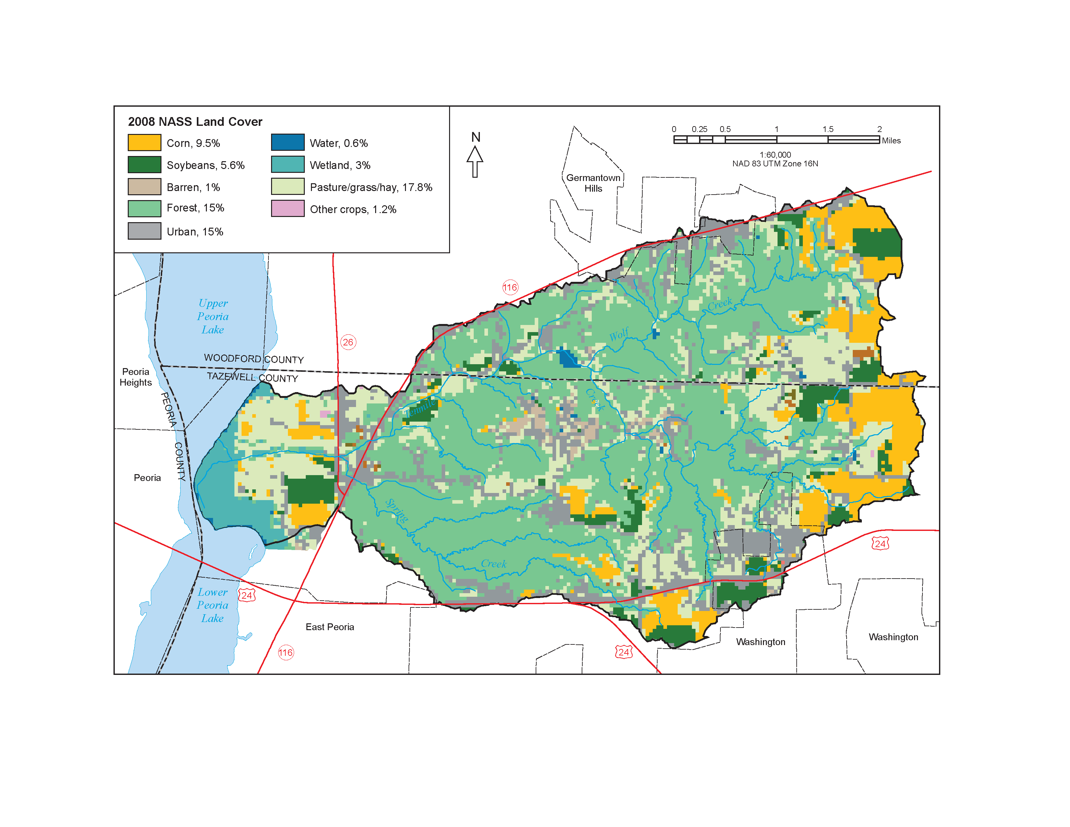

Figure 1634 2008 NASS land cover classes by acreage and percentage.

Table X. 2008 NASS land cover classes by acreage and percentage. NLCD refers to classes identified using a different set of training data from the National Land Cover Dataset, primarily for non-agricultural areas.
CLASS_NAME | Acres | Percent
Corn | 1111.24 | 9.46
Soybeans | 662.56 | 5.64
Winter Wheat | 25.57 | 0.22
W. Wht./Soy. Dbl. Crop | 5.42 | 0.05
Alfalfa | 6.97 | 0.06
Misc. Vegs. & Fruits | 0.77 | 0.01
Seed/Sod Grass | 0.77 | 0.01
Fallow/Idle Cropland | 1.55 | 0.01
Pasture/Grass | 155.76 | 1.33
Woodland | 2.32 | 0.02
NLCD - Open Water | 68.97 | 0.59
NLCD - Developed/Open Space | 945.41 | 8.05
NLCD - Developed/Low Intensity | 671.86 | 5.72
NLCD - Developed/Medium Intensity | 157.31 | 1.34
NLCD - Developed/High Intensity | 13.95 | 0.12
NLCD - Barren | 99.19 | 0.84
NLCD - Deciduous Forest | 5449.27 | 46.40
NLCD - Grassland Herbaceous | 102.29 | 0.87
NLCD - Pasture/Hay | 1937.31 | 16.50
NLCD - Woody Wetlands | 323.14 | 2.75
NLCD - Herbaceous Wetlands | 3.10 | 0.03

In 2000 the Illinois Natural History Survey’s Gap Analysis Program (GAP) created a land cover dataset at a higher resolution of 30 m, (Illinois Natural History Survey 2003b, Figure LC00). Land cover from this dataset shows that Tenmile creek in 2000 was 46% agricultural, 2% barren and exposed, 36% forested, <1% surface water, 9% urban and built-up land, and 6% wetland. Table X shows a more detailed breakdown of this land cover analysis.

Table X. 2000 GAP land cover classes by acreage and percentage.
CLASS_NAME | Acres | Percent
Corn | 1290.5 | 10.98
Soybeans | 1626.3 | 13.84
Winter Wheat | 17.8 | 0.15
Winter Wheat/Soybeans | 8.5 | 0.07
Rural Grassland | 2559.7 | 21.79
Dry-Mesic Upland Forest | 3538.7 | 30.12
Mesic Upland Forest | 334.9 | 2.85
Partial Canopy/Savanna Upland Forest | 355.2 | 3.02
Coniferous Forest | 3.8 | 0.03
High Density Urban | 675.4 | 5.75
Low/Medium Density Urban | 298.2 | 2.54
Urban Open Space | 100.5 | 0.86
Shallow Marsh/Wet Meadow | 2.2 | 0.02
Deep Marsh | 1.6 | 0.01
Seasonally/ Temporarily Flooded Wetland | 31.6 | 0.27
Wet-Mesic Floodplain Forest | 207.0 | 1.76
Wet Floodplain Forest | 447.0 | 3.80
Shallow Water Wetland | 1.6 | 0.01
Surface Water | 20.0 | 0.17
Barren and Exposed Land | 228.4 | 1.94

The GAP land cover data from 2000 and the NASS data from 2008 are of different resolutions and were derived from different satellite sources and different image classification methods. Therefore, a detailed change detection analysis would not be accurate. The land cover data do, however, show an increase in urban land and a decrease in agricultural land, a realistic trend.

- We also compiled more spatially-restricted land cover data from The Illinois Stream Information System (ISIS 1989) and field observations collected for this study by the ISWS Both of these data sets characterize conditions along the stream channels. The ISIS Bankside Land cover data were developed from inspection of oblique aerial photography (ISIS 1989). The ISWS data set was extracted from Qualitative Habitat and Evaluation Index parameters (QHEI 2008) as described above.

To examine recent land cover change with time, Figure LC_change shows bankside land cover within a 100-meter wide buffer along Tenmile Creek, with data extracted from (ISIS 1989), GAP (2000), and the ISWS field data (this study). The different land cover classes used by the 3 datasets were standardized. We chose to keep the classification scheme of the QHEI data because it employed the fewest classes. Data from the other 2 sources were reclassified/generalized into the QHEI classes. For each possible time interval (1989–2000, 2000–2008, and 1989–2008), the score of the beginning date was subtracted from the score of the ending date. The results show the change in the QHEI score for each stream segment. Because the datasets for each year are based on different source types (ISIS on aerial photo interpretation, GAP on satellite image classification, and QHEI on field observations) the resulting areas of change should be considered an approximation. Segments with a change of -1 to 1, shown in yellow, can be considered minor or within the margin of error, given the data translation issues. Segments with a change between -1 and -3, shown in red, imply habitat degradation. These areas may be candidates for restoration.

Land Use
Agriculture
In 2008 approximately 34% of Tenmile Creek watershed was used for agriculture (USDA, 2009). Specifically, 17.8% was used for pasture, grass, or hay; 9.5% was used for corn; 5.6% was used for soybeans; and 1.2% was used for other crops, including winter wheat and alfalfa (Fig. NASS_LC). About 194 acres of land, less than 2% of the total watershed, in Spring Creek valley mostly classified as Dry-Mesic Upland Forest is shown on plat maps as managed by a timber company (Fig. misc_LU) although there is no field evidence that it is currently worked. The specific agricultural practices used to manage these crops can have significant impacts for water and sediment runoff. However, the types of agricultural practices are not known. In his sediment delivery analysis, Windhorn (2003) noted some variability in tillage across the watershed, but the observations were instantaneous and are not available for analysis.
Industrial Land
Roughly 22% (2,543 acres) of the land in the watershed is owned by the heavy equipment manufacturer Caterpillar. Until the late 1960s, most of this land was used as proving grounds, where earth-moving equipment was tested. As a result of a conservation program, the amount of land used for testing was reduced to approximately 300 acres (Kramer 1980). The program has allowed the rest of the proving grounds to be re-vegetated and serve as a buffer zone.
Mining
One mine for gravel from the middle Ten Mile channel and possibly the adjacent terrace is indicated on topographic maps (Fig. misc_LU). It is now abandoned. Several polygonal depressions on the terrace treads between the gravel pit and the Spring Creek confluence may also have been borrow areas. There are no current mining operations.
Sewage Treatment, and Stormwater Runoff
The City of Washington has a municipal sewage treatment plant on Wolf Creek (Fig. misc_LU). There are currently no stormwater runoff facilities operating in the watershed, although stormwater ordinances are under development (see Land Use Planning, below). Runoff is transferred to the channels by ditch or culvert
Former Landfills
The TCRPC (2004a) reported two private landfills within the watershed, 15 and 30 acres in size respectively. Their location is uncertain. Both have been closed for over 30 years, but neither is monitored.
EPA Permitted Activities
Figure Misc_LU shows where the U.S. Environmental Protection Agency (EPA) has granted permits for polluting activities (http://www.epa.gov/enviro/emef/, accessed 5/18/2009). Five water dischargers are listed, though 3 of the permits on record have expired (Table NPDES). There is also one hazardous waste permit listed for an Illinois EPA remediation site and an air emissions permit for the Caterpillar proving grounds.
Table NPDES
name | Permit for | type | expiration
GERMANTOWN HILLS WWTP #2 | BOD 5-day, pH, TSS, flow, Cl, BOD carbon. 20C | water dischargers | 12-31-07
CATERPILLAR TRAIL PWD | pH, TSS, Fe, flow, Cl total resid. | water dischargers | 03-30-10
PEORIA CATERPILLAR-PROV GROUND |  | water dischargers | 05-31-08
CATERPILLAR-PROVING GROUND | BOD 5day, pH, TSS, oil/grease freon, flow, Cl | water dischargers | 03-31-11
CATERPILLAR INC- PEORIA PROVING GROUND | CO, VOC, SO2, NO2, TSP | POTENTIAL UNCONTROLLED EMISSIONS < 100 TONS/YR
IL EPA RPMS HARMON AUTO SAL |  | hazardous waste
MALLARD CROSSING LTS 1,2,3,6 |  | water dischargers | 05-31-08

Conservation
Figure Conservation shows 3 conservation areas in Tenmile Creek watershed: the 10-acre Caterpillar Hill Prairies, a 127-acre Illinois River Fish and Wildlife Area, managed by the Illinois Department of Natural Resources (IDNR), and the Fondulac Park District’s 270-acre Spring Creek Preserve. The Spring Creek Preserve Forested Restoration Plan (2003–2005, Appendix?) calls for controlled burning, invasive species removal, and the placement of log check dams in an eroding ravine on the Spring Creek property.
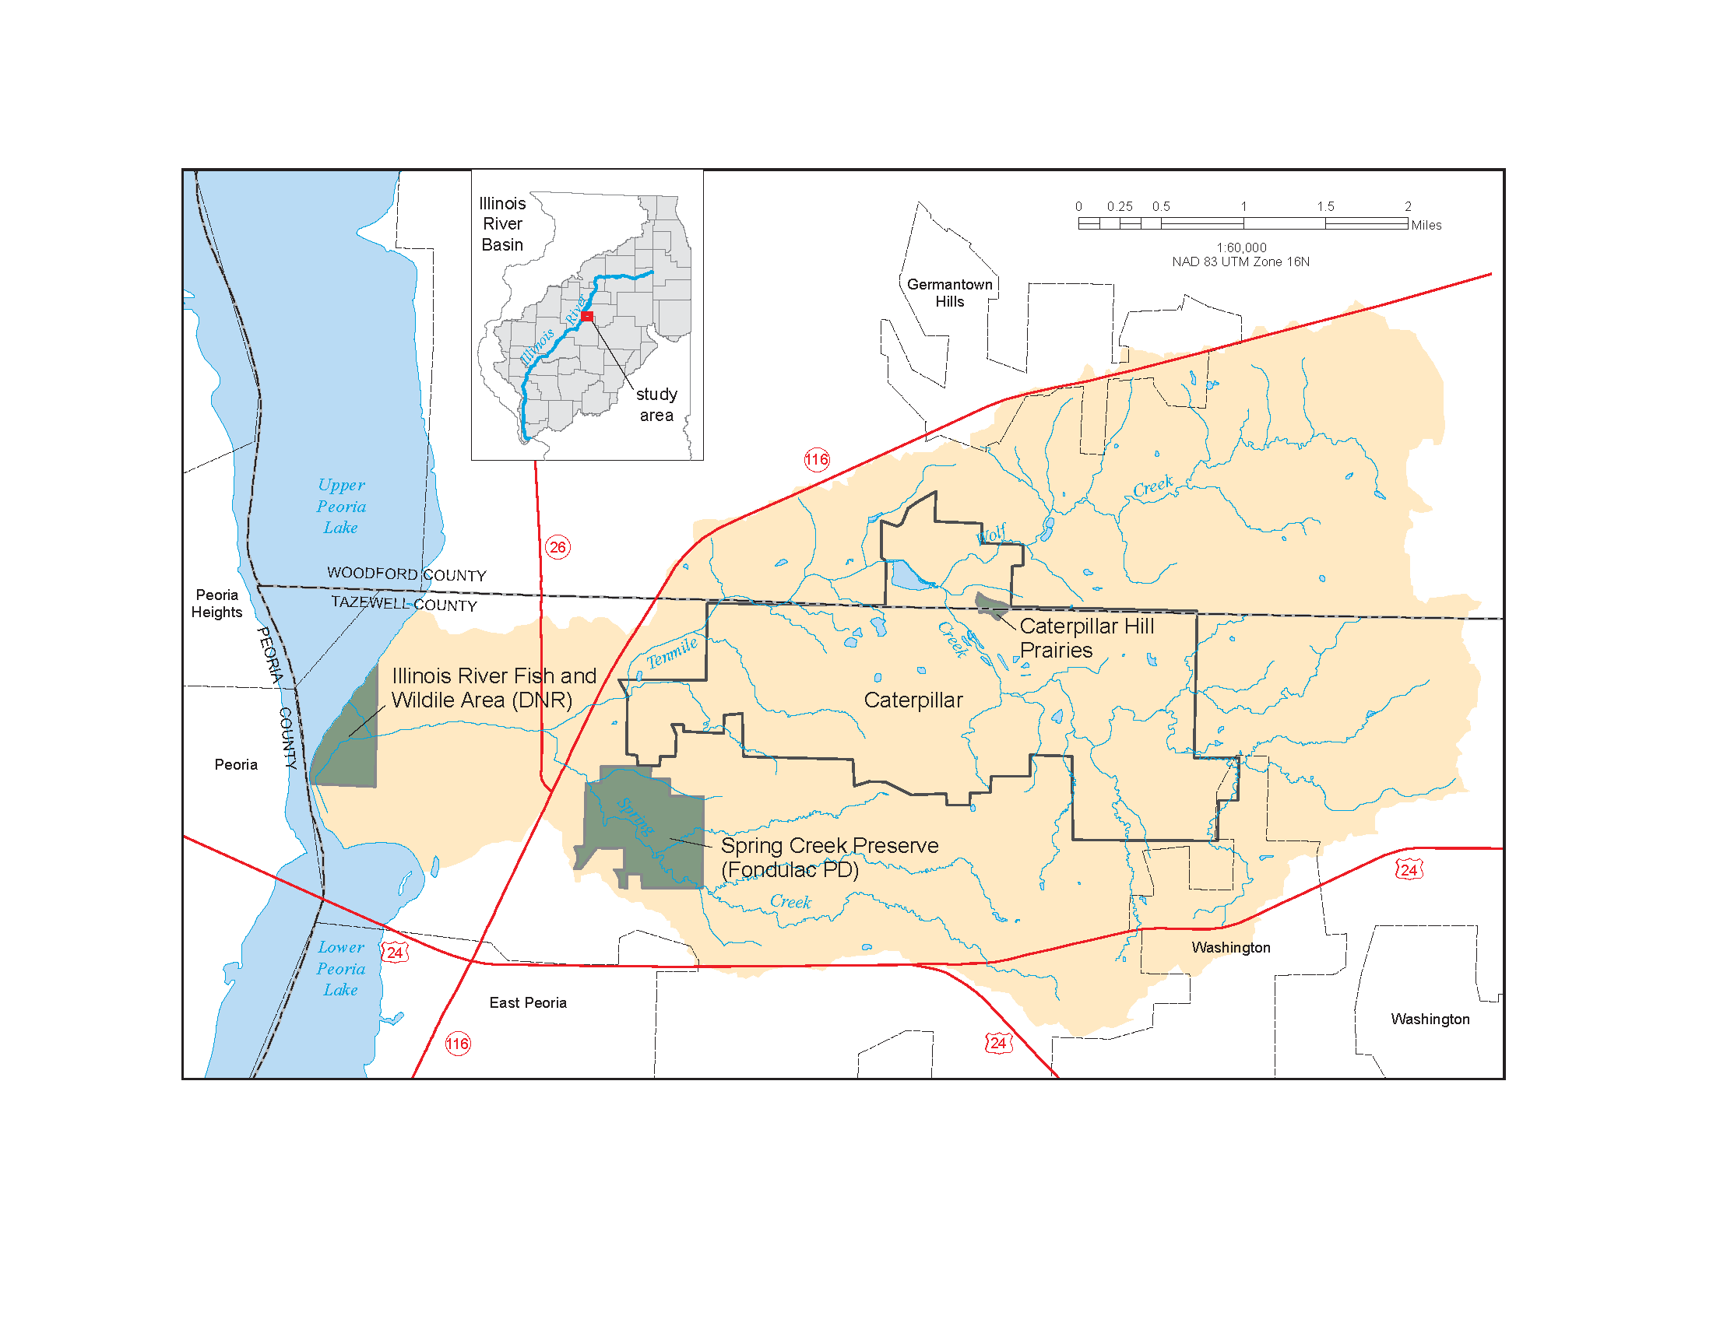
Figure 1254 Conservation areas within the Tenmile Creek watershed.

The entire Tenmile Creek watershed lies within 2 larger areas targeted for conservation: the Illinois River Bluffs Assessment Area and the Peoria Wilds Resource-Rich Area (Figure IRBAA). The Illinois River Bluffs Assessment Area was designated by IDNR for the purposes of the Ecosystems Program. The program is funded through Conservation 2000, an ongoing state initiative to enhance and preserve Illinois’ natural areas through partnerships of public and private stakeholders (http://dnr.state.il.us/orep/pfc/assessments/IRB/pagei.htm). Within IRBAA lies the Peoria Wilds, one of several Resource-Rich Areas designated by IDNR for the purpose of guiding ecosystem-specific conservation strategies. In 2003 Tenmile Creek Watershed was selected as one of seven priority watersheds in the Illinois River Bluffs Ecosystem Partnership due to its high degree of habitat quality, the threat of degradation from development, and the planning efforts underway (TCRPC 2004a). Priority watersheds are given preference for funding through the Conservation 2000 program.

Transportation
Tenmile Creek watershed is transected by 3 major roads (Figure 1). US 24 runs through the town of Washington in the southern part of the watershed. State Route 116 runs NE-SW along the northern watershed boundary and crosses Tenmile and Spring Creeks in the eastern part of the watershed. State Route 26 crosses Tenmile Creek near its confluence with Spring Creek. The expansion of SR 116 from two to four lanes in the late 1970s was a major factor contributing to the growth of Germantown Hills in subsequent decades (TCRPC 2004b).

The Illinois Department of Transportation (IDOT) is in the process of conducting The Eastern Bypass Study, which will determine the best location for a proposed, fully controlled or partially controlled highway that would connect Interstate 74 with Illinois Route 6, east and north of Peoria (Figure Eastern Bypass, IDOT 2008). The Proposed highway would likely transverse Tenmile Creek watershed and would have profound effects on “(1) the amount of stormwater flushed into the creek system from the additional impervious areas; (2) the non-point source pollutants (oils, antifreeze, litter) entering the stream; and (3) the urbanization of the watershed,” (TCRPC 2004a). The TCRPC recommends that stormwater detention and filtration infrastructure be a priority as the planning for the Eastern Bypass continues. Impacts on stream channel stability downstream of the corridor should also be investigated, and appropriate grade stabilization structures should be put into place before road construction. Additionally, the City of Washington and the Village of Germantown Hills should implement appropriate conservation zoning to protect valued forested bluffs and prime farmland in the watershed (TCRPC 2004a).
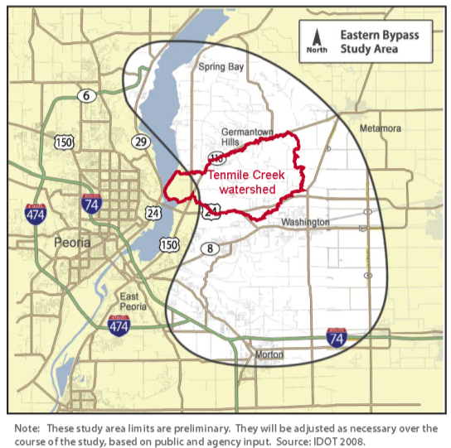
- Figure 9253. Study area of the Eastern Bypass around Peoria.

- The TCRPC (2004a) identified 26 culverts within the watershed (Fig. misc_LU). Their ages and condition are not generally known, although several were inspected during ISWS field investigations. Depending on their relative size and construction, culverts can serve as both grade control and foci of channel instability, flow inhibitors and flood conveyance races, and channel bed datums.
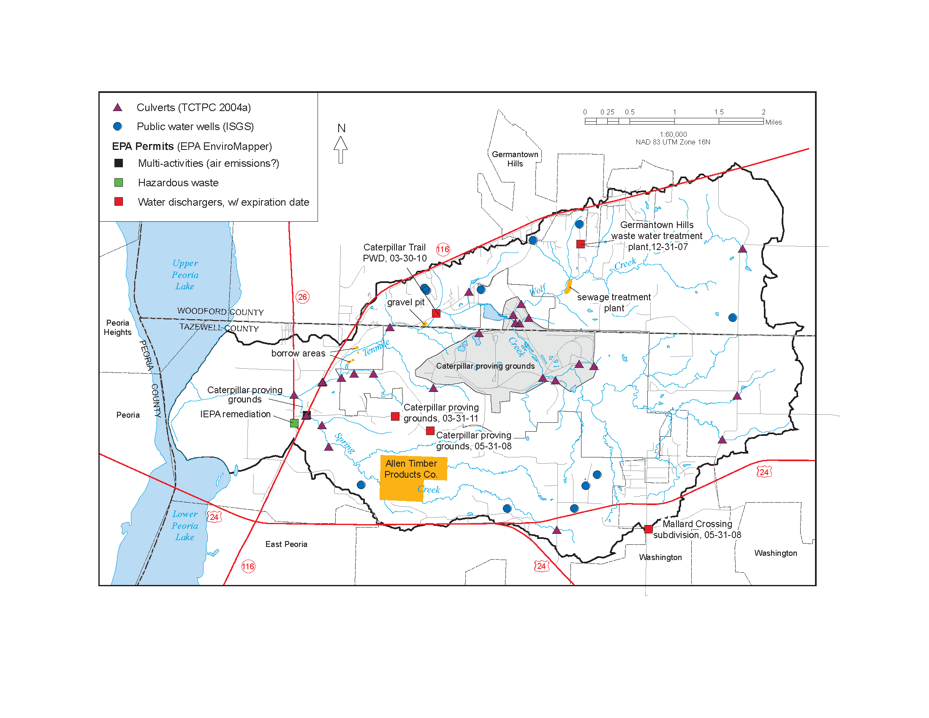
Figure 1295 Location of miscellaneous structures and facilities that may impact the watershed.

Residential
Residential subdivisions constitute a relatively small part of the watershed, as they are only part of the roughly 10–15% of the watershed that is urbanized, but their proportion is likely to grow as the communities of Washington and Germantown Hills expand. There also are several rural residences and low-density subdivisions in the unincorporated areas of the watershed. Most of the forested areas outside the Caterpillar property are currently zoned as residential in Woodford County or planned as rural residential in Tazewell County (TCRPC 1996, Figure Future Land Use).
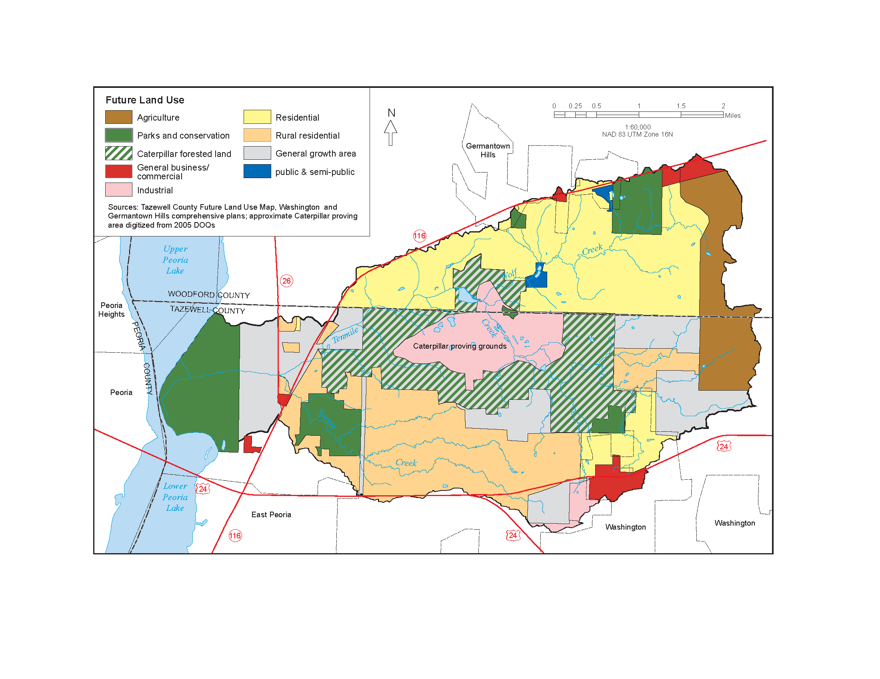
Figure 997. Future land use within the Tenmile Creek watershed from the city of Washington and the village of Germantown Hills comprehensive plans.

Land Use Planning
Germantown Hills has experienced significant growth since the early 1990s, resulting in an expansion of the sewer and water treatment facilities in 1997 (TCRPC 2004a, Fig. misc_LU). Growth is also anticipated along the US 24 bypass north of the Village of Washington in Tazewell County (TCRPC 2004a). Comprehensive plans of the two municipalities and two counties in the watershed show that they are planning for more residential, commercial, and light industrial land within Tenmile Creek watershed (Figure Land Use Planned). The implications of this are that some land currently used for agriculture will become urbanized. Tazewell and Woodford Counties are scheduled to release new comprehensive plans in fall of 2009.

To promote the reduction of sedimentation, erosion, and contamination in the Illinois River and its tributaries, the TCRPC provides model stormwater and riparian ordinances as guides to local planners. However, the ordinances have not been implemented by local jurisdictions within Tenmile Creek watershed (Melissa Eaton, TCRPC, personal communication, 4-20-09). The TCRPC is currently in the process of creating a Regional stormwater management plan: http://www.tricountyrpc.org/environment-page/regional-stormwater-plan.
(end DREW insert)
a. Current Land Cover
Existing land cover (Figure 10) was simplified from IL-GAP (2001) to give a synoptic view of the watershed within the format of this report. Tenmile Creek watershed is predominantly in upland/ravine forests and row-crop agriculture with a much smaller area of scattered rural grasslands. Winter wheat accounts for a small portion of overall acreage. Statistics (Table 2) derived from IL-GAP (2001) were obtained from the Illinois Department of Agriculture (http://www.agr.state.il.us/gis/stats/landcover/index.htm).Urban development is limited. Germantown Hills (population ~2,111) is the largest town, but suburban development is occurring, particularly in the uplands.

Data for each HUC (Figures 11–13) within the watershed are shown at original scale (IL-GAP, 2001). Almost the entire HUC 401 (98%, Table 2) is in corn and bean production (Figure 11). Grassland and forest generally are limited to narrow bands along stream courses, but a riparian corridor widens abruptly downstream of County Road 950 N.

Row-crop agriculture is also the predominant land cover of HUC 402 (Figure 12). Forested land occurs along stream valleys as the stream descends the bluff (Figure 5). Floodplain forest wetlands comprise a small portion of watershed land cover but a significant portion of forest cover (Table 2).
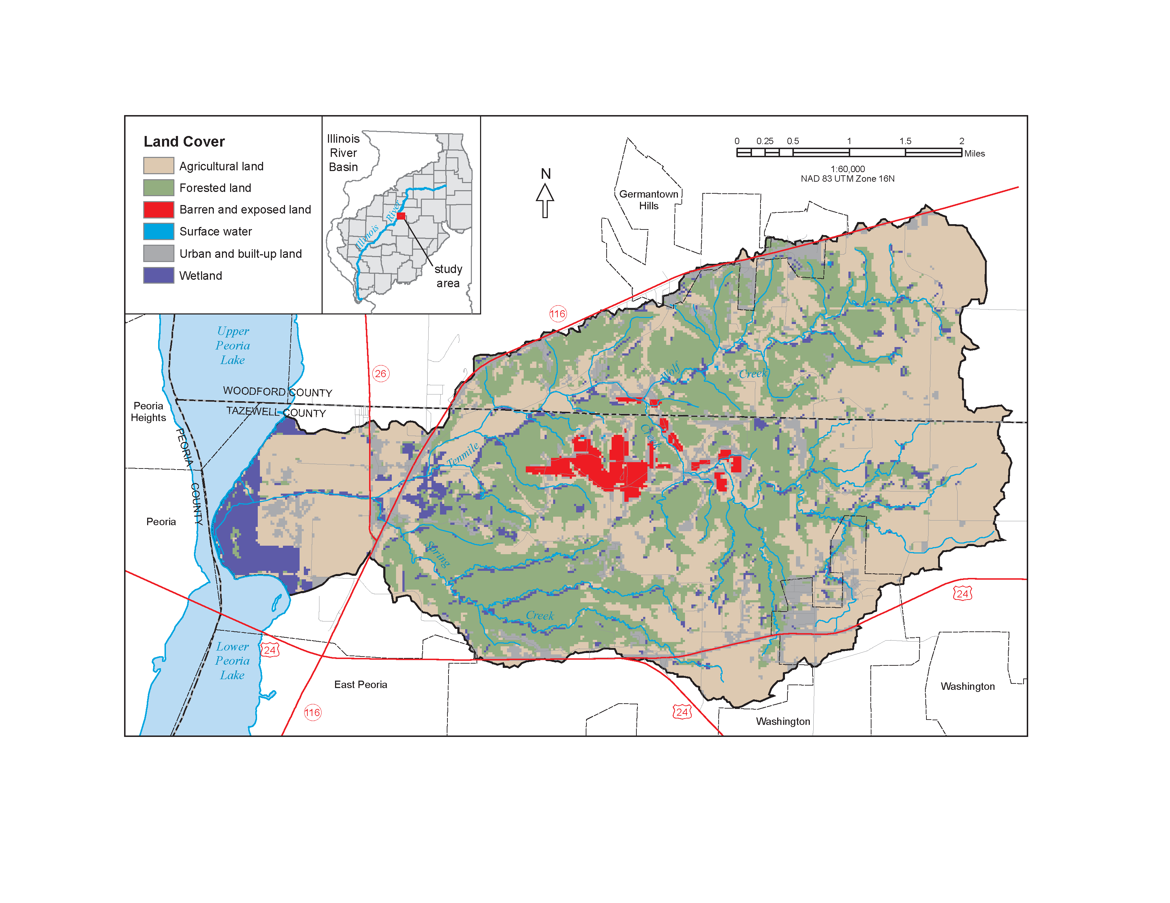

Figure 10. Generalized land cover of the Ten Mile Creek watershed, from Illinois Gap Analysis Program (INHS 2003), 1:100,000 scale.

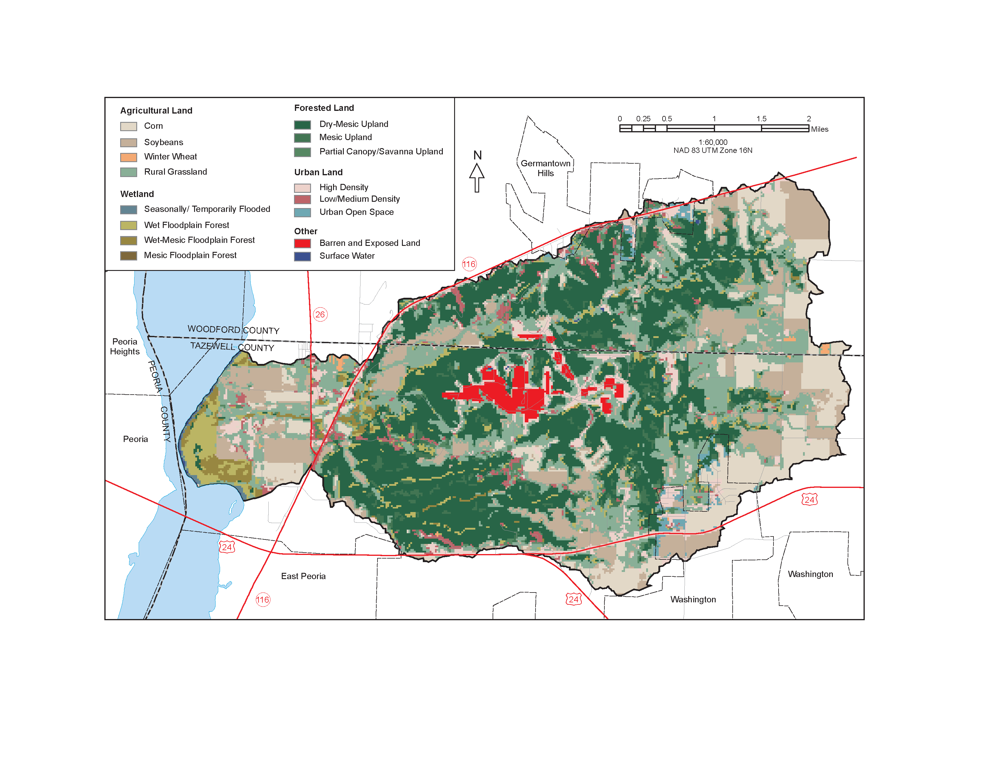
Figure 11. Detailed land cover of the Ten Mile Creek watershed, from Illinois Gap Analysis Program (INHS 2003), 1:100,000 scale.

Table 5. Land cover statistics of Tenmile Creek Watershed

There are two distinct landscapes in HUC 403: steeply sloped areas along the bluff line and lower relief areas in the Illinois River floodplain (Figure 13; Table 2). Steeper slopes mark areas that Creek and its tributaries incised into the Tiskilwa Till Plain. Valley walls in the incised Tiskilwa Till Plain are predominantly forested, whereas less dissected areas on the till plain and in the Illinois River floodplain are largely used for row-crop agriculture. Rural grassland occurs mainly at fringes of forested land on moderate slopes, along water courses, and in patches up to several acres in size across Post-glacial Floodplain and Outwash Terrace regions. Most existing wetland area in the watershed also occurs within the Illinois River valley, mainly near the mouth of Tenmile Creek in and around
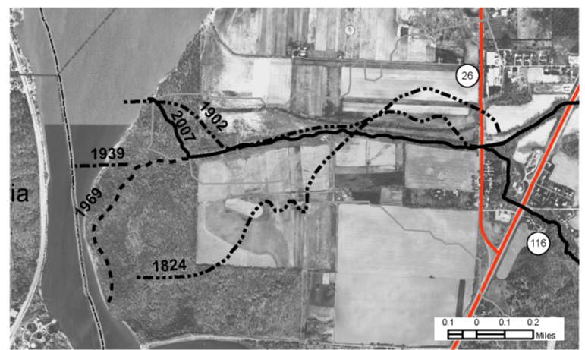

Figure 000. Movement of the Mouth of Tenmile Creek over time.

(DREW insert) This figure shows the types of land cover within a 100-meter wide buffer along Tenmile Creek, for three data sources of different ages: ISIS by UIUC/DNR, data date 1989?; GAP by INHS, data date 1999–2000; and QHEI by ISWS, data date 2008. In order to analyze land cover change over time, it was necessary to standardize the land cover classes used by the 3 datasets. We chose to keep classification scheme of the QHEI data because it employed the fewest classes. Data from the other 2 sources were reclassified/generalized into the QHEI classes. Because the QHEI classes are a measure of riparian quality, it was not always obvious in which QHEI class a land cover value from the GAP or ISIS data belonged. For example in QHEI, agricultural land could have a score of 0 or 1, depending on whether it is “row crop” or “conservation tillage,” while the ISIS data has just one class called “agricultural/cropland,” and the GAP data has subclasses for the type of crop, e.g., corn, soybeans, wheat, etc. For the purpose of our analysis, all agricultural land cover types from ISIS and GAP were assigned a QHEI score of 1. This may overestimate the QHEI value for some agricultural land by one point.

Another incongruity among the datasets was that the location of stream reaches in ISIS do not match the stream reaches (based on sampling points) in the QHEI data. To compare the GAP raster data with the other 2 datasets, the ISIS and QHEI stream buffer polygons were each intersected with the GAP raster, and the average QHEI score of all the cells in each buffer polygon was calculated. Note that this resulted in output decimal values rather than the integer classes from the input.

For each possible time interval (1989–2000, 2000–2008, and 1989–2008), the score of the beginning date was subtracted from the score of the ending date. The results show the change in the QHEI score for each stream segment. Segments with a change of -1 to 1, shown in yellow, can be considered minor or within the margin of error, given the data translation issues. Segments with a change between -1 and -3, shown in red, imply habitat degradation. These areas may be candidates for restoration.
(end DREW insert)

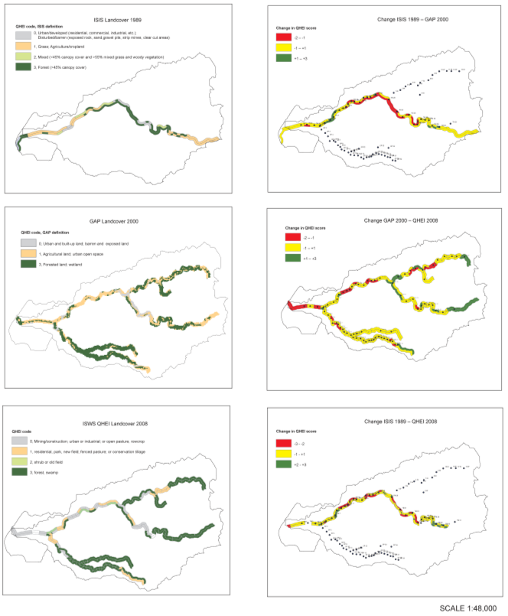

Figure 5100. Tenmile Creek Land Cover through Time.

b. Current Landuse
i. Agriculture
ii. Industry (Figure 14?)
iii. Transportation (Figure 15?)
iv. Urban Areas and Impervious Surfaces
The buried bedrock surface slopes down towards the narrow and deep Wyoming bedrock valley that trends subparallel to Creek. In this location, the total drift thickens down the slope of the valley as well. This valley and its sediment fill are important for watershed assessment and represent the only groundwater source for residential or other development within the watershed. The Wyoming valley thus may define the region of most likely future development. Recent residential development beyond valley boundaries must rely on ponds and trucked or piped water (Andrew Stumpf, Illinois State Geological Survey (ISGS), Personal Communication, 2006). Rapid development is occurring in forested bluffs occur within this area.
v. Zoning
vi. Prime Farmland
vii. Public Lands with Ecological Designations
These areas include:

- Illinois River Bluffs Assessment Area
The Illinois River Bluffs Assessment Area was developed by the IDNR as part of the Conservation 2000 Ecosystem Partnerships programs (http://dnr.state.il.us/orep/c2000/assessments/Illinois_river_bluff/pagei.htm). The Illinois River Bluffs begins near Hennepin and ends at the southern end of Peoria Lake at East Peoria. Tenmile Creek is one of the tributaries that drains into this stretch of the river along with others including, Senachwine Creek, Creek West, Crow Creek East, Clear Creek, Sandy Creek. All these tributaries drain nearly 561,000 acres in west central Illinois. The area includes most of Marshall and Woodford counties as well as small portions of Stark, Bureau, La Salle, Tazewell, Putnam, and Peoria counties. The Illinois River Bluffs marks the furthest reach of the massive glaciers that crept from the north and east during the most recent ice age. The rugged local topography supports a rich variety flora and fauna, such as a mix of woodland, savanna, and prairie and 16 species of birds that are officially recognized as threatened or endangered in Illinois.

- Peoria Wilds

Tenmile Creek watershed also occurs within the RRA called Peoria Wilds (http://www.inhs.uiuc.edu/cwe/rra/site13.html). Peoria Wilds encompasses the floodplain of the Illinois River, deeply dissected bluffs and hills bordering the floodplain, and relatively flat agricultural areas away from the river (Figure 2). A large tract of forest runs along the bluff west of the Illinois River. Nonforested wetlands are concentrated next to the river. Several hill prairies in this area have been included in the Illinois Natural Areas Inventory. Sun- and wind-exposed west- and southwest-facing slopes of hill prairies create a harsh environment more suited to prairie than forest.

- Natural Areas

Peoria Wilds RRA includes 24 natural areas of woodlands, hill prairies, marshes, fens, seeps, and the Marshall County Conservation Area Hill Prairies. Few hill prairies have been plowed because of their steep slopes, but they are sometimes grazed. The Creek watershed has no known hill prairies but does have two Natural Areas: the 21-acre Hatcher Woods and 41-acre Leigh Woods (Figure 16).

- Biological Stream Characterization ?

The Creek mainstem is listed as a Class B stream (Figure 17; See Biotic Environment; Section V, 6, c). Class B streams are a highly valued aquatic resource with good fisheries for important gamefish species.

- 303(d) Streams - Three segments were mentioned in the 2004 Illinois water Quality Report as evaluated but the Use Support was not assessed. The segments were 7.76 miles of Tenmile Creek (DZZS), 3.94 miles of Spring Creek (DZZSA), and 3.42 miles of Wolf Creek (DZZSB).

- Nature Preserves—Only one nature preserve exists in the watershed, the 2.5-acre Root Cemetery Savanna (Figure 16) near in Township. This preserve, dedicated in February 1994, is a mesic savanna of the Illinois River Section of the Upper Mississippi and Illinois River Bottomlands Natural Division. For further information about this sensitive site, contact the Illinois Nature Preserves Commission (217/785-8686).

- State Fish and Wildlife Areas—Nearby, the Woodford County Conservation Area and the Marshall State Fish and Wildlife Area occurs in the Illinois River Floodplain. The IDNR Conservation Area is adjacent to the mouth of Creek in Upper Peoria Lake on the north side of (Figure 16).

- Threatened and Endangered Species—The Tenmile Creek landscape is highly disturbed. Softleaf Arrowwood; (Viburnum molle) is a threatened and endangered species only found at the two designated natural areas, (??????)).

5. Abiotic Environment
a. Geologic Setting
i. Bedrock Geology
Pennsylvanian age sedimentary rocks underlie the Creek watershed in layers of interbedded shale, clay, sandstone, limestone, and coal in approximate order of abundance (McKay et al., in review). Shale tens of feet thick predominates, whereas limestone, coal, and clay tend to be only a few feet thick.

Based on ISGS field investigations (Figure 18), the glacier that formed the Providence Moraine (Figure 4) eroded the pre-existing landscape of the northern half of Creek watershed to bedrock. Subsequent glacial and proglacial deposits comprise a generally thin drift cover. Bedrock is near or at the surface in approximately the northern half of the watershed. There are bedrock outcrops at elevations of 590-600 feet north of along the Illinois River bluffs to the east and near the bluff line of and Creek valleys (McKay et al., in review; Stumpf, in review). The buried bedrock surface slopes down towards the narrow and deep Wyoming bedrock valley that trends sub-parallel to Henry Creek; the total drift thickens commensurately. The occurrence of this valley is important for watershed assessment because its sedimentary fill comprises the only groundwater source for residential or other development within the watershed. Recent residential development beyond valley boundaries must rely on ponds and trucked or piped water (Andrew Stumpf, ISGS, Personal Communication, 2006). The Wyoming valley may thus define the region of most likely future development.

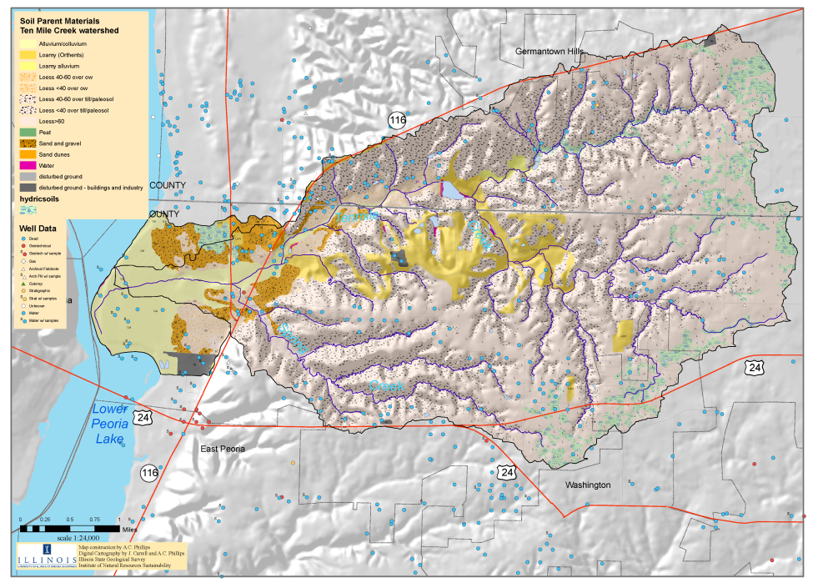

Figure 5900. Soils parent material and ISGS field observation sites in the Tenmile Creek watershed. Compiled from USDA NRCS soil surveys for Woodford (NRCS xxxx) and Tazewell (NRCS xxxx) Counties

Upstream of approximately County Road 700 N to County Road 950 N, the stream is incised into bedrock, typically shale outcrops up to 10 feet above the channel bottom in one or both channel walls. Where underlying rock is relatively erodible shale, the channel substrate comprises a veneer up to several feet thick of alluvial sediments over bedrock. Occasionally rock outcrops form ledges in the creekbed where underlying rock is relatively resistant sandstone and limestone. Further upstream (County Road 950 N to approximately County Road 500 E), shale fragments are common in the subsurface till. This suggests bedrock near the surface because glacial ice rapidly pulverizes shale. Bedrock appears to deepen in Creek, although large blocks of shale and limestone can be found as inclusions in till outcrops.

Bedrock tends to inhibit erosion, although erosion continues to occur as evident from several steep banks along the creek at the base of the eastern valley wall. Where the creek is incised into the rock, that is, where rock outcrops occur in both channel walls, the channel planform and channel cross section are relatively stable. Where the rock is exposed in the channel bed, however, stream power may enhance lateral migration. It was not possible to confirm this correlation in this limited study, however.

ii. Surficial Geology
The moraines, which border the Creek watershed, were formed by the Wisconsin Episode glacier (Figure 4). The Providence Moraine, which comprises the western watershed divide, was deposited about 20,000 radiocarbon years ago (Hansel and Johnson, 1996). The Eureka Moraine, which comprises the eastern watershed divide, was deposited between about 15,500 and 18,500 radiocarbon years ago.
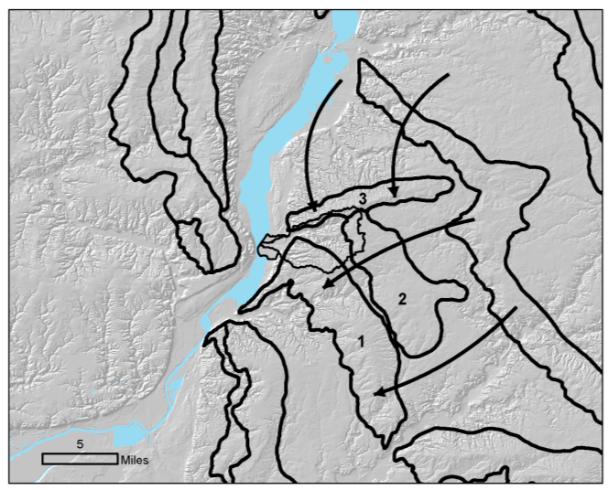

Figure 4760. Moraines of the Illinois River valley near Lake Peoria
.
The entire upland surface is covered by 8-12 feet of loess where it is not eroded away. Loess probably comprises the main source of sediment in overland flow (Figure 19; cf. Stumpf, in review). Silt tends to be transported easily so sediment moves out of the watershed and deposits in the lower energy environment of Peoria lakes. The upper watershed is underlain by till and ice-contact deposits of the Tiskilwa, Lemont, and Equality Formations (Lineback, 1979). A region of fine glacial lake sediment (Equality Formation) shown on the statewide map (Lineback, 1979) was mapped by geomorphic expression of a very low sloping area between moraines. The landform is covered by thick loess (>5 feet), but subsurface materials cannot be confirmed with existing borehole data. A cutbank just north of County Road 1050 N contained ~5.5 feet of interbedded, soft, laminated to massive silt, fine to medium sand, and silty clay capped by loess (Figure 19). Below the creek level was soft, massive, fine pebbly silt. This sequence appears to represent alluvial sedimentation with seasonal lake sedimentation filling in the true glacial lake basin below creek level. The sequence thus may comprise a source of erodible fine sediment that Senachewine Creek accesses through channel incision. In the middle reach, the floodplain comprises ~7 feet of fine stream sediment (silty clay to silt loam) over ~8 feet of coarse stream sediment (fine sand to gravel), possibly glacial outwash. Approximately, the lower 7 kilometers (km) of Creek flows through Illinois River terrace and floodplain before emptying into the Illinois River. Cahokia and Henry Formations underlie this portion of the Creek valley. Sand and gravel from these formations have been quarried extensively between and Creek. Drift thickness in the watershed ranges from 0 in the southern part of Township to 200 feet in the southeastern part of Marshall County (Piskin and Bergstrom, 1975). The thickest drift cover occurs over the Wyoming buried bedrock valley, described briefly above but in more detail below, which trends West North West-East South East under the western portion of the watershed (Herzog et al., 1994).

Two soils, the Jules and Paxico map units, stand out because they each contain an A horizon (rich organic topsoil) of up to 9 inches of calcareous silt loam over stratified C horizon (parent material) sediment (Figure 20). The Jules and Paxico map unit soils are positioned mainly on the floodplain of Creek through the near-bluff region and on the Illinois River floodplain. Because calcite is readily lost during sediment transport and deposition and soils lack B horizons, their presence may indicate areas where cultivation of calcareous loess on slopes has caused rapid sediment runoff and deposition in nearby floodplains. Areas immediately upstream of these soils should thus be examined more closely for potential upland remediation.
DREW’s insert bold
b. Hydrogeomorphic Setting

i. Channel Gradient and Stream Power

The overall geomorphic potential of the Ten Mile Creek watershed was assessed by examining the distribution of channel slope and stream power within the watershed. Energy gradient (approximated by channel slope) is a primarily control on geomorphic adjustment in stream channels. The energy gradient and discharge are the principal factors that determine stream power—a measure of the energy available to erode or transport sediment (Rhoads, 1995).

In the absence of abrupt natural or anthropogenic disturbance, channel gradient changes gradually and progressively. Abrupt changes in gradient by manipulation or natural disturbance such as mass wasting can lead to accelerated erosion or bank failure in the watershed. Likewise, an increase in frequency and/or magnitude of discharge regime will increase the stream’s capacity for erosion and sediment transport.

Brookes (1988) related the response of straightened stream channels to stream power and found that channels with stream power values higher than 100 W/m² at bankfull discharge regained their sinuosity, channels with stream power between 35 and 100 W/m² adjusted by mainly erosive processes and those below 35 W/m² adjusted mainly by depositional processes. Based on these guideline levels, determination of stream power can provide a context for the potential for geomorphic response within a watershed, particularly if channel instability and dynamics are also examined (c.f. Herricks et al. 2004).

Potential responses to gradient change include incision due to increased gradient and deposition due to decreased gradient. Simon (1989) showed that channel disturbance caused by dredging and straightening of alluvial channels can initiate a sequence of morphologic changes characterized by channel incision upstream of the channel disturbance followed by a secondary depositional stage and deposition downstream of the disturbance. Conversely, manipulation by impoundment or grade control can initiate increased deposition due to a local reduction in gradient upstream and increased erosion due to a local increase in downstream gradient (Montgomery and Buffington 1998; Simon and Darby 2002).

Channel slopes in the Ten Mile Creek watershed were estimated using stream channels digitized by ISGS and 3 m contours derived from a seamless USGS digital elevation model. The slopes estimated from these sources were cross-checked with slopes estimated by interpolating stream distance between contours on USGS topographic maps. The distribution of channel slope in the watershed is shown in Figure [Channel_Slope]. Of the nearly 55 miles of streams for which gradient was estimated, about 42% were lower than 0.01 and about 75% were lower than 0.02. Most stream segments with gradients greater than 0.02 occur in first order tributaries.

Estimates of stream power for Ten Mile, Spring and Wolf Creeks were calculated using discharge values extracted from the Illinois Stream Stats website (USGS 2009). The 2-year peak flow (PK2) was presumed to approximate bankfull discharge. Details regarding development of the regional regression used to estimate discharge are available in Soong et al. (2004). Energy gradient input values were approximated using the channel slope estimates described above, and channel width was taken as the average channel top-bank width measured by the ISWS field crew. The estimate of stream power per unit wetted area of the channel (ω) in W/m² was calculated by:

ω = γQ S_{e} /W

where:

γ is the specific weight of water (9810 N/m)
Q is discharge (m³/s)
S_{e} is the energy gradient (approximated by channel slope)
W is channel top-bank width (m)

Figures [Power_Map] and [Power_Graph] show the locations and the profiles of stream power estimates along Ten Mile, Spring and Wolf creeks. There is a general increase in stream power downstream with increasing catchment area and thus increasing discharge. There is little correlation between stream power and either channel slope or discharge, suggesting that local conditions prevail.

The middle portion of Ten Mile Creek encompassing the Proving Grounds shows the highest stream power values. Notable spikes in stream power occur along Ten Mile Creek near Station TM8 and in the upper portion of Wolf Creek where channel slope steepens abruptly. The spike at TM8 may be due mainly to a narrowing of the channel there; width is about ½ that at the neighboring locations. The stream at TM8 is impinging on the valley wall and armoring of the right bank by piles occurs, thus energy may be focussed into incision. By contrast, it was observed that the TM8 reach was dominantly depositional compared to mixed depositional/erosional both up- and downstream. This may be attributed to the surveys having been taken during low flow conditions. A second local maximum at TM19 (RM 4.2) occurs just downstream of the CAT detention pond where the channel is both deeper and wider than at downstream locations. Stream power values are near or below the erosional/depositional threshold (35 W/m²) along the portion of Ten Mile Creek that passes across the alluvial fan and in the uppermost portions of each creek.

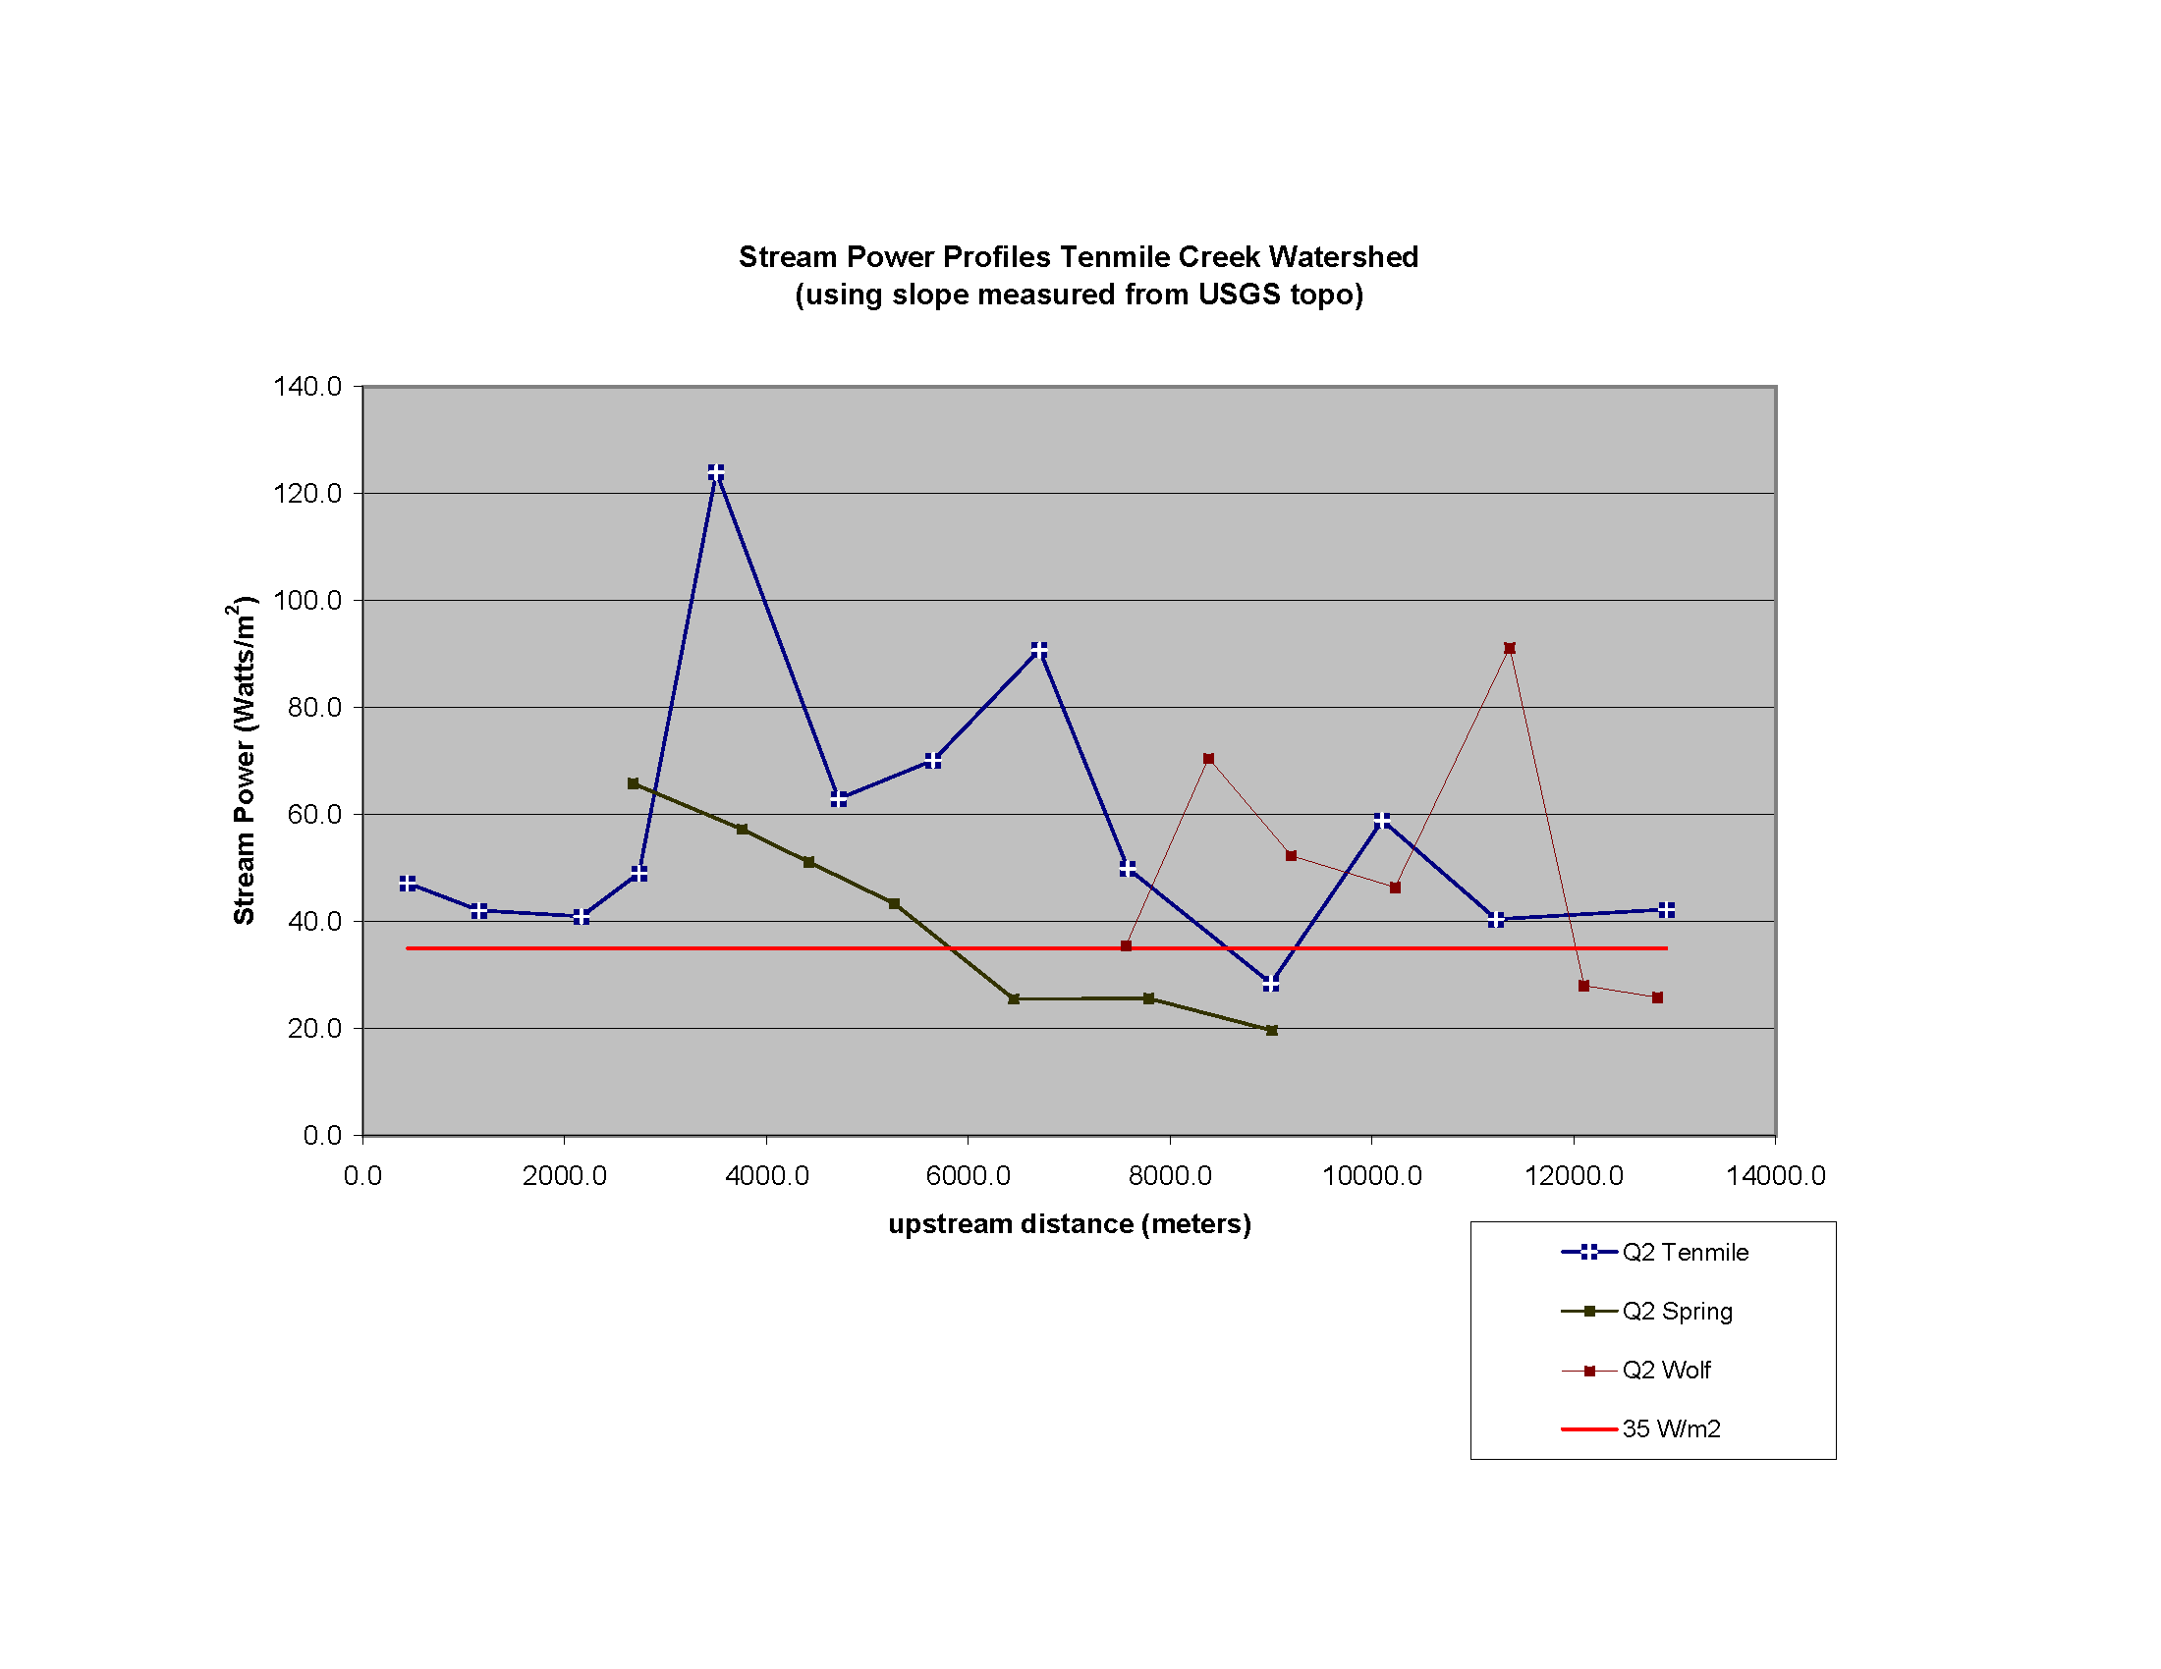

Figure 100000. Graph showing the stream power (Watts/mile²) of selected streams in the Tenmile Creek watershed

ii. Hydrology and Sediment Transport Conditions

INSERT SUMMARY OF ISWS DATA FROM PAST STUDIES HERE

A waterbody inventory was conducted to determine the location distribution and density of surface water features other than streams in the watershed. The influence of waterbodies on the catchment hydrology depends on their number, storage capacity, base level, and outflow. This inventory gives only the number and locations of waterbodies. Analysis beyond what is presented here would be required to evaluate the effect that waterbodies may have on the reduction of peak discharges, increase in base flow, and channel incision or aggradation. However, this inventory can be used to guide selection of areas for further analysis.

The inventory was conducted by inspection of the 1998 DOQ, 2004 NAIP infrared, and 2007 NAIP true color aerial imagery (Figure 1) supported by digital image analysis of the infrared imagery. Based on this inventory, there are a total of 57 waterbodies covering over 60 ac within the Ten Mile Creek watershed (Table [Waterbodies]). Eighteen (18) of these are located within the Proving Grounds; they account for nearly one half (~35 ac) of the total waterbody area in the watershed, and the sediment detention basin below the confluence of Ten Mile and Wolf Creeks itself accounts for one fourth (15 ac) of the total waterbody area. Many of the remainder of the waterbodies are impoundments along tributaries throughout the watershed. Many of these are located at the heads of streams. Some of the waterbodies appear to be intermittent or ephemeral, but their status cannot be confirmed without additional field work, imagery data, or both. During a field visit in December, 2007, two ponds totalling about 75 ac and managed for waterfowl were observed adjacent the channelized reach of Ten Mile. They were not digitized for this data set because they do not appear in our most recent (2007) imagery.

Subbasin Name | Number of Waterbodies | Acres
Spring Creek | 3 | 2.2
Wolf Creek | 13 | 9.2
Ten Mile Creek | 40 | 47.0
Other | 1 | 2.5

Table [Waterbodies]. Occurrence of waterbodies in subbasins of Ten Mile Creek

iii. Channel Bed Materials

The character of channel bed materials largely dictates the mobility of bedload and the susceptibility of the channel to incision. The channel bed material in the Ten Mile Creek watershed consists mainly of poorly-graded gravels and sands with little or no fine material. This bed material is derived primarily from reworked alluvium (floodplain and channel deposits) except where the channel has incised into glacial deposits or where hillslope failures supply the channel with material directly from glacial and loess deposits from the valley walls. Along reaches where bedforms are patchy or do not occur, the streams flow on cohesive till or loess deposits.

The hydrologic conditions in nearby watersheds (e.g. Senachwine Creek, Partridge Creek) suggest that flows in Ten Mile Creek are only rarely able to transport bedload coarser than fine gravel, although most flows are capable of transporting fine material (silt and clay particles) through the watershed and into Peoria Lake. This is evident from ISWS field observations, which indicate that the primary channel bed material throughout the watershed consists of gravel sand mixtures with little or no fine material and coarser materials were found in only a few cases. The coarser materials (cobble or larger) were noted immediately downstream of the spillway downstream of the proving grounds, within the proving grounds and in a few upper reaches of Ten Mile and Spring Creeks (Figure [Bed_Material_Knickpoint _Map]). These lag deposits likely indicate localized zones of higher stream energy (i.e. knickpoints) within the channel or local sources of large calibre sediment where incision may now be inhibited by the coarser material (cobbles and boulders) armoring the bed.

iv. Stream Planform Change 1939-1998

Streams evolve dynamically with time in response to natural (e.g., climate, geology) and anthropogenic (e.g. land use, channel manipulation) forcings. Stream channels change their planform, cross section form, or both, by eroding their banks laterally, scouring the bed, or depositing sediment on floodplains and within channels. The rates and modes of these behaviors are functions of the geomorphic, hydrologic, and geologic settings. The net planform change between 1939 and 1998 was quantified as polygonal areas determined with digital methods (see Methods, above).

Change polygons were divided into five dynamic behavior classes: lateral or downstream migration, avulsion, channelization, post-channelization response by various mechanisms, and chute development. Lateral or downstream migration is a natural process by which streams erode sediment from their outside banks and deposit sediment along their inside banks. Avulsion is an abrupt change in channel position. It can be caused by rapid influx of sediment from mass wasting, or result from transformation of a chute, an ephemeral channel that occurs on floodplain during high flow, into the main channel through incision and stream capture. Chutes may also be short-lived features that do not develop fully to an avulsed channel. Channelization is anthropogenic avulsion, in which channel bends are straightened or channels are moved from their original positions. Channelization is usually recognized on imagery as an abrupt change in channel planform that results in a straightened channel where construction activities and an apparent advantage to expedited drainage are evident. Where avulsion, chute formation, or migration occur after a reach shows evidence of channelization, post- channelization is assigned as the dynamic class.

The preliminary results from assessment of channel dynamics between 1939 and 1998 are given in Tables I and II below and areal planform change is depicted in Figure [PLANFORM CHANGE]. The ratio of total areal change per unit stream length is a metric of total planform change, with planform stability inversely related to magnitude. Total areal change per unit stream length was greatest (12.9 m²/m) in the middle valley and least in the headwaters (1.0 m²/m) of the watershed. Most occurrences of planform change not associated with the Caterpillar Proving Grounds occurred via lateral and downstream migration in Spring Creek, Wolf Creek, and the upper tributaries of Ten Mile Creek. The largest planform changes outside of the Proving Grounds occurred in the middle valley approximately 1 km downstream of the detention pond and in the lower portions of Spring and Wolf Creeks. These changes were substantially smaller than those within and just upstream of the proving grounds. Relative planform stability between 1939 and 1998 outside of the Proving Grounds could be due to could be due to several factors including increased forested area in the headwaters, regulation of flow and sediment load by the dam and reservoir just downstream of the Proving Grounds in the middle valley, and raised base-level due to the regulation of water levels in Peoria pool after construction of the Peoria Lock & Dam in 1938. Channelization was a relatively small portion of the total change further downstream. Field observations of active slumping and the use of rip-rap and fill to stabilize banks along Ten Mile Creek near the intersection of Ten Mile Creek Road and North Randy Drive CR1050N suggest that channel widening or deepening or both are occurring. The width of the middle valley of Ten Mile Creek appears to have narrowed between 1939 and 1998.

This stream dynamics analysis component of the overall project characterizes the dominant modes and relative activity of stream planform change through the watershed. In common with many other streams in the region, human modification by relocating or damming the streams is a dominant process in planform change. However, it is clear that the system has enough energy to modify its planform naturally. Evidence of lateral migration is common in Wolf, upper Ten Mile, and Spring creeks. Further, a meandering inset channel appears to be developing within the channelized alluvial fan reach. Most instances of avulsion occurred in Spring Creek valley, and may have been caused by sediment piles from the mass wasting that was noted commonly along the steep valley walls although although causal links cannot be determined from the extent of this study. However, at least one instance of avulsion by alluvial processes was also observed (ISGS field point SC13). The direct contribution of large mass-wasting events to sediment loads appears to be lower than remobilization of alluvium by meander migration.

At this level of study – examining only two points in time -- we cannot determine when the observed changes occurred, or whether they are in stasis or are progressive. As well, the correlations between areas of planform change and habitat, landscape erosion, channel form, and sediment delivery are yet to be determined. By comparison with limited field investigations it is clear, however, that there is sufficient stream power for Ten Mile, Wolf, and Spring Creeks to erode their banks and transport much of the sediment loads delivered to them by overland and mass wasting processes. However, the relative effects of slope, discharge, land cover, and geology (erodibility of channel banks and substrate, availability of bedload) must be distinguished in order for project selection and design to proceed. When combined with the channel geomorphology field studies, we may be able to better assess the evolution of channel form and incision.

It is important to reiterate that correlations between landscape or channel change and stream response are tentative. More comprehensive analyses of stream dynamics are needed for individual project design and implementation. In particular, we cannot determine the response of streams after direct modification of stream channels (‘channelization’) or other identifiable land use changes. As well, only net rates of planform evolution can be estimated; actual rates may be significantly higher. Understanding these responses is important for predicting the long term survival of stream restoration projects. Greater understanding could come from examining imagery of intervening years and estimating long term and synoptic trends in stream power.

Table I: Channel planform change, Ten Mile Creek Watershed, 1939-1998
Dynamic Class | Number of Occurrences | Total Area (m²) | Total Areal Change (%)
Avulsion | 22 | 16835 | 6
Channelization | 17 | 110545 | 39
Lateral or downstream migration | 310 | 110154 | 39
Reservoir/Dam | 3 | 46338 | 16
Total | 352 | 283871 | 100

Table II: Channel planform change breakdown by slope class
Slope Class | Valley-slope range | Channel length assessed | Areal change (m²) |  | Areal change/unit stream length (m²/m)
 |  |  | Proving grounds | Total
Alluvial Fan | <0.004 | 2705 | n/a | 10035.9 | 3.7
Middle Valley | 0.004-0.010 | 9449 | 81653.5 | 122079.6 | 12.9
Headwaters | >0.010 | 151196 | 71887.6 | 151755.6 | 1.0
All |  | 163350 | 153541.1 | 283871.1 | 1.7

c. Geomorphic and Physical Habitat Condition Assessment

A rapid synoptic view of current conditions was established by helicopter-based aerial reconnaissance. Larger instances of channel instability, and important land uses and possible channel interactions were observed, and critical documentation with geolocated videography was obtained. The aerial reconnaissance was followed by field surveys of channel conditions were conducted in part to verify conditions identified from aerial reconnaissance

i. Aerial Reconnaissance

An list of sites identified for analysis within the Ten Mile Creek Watershed based on the aerial reconnaissance is given in Table [Aerial Problem Areas]. A total of # potential problem sites were initially identified. Based on review of recent historical aerial panchromatic photographs covering areas outside of GPS-tracked aerial reconnaissance, another # potential problem sites were identified. These # potential project sites (Figure [Aerial Problem Areas]; Table [Aerial Problem Areas]) were investigated in the field for geomorphic and physical habitat characteristics in summer 2008. The locations of potential problem areas/project reaches identified from the rapid aerial reconnaissance and still aerial photos were mapped and compared with maps of geomorphic and biologic field data and sites were either added to or eliminated from the list of potential project sites based on field verification. Sites that continue to remain on the list for potential restoration will be monitored and analyzed further for project feasibility determinations.

Point | Video minutes | Longitude | Latitude | Description
LB = Left Bank, RB = Right Bank
Table [Aerial Problem Areas]. Potential Project Sites Identified During Aerial Reconnaissance (concluded)

ii. Channel Evolution Model

The six-stage Channel Evolution Model (CEM), developed by Simon and Hupp (1986) and Simon (1989), was used both within the Channel-Stability Ranking and for consideration in spatial assessment of watershed condition (Figure [CEM] Table [CEM]). The six-stage CEM can be useful for watershed assessment in the loess area of the Midwest because it can provide a process-based context for channel adjustment after a major channel disturbance (i.e., dredging/channelization) in sand-bedded streams with cohesive alluvial banks (Simon 1989; Simon and Hupp, 1986; USACE, 1990; Federal Interagency Working Group, 1998). If the spatial distribution of CEM stage throughout the watershed and the history of major channel disturbance are known, then the CEM can be used to assess potential future stream response, including potential for slope and streambank instability. In this case, the CEM provides a consistent rationale that can be used for prioritization of restoration activities. However, factors such as variable geologic controls, ongoing disturbances throughout a watershed (e.g., agricultural tiling, urban development, climate change) can complicate interpretation of CEM stage. Although the CEM is generally applicable to watersheds within the ILRB that have similar conditions under which the model was developed, it has limited applicability in low-gradient streams and is not applicable where the bed or banks are not alluvial (e.g., bedrock or resistant glacial deposits).

The six-stage CEM is depicted in Figure [CEM] and each channel stage and associated characteristic processes and forms are given in Table [CEM]. In the idealized six-stage CEM, the elevation of the post-disturbance bankfull level is lower than the pre-disturbance channel and the pre-disturbance floodplain forms a terrace above the new active floodplain. Relatively stable reaches occur downstream (Stages V and VI), and less stable reaches (Stages II and III) are upstream of those classified as Stage IV (i.e., threshold stage; Federal Interagency Working Group, 1998). This progression happens because initiation of channel incision by a major disturbance or modification produces an increased gradient (e.g., headcut or knickpoint) locally that advances upstream until it meets more resistant bed and bank material or until stream energy becomes too low to support erosion of the bed due to decreased slope or discharge in upper reaches of the watershed. Thuse Stage I and Stage VI channels of the CEM generally indicate relative stability.

The spatial distribution of CEM stages based on the 2007-2008 field data collection campaign in the Ten Mile Creek Watershed are shown (Figure [CEM_MAP]). Overall, the watershed has 59 miles of 1st, 2nd, and 3rd order streams (Strahler 1952) as digitized by ISGS. (See Appendix D for a list of longest stream sections in the Ten Mile Creek watershed). Stream segments along Ten Mile Creek, as well as Wolf and Spring Creeks were assessed. 17.1 miles had 78 assessed segments: 40 segments (51%) in Stage IV, 21 segments (27%) in Stage V, 7 segments (9%) in Stage III, 6 segments (8%) in Stage II, and 4 segments in Stage VI. Most of the channel segments in the Ten Mile Creek watershed were classed as Stage IV.

The Ten Mile Creek mainstem, from its mouth at the Illinois River to a point about 8.0 miles upstream, had 31 assessed segments: 11 segments (35%) in Stage V, 8 segments (X%) in Stage IV 6 segments (6%) in Stage VI, 12 segments (12%) in Stage IV, and 17 segments (17%) in Stage II. The Ten Mile Creek mainstem had more Stage V channel segments than any of its tributaries. An 3.9 mile reach of Spring Creek had 34 assessed segments: 24 segments (70%) in Stage IV, 6 segments (18%) in Stage V, and 4 segments (12%) in Stage III. Wolf Creek had 13 assessed segments within a 3.6 mile reach: 8 segments (61%) in Stage IV, 4 segments (31%) in Stage V, and 1 segment (8%) in Stage III. There were no Stage I, II or VI segments.

iii. Channel Stability and Habitat Integrity

Channel conditions along Ten Mile Creek, Spring Creek, Wolf Creek, and an unnamed tributary (S4) of Spring Creek assessed using geomorphic and physical habitat protocols following Keefer (2006). These protocols incorporate components of several geomorphic and physical habitat assessment approaches (e.g., Kuhnle and Simon, 2000, Barbour et al., 1999) that have been adapted for use in Illinois streams (Keefer 2006). The initial components of the channel condition assessment are the Channel-Stability Ranking and the Biological/Habitat Ranking. Each of these ranking schemes considers various channel characteristics such as bed material/substrate, type and degree of channel erosion and deposition, and vegetative cover on and long the channel banks (See Appendix C for samples of field data sheets). Geomorphic and physical habitat data were collected from # stream reaches throughout the watershed (Figure 20).

The CEM classifications determined in the field in Ten Mile Creek watershed generally correlate well with channel stability indices (CSIs). CSI scores greater than 20 have been interpreted to generally indicate dynamically unstable channel conditions. Scores of 11-19 indicate potential instability or transitional conditions, while scores of 10 and under indicate stable conditions (L. Keefer, ISWS, Personal Communication, 2004) (Figure 32). Significant autocorrelation between CEM stage and channel stability indices is expected because CEM stage is a parameter in the stability ranking scheme, and the two indices share some common parameters such as bed material and channel configuration. When poor correlations between stage and stability indices occur, they can almost always be explained by influences from other factors such as bedrock exposure, mass wasting, large woody debris accumulations, etc.

Channel stability metrics in certain stream segments and CEM can be poorly correlated in some cases (Figure ##). The varied sediment textural classes that comprise the bed material in Stage IV, V, and VI channels in this watershed impact channel processes, influc channel evolution. For example, Stage IV channels already have degraded and widened to a new state of dynamic stability (Channel Stability Index <10) and often occur where there are large sediment loadings from mass wasting of valley walls. Such a circumtance is also found where sediment loadings are low because bedrock inhibits channel incision and channel banks are relatively low (insets in Figure 33). As such, instances of mass wasting, exposure of bedrock or large woody debris in the channel bed modify local channel conditions and lead to poor correlations between stage and channel stability indices.

Physical habitat quality was evaluated using a ranking scheme developed by Barbour et al. (1999). QHEI INSTEAD??? (Copies of evaluation sheets containing ranking schemes for channel stability and biological habitat used at field assessment sites are found in Appendix C).

The metrics of the Barbour et al. (1999) ranking scheme are similar to the Quality Habitat Evaluation Index (QHEI) method (OEPA, 1987), although simplified to efficiently and effectively meet the needs of these and similar assessment objectives. Biological habitat index (BHI) scores from Barbour et al. (1999) can range from a low of 11 to a high of 44, with higher scores indicating better habitat (Figure 32). Where Stage VI channel segments occur in the CEM, habitat scores are generally higher. By contrast, where Stage IV channel reaches occur, habitat scores are generally lower unless some other influencing factor modifies the channel segment and its habitat. No statistical analysis has been performed yet on these data because detailed biotic information is lacking. For example, actual fishery and macroinvertebrate data are scarce for this watershed; therefore, these parameters were not examined in relation to stage of channel evolution or habitat indices. Currently, the authors suggest using a habitat score of 25 as a general “working” threshold to delineate between good and poor habitat areas in the Ten Mile Creek watershed (Figure 35). Additional data may suggest adjusting this threshold score up or down for this watershed.

Physical habitat quality scores (QHEI) plotted versus CEM and CSI show… (Figure CSI_QHEI). Sites having CSI and BHI scores that fall into the upper right quadrant of Figure 32 indicate better habitat quality systems, while stream segments having CSI and QHEI scores that fall into the lower left quadrant are in critical condition, both in terms of stability and habitat conditions. Sites having CSI and BHI scores that fall into the upper left quadrant are unstable sites that seem to support better habitat, while stream segments having CSI and BHI scores that fall into the lower right quadrant are deemed to have potential instability or are transitional with poor habitat.

Preliminary field data from Ten Mile Creek indicates good biological habitat for most channel segments (Figure 35). However, CSI scores indicate most segments are either unstable or relatively unstable. No channel segments are highly stable. The authors believe that the occurrence of beaver dams, log jams, and high-point riffles positively influence habitat scores by creating deep pools that contribute to good habitat scores, even though other aspects of channel morphology suggest instability. Channel segments that have indices which indicate channel stability and good biological habitat should show more divergence in CSI and BHI scores as the conditions become more stable and richer in habitat. Aberrations can occur, but they are generally explainable. For example, some mass wasting sites along the channel strongly influence channel stability ranking and establish conditions that register higher scores (less stability), but pooled water from beaver dams, log jams, high-point riffles, etc. minimize the anticipated strong divergence of scores (healthier stream conditions) between biological habitat indices and channel stability indices. Close examination of CSI scores, channel morphology (CEM), and BHI scores indicate at least five and possibly six distinct stream segments, (one to four miles long), that have problematic concerns and appear to either have less physical stability or less habitat or both. Little Ten Mile Creek has CEM Stage II morphology in the upper channelized mile, with channel stability scores indicating potential instability and habitat scores indicating poorer conditions upstream. Although this upper channel segment is well vegetated with grass, no standing water and no pools exist. With respect to the entire assessed reach of Little Ten Mile Creek, it is not year clear if the majority of segments exhibit problems predominantly from local or systemic causes. Problems in the upper reach appear to be from channelization. Other outlier channel areas exhibiting relatively significant erosion were also recorded, but the data suggest that the critical target areas are those 5-6 channel reaches decided above (Figure 35).

Preliminary field data from Deer Creek indicates three reaches of concern (Figure 36). The longest stream segment is in the middle area of Deer Creek. The next longest is at the upper end of the channel and the third is a short segment near the end of the channel about one-quarter mile upstream of the channel mouth at the confluence with Little Ten Mile Creek. It is interesting to note that the segment 1-2 miles from the mouth of Deer Creek is in Stage III (in an actively downcutting phase of channel evolution) yet habitat is comparatively better and the channel is still somewhat more stable than other stream segments in this system. This aberration at the lower end of the channel requires further examination to more accurately explain these conditions. Another aberration exists at the upper end of Deer Creek where both habitat and physical stability scores are good, but channel morphology is in Stages II and III (downcutting phases of channel evolution). Two beaver dams at this upper end created deep pools that definitely improved habitat scores. A nearby nick-point (headcut) in a side channel that drains into Deer Creek was recorded and scored with the geomorphic CEM and stability protocols as well as with habitat protocols. This channel segment scores as having potential for critical instability and will require further examination and most likley, restoration/grade control. Preliminary field data from Hallock Creek indicates three reaches of concern (Figure 37). The lowermost channel segment is indicated as a potential problem area based on CEM stage, channel stability, and habitat scores. This area also has an exposed gas pipeline. A channelized reach above this lowermost segment scores as fairly stable, yet has poor habitat scores. This area appears to be aggrading somewhat but also appears to be maintained, As such, it is currently not considered a critical candidate for restoration. The channel profile is steeper downstream of the channelized area and this steeper gradient is where the pipeline is exposed. Just upstream of the channelized area, the channel ascends from the floodplain into the bluffs. At this point, another potential critical channel segment about one mile long has CEM Stages IV and V channel morphology. Channel stability scores indicate a potential for critical instability, and habitat scores indicate relatively poor habitat. The upper most reach has one stretch of channel harboring a significant nick-point and appears to be at Stage II in an area with predominantly Stage IV channels both upstream and downstream. Channel stability scores in this upper segment are indicative of areas having potential for critical instability and relatively poor habitat.

iv. Mass Wasting
Mass wasting of high valley walls is common to many watersheds draining directly into Peoria Lake. Twenty-two (22) active and 2 recovered sites of mass wasting were identified throughout the Ten Mile Creek watershed and others are likely to exist. These episodically contribute large amounts of glacial sediment directly into streams (Figure ?). Mass wasting tends to occur where the stream impinges on upland valley walls and persistent erosion at the toe of the slope maintains a steep escarpment (Figure ?). Although mass wasting appears to continue despite the colonization by woody vegetation at toe of slope in some instances, the scarp may self-stabilize if the young woody vegetation becomes better established. Slope failures of this type tend to occur in a similar geologic setting in southwestern Illinois. Straub et al. (2006) found that slope failures occurred during waning of flood flows as hydrostatic support of the base of the slope decreased.
METHODS

Stream Planform Dynamics Analysis Stream planform dynamics were analyzed by comparing the 1939 channel position and planform of Ten Mile, Spring and Wolf creeks to the 1998 position and planform using methods adapted from Phillips et al. (2002, see also Urban and Rhoads 2003). Historical aerial photographs (HAPs) taken in 1939 were obtained from the ISGS Digital Archive of Illinois Historical Aerial Photography (http://www.isgs.uiuc.edu/nsdihome/webdocs/ilhap/) and orthorectified. Stream channel centerlines were digitized on-screen from the 1939 imagery and 1998 digital orthophotographic quadrangles (DOQs) in a GIS environment. “Buffers” were generated in the GIS for each stream trace using the respective image root-mean-square error. Areal “change polygons” were generated by merging pairs of buffers and extracting the interstitial “donut-holes”. The change polygons are the metric representing the net areal change in stream planform between 1939 and 1998. Therefore the polygons cannot be used to interpret stream dynamical behaviors that occur at timescales less than the duration between the photo years. In fact, because time and funding constraints within this project limited the analysis to only the earliest and latest available images, cause-and-effect relationships are tentative. Rather, interpretations are limited to broad styles, locations, and relative rates of planform change.

Aerial Reconnaissance Low-altitude, rapid aerial reconnaissance was conducted along 1292.04 miles (2079.18 km) of stream channels in the ILRB including the Ten Mile Creek Watershed in spring 2004 as a first phase of watershed and stream assessment efforts. The aerial survey was flown with a helicopter outfitted with a high-resolution, stabilized aerial video camera and Global Positioning System (GPS). Continuous, simultaneous video footage and synchronized GPS locations were obtained along the mainstem channel of Ten Mile Creek. Sites that appeared from the air to be unstable, (i.e., active sediment delivery to the stream channel from mass wasting, bank erosion, or bed incision, if detectable) were recorded and GPS coordinates marked. These sites were further inspected during subsequent field investigations and office analysis. Although sediment delivery or channel migration rates cannot be determined from the aerial survey, this rapid reconnaissance approach was used to quickly identify channel and near-channel sediment sources and disturbances that may indicate recent channel or hillslope destabilization. The rapid aerial reconnaissance was used to identify potential problem areas in or near the channel that otherwise may not be recognized for years which helped to focus subsequent field assessments.

CONCLUSIONS [to be incorporated into V.5.B-D]

Based on this study [stream dynamics analysis], projects directed at reducing sediment transport should be targeted at the middle valley downstream of the proving grounds, the lower reaches of Spring Creek, and the floodplain/delta area.

End of Drew’s insert
b. Hydrogeomorphic Setting
i. Aerial Reconnaissance

The aerial reconnaissance stream and watershed assessment tool used either a private or State of Illinois helicopter with a high-resolution, stabilized aerial camera and Global Positioning System (GPS) for aerial videomapping and rapid identification of potential restoration project sites. Low-level aerial surveys significantly help identify stable and unstable stream reaches using available technology. Although low-altitude aerial imagery cannot provide information on all sediment sources and disturbances, it, nonetheless, is an economical way for rapid reconnaissance to identify potentially significant problems in or near a channel that otherwise may not be recognized and addressed for years. Low-altitude aerial videomapping allows increased ability to see some channel and near-channel disturbances or sediment sources rapidly and possibly help identify some causative factors for channel morphology changes. After potential sites are identified, analyses help determine hydrology, hydraulics, geomorphology, and biology, which help prioritize locations for design and construction of restoration work.

Aerial videomapping was conducted along 1292.04 miles (2079.18 km) of stream channels in the ILRB in spring 2004, fall 2005, and as a component of watershed and stream assessment efforts. A list of potential problem areas, including coordinates and a general description of the problem, was prepared for each channel system aerially surveyed in spring 2004, and a similar list is being compiled for channel systems overflown in fall 2005 and winter 2006 (Table 3). Further inspections both add and eliminate potential restoration sites based on intensive review of aerial features from historic panchromatic aerial photographs and geomorphologic field investigations. Data will be collected upstream and downstream of targeted sites to verify geomorphic history of the channel and near-channel environment, channel equilibrium conditions, and potential responses to restoration. Sites that continue to remain on the list for potential restoration will be monitored and analyzed further for project feasibility determinations. Those data will help managers with development of detailed restoration design, actual restoration, and performance evaluation.

Middle and lower reaches of Tenmile Creek were surveyed for a rapid, synoptic view of general channel conditions and preliminary identification of potential project sites. Continuous video footage along the channel was obtained simultaneously along with synchronized GPS locations. Sites that appeared from the air to be unstable, (i.e., active sediment delivery to the stream channel from mass wasting, bank erosion, or bed incision, if detectable) were recorded and GPS coordinates marked. These sites were characterized further during field investigations generally described below in more detail. Potential project sites identified from the air are reported (Table 3). Considerable additional information on current channel and near-channel conditions could be interpreted from video footage after further, more detailed, data examination and analysis that would come later as part of a feasibility study.

Table 6. Potential Project Sites Identified during Aerial Reconnaissance of Tenmile Creek watershed, Date 30-Mar-04

Tenmile Creek
Points |  | Longitude | Latitude |  | Description
1 |  | 89 32' 43.40'' W | 40 44' 14.75'' N |  | Mouth
2 |  | 89 32' 29.40'' W | 40 44' 07.43'' N |  | Beaver Dam, Bank Erosion
3 |  | 89 30' 01.74'' W | 40 44' 53.23'' N |  | Riffle, Bank Erosion
4 |  | 89 29' 31.86'' W | 40 44' 58.69'' N |  | Bank Erosion, Riffle, Grade Control
5 |  | 89 29' 04.64'' W | 40 45' 04.89'' N |  | Riffle Dam (Caterpillar Proving Ground)
6 |  | 89 28' 32.68'' W | 40 44' 58.36'' N |  | Bank Erosion, Grade Control (CAT P.G.)
7 |  | 89 28' 05.10'' W | 40 44' 25.61'' N |  | Mass Wasting, Log Jam, Grade control
8 |  | 89 27' 36.19'' W | 40 44' 15.39'' N |  | Mass Wasting, Beaver Dams, Riffle
Spring Creek
Points |  | Longitude | Latitude |  | Description
1 |  | 89 31' 16.91'' W | 40 44' 9.24'' N |  | Mouth
2 |  | 89 30' 43.81'' W | 40 43' 41.00'' N |  | Mass Wasting, Bank Erosion, Log Debris
3 |  | 89 30' 32.09'' W | 40 43' 32.05'' N |  | Bank Erosion, Log Debris
4 |  | 89 30' 8.15'' W | 40 43' 19.85'' N |  | Mass Wasting, Bluff Erosion, Log Debris
5 |  | 89 29' 24.09'' W | 40 43' 12.39'' N |  | Log Debris

Aerial reconnaissance of middle and lower sections of Tenmile Creek watershed indicated 8 potential sites of concern. Another 18 sites were identified from the most recent low-altitude panchromatic black-and-white photos outside the area of GPS tracked aerial reconnaissance. The 97 potential project sites (Figure 21?: Aerial_Locs: Table 3) were investigated in the field for geomorphic and physical habitat characteristics in summer 2006.

ii. Channel Morphology
It has been widely recognized that some areas of the United States, including Illinois, would benefit from more focused integration of stream, riparian, and hillside management that complement more traditional upland conservation practices. Several studies document the importance of sediment contributions from streambanks and streambeds. A study on Court Creek in western Illinois used spatial and temporal channel morphologic data and suspended sediment transport information to determine that streambank erosion constituted more than 50 percent of sediment yield to the stream (Roseboom and White, 1990). Up to 90 percent of channel sediments in unstable stream systems in a similar loess-dominated region originated from streambanks (Grissinger et al., 1991; Simon and Rinaldi, 2000). Similarly, estimates of bank erosion contribution range from 40% in the Spoon River in western Illinois (Evans and Schnepper, 1977) to 50% in northern Illinois streams (Vagt, 1982). Streambed erosion also could be a very significant sediment source, however (Leedy, 1979; Lee et al., 1982).

The adapted geomorphic assessment approach involves gathering existing watershed and stream-channel data/information (historic and recent); evaluating watershed physical characteristics based on geology, soils, hydrology, land cover, and climate; conducting and recording aerial surveys that preliminarily evaluate channel conditions and identify unstable reaches; and conducting a field-based rapid channel-stability/physical-habitat ranking of many sites throughout the watershed.

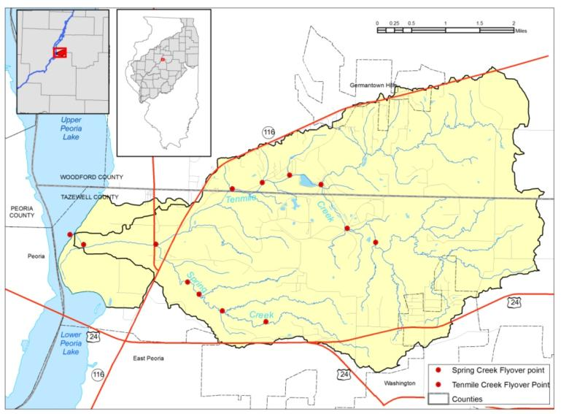

Figure 2900. Map showing the location of the aerial reconnaissance sites.

Customized geomorphologic protocols are being developed and systematically incorporated into assessment efforts by the State of Illinois (White et al., 2005). Condition of channels of Tenmile Creek mainstem, Spring Creek, Spring Creek tributary S4, and Wolf Creek were assessed using channel geomorphic protocols (Kuhnle and Simon, 2000) and habitat condition protocols (Barbour et al., 1999). Both geomorphology and habitat protocols include determination of channel evolution stage, categorization of channel stability, and characterization of current physical habitat conditions in channel and near-channel environments. These rapid watershed assessment protocols were performed to give a general overview of the state of erosion and deposition and condition of habitat in the watershed. Details of the general assessment framework are provided (White et al., 2005; White and Keefer, 2005). Details on field use of the geomorphologic and habitat protocols also are provided, and Keefer (2006) provides further details on the general use. Geomorphology and habitat protocol data were collected from stream channel segments across a large portion of the watershed (Figure 18). Several geomorphic assessment approaches were adapted and streamlined for use in Illinois streams based on geomorphic studies in the United States and applicable to the Midwest (Keefer, 2006).

Channel evolution models (CEMs) are useful for assessing the present and predicting future watershed conditions after a major channel disturbance (Simon and Hupp, 1986; USACE, 1990; Federal Interagency Working Group, 1998). Identifying channel evolution after channel disturbance and corresponding ages of evolution according to a CEM is a key element of watershed restoration planning (Federal Interagency Working Group, 1998). The spatial relationship of CEM stage to known ongoing channel disturbances (e.g., dredging, channelization, urban development, agricultural tiling, climate change, tectonic uplift, etc.) also can be used to assess potential future stream response, including potential for slope and streambank instability. The CEM context also helps with prioritizing restoration activities if modification is planned and helps match problems with appropriate solutions (Federal Interagency Working Group, 1998). Therefore, the six-stage Channel CEM developed by Simon and Hupp (1986) was used to characterize channel condition throughout the watershed. General spatial and temporal trends in channel erosion and deposition were assessed by determining CEM stage at selected reaches throughout the watershed.

The six-stage CEM was based on the original channel evolution concept of Schumm et al., 1984 (Figure 22; Table 4). Because the Simon and Hupp (1986) model was developed in sandbed streams with cohesive alluvial banks in the loess area of the Midwest, it is generally applicable to watersheds within the ILRB.

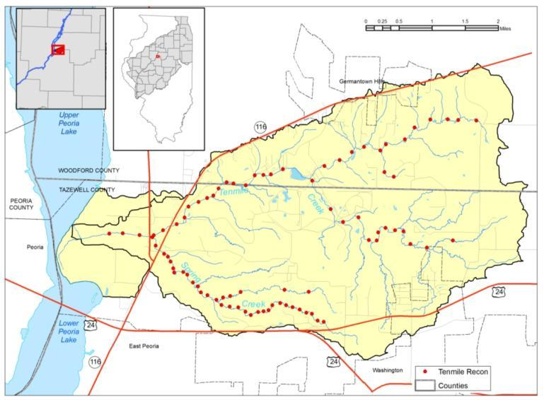

Figure 3000. Map showing the location of the ISWS field sites.

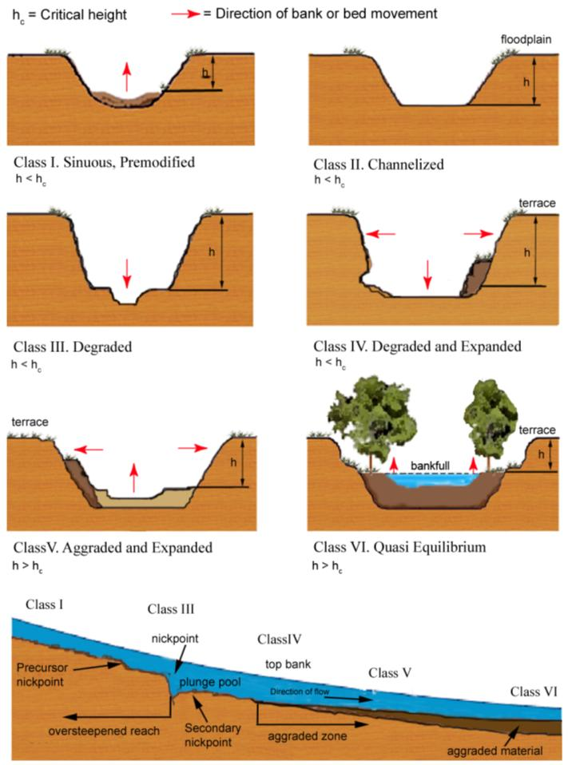

Figure 3100. Illustration of the six stages of channel evolution following disturbance from Simon (1989) Figure 5: see also USACE, 1990). “Construction Stage” can be generalized to “Disturbance Stage”

Table 7. Six Stages of Simon (1989) and Simon and Hupp (1986) Channel Evolution Model
Stage |  | Dominant Processes |  | Characteristic Forms | Geobotanical Evidence
No. | Name | Fluvial | Hillslope
I | Pre-modified | Sediment transport – mild aggradation; basal erosion on outside bends; deposition on inside bends. | - | Stable, alternate channel bars; convex top-bank shape; flow line high relative to top bank; channel straight or meandering. | Vegetated bank to flow line.
II | Constructed | - | - | Trapezoidal cross section; linear bank surfaces; flow line lower relative to top bank. | Removal of vegetation (?).
III | Degradation | Degradation; basal erosion on banks. | Pop-out failures | Heightening and steepening of banks; alternate bars eroded; flow line lower relative to top bank. | Riparian vegetation high relative to flow line and may lean towards channel.
IV | Threshold | Degradation; basal erosion on banks. | Slab, rotational and pop-out failures. | Large scallops and bank retreat; vertical-face and upper-bank surfaces; failure blocks on upper bank; some reduction in bank angles low line very low relative to top bank. | Tilted and fallen riparian vegetation.
V | Aggradation | Aggradation; development of meandering thalweg; initial deposition of alternate bars; reworking of failed material on lower banks. | Slab, rotational and pop-out failures; low-angle slides of previously failed material. | Large scallops and bank retreat; vertical face, upper bank, and slough line; flattening of bank angles; flow line low relative to top bank; development of new flood plain (?) | Tilted and fallen riparian vegetation; reestablishing vegetation on slough line; deposition of material above root collars of slough-line vegetation.
VI | Restabilization | Aggradation; further development of meandering thalweg; further deposition of alternate bars; reworking of failed material; some basal erosion on outside bends deposition of flood plain and bank surfaces. | Low-angle slides  pop-out failures near flow line. | Stable, alternate channel bars; convex-short vertical face on top bank; flattening of bank angles, development of new flood plain possible; flow line high relative to top bank. | Reestablishing vegetation extends up slough line and upper bank; deposition of material above root collars of slough-line and upper-bank vegetation; some vegetation establishing on bars.

Each channel stage and associated characteristic processes and forms are given (Table 5). The initial CEM stage (Stage I) is a pre-modified natural condition. Stage II is the channel condition resulting from initial channelization, dredging, construction, land-use change, climate change, tectonic uplift, or other major disturbance. Degradation (channel incision) after channel disturbance (Stage III) results from excess stream power initially that leads to oversteepening of banks just upstream of the disturbance. Eventually, a threshold (Stage IV) is reached in which continued oversteepening leads to excessive bank erosion and mass wasting that widen the channel and contribute increased amounts of sediment to the stream. Over time, channel widening and mass wasting proceed upstream from the location of maximum disturbance followed by aggradation and channel widening (Stage V) in reaches downstream of active mass wasting. Although channel reaches in Stage V generally trend toward increasing stability, upper portions of streambanks may continue to be unstable. The final stage (Stage VI) is development of a quasi-stable channel inset into disturbed channel valley with dimensions and capacity similar to those of the pre-disturbance channel (Simon and Downs, 1995). Elevation of the post-disturbance bankfull level is typically lower than the pre-disturbance channel, however, and the pre-disturbance floodplain forms a terrace above the new active floodplain. In other words, the existing stream channel remains disconnected from the main valley floodplain and intrinsically forces the stream to curve into a new, lower floodplain.

Table 8. Results of CEM stage and Habitat analysis

CEM  STAGE | GENERAL  STABILITY  CONDITION | DYNAMIC STYLE | BIOLOGICAL/HABITAT QUALITATIVE CONDITION
I | Stable | In  Equilibrium | Highest
II | Transitional | Stable to  Degrading | Variable
III | Unstable | Degrading | Low
IV | Unstable | Degrading | Low
V | Transitional | Stable to  Aggrading | Variable
VI | Stable | In  Equilibrium | Highest

Relatively stable reaches typically occur downstream (Stages V and VI), and less stable reaches (Stages II and III) are upstream of those classified as Stage IV (i.e., threshold stage; Federal Interagency Working Group, 1998). This progression happens because initiation of channel incision by a major disturbance or modification produces an increased gradient (e.g., headcut or knickpoint) locally that advances upstream until it meets more resistant bed and bank material or until stream energy becomes too low to support erosion of the bed due to decreased slope or discharge in upper reaches of the watershed. Examples of CEM-guided restoration strategies are using “environmentally friendly” grade control structures to stem incision in reaches identified as early Stage III, treating bank instability with structural or bioengineering approaches such as riffles and pools in Stage IV and V reaches, and maintaining, preserving, enhancing, and expanding habitats supported within Stages I and VI. Generally, Stage III and IV reaches require more intensive restoration efforts than Stage V and VI reaches. It is important, however, to identify not only the CEM stage but also to coordinate watershed restoration strategies with planned channel disturbances, including but not limited to, bridge construction, channelization, maintenance dredging, and other in-channel BMPs for mutual success in watershed restoration and infrastructure and land-use needs.

Spatial distribution of CEM stages based on the 2007-2008 field data collection campaign in Tenmile Creek are shown (Table 6?; Figure 23). Overall, the watershed has 274 miles of stream. Forty-one miles had 239 assessed segments: 94 segments (39%) in Stage V, 84 segments (35%) in Stage IV, 35 segments (15%) in Stage II, 15 segments (6%) in Stage VI, 9 segments (4%) in Stage III, and 2 segments (~1%) more clearly evolving between Stage V and Stage VI.

Most of the main channel of the Creek watershed in this study was classed as Stage V. The Creek mainstem, from its mouth at the Illinois River to a point about 22 miles upstream, had 101 assessed segments: 66 segments (65%) in Stage V, 6 segments (6%) in Stage VI, 12 segments (12%) in Stage IV, and 17 segments (17%) in Stage II. The Creek mainstem had more Stage II channel segments than any of its tributaries. There were no Stage I or Stage III segments. An 8.5-mile reach of Creek had 71 assessed segments: 38 segments (54%) in Stage IV, 16 segments (22%) in Stage V, 9 segments (13%) in Stage VI, 7 segments (10%) in Stage II, and 1 segments (~1%) in Stage III. Two segments (3%) scored between Stages V and VI, indicating morphology evolving more closely toward Stage VI. Creek, a tributary of Creek, had 30 assessed segments within a 4.5-mile reach: 19 segments (63%) in Stage IV, 6 segments (21%) in Stage III, 4 (13%) in Stage V and 1 segment (3%) in Stage II. Six miles of Creek had 37 segments assessed, including a 2-mile channelized stretch with levees on both sides of the stream channel. Creek had 15 segments (41%) in Stage IV, 10 segments (27%) in Stage V, 10 segments (27%) in Stage II, and 2 segments (5%) in Stage III. No reaches ranked as Stage I, and Creek and Creeks had no Stage VI segments. It would appear from CEM stage data alone that tributary systems feeding into the Creek mainstem are less stable overall than the mainstem so prioritizing restoration of relatively unstable segments in those tributaries should be considered. The greater slope of the landscape and higher gradient tributary streams explains, in part, the more erosive channel morphology.

iii. Channel Gradient and Channel Bed Texture
Under quasi-equilibrium conditions, channel gradients and forms adjust to imposed sediment and water loads. The energy gradient (practically approximated as channel slope) along with discharge and specific water weight determine stream power, or energy amount available to erode or transport sediment (Rhoads, 1995). An imposed change in stream gradient from channel disturbance or base-level change, can initiate bed, bank, or watershed scour, thus increasing sediment load in the stream (Bhowmik et al., 1993). When this higher sediment load is delivered to the main channel, new delta growth could be initiated unless the mainstem can continue to transport it.

Gradients of stream channels (including headwater reaches) in Creek watershed were determined by interpolating contours from topographic maps (Figures 24 and 25 and Table 7). Geomorphic and biologic field data collection occurred along approximately 41 miles of the 274 miles of channel in the watershed. (The ten longest channels are highlighted in red and black in Figure 24). Four of these channels were investigated in the field for this report: Creek (mainstem), Creek, Creek, and Creek (Figures 24 and 25). Figure 24 also shows that the gradient of Creek (0.63%, or 33.4 feet/mile) is much steeper than the gradient of the Creek mainstem (0.25%, or 13.4 feet/mile). Channel gradients range from 0.25% in the Creek mainstem to 4.9% in the case of some small tributary valleys in steeper, wooded, southern portions of the watershed. Overall, gradients were 0.02-1.0% (31 channels), 1.01-2% (82 channels), 2.01-3% (44 channels), 3.01-4% (11 channels), and 4.01-5% (4 channels) (Figure 25), see Appendix also).These gradients are steeper than most streams in Illinois but typical of direct tributaries to Peoria Pool.

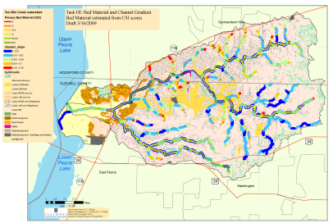

Figure 2500. Bed Material and Channel Gradient Bed Material estimated from CSI scores.

A clear downstream gradation in texture occurs within the assessed streams (Figure 26). Bed deposits above the bluff line contain more boulders and cobbles than those below the bluff line where gravels are concentrated. The Creek mainstem has a concentration of gravels above rock outcrop areas in the channelized section of the stream. Glacial diamicton, glacial stream sediment, and bedrock outcrops supply the channel with rock debris in the area above the bluff line. Exposed bedrock is mostly shale, which easily breaks down into fine sand and silt. Shale debris therefore typically occurs in the bed only up to 100 feet downstream of an outcrop. More resistant sandstone and limestone debris between County Road 950 N and the bluff line is an important coarse bed material component locally, but the drift is probably the main source of bed material of all size ranges. The relatively low slope of the channel on the Holocene Floodplain of the Illinois River (Figures 4 and 24) limits downstream transport of the coarser material, thus constraining the lowermost reach to sand and gravel and transporting silts and clays the farthest, into Goose Lake of Peoria Pool (Figure 25).

Flows in Creek probably are only rarely sufficient to transport bedload coarser than fine gravel. Those coarser bed materials provide some degree of armoring of the bed, inhibiting incision. In the middle part of the watershed, bedrock is exposed in the streambed, and incision is also relatively slow. Bedload size there is approximately one grain to two feet thick. Aggrading reaches, mainly downstream of County Road 650 E are evident by accumulation of sandbars and evidence of overbank sedimentation. By contrast, several incising reaches are evident by exposed gas pipelines (Figures 27 and 28). Sands are transported downstream to the Holocene Floodplain, some reaching the stream mouth at Peoria Lake, whereas silts and clays may be deposited on floodplains (e.g. Figure 19) or transported out of the watershed in the washload. Bed texture of Creek consists of mostly gravel in the channelized reach, which extends from approximately halfway upstream from the mouth of Creek to the bluff line (Figure 26). Gravel bed material is prevalent below the confluence of Creek and Creek; however there are also some concentrations of sand and silt in the bed.

iv. Mass Wasting
Mass wasting of high valley walls is common to many watersheds draining directly into Peoria Lake. Twenty-one (21) mass wasting sites were identified throughout assessed channel segments in Creek watershed. Field investigation along Creek identified 11 mass wasting sites that episodically contribute large amounts of glacial sediment and bedrock debris directly into the channel (Figure 29?). Six sites were along the channel of Little Creek, and five sites were along the channel of Creek. Creek did not exhibit any signs of mass wasting. Aerial photo reconnaissance indicated additional areas of mass wasting where field work was not practical because of time and budget constraints.

Mass wasting sites tend to occur where the stream impinges on upland valley walls (Figure 29?). Geologic settings are varied. For example, the stream is incised 10 feet into shale bedrock overlain by sand-and-gravel outwash and silty loess at Site A. Although the shale seems relatively resistant to vertical incision, it is clearly less resistant to lateral erosion, perhaps because bedding planes are exposed. By contrast, a 100 foot high bank comprised entirely of stiff pebbly diamicton (till) is overlain by approximately 10 feet of silt loam (loess) at Site B. Persistent erosion at the toe of the slope maintains a steep escarpment, however. In a similar geologic setting in southwestern Illinois, Straub et al. (2006) found that slope failures occurred during waning of flood flows as hydrostatic support of the base of the slope decreased.

v. Hydrologic and Sediment Transport Conditions
In a previous study, the ISWS collected 275 water samples, 32 stage samples, and made 90 discharge measurements at Benedict Bridge (Figure 30?) from October 1988 to November 1990 (Bhowmik et al., 1993). The creek was completely dry for five of the first 12 months of that project period, and average water discharge was about 6 times lower in 1989 than 1990. During the early dry period, Creek received some flow from snowmelt over frozen ground, but no significant flow until a storm in early June 1989, after which the creekbed was dry again two weeks later. Recorded stages showed extreme variability in spring 1989. Field measurements showed that the streambed was absorbing streamflow. Creek was again dry for an extended period during fall 1988 and summer 1989. Following recovery from that prolonged drought period, the creek was very flashy during storm periods, rising 10 feet or more during 3- to 4-hour periods, then dropping 8 feet within 12 hours. Over the period of record, five events occurred in which peak stage exceeded 10 feet. At these stages, discharge was nearly 10,000 cubic feet per second (cfs). The two-year average sediment load was 85,200 tons and 1,000 tons/square mile.

Because monitoring data are very limited, a sediment rating curve developed by Demissie et al. (2004) was used to estimate sediment yields. Demissie et al. (2004) reported a sediment load for Creek that was half that reported in earlier work (Bhowmik et al., 1993). Demissie et al. (2004) also estimated sediment yields from tributary streams of the Illinois River based on suspended sediment load data collected by the USGS. The duration of the sediment data ranged from one to 20 years, although most stations had records of less than five years. Because rating curves often underestimate sediment yield, Demissie et al. (2004) also developed a procedure to minimize underestimation. Annual water discharge and sediment yield of Creek estimated by this method for Water Years 1981 to Water Year 2000 are shown (Table 8).

Annual sediment yield values typically vary with log-transformed annual discharge values (Figure 31). Low-flow years 1988, 1989, and 2000 contributed the least sediment into the Illinois River valley (Demissie et al., 2004). Water Year 1993 was very wet, and average annual water discharge and sediment yield were correspondingly higher for the Illinois River valley. Intrinsic (e.g., local land use) and extrinsic (e.g., global climate change) effects on variability of flow are not clearly understood. It is known, however, that regional climate has been cooler and wetter over the past 30 years than in the first half of the 20th Century (Changnon et al., 2004). Evaluation of effects of future BMPs will require at least 5-10 years of continuous monitoring of rainfall, flow, and sediment discharge in Creek, including monitoring of initial baseline years.

vi. Changes in Stream Planform: 1939 and 1998 Comparison
Streams evolve dynamically over time in response to natural (e.g., climate and geology) and anthropogenic (e.g., land use and channel manipulation) forcings. Stream channels change their planform by eroding their banks laterally, incising the bed, and depositing sediment on floodplains and within channels. The rates and modes of these behaviors are functions of the geomorphic, hydrologic, and geologic setting.

Stream dynamics were characterized by comparing the 1939 channel planform position of and Creeks to the 1998 position using methods adapted from Phillips et al. (2002; see also Rhoads and Urban, 1997; Urban, 2000). The basic method is to compare channel centerlines digitized from aerial photographs taken at two different points in time. Because only two points were considered in this study, it is not possible to draw definitive conclusions about modes and rates of channel planform change, nor to identify process-response relationships. Instead the goal is to identify relatively active reaches with respect to planform evolution. It was possible to compare those data with channel stability data collected in the field. Observation of features such as exposed sandbars and floodplain deposits can also indicate stream behaviors. During the analysis of aerial photos, observations of land use and land cover change were noted.

Historical aerial photographs (HAPs) taken in 1939 were provided in digital (TIFF) format by the ISGS Digital Archive of Illinois Historical Aerial Photography (http://www.isgs.uiuc.edu/nsdihome/webdocs/ilhap/). Images were orthorectified to a 30 meter (m) digital elevation model (DEM) using Erdas Imagine 8.7, Leica Photogrammetry Suite. Recent (1998) imagery was obtained as digital (Mr. Sid format) orthophotographic quadrangles (DOQs) from the Illinois Natural Resources Geospatial Data Clearinghouse (http://www.isgs.uiuc.edu/nsdihome/ISGSindex.html). Stream channel centerlines were traced digitally from the 1939 and 1998 imagery using ESRI ArcGIS software. Buffers were generated in the GIS for each stream trace using respective image root-mean-square error. Areal change polygons, representing gross areal change in stream planform between 1939 and 1998, were generated by merging the pair of buffers and extracting the interstitial area.

Change polygons were divided into five dynamic behavior classes: lateral or downstream migration, avulsion, channelization, post-channelization, and chute development. Lateral or downstream migration is a natural process by which streams erode sediment from their outside banks and deposit sediment along their inside banks. Avulsion, an abrupt change in channel position, occurs when a chute develops on the floodplain during high flow and subsequently incises and captures the main flow of the stream. Chutes may also be ephemeral features that may not develop fully to an avulsed channel. Channelization is usually recognized as abrupt change in channel planform that results in a straightened channel where construction activities and an apparent advantage to expedited drainage are evident. Where avulsion, chute formation, or migration occur after a reach shows evidence of channelization, post-channelization is assigned as the dynamic class.

Preliminary results of stream dynamics analysis are given (Table 9and Figure 32). The ratio of total areal change per unit stream length is a metric of total planform change, with planform stability inversely related to magnitude. Total areal change per unit stream length was greatest (14.9 m²/mile) in the lower portion of the watershed and least in the middle portion (9.0 m²/mile) of the watershed. Most of the change not attributed to channelization occurred via lateral and downstream migration of meanders along Creek and below its confluence with Creek, with the magnitude of the changes increasing downstream (Figure 33). Both activity and downstream increase in magnitude could be due to downstream increases in valley slope, discharge, or bedload. The relatively low ratio of change to stream length (i.e., planform stability) in the middle HUC is probably partly due to bedrock control of the channel that inhibits incision and, where the stream cuts into the eastern valley wall, inhibits lateral migration. The relatively high ratio (11.6 m²/mile) in the upper HUC is attributable to channelization, the predominant mode of channel planform change there (Figure 34). Channelization was a relatively small portion of total change further downstream. Only two observations of planform change following channelization were identified, and those were in the lower watershed where observations of extensive meander migration suggest relatively high intrinsic change. Long-term stability of channelized reaches could be due to low stream power in the upper watershed because of low channel slope there, regular maintenance of straightened reaches, or limitations in discerning changes because of the imagery scale or limited temporal resolution. Field observations of active slumping and use of riprap and fill to stabilize banks along part of the channelized reach near County Road 1050 N (Figure 19) suggest that channel widening or deepening is occurring, phenomena not observable from imagery used.
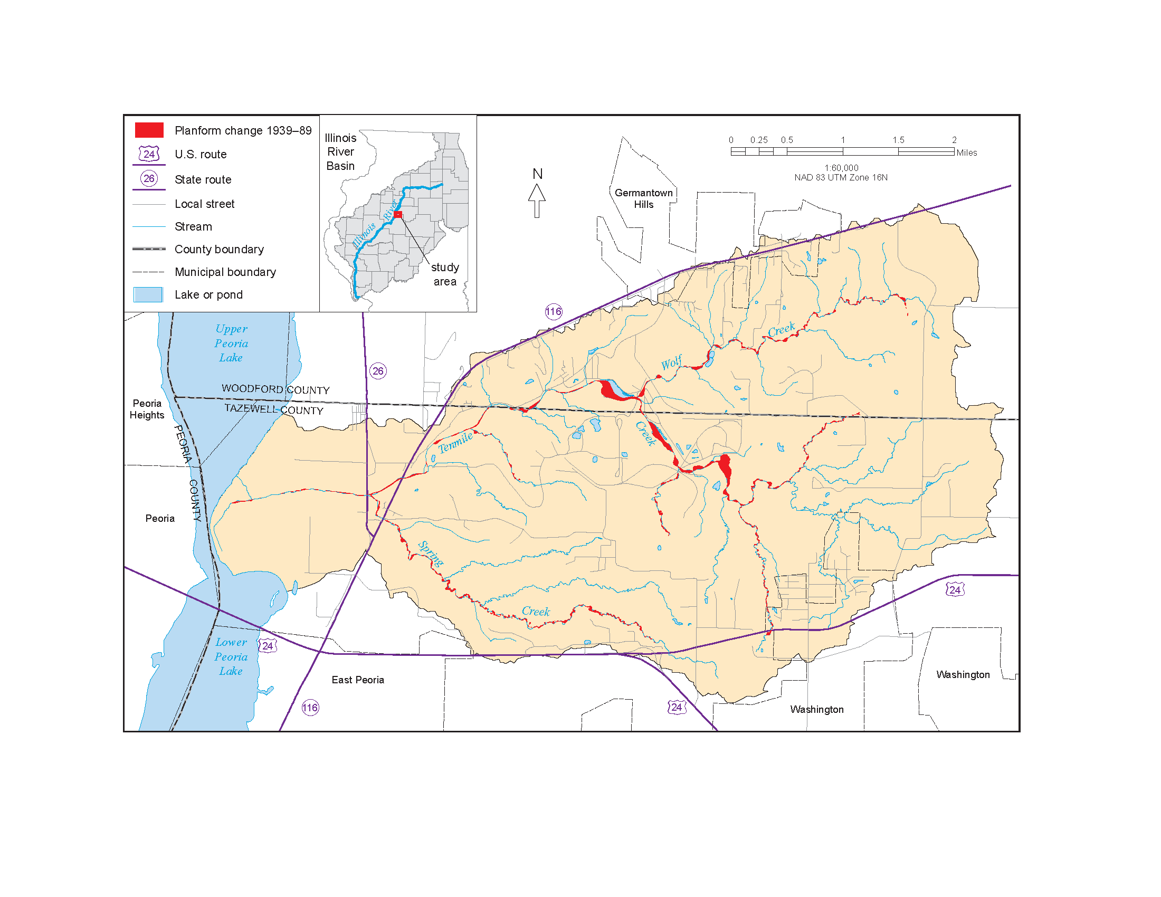

Figure 2800. Net areal change in planform of Ten Mile, Spring, and Wolf Creeks based on analysis of orthorectified airphotos from 1939 and 1989.

This stream dynamics aspect of this report characterizes dominant modes and relative activity of stream planform change through the watershed. At this level of study, it cannot be determine if observed changes are in stasis or if they are progressive. However, correlations between areas of planform change and habitat, landscape erosion, channel form, and sediment delivery are strong. The planform analysis and field investigations of channel geomorphology provide corroborating evidence that projects intended to reduce sediment transport should be targeted to lower reaches of the Creek mainstem. Relative effects of slope, discharge, and geology (erodibility of channel banks and substrate, and bedload availability) must be distinguished more clearly for project design to proceed. Geomorphic field data collection and analysis of channel gradients also suggest potential projects in tributaries (Creeks) to the Creek mainstem.

It is important to reiterate that correlations between landscape or channel change and stream response are tentative. More comprehensive analyses of stream dynamics are necessary for individual project design and implementation. In particular, stream response cannot be determined after direct modification of stream channels (channelization) or other identifiable land-use changes. Only net rates of planform evolution can be estimated; and actual rates may be significantly higher. Understanding these responses is important for predicting long-term viability of stream restoration projects. Greater understanding could come from examining imagery of intervening years and estimating long-term and synoptic trends in stream power.

vii. Channel Stability and Habitat Integrity
Stage I and Stage VI channels of the CEM generally indicate relative stability and, therefore physical habitat is expected to be abundant and, barring other negative influences, support relatively high-quality ecosystems (Table 4; Figure 22 [change to FIWG fig, as above]) (see also Simon, 1989; USACE, 1990; and Federal Interagency Working Group, 1998). The CEM classifications determined in the field in Creek watershed generally correlate well with channel stability indices (Figure 35), except where mass wasting modifies local channel conditions or bedrock is exposed in the channel bed. Significant autocorrelation between CEM stage and channel stability indices is expected because CEM stage is a parameter in the stability ranking scheme, and the two indices share some common parameters such as bed material and channel configuration. Channel stability scores greater than 20 generally have been interpreted to indicate dynamically stable channel conditions, scores of 11-19 indicate transitional conditions, and scores of 10 and under indicate unstable conditions (L. Keefer, ISWS, Personal Communication, 2004) (Figure 36).
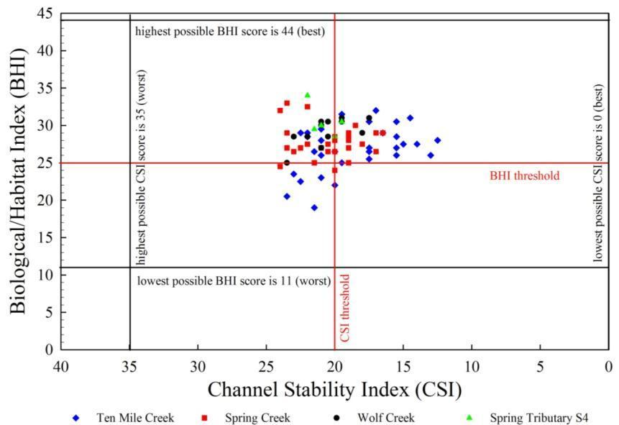

Figure 4500. Stream rankings of the CSI and BHI in the Tenmile Creek watershed

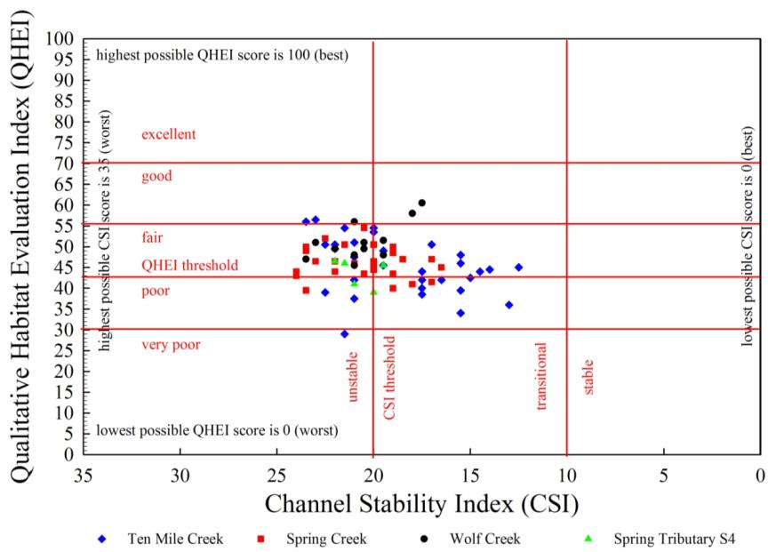

Figure 4600. Stream rankings of the QHEI and CSI in the Tenmile Creek watershed

In Creek, however, the metrics do not always correlate. A wide range of sediment textural classes comprise the bed material in Stage IV, V, and VI channels in this watershed. For example, Stage IV channels already have degraded and widened to a new state of dynamic stability (Channel Stability Index <10-15) and often occur where there are large sediment loadings from mass wasting of high valley walls, as well as where sediment loadings are low because bedrock inhibits channel incision and channel banks are relatively low (insets in Figure 35). Poor correlation between stage and stability indices generally can be explained by recognizing other influencing factors such as bedrock exposure, mass wasting, etc.

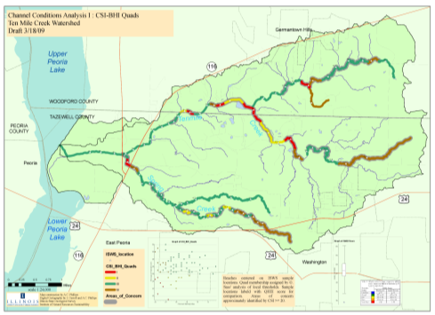

Figure 6200. Channel Condition Analysis CSI, BHI Quads

Ecosystem health can be assessed by compiling metrics tuned to assessment goals. Shields et al. (1998), for example, showed that fish species populations vary with stages of channel evolution in the loess hills of Mississippi. Such a comprehensive analysis of biological indices and their correlation to CEM stage is beyond the scope of this assessment, however. Rather, ecological quality of physical habitat was evaluated by using a ranking scheme developed by Barbour et al. (1999). The metrics are similar to the Quality Habitat Evaluation Index (QHEI) method (OEPA, 1987), although simplified. Habitat scores from Barbour et al. (1999) can range from a low of 11 to a high of 44, with higher scores indicating better habitat (Figure 36). Where Stage VI channel segments occur in the CEM, habitat ranks are generally higher. By contrast, where Stage IV channel reaches occur, habitat ranks are generally lower unless some other influencing factor modifies the channel segment and its habitat. No statistical analysis has been performed yet on these data because detailed biotic information is lacking. For example, actual fishery and macroinvertebrate data are scarce for this watershed; therefore, these parameters were not examined in relation to stage of channel evolution or habitat indices. Currently, the authors suggest using a habitat score of 25 as a general “working” boundary to delineate between good and poor habitat areas in the Creek watershed (Figure 35). Additional data may suggest adjusting that threshold score up or down for this watershed.

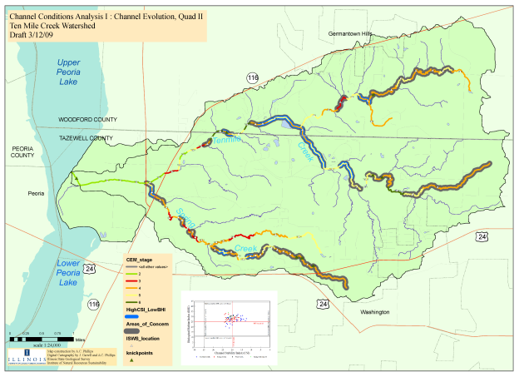

Figure 6300. Channel Condition Analysis Channel Evolution, Quad II

Physical habitat indices (Barbour et al., 1999) generally correlate well with CEM stages and with channel stability indices (Figure 35). As noted above, however, these correlations are not always as clear because singular influences such as large pools formed by beaver dams or large woody debris control channel forms locally. On occasion when large pools were formed recently, channel segments with Stage IV channel forms also had relatively high habitat indices.

Preliminary field data from the Tenmile Creek mainstem

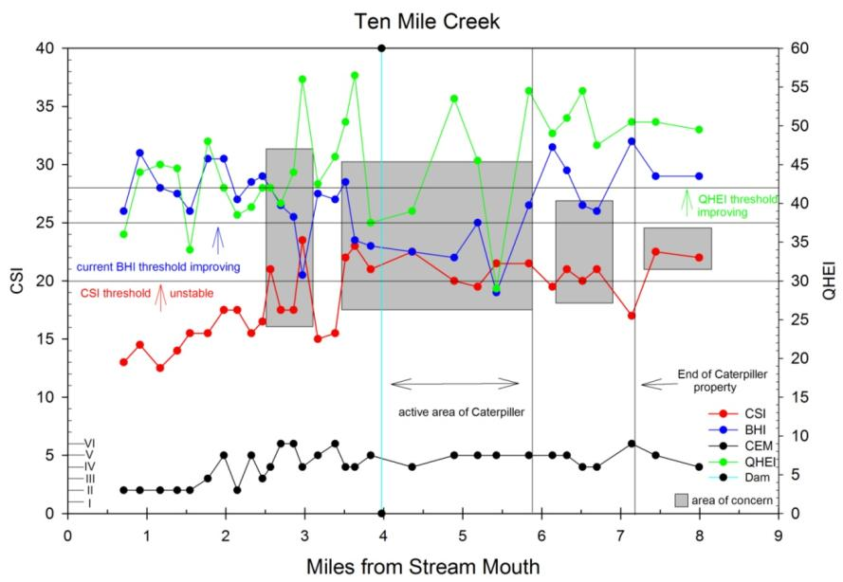

Preliminary field data from Spring Creek (Figure 39

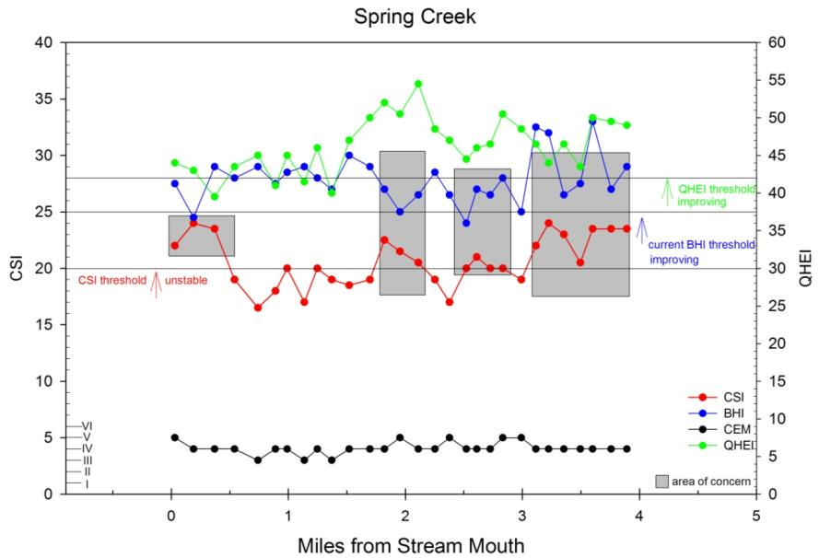

Preliminary field data from Spring Creek tributary (S4) (Figure 40

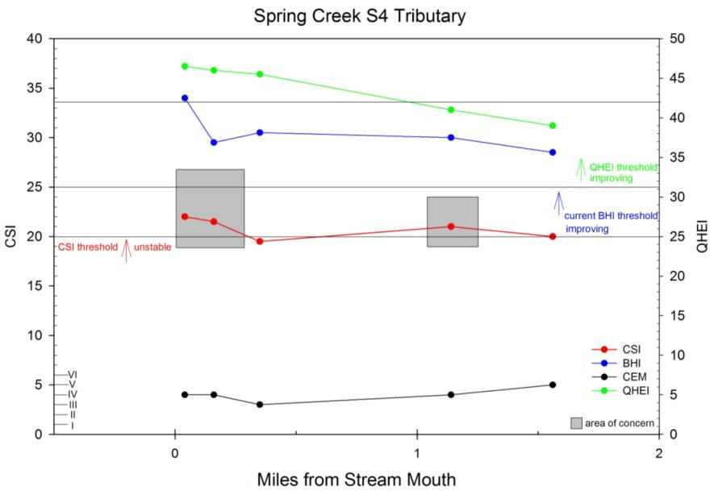

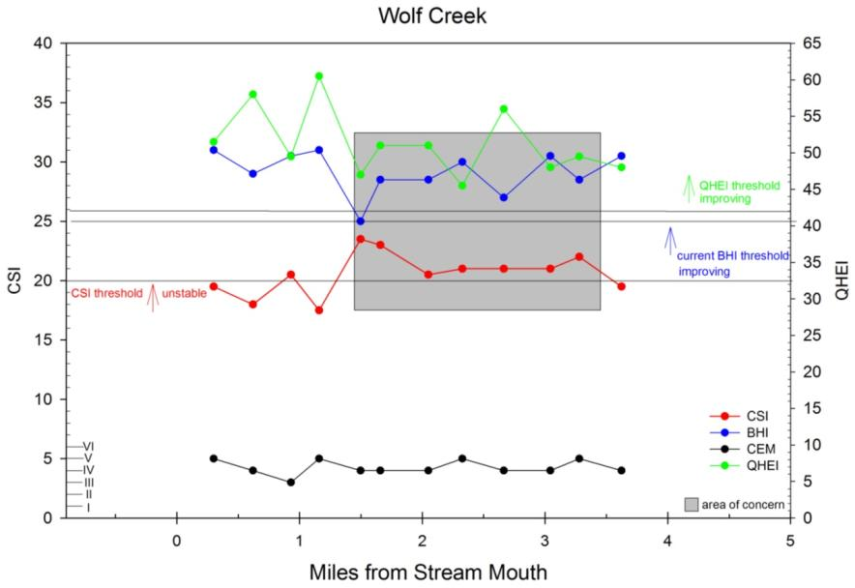
Preliminary field data from Wolf Creek (Figure 41).

viii. Water Quality
Existing water quality datasets are generalized and not specific to TenmileCreek and its tributaries. The IEPA (2004) assessed Creek as having fully attained its designated use in the aquatic life category based on waterbody-specific monitoring data. Tributaries of Creek, including Creek, Creek, Creek, Creek, Creek, were listed in that report but were not assessed.

Many NPS control projects have been implemented in watershed with funding made available through Section 319 of the CWA. Any BMPs implemented under Phase II of the Creek watershed Project were estimated to have reduced sediment load in Creek by 8507 tons/year, phosphorus by 1767 pounds/year, and nitrogen by 14,073 pounds/year (IEPA, 2006b).
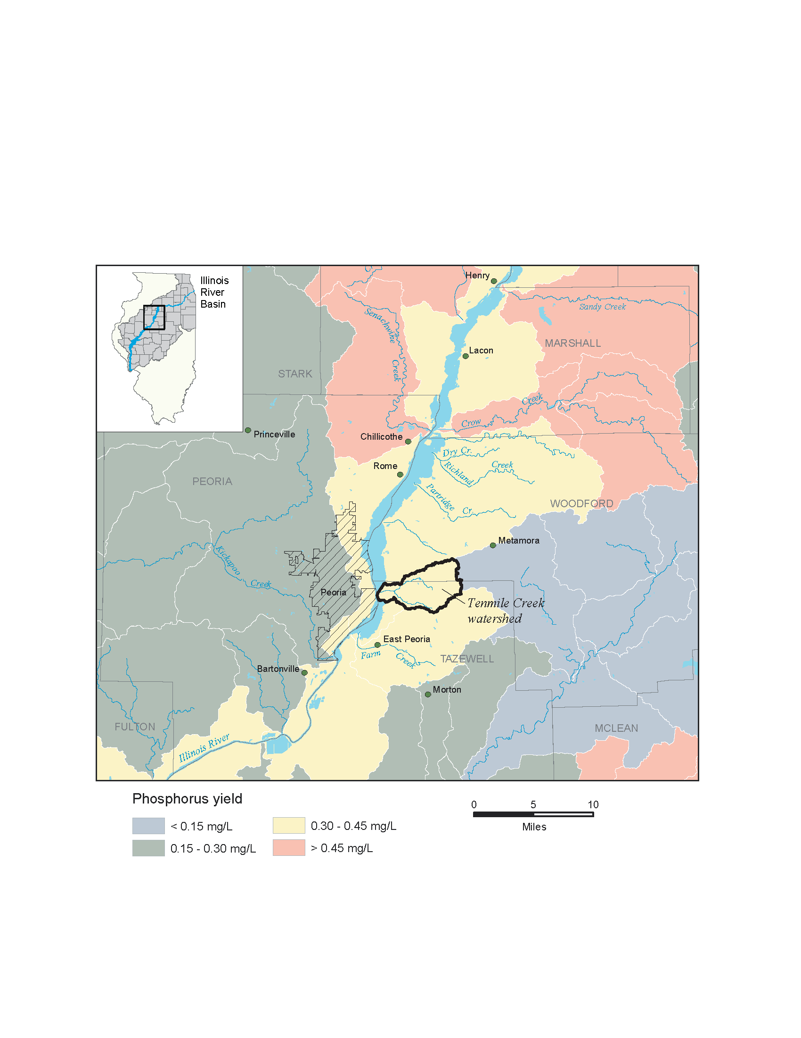

Figure 3500. Estimated phosphorous Yield in Ten Mile Creek watershed (Illinois EPA, 1999).

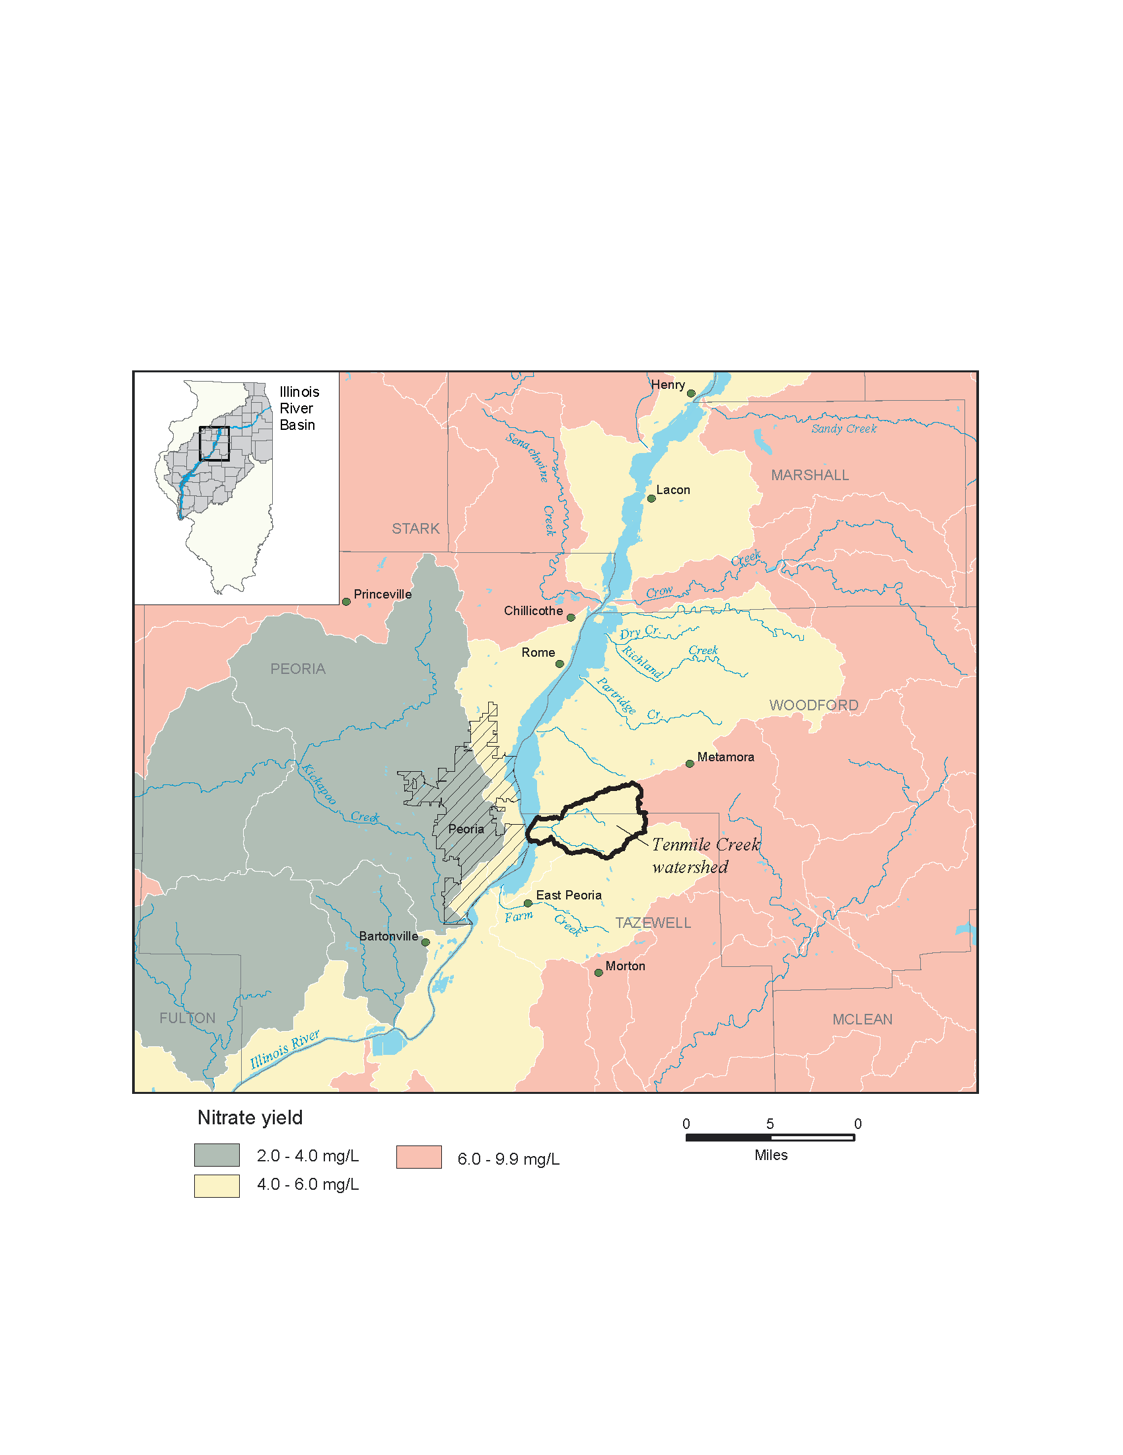

Figure 3600. Estimated nitrate yield in Ten Mile Creek watershed (Illinois EPA, 1999).

The IEPA (2000) classed watershed among those having the highest nutrient yields in Illinois, with total nitrate levels in watershed of 6.0-9.9 milligrams per liter (mg/L) and phosphorous levels >4.5 mg/L (Figures 42 and 43). These values are based on regional studies of similar watersheds. Measurements of nitrate concentrations at the mouths of agricultural watersheds during spring and fall field applications were low (x mg/L). During the low-flow period of late summer, nitrate concentrations were below detection limits. Contributions of Creek to the nitrate and phosphate load of the Illinois River were negligible compared to those of the metropolitan Chicago area (K. Hackley, USEPA, Personal Communication, 2006).

6. Biotic Environment
a. Terrestrial Habitat
Reptiles

Potential species richness of reptiles in the Ten Mile Creek watershed according to GAP data was high in almost all areas adjacent to the creek and its tributaries. Reptile species richness was greater, more contiguous, and more evenly distributed spatially in the Ten Mile Creek watershed compared to the Senachwine Creek watershed suggesting more suitable habitat conditions within the Ten Mile Creek watershed. The overall probability of species richness was higher for the Ten Mile Creek watershed (maximum = 30 species) than the Senachwine Creek watershed (maximum = 26 species).

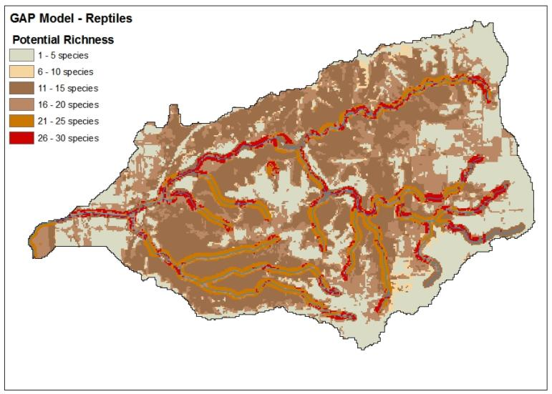

Figure 100 Map showing the Potential Richness of Reptiles based on GAP Data.

Summer Birds

Potential species richness of summer birds in the Ten Mile Creek watershed according to GAP data was high in almost all areas adjacent to the creek and its tributaries. Summer bird species richness was greater, yet variable, and more evenly distributed spatially in the Ten Mile Creek watershed compared to the Senachwine Creek watershed suggesting more suitable habitat conditions within the Ten Mile Creek watershed. The overall probability of species richness was lower for the Ten Mile Creek watershed (maximum = 62 species) than the Senachwine Creek watershed (maximum = 64 species).

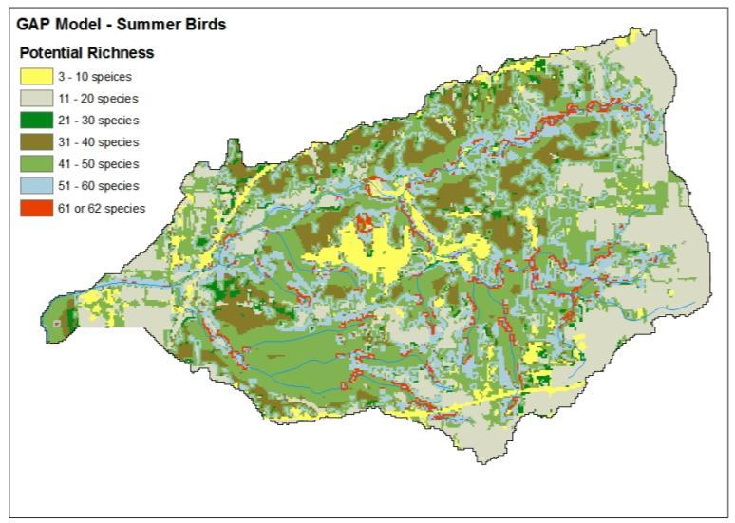

Figure 200 Map showing the Potential Richness of Summer Birds based on GAP Data.

Mammals

Potential species richness of mammals in the Ten Mile Creek watershed according to GAP data was high in almost all areas adjacent to the creek and its tributaries. Mammal species richness was greater and more evenly distributed spatially in the Ten Mile Creek watershed compared to the Senachwine Creek watershed suggesting more suitable habitat conditions within the Ten Mile Creek watershed. The overall probability of species richness was higher for the Ten Mile Creek watershed (maximum = 28 species) than the Senachwine Creek watershed (maximum = 27 species).

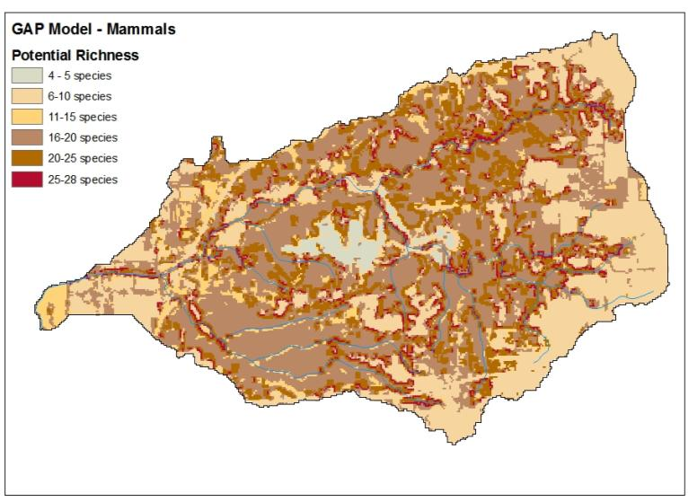

Figure 300 Map showing the Potential Richness of Mammals based on GAP Data.

Wildlife Restoration Priorities in the Ten Mile Creek Watershed

Similar to Senachwine Creek, combinations of GAP data for wildlife and hydrologic and geological data allowed for the development of composite scores to rank wildlife restoration priorities. We created an index of wildlife restoration priorities for 78 sites within the Ten Mile Creek watershed. Briefly, each location was given a score based upon amphibian, reptile, summer bird, and mammal species richness. Taxa-specific scores ranged from 1 (lowest categorical species richness) to 7 (highest categorical species richness for summer birds). Index scores could range from a minimum of 4 (lowest overall species richness) to 22 (maximum overall species richness). We used the 25th, 50th, and 75th percentiles of the composite score data to define restoration priorities. Composite scores ranged from 11.5 – 21 across the 78 sites. The 25th, 50th, and 75th percentiles were composite scores of 16, 18, and 20. Composites scores ≤ 16 were defined as high restoration priority, composite scores of 16 ≥ 18 were defined as intermediate-high restoration priority, scores of 18 ≥ 20 were considered intermediate-low restoration priority, and scores > 20 were considered low priority restoration sites. Thirty-one percent of the sites were considered high priority, 22% were considered intermediate-high priority, 27% were considered intermediate low priority, and the remaining 20% of the sites were considered low priority for restoration based upon wildlife species richness.

Table 600. Hydrologic, geologic, and wildlife species richness characteristics for 78 sites sampled in the Ten Mile Creek watershed. Number range under the wildlife categories signifies species richness. The composite score was based on an index that summarized species richness for each site across all four wildlife taxa. CSI = channel stability index (E = Excellent, G = Good, F = Fair, P = poor), BHI = biotic habitat index, CEM = channel evolution model, Amph. = amphibian, Rept. = reptile, Mamm. = mammal, and Comp. = index composite score. Priority was defined as high = H, intermediate-high = I-H, intermediate-low = I-L, and low = L.

Site | CSI | BHI | CEM | Amph. | Rept. | Bird | Mamm. | Comp. | Priority
1 | E | 1(0,0) | 2 | 9-14 | 21-25 | 51-62 | 20-28 | 20 | I-L
2 | E | 4(1,0) | 2 | 9-14 | 21-25 | 51-60 | 20-25 | 19 | I-L
3 | E | 4(1,0) | 2 | 9-14 | 21-25 | 51-60 | 20-25 | 19 | I-L
4 | F | 4(1,1) | 5 | 9-14 | 16-20 | 41-50 | 16-20 | 16 | I-H
5 | E | 3(1,1) | 2 | 5-8 | 21-25 | 41-50 | 11-20 | 15.5 | H
6 | E | 3(1,1) | 2 | 5-8 | 21-30 | 41-50 | 11-20 | 16 | I-H
7 | E | 3(0,1) | 3 | 9-14 | 21-25 | 51-60 | 20-25 | 19 | I-L
8 | G | 4(0,0) | 5 | 9-14 | 26-30 | 41-50 | 16-20 | 18 | I-L
9 | G | 4(1,1) | 2 | 9-14 | 21-30 | 51-62 | 20-28 | 20.5 | L
10 | E | 4(0,0) | 5 | 9-14 | 21-30 | 51-62 | 20-28 | 20.5 | L
11 | E | 4(0,1) | 3 | 9-14 | 26-30 | 41-50 | 16-20 | 18 | I-L
12 | F | 4(2,0) | 4 | 9-14 | 16-25 | 41-50 | 11-20 | 16 | I-H
13 | G | 4(1,1) | 6 | 9-14 | 16-25 | 41-50 | 11-20 | 16 | I-H
14 | G | 4(1,1) | 6 | 9-14 | 21-30 | 51-60 | 20-25 | 19.5 | I-L
15 | P | 3(1,1) | 4 | 5-14 | 21-25 | 3-20 | 6-15 | 11.5 | H
16 | E | 4(1,0) | 5 | 9-14 | 26-30 | 51-60 | 20-28 | 20.5 | L
17 | E | 4(1,1) | 6 | 9-14 | 21-25 | 41-50 | 16-20 | 17 | I-H
18 | F | 4(1,1) | 4 | 5-8 | 21-25 | 41-60 | 11-20 | 16 | I-H
19 | P | 4(1,1) | 4 | 9-14 | 21-25 | 51-60 | 16-25 | 18.5 | I-L
20 | F | 4(1,1) | 5 | 9-14 | 21-30 | 51-60 | 6-10 | 16.5 | I-H
21 | P | 3(2,1) | 4 | 9-14 | 21-25 | 3-20 | 11-15 | 12.5 | H
22 | G | 4(1,1) | 5 | 5-14 | 16-20 | 51-60 | 16-20 | 16.5 | I-H
23 | G | 4(1,1) | 4 | 9-14 | 16-25 | 51-60 | 20-28 | 19 | I-L
24 | F | 4(1,1) | 3 | 9-14 | 21-30 | 51-62 | 20-28 | 20.5 | L
25 | G | 1(1,1) | 5 | 9-14 | 26-30 | 51-60 | 20-28 | 20.5 | L
26 | P | 4(1,1) | 4 | 5-8 | 26-30 | 41-60 | 16-25 | 18 | I-L
27 | P | 4(1,1) | 4 | 9-14 | 21-30 | 51-62 | 20-28 | 20.5 | L
28 | F | 4(1,1) | 4 | 9-14 | 21-30 | 51-62 | 20-28 | 20.5 | L
29 | F | 4(1,1) | 5 | 9-14 | 21-30 | 51-60 | 20-25 | 19.5 | I-L
30 | F | 4(1,1) | 4 | 9-14 | 21-30 | 61-62 | 20-28 | 21 | L
31 | F | 4(1,1) | 4 | 9-14 | 21-25 | 51-60 | 16-20 | 18 | I-L
32 | F | 4(1,1) | 5 | 9-14 | 16-20 | 51-60 | 11-20 | 16.5 | I-H
33 | G | 4(1,1) | 4 | 9-14 | 21-30 | 51-62 | 20-28 | 20.5 | L
34 | P | 4(1,1) | 4 | 5-14 | 11-20 | 21-40 | 11-20 | 13 | H
35 | G | 4(1,1) | 5 | 9-14 | 21-25 | 51-60 | 20-25 | 19 | I-L
36 | G | 4(1,1) | 5 | 5-8 | 16-25 | 11-30 | 11-20 | 12.5 | H
37 | F | 3(1,1) | 5 | 5-8 | 16-25 | 21-40 | 11-20 | 13.5 | H
38 | F | 4(1,1) | 5 | 5-14 | 21-30 | 51-62 | 20-28 | 20 | I-L
39 | G | 3(1,1) | 5 | 9-14 | 21-30 | 51-60 | 20-28 | 20 | I-L
40 | F | 4(1,1) | 5 | 9-14 | 21-25 | 51-60 | 20-28 | 19.5 | I-L
41 | G | 3(1,1) | 5 | 9-14 | 21-25 | 41-50 | 11-20 | 16.5 | I-H
42 | F | 4(1,2) | 4 | 9-14 | 21-30 | 51-62 | 20-28 | 20.5 | L
43 | E | 3(1,1) | 6 | 9-14 | 26-30 | 51-60 | 20-28 | 20.5 | L
44 | P | 4(1,2) | 5 | 9-14 | 21-25 | 51-60 | 20-25 | 19 | I-L
45 | F | 4(1,1) | 4 | 9-14 | 21-25 | 51-60 | 20-25 | 19 | I-L
46 | P | 4(1,1) | 4 | 9-14 | 21-25 | 41-50 | 11-20 | 16.5 | I-H
47 | P | 4(1,1) | 4 | 9-14 | 11-20 | 41-50 | 20-25 | 16.5 | I-H
48 | G | 4(1,1) | 4 | 9-14 | 21-25 | 41-50 | 16.20 | 17 | I-H
49 | E | 4(1,1) | 3 | 9-14 | 21-25 | 51-60 | 16-20 | 18 | I-L
50 | G | 4(1,1) | 4 | 9-14 | 21-30 | 51-62 | 20-28 | 20.5 | L
51 | G | 4(1,2) | 4 | 5-14 | 21-30 | 51-62 | 20-28 | 20 | I-L
52 | E | 4(1,1) | 3 | 9-14 | 21-30 | 51-62 | 20-28 | 20.5 | L
53 | G | 3(1,1) | 4 | 9-14 | 21-25 | 51-62 | 20-25 | 19.5 | I-L
54 | G | 3(1,1) | 3 | 9-14 | 21-25 | 51-62 | 20-25 | 19.5 | I-L
55 | G | 4(2,1) | 4 | 9-14 | 16-25 | 41-50 | 11-20 | 16 | I-H
56 | G | 4(1,1) | 4 | 9-14 | 16-25 | 41-50 | 11-20 | 16 | I-H
57 | F | 4(1,1) | 4 | 9-14 | 16-25 | 41-50 | 11-20 | 16 | I-H
58 | F | 4(1,1) | 4 | 9-14 | 16-25 | 41-50 | 11-20 | 16 | I-H
59 | G | 4(2,1) | 3 | 9-14 | 16-25 | 21-30 | 11-20 | 14 | H
60 | P | 3(2,1) | 4 | 9-14 | 16-25 | 41-50 | 11-20 | 16 | I-H
61 | F | 2(1,2) | 5 | 9-14 | 16-25 | 41-50 | 11-20 | 16 | I-H
62 | F | 2(1,2) | 5 | 9-14 | 16-25 | 41-50 | 11-20 | 16 | I-H
63 | G | 3(1,1) | 4 | 9-14 | 16-25 | 41-50 | 11-20 | 16 | I-H
64 | E | 1(1,1) | 5 | 9-14 | 16-25 | 41-50 | 11-20 | 16 | I-H
65 | G | 2(1,1) | 4 | 9-14 | 16-25 | 41-50 | 11-20 | 16 | I-H
66 | F | 4(1,2) | 4 | 9-14 | 16-25 | 41-50 | 11-20 | 16 | I-H
67 | G | 4(1,2) | 4 | 9-14 | 26-30 | 51-62 | 20-28 | 21 | L
68 | G | 4(1,2) | 5 | 9-14 | 21-30 | 51-62 | 20-28 | 20.5 | L
69 | F | 4(1,1) | 4 | 9-14 | 21-30 | 51-60 | 20-25 | 19.5 | I-L
70 | G | 3(1,2) | 5 | 9-14 | 21-25 | 41-50 | 16-20 | 17 | I-H
71 | F | 4(1,1) | 4 | 9-14 | 21-25 | 41-50 | 16-20 | 17 | I-H
72 | P | 3(1,1) | 4 | 9-14 | 21-25 | 41-50 | 11-20 | 16.5 | I-H
73 | P | 2(2,1) | 4 | 9-14 | 21-25 | 41-50 | 16-20 | 17 | I-H
74 | F | 3(1,1) | 4 | 9-14 | 21-30 | 51-62 | 20-25 | 20 | I-L
75 | P | 4(1,1) | 4 | 9-14 | 21-30 | 51-60 | 20-25 | 19.5 | I-L
76 | P | 3(1,1) | 4 | 9-14 | 21-30 | 51-60 | 20-25 | 19.5 | I-L
77 | P | 3(1,1) | 4 | 9-14 | 21-30 | 61-62 | 20-28 | 21 | L
78 | G | 4(1,1) | 5 | 9-14 | 16-25 | 41-50 | 11-20 | 16 | I-H

[Figures 44, 45, 46, 47 and 48]
Address T&E criteria from Table 1
Discuss threats to Ecological integrity (per Table 1)
b. Wetlands
Soils classed as “hydric” have properties that show they are, or were once, wetlands. Figure 49 shows soil map units within the watershed that are considered to have hydric properties throughout (Soil Survey Staff, 2005a, 2005b). These areas have potential for wetland recreation or restoration to achieve ecosystem restoration goals, including sediment runoff reduction, improved wetland quality, and flood control. Hydric soils cover about 14% of the watershed and range in size from 0.04 to 640 acres, although the median size is 5.8 acres. Peoria County also has soil map units with small inclusions of hydric soils, less than 0.3 acres each, and thus are assumed to be unlikely sites for wetland projects.

Existing wetlands were interpreted for the land cover map (nominal 1:100,000 scale) of Figure 10 (IL-GAP. 2001). These areas are independent of the National Wetlands Inventory or NWI (nominal 1:24,000 scale). Although their accuracy is low and the scale is relatively coarse, IL-GAP data are preferred over NWI data because aerial imagery source data were 25 years newer, fluctuating water regimes were characterized, and results do not suffer from the digitization error inherent in the NWI creation (D. Luman, ISGS, Personal Communication, 2006). The wetland land cover class occurs over about 2% of the watershed across uplands and floodplains in the very lowest portion of HUC 071300011401, and across HUC 071300011402 and 071300011403.

Clearly, the largest area of hydric soils is in the glacial lake plain of HUC 071300011401 (Figure 49). This is also the one region where no wetland landcover class occurs (Figure 10). July 1939 aerial photography showed the northern tributary as partly ditched and tiled, but the main stream appeared to be strongly meandering and free flowing (Figure 50). By 1988, however, both the mainstem within the glacial lake plain and northern tributary were almost completely altered.
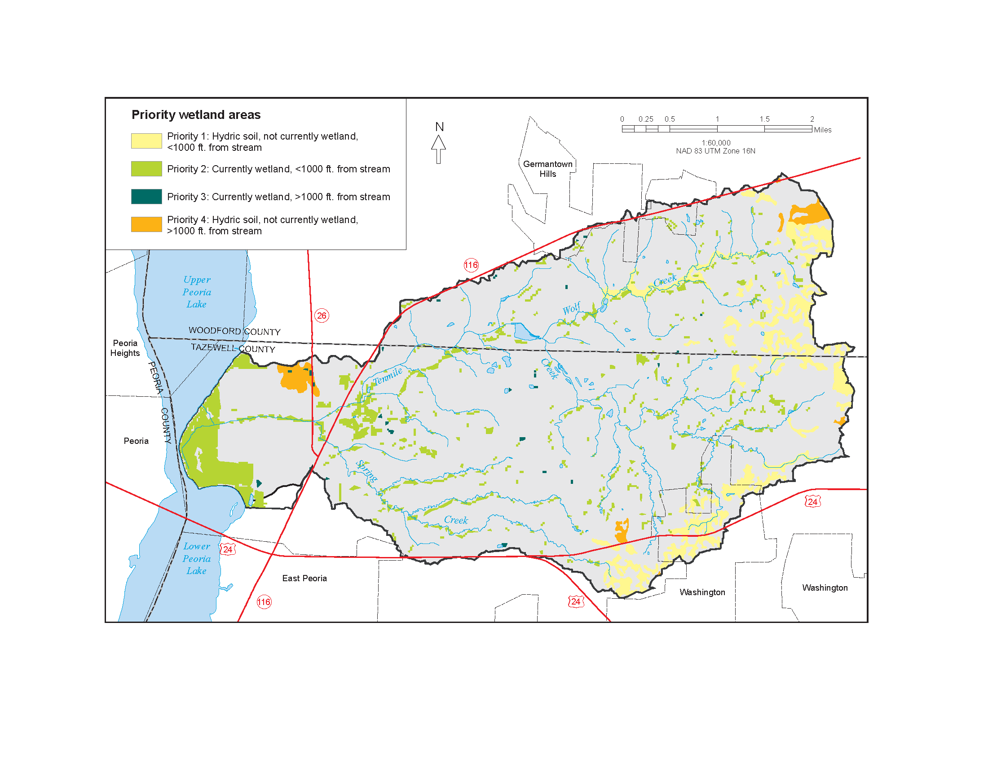
Figure 2315. Priority wetland areas in the Tenmile Creek watershed.

To prioritize areas for potential wetland restoration projects, proximity to main stream courses and existing wetlands were considered (Figure 49). Areas within 1000 feet of a stream were ranked higher because of the project focus on stream corridors. Present wetlands could be used in two different ways. On one hand, an existing wetland could be considered highly valuable as the start of a more extensive wetland because wetland function already exists that may be easier for projects to enhance than to create or restore an area with no wetland function. On the other hand, it may be more valuable to distribute wetland function more widely across the watershed; if so, areas where wetlands do not presently occur should be prioritized. The latter was chosen for illustrative purposes. Thus, Priority 1 wetlands are those areas not presently wetland and within 1000 feet of a major stream channel; Priority 2 wetlands are those that have one or more wetlands (IL-GAP, 2001) and are within 1000 feet of a major stream channel; and Priority 3 wetlands are those wetlands more than 1000 feet from a stream channel (Table 10). Areas with hydric soils but no existing wetlands and more than 1000 feet from a stream channel were classed as Priority 4. Nearly all of the soils classed as Priority 1 are poorly drained (Soil Survey Staff 2005a, 2005b), which may have implications for project goals, design, and long-term success.

c. Aquatic Habitat
A Biological Stream Characterization (BSC) Work Group was convened to develop a statewide biological classification of Illinois streams in 1984. The first BSC report, published as Special Report No. 13 of the State Water Plan Task Force (Hite and Bertrand, 1989), provided a map of streams rated and described the process and criteria for developing BSC ratings. The BSC report was developed as an aquatic resource management tool. Criteria used to identify streams or stream segments were based primarily on the fish community as enumerated by the Index of Biotic Integrity (IBI). The 12-metric IBI encompasses trophic composition, abundance, and condition of the fish community (Karr et al., 1986). The IBI scoring system was adjusted to reflect regional differences and stream size (Hite and Bertrand, 1989). Resulting scores ranged from 12 to 60, with higher scores reflecting a fish community characteristic of a system with little human influence and lower scores for a fish community that departs significantly from the reference condition.

When qualitative stream fish data were unavailable, BSC scores were derived from subjective evaluation of fishery information or macroinvertebrate community data. The Macroinvertebrate Biotic Index (MBI) used for this BSC is a modification of a biotic index developed in Wisconsin (Hilsenhoff, 1982). Tolerance values assigned to each taxon and relative abundance of those taxa in the sample are summed to achieve a 0-11 scale, where low values indicate good water quality and high values, degraded water quality (Hite and Bertrand, 1989). The MBI primarily was used to rate poor (Class D) and very poor (Class E) streams (Bertrand et al., 1993; Table 11).

The BSC objectives were to inventory the nature, extent, and distribution of Illinois stream resources and to identify stream segments of exceptional quality that warrant special consideration for protection. A five-tiered classification system was developed, and streams were ranked into categories (Table 11).

The Creek mainstem was classified as a Class B stream (Bertrand et al., 1993; Figure 17). Those highly valued aquatic resources are characterized as good fishery for important gamefish species even though species richness may be moderately below expectations for the size of the stream or geographic region. Smaller tributary streams to Creek were not rated because of lack of data.

Aquatic macroinvertebrates of Ten Mile Creek

A 2003 aquatic macroinvertebrate survey of Ten Mile Creek suggested high species richness and diversity compared to other tributaries to the Illinois River. In the 2003 survey, 30 species were collected with a Shannon-Wiener diversity index score of 2.14. The Nature Conservancy noted higher diversity of mayflies and caddisflies compared to Partridge or Ackerman creeks. Species richness was intermediate at Ten Mile Creek (30) compared to Partridge Creek (34) and Ackerman Creek (22). Aquatic macroinvertebrate species diversity was also intermediate at Ten Mile Creek (2.14). Species diversity was 2.59 for Partridge Creek and 1.62 for Ackerman Creek. The Nature Conservancy suggested that aquatic macroinvertebrates may be negatively influenced in the upper and middle portions of the creek by urbanization, high pesticide runoff, hydrologic variability, and in-stream mining. Mayfly taxa collected were considered ecologically tolerant to organic pollution and low dissolved oxygen (i.e. Hydropsychidae, Baetidae, Caenidae). The results of the aquatic macroinvertebrate collection in 2003, in accordance with fish collections, suggest that Ten Mile Creek is intermediate in habitat quality for aquatic organisms compared to other local tributaries to the Illinois River.

Mussel community of Tazewell County, Illinois

Freshwater mussels comprise one of the most endangered taxa on earth. Thirty-two mussel species have been collected in Tazewell County, Illinois. The status of the mussel community in Ten Mile Creek is unknown.

Table 100. Common and scientific name of mussels collected in Tazewell County, Illinois by the Illinois Natural History Survey, 1947-1998.

Common name | Scientific name
Elktoe | Alasmidonta marginata
cylindrical papershell | Anodontoides ferussacianus
rock-pocketbook | Arcidens confragosus
white heelsplitter | Lasmigona complanata
creek heelsplitter | Lasmigona compressa
fluted-shell | Lasmigona costata
giant floater | Pyganodon grandis
squawfoot | Strophitus undulates
paper pondshell | Utterbackia imbecilis
threeridge | Amblema plicata
Spike | Elliptio dilatata
Wabash pigtoe | Fusconaia flava
washboard | Megalonaias nervosa
round pigtoe | Pleurobema sintoxia
pimpleback | Quadrula pustulosa
mapleleaf | Quadrula quadrula
pistolgrip | Tritogonia verrucosa
mucket | Actinonaias ligamentina
plain pocketbook | Lampsilis cardium
fatmucket | Lampsilis siliquoidea
yellow sandshell | Lampsilis teres
fragile papershell | Leptodea fragilis
black sandshell | Ligumia recta
pink heelsplitter | Potamilus alatus
pink papershell | Potamilus ohiensis
Lilliput | Toxolasma parvus
fawnsfoot | Truncilla donaciformis
deertoe | Truncilla truncata
Ellipse | Venustaconcha ellipsiformis
rainbow | Villosa iris
zebra mussel | Dreissena polymorpha
Asian clam | Corbicula fluminea

Fish community of Ten Mile Creek, 2007-2008

The Illinois River Biological Station sampled the fish community of Ten Mile Creek at three locations; one within the upper reach (40°44’52.13”N, 89°28’31.84”W) (2008), one within the middle reach (40°44’50.29”N, 89°29’50.83”W) (2007), and one in the lower reach (40°44’13.07”N, 89°31’06.31”W) (2007). Fishes at each location were sampled using backpack electroshocking in habitats with structurally diverse streambeds (i.e. pools, riffles) and with an electric seine in habitats with homogenous streambeds (i.e. runs). Each site was 150 m long and electroshocking proceeded from a downstream to upstream direction at each site. Block nets were placed at each endpoint of the site to prevent fish movements out of the sample area. Stunned fishes were collected by at least two dip netters located just downstream of the electroshocker or seine. All captured fishes were identified to species, measured, and generally returned to the creek alive. Voucher and unidentifiable fishes were preserved for later identification in the laboratory. In total, 15 fish species representing five families were collected from Ten Mile Creek. Shannon-Wiener fish species diversity from 2007-2008 sampling was 1.61.

Catostomidae

The family Catostomidae (suckers) are comprised of 10 genera, with 8 representative genera native to Illinois. The catostomids are distinguished by a subterminal mouth used for benthic feeding. The suckers are considered indicators of high water quality, as they have low tolerance for degraded habitat conditions. White sucker Catostomus commersoni were collected from Ten Mile Creek in 2007-2008.

white sucker – Catostomus commersoni

White sucker are a statewide inhabitant of Illinois. No evidence exists for the loss of this species within the state; however, distributions are limited by deteriorations of preferred habitat and pollution. This species is not widely represented in the state’s large rivers. White sucker are typically found in high water quality, sand and gravel creeks and small rivers. Spawning occurs in riffles and pools over gravel in March to May. White sucker primarily consume benthic invertebrates. The presence of white sucker in Ten Mile Creek suggests that this system may contain higher water quality than many other Illinois River tributaries. The presence of riffles and pools within Ten Mile Creek may suggest that reproduction can occur; however, we collected relatively few white sucker during sampling efforts.

Centrarchidae

The family Centrarchidae (basses and sunfishes) are native to the United States, widely distributed, and represent about 30 species. Centrarchids are habitat generalists and are typically found in low gradient streams, ponds, lakes, rivers, and reservoirs. Centrarchids are nest guarding spawners that may require more than a month to complete spawning under stable water conditions. The centrarchids are among the most popular freshwater sportfishes in the world. Bluegill Lepomis macrochirus, green sunfish Lepomis cyanellus, and largemouth bass Micropterus salmoides were collected from Ten Mile Creek in 2007-2008.

bluegill – Lepomis macrochirus

Bluegill are native to the eastern United States (i.e. east of the Rocky Mountains) and now inhabit all states within the continental United States due to stocking. Currently, bluegill populations are not threatened in any state. Bluegill are common in clear creeks, rivers, ponds, and lakes and may be considered a cosmopolitan species. Bluegill are generally considered a warmwater fish, which depends on warm temperatures for spawning. Bluegill spawn in colonies, which may consist of 10-50 crater-like nests located within close proximity to one another. Males create the nest, attract females, and guard the nest and young during the spawning period in spring, which may last for up to a month. Bluegill diets generally consist of zooplankton, microcrustaceans, snails, insects, and fish. The bluegill collected in Ten Mile Creek are likely transients that have migrated upstream from the Illinois River. Due to the intermittency of the creek, it is highly likely that bluegill are not residents within Ten Mile Creek and do not maintain a self-sustaining population.

green sunfish – Lepomis cyanellus

Green sunfish are a pioneering species common to small ponds and low current velocity streams. The species is less common in large lakes and rivers. Feeding habits are similar to that of bluegill; however, the large gape of the green sunfish likely makes feeding habits intermediate between bluegill and largemouth bass. Spawning behavior is similar to other centrarchids including nest building and parental care by males. Spawning begins in May and is protracted throughout the summer. The green sunfish occurs statewide in Illinois and is a highly ecologically tolerant species. The characteristics of Ten Mile Creek suggest that a self-reproducing population of green sunfish is not likely in the creek and that green sunfish are transients from the Illinois River.

largemouth bass – Micropterus salmoides

Largemouth bass are native to most of the eastern United States (i.e. east of the Rocky Mountains) and are now stocked in all of the continental United States. Largemouth bass are popular sportfishes that are not protected. Largemouth bass are well-suited to turbid waters and are abundant in creeks, rivers, ponds, lake, and reservoirs. Due to their popularity as sportfishes and ecological tolerances, largemouth bass may be considered a cosmopolitan species. Largemouth bass are a warmwater, nest-guarding species. Male largemouth bass create a nest, attract a female, spawn, and guard nests and young for up to a month in spring. Largemouth bass do not spawn in colonies. Largemouth bass diets consist of fish, crayfish, macroinvertebrates, and terrestrial invertebrates and vertebrates. The largemouth bass collected in Ten Mile Creek are likely transients that have migrated upstream from the Illinois River. Due to the intermittency of the creek, it is highly likely that largemouth bass are not resident species within Ten Mile Creek and do not maintain a self-sustaining population.

Cyprinidae

The family Cyprinidae (minnows) represents the largest family of fishes in the world with over 1,500 species. About 250 species are native to North America. Minnow species are ubiquitous and the family represents high plasticity in habitat preferences, diet, and behavior. Minnows are highly fecund, thus representing the classic r-selected family and serve as the forage base in many aquatic systems. Individual cyprinid species vary greatly in habitat needs, their ability to cope with environmental changes, and presence or absence of species may be indicative of habitat conditions. Blacknose dace Rhinichthys obtusus, bluntnose minnow Pimephales notatus, central stoneroller Campostoma anomalum, creek chub Semotilus atromaculatus, fathead minnow Pimephales promelas, red shiner Cyprinella lutrensis, river shiner Notropis blennius, sand shiner Notropis stramineus, and suckermouth minnow Phenacobius mirabilis were collected in Ten Mile Creek in 2007-2008.

blacknose dace – Rhinichthys obtusus

Blacknose dace are native to the northeastern United States and Canada and their range extends west to the eastern Dakotas and extreme northeastern Kansas. Blacknose dace are not protected in the central United States. Blacknose dace typically inhabit clear permanent streams and are occasionally found in lakes and moderately turbid streams. The blacknose dace is commonly found in gravel runs and pools. Blacknose dace spawn in sand and small gravel riffles and do not provide parental care. Young-of-year blacknose dace typically migrate into headwaters where there may be too little water for other fishes to survive. Blacknose dace diets consists of insects, aquatic invertebrates, and small amounts of algae. In Illinois, the blacknose dace is typically restricted to spring-fed streams that remain cool in the summer months. The species is not tolerant to silt and high temperatures. The blacknose dace collected in Ten Mile Creek likely represent resident species with adequate habitat present to allow a self-sustaining population. The intermittency of Ten Mile Creek does not appear to be an impediment to this fish species, which may suggest a high quality creek for this species.

bluntnose minnow – Pimephales notatus

Smith et al. (1979) states that bluntnose minnow are the most abundant and widespread species in the state. It is common to hard-bottomed pools in creeks and small rivers, but also inhabits other aquatic systems except swamps and highly polluted waters. Bluntnose minnow are primarily invertivores. Spawning occurs in May and June. The male creates a depression under structure (e.g. rocks), under which, the female deposits eggs and the male guards until hatching. Due the habitat present within Ten Mile Creek and the ubiquitous nature of bluntnose minnow, the population is likely self-sustaining.

central stoneroller – Campostoma anomalum

Central stoneroller are widespread in the eastern United States and are common to the streams of the southern high plains. The central stoneroller is absent from North Dakota and the Atlantic and Gulf coasts. The central stoneroller is not threatened in any state. In Illinois, the central stoneroller is an ecologically tolerant species that is abundant in creeks, except for in the south-central part of the state. The central stoneroller is one of the more widespread and abundant minnows in the Midwest. Central stoneroller habitat consists of permanent, small streams with rocky, sandy, and bedrock riffles. In summer, central stoneroller may occur in pools when water levels become low. The species is intolerant of silt. Male central stonerollers create spawning pits in gravel riffles and abandon eggs before hatching. Central stoneroller diets consist primarily of algae and encrusted organisms. The central stoneroller collected in Ten Mile Creek likely represent resident species with adequate habitat present to allow a self-sustaining population. The intermittency of Ten Mile Creek does not appear to be an impediment to this fish species, which may suggest a high quality creek for this species.

creek chub – Semotilus atromaculatus

Creek chub inhabit the United States from the northern Great Plains to the Atlantic Coast. Creek chub are not present in the Gulf Coastal plain. The creek chub is not threatened in any state. The creek chub is the most widespread member of the genus Semotilus. Creek chub typically inhabit small, clear streams and sometimes clear lakes. Creek chub are generally abundant in low gradient streams with mud or clay substrates. They are ecologically tolerant of turbid and warm water conditions. Creek chub spawn over gravel bottoms in flowing water by creating a pit for the female to lay her eggs into. Following egg deposition, the male creek chub moves gravel on top of the eggs to create a low ridge of gravel. The diet of the creek chub consists of invertebrates, plant material, and occasionally small fish. The creek chub collected in Ten Mile Creek likely represent resident species with adequate habitat present to allow a self-sustaining population. The presence of creek chub may indicate that the benthic habitat of the creek is adequate and that turbidity is not abnormally high. However, the collection of creek chub in a stream often denotes a modified habitat by pollution or siltation.

fathead minnow – Pimephales promelas

Fathead minnow are found in northern and western portions of Illinois. The species typically occurs in slow moving creeks, ditches, and ponds dominated by mud bottoms. In general, fathead minnow are not present when bluntnose minnow are present. Fathead minnow are detritivores and insectivores. Reproductive ecology is similar to that of the bluntnose minnow. Although bluntnose and fathead minnow were both collected in Ten Mile Creek at low abundances, available habitat and each species life history characteristics suggest a self-sustaining population.

red shiner – Cyprinella lutrensis

Red shiner are an ecologically tolerant species typically occurring in western Illinois; however, range expansions continue eastward. The red shiner prefers moderately-flowing creeks with sand and sand-silt-gravel substrates. The species is very tolerant to changes in turbidity, siltation, and fluctuating water levels. Red shiner typically consume terrestrial and aquatic invertebrates. Spawning takes place in May through August below riffles. Eggs are fertilized and broadcast to adhere to bottom substrates. Due to the ecological tolerance and available spawning habitat in Ten Mile Creek, it is likely that the red shiner population is self-sustaining.

river shiner – Notropis blennius

River shiner are present in the large and medium-sized rivers of Illinois, but do not ascend the Illinois River a great distance. River shiner are less abundant in the Illinois River compared to the Mississippi River. River shiner typically inhabit clear flowing streams over sand and gravel substrates. River shiner are not tolerant of high turbidity. The river shiner is a schooling, mid-water species. Little is known about the feeding and reproductive behavior of river shiner. The presence of river shiner may suggest that Ten Mile Creek is not abnormally turbid and provides adequate feeding and spawning habitat.

sand shiner – Notropis stramineus

Sand shiner are abundant throughout the northern four-fifths of Illinois and absent in extreme southern Illinois. Sand shiner were likely more abundant historically prior to increased stream degradation through pollution and siltation. Sand shiner are common to permanent streams and lakes where sand and gravel substrates are available. Greatest abundances of sand shiners are found in fast-flowing creeks with bottoms of mixed sand and gravel. Sand shiner are generally absent in turbid streams with substrates of clay or silt. Little information is available on its spawning habits. Sand shiner diets typically consist of plant material and aquatic insects. The sand shiner collected in Ten Mile Creek likely represent a resident species with adequate habitat present to allow a self-sustaining population. Due to their ecological tolerances, the presence of sand shiner may indicate that intermittency, high turbidity, and clay and silt bottoms are not characteristics of Ten Mile Creek.

suckermouth minnow – Phenacobius mirabilis

Suckermouth minnow are distributed widely in the United States and their distribution spans from Ohio and West Virginia through the Dakotas and eastern Wyoming, south to New Mexico and Alabama. Suckermouth minnow are endangered in New Mexico and are a species of special concern in South Dakota and Wyoming. Suckermouth minnow are considered to be pioneering species. Suckermouth minnow prefer riffles of permanent streams with gravel and sand bottoms. Suckermouth minnow avoid high-gradient streams with cool water. The species is ecologically tolerant of intermittency and high turbidity as long as flows keep riffles free of silt. Suckermouth minnow are thought to spawn in late spring in riffles and their spawning habitat is the same habitat used for the species throughout the year. Little additional information exists on the spawning behavior of suckermouth minnow. The diet of suckermouth minnow consists of invertebrates. The suckermouth minnow collected in Ten Mile Creek likely represent a resident species with adequate habitat present to allow a self-sustaining population. The presence of suckermouth minnow may suggest that siltation is not abnormally high in Ten Mile Creek.

Ictaluridae

The Ictaluridae (catfishes) are characterized as scaleless with barbels and an adipose fin. The family consists of 37 species ranging in size from several inches (madtoms) to two species capable of exceeding 100 pounds in size (flathead catfish Pylodictis olivaris, blue catfish Ictalurus furcatus). Prior to stocking and aquaculture, the catfishes were restricted to North America and were not native west of the Rocky Mountains. Barbels of catfishes are covered with taste receptors and are thus bottom feeders, which are typically present in highly turbid waters. Catfishes spawn in cavities, depressions, brush, and rock. Males guard the eggs and young until juvenile fish are several weeks old. Catfishes are very ecologically tolerant of siltation, pollution, and low dissolved oxygen levels. Yellow bullhead Ameiurus natalis were collected in Ten Mile Creek in 2007-2008.

yellow bullhead – Ameiurus natalis

Yellow bullhead are native to North America and common in the eastern half of the United States. Yellow bullhead are uncommon in the High Plains from western North Dakota to west Texas. Yellow bullhead are a species of special concern in North Dakota. Yellow bullhead prefer clear waters with a firm substrate of sand, gravel, and/or rock. Yellow bullhead are typically considered a stream species. The yellow bullhead collected in Ten Mile Creek likely represent a resident species with adequate habitat present to allow a self-sustaining population. Conditions in Ten Mile Creek appear adequate to sustain the cosmopolitan yellow bullhead.

Percidae

The Percidae (perches and darters) are a widely distributed family that spans much of Asia, Europe, and North America. Over 100 percid species are native to North America. Darters are endemic to North America. The Percidae are characterized by fusiform bodies, one or two spines associated with the anal fin, and spiny and soft dorsal fins. Sizes of percids range from large walleye (Sander vitreus) (> 20 pounds) to small darters (< 3 inches). Reproductive biology of percids is varied from non-nest guarding North American species to nest-guarding European species. Darters are well known for the brilliantly colored male darters during spawning season. Percids occupy a wide range of aquatic habitats and conditions (lakes, streams, rivers, ponds), however the presence of darters generally signifies higher water quality conditions. Orangethroat darter (Etheostoma spectabile) were collected in Ten Mile Creek in 2007-2008.

orangethroat darter – Etheostoma spectabile

The range of the orangethroat darter is primarily limited to the drainages of the Illinois, Mississippi, and Wabash rivers in Illinois. The orangethroat darter is completely absent from many watersheds in the state of Illinois. The orangethroat darter is more ecologically tolerant than the closely related rainbow darter (Etheostoma caeruleum). Typical habitats of orangethroat darter include riffles and pools of small creeks with sand and gravel substrates. Orangethroat darter are considered pioneer species. Spawning occurs in April in Illinois. Males are territorial and spawning occurs on riffles with fine gravel. The diet of the orangethroat darter consists of black fly larvae, bloodworms, caddisfly larvae, and other larval insects and fish eggs. The collection of orangethroat darter in Ten Mile Creek suggests a resident species with suitable habitat to complete its life history. The ecologically tolerant nature of orangethroat darter suggest reasonable water quality and habitat conditions of Ten Mile Creek.

The fish community composition of Ten Mile Creek suggests intermediate in-stream habitat conditions along a gradient from highly degraded to pristine creek conditions. The fish community represents a mixture of transient (Centrarchidae, Ictaluridae) species whose likely source is the Illinois River and resident species, which may be found year-round in Ten Mile Creek and have established breeding populations (Catostomidae, Cyprinidae, Percidae). The relatively high fish species richness observed in Ten Mile Creek is suggestive of a diversity of in-stream habitats with adequate pools, riffles, and runs and associated gravel, sand, and silt substrates. Siltation does not appear to be a major issue for the fish populations of Ten Mile Creek; however, several species collected are only found in such habitats. Barring major issues of siltation, Ten Mile Creek appears to offer several niches for unique and cosmopolitan native fish species. Invasive species were not collected from Ten Mile Creek in 2007-2008.

Table 200. Common name, scientific name, family, and number of each fish species collected in 2007-2008 collections conducted by the Illinois River Biological Station on Ten Mile Creek.

Common name | Scientific name | Family | Number
white sucker | Catostomus commersoni | Catostomidae | 3
bluegill | Lepomis macrochirus | Centrarchidae | 9
green sunfish | Lepomis cyanellus | Centrarchidae | 5
largemouth bass | Micropterus salmoides | Centrarchidae | 24
blacknose dace | Rhinichthys obtusus | Cyprinidae | 767
bluntnose minnow | Pimephales notatus | Cyprinidae | 6
central stoneroller | Campostoma anomalum | Cyprinidae | 1778
creek chub | Semotilus atromaculatus | Cyprinidae | 241
fathead minnow | Pimephales promelas | Cyprinidae | 2
red shiner | Cyprinella lutrensis | Cyprinidae | 50
river shiner | Notropis blennius | Cyprinidae | 931
sand shiner | Notropis stramineus | Cyprinidae | 154
suckermouth minnow | Phenacobius mirabilis | Cyprinidae | 47
yellow bullhead | Ameiurus natalis | Ictaluridae | 1
orangethroat darter | Etheostoma spectabile | Percidae | 191

Table 300. Common name, scientific name, family, and number of each fish species collected in 2007-2008 collections conducted by the Illinois River Biological Station categorized by reach on Ten Mile Creek.

 | Common name | Scientific name | Family | Number
Upper | bluegill | Lepomis macrochirus | Centrarchidae | 1
 | blacknose dace | Rhinichthys obtusus | Cyprinidae | 72
 | creek chub | Semotilus atromaculatus | Cyprinidae | 81
 | central stoneroller | Campostoma anomalum | Cyprinidae | 186
 | green sunfish | Lepomis cyanellus | Centrarchidae | 4
 | red shiner | Cyprinella lutrensis | Cyprinidae | 46
 | river shiner | Notropis blennius | Cyprinidae | 129
Middle | bluegill | Lepomis macrochirus | Centrarchidae | 3
 | blacknose dace | Rhinichthys obtusus | Cyprinidae | 19
 | creek chub | Semotilus atromaculatus | Cyprinidae | 11
 | central stoneroller | Campostoma anamolum | Cyprindae | 284
 | fathead minnow | Pimephales promelas | Cyprinidae | 2
 | green sunfish | Lepomis cyanellus | Centrarchidae | 1
 | largemouth bass | Micropterus salmoides | Centrarchidae | 2
 | orangethroat darter | Etheostoma spectabile | Percidae | 3
 | red shiner | Cyprinella lutrensis | Cyprinidae | 4
 | river shiner | Notropis blennius | Cyprinidae | 17
 | suckermouth minnow | Phenacobius mirabilis | Cyprinidae | 3
 | sand shiner | Notropis stramineus | Cyprinidae | 7
 | white sucker | Catostomus commersoni | Catostomidae | 2
Lower | bluegill | Lepomis macrochirus | Centrarchidae | 5
 | blacknose dace | Rhinichthys obtusus | Cyprinidae | 676
 | bluntnose minnow | Pimephales notatus | Cyprinidae | 6
 | creek chub | Semotilus atromaculatus | Cyprinidae | 149
 | central stoneroller | Campostoma anamolum | Cyprinidae | 1308
 | largemouth bass | Micropterus salmoides | Centrarchidae | 22
 | orangethroat darter | Etheostoma spectabile | Percidae | 188
 | river shiner | Notropis blennius | Cyprinidae | 785
 | suckermouth minnow | Phenacobius mirabilis | Cyprinidae | 44
 | sand shiner | Notropis stramineus | Cyprinidae | 147
 | white sucker | Catostomus commersoni | Catostomidae | 1
 | yellow bullhead | Ameiurus natalis | Ictaluridae | 1

Fish community of Ten Mile Creek, 2003

The Illinois Department of Natural Resources conducted a fish survey of Ten Mile Creek in 2003 in one upper, middle, and lower reach of the creek. The IDNR collected 17 fish species comprising a Shannon-Wiener diversity of 1.74. According to this survey, fish species richness and diversity was greater in Ten Mile Creek compared to other similar local watersheds. Nevertheless, an H value equal to 1.74 was considered fair-poor compared to other streams in the Peoria Lakes Basin. Ten Mile Creek’s fish community exhibited a high number of pollution intolerant species (25% of the community) compared to other streams.

The fish survey conducted by the Illinois River Biological Station in 2007-2008 showed a similar fish community to that recorded in 2003. However, slight differences in fish species richness, the fish community, and fish species diversity were recorded. The IDNR collected 17 fish species, while the IRBS only collected 15. Fish species common to both surveys included central stoneroller, creek chub, bluegill, bluntnose minnow, red shiner, sand shiner, blacknose dace, largemouth bass, orangethroat darter, and green sunfish. Fish species unique to the 2003 survey were bigmouth shiner, southern redbelly dace, emerald shiner, hornyhead chub, black bullhead, fantail darter, and golden shiner. Fish species unique to the 2007-2008 survey include white sucker, fathead minnow, river shiner, suckermouth minnow, and yellow bullhead. About 53% of the total catch in 2003 was represented by species not collected in the 2007-2008 surveys. Bigmouth shiner and southern redbelly dace were the most notable species not collected in 2007-2008 surveys. About 23% of the total catch in 2007-2008 was represented by species not collected in the 2003 survey; most notably river shiner and suckermouth minnow. The loss of southern redbelly dace in the 2007-2008 surveys is troubling due to the pollution intolerant nature of this species, which may suggest degrading conditions within the Ten Mile Creek watershed. The remaining unique species to each survey were captured at low abundances suggesting small or transient populations of these species in Ten Mile Creek.

Fish species diversity was similar in the Ten Mile Creek watershed among the 2003 and 2007-2008 surveys. Shannon’s H was slightly lower in the 2007-2008 surveys (1.61) compared to the 2003 survey (1.74). Despite being slightly lower, Ten Mile Creek would still fall in the category of fair-poor fish species diversity compared to other Peoria Lakes Basin tributaries.

Fish species richness, total catch, and species diversity was variable among reaches of Ten Mile Creek and across sampling periods. The 2003 survey suggested the poorest conditions in the watershed for the upper reach only collecting 4 species comprised of 48 individuals and a H value of 0.87. Nine and 16 fish species were collected in the middle and lower reaches, respectively. Species diversity for the 2003 sampling was greatest in the middle reach at 1.62. Surveys in 2007-2008 showed different patterns, particularly for the upper reach. The upper reach showed collections of 7 species comprised of 519 individuals with a 1.54 fish species diversity score. Our analysis suggests that habitat conditions of the upper reaches may be improving over time. In contrast, the middle reach appears to have degraded the most between surveys. Although fish species richness was highest in the middle reach during 2007-2008 surveys (13 species), total catch (358) and species diversity (0.94) was lowest. Our observation may suggest that the middle reach of Ten Mile Creek is degrading over time. Similarly, the lower reaches in both surveys showed high fish species richness, high total catches, and good species diversity suggesting maintained habitat conditions for fishes.

Table 400. Common name, scientific name, family, and number of each fish species collected in 2003 collections conducted by the Illinois Department of Natural Resources categorized by reach on Ten Mile Creek.

 | Common name | Scientific name | Family | Number
Upper | bigmouth shiner | Hybobsis dorsalis | Cyprinidae | 34
 | central stoneroller | Campostoma anomalum | Cyprinidae | 1
 | creek chub | Semotilus atromaculatus | Cyprinidae | 7
 | southern redbelly dace | Phoxinus erythrogaster | Cyprinidae | 6
Middle | bluegill | Lepomis macrochirus | Centrarchidae | 42
 | bluntnose minnow | Pimephales notatus | Cyprinidae | 12
 | bigmouth shiner | Hybobsis dorsalis | Cyprinidae | 28
 | creek chub | Semotilus atromaculatus | Cyprinidae | 28
 | emerald shiner | Notropis atherinoides | Cyprinidae | 1
 | hornyhead chub | Nocomis bigguttatus | Cyprinidae | 4
 | red shiner | Cyprinella lutrensis | Cyprinidae | 124
 | sand shiner | Notropis stramineus | Cyprinidae | 6
 | southern redbelly dace | Phoxinus erythrogaster | Cyprinidae | 17
Lower | black bullhead | Ameiurus melas | Ictaluridae | 1
 | blacknose dace | Rhinichthys obtusus | Cyprinidae | 1
 | bluegill | Lepomis macrochirus | Centrarchidae | 8
 | bluntnose minnow | Pimephales notatus | Cyprinidae | 6
 | bigmouth shiner | Hybobsis dorsalis | Cyprinidae | 187
 | central stoneroller | Campostoma anamolum | Cyprinidae | 5
 | creek chub | Semotilus atromaculatus | Cyprinidae | 10
 | fantail darter | Etheostoma flabellare | Percidae | 4
 | golden shiner | Notemigonus crysoleucas | Cyprinidae | 2
 | green sunfish | Lepomis cyprinellus | Centrarchidae | 1
 | hornyhead chub | Nocomis bigguttatus | Cyprinidae | 1
 | largemouth bass | Micropterus salmoides | Centrarchidae | 1
 | orangethroat darter | Etheostoma spectabile | Percidae | 6
 | red shiner | Cyprinella lutrensis | Cyprinidae | 4
 | sand shiner | Notropis stramineus | Cyprinidae | 7
 | southern redbelly dace | Phoxinus erythrogaster | Cyprinidae | 18

Fish community of Ten Mile Creek, 1997

Twenty-four fish species were collected in Ten Mile Creek during 1997 sampling. Fifteen species captured in 1997 were not collected in 2003, while 14 species collected in 1997 were not collected in 2007-2008. Most notable losses were pollution intolerant indicator species of aquatic ecosystem health, such as the golden redhorse, shorthead redhorse, northern hog sucker, and silver redhorse. Invasive common carp were not collected in surveys conducted after 1997. Surveys in 2003 collected 8 new fish species, while surveys in 2007-2008 included two new species. The loss of several redhorse and sucker species suggests degrading water quality and habitat conditions over time. Further, high extirpation and recolonization rates over time, as evidenced by changes in the fish community, suggests a moderately disturbed watershed.

Table 500. Common name, scientific name and presence or absence of collections for each fish species in the 1997, 2003, and 2007-2008 surveys. An X denotes collection.

Common name | Scientific Name | 1997 | 2003 | 2007-2008
golden redhorse | Moxostoma erythrurum | X
shorthead redhorse | Moxostoma macrolepidotum | X
yellow bullhead | Ameiurus natalis | X |  | X
stonecat | Noturus flavus | X
rock bass | Ambloplites rupestris | X
green sunfish | Lepomis cyanellus | X | X | X
bluegill | Lepomis macrochirus | X | X | X
smallmouth bass | Micropterus dolomieu | X
fantail darter | Etheostoma flabellare | X | X
johnny darter | Ethestoma nigrum | X
striped shiner | Luxilus chrysocephalus | X
redfin shiner | Lythrurus umbratilis | X
hornyhead chub | Nocomis bugguttatus | X | X
sand shiner | Notropis stramineus | X | X | X
suckermouth minnow | Phenacobius mirabilis | X |  | X
bluntnose minnow | Pimephales notatus | X | X | X
creek chub | Semotilus atromaculatus | X | X | X
white sucker | Catostomus commersoni | X |  | X
northern hog sucker | Hypentelium nigricans | X
silver redhorse | Moxostoma anisurum | X
central stoneroller | Campostoma anomalum | X | X | X
red shiner | Cyprinella lutrensis | X | X | X
steelcolor shiner | Cyprinella whipplei | X
common carp | Cyprinus carpio | X
bigmouth shiner | Hybobsis dorsalis |  | X
southern redbelly dace | Phoxinus erythrogaster |  | X
emerald shiner | Notropis atherinoides |  | X
black bullhead | Ameiurus melas |  | X
blacknose dace | Rhinichthys obtusus |  | X | X
largemouth bass | Micropterus salmoides |  | X | X
orangethroat darter | Etheostoma spectabile |  | X | X
golden shiner | Notemigonus crysoleucas |  | X
fathead minnow | Pimephales promelas |  |  | X
river shiner | Notropis blennius |  |  | X

Threatened and Endangered Species of Tazewell County, Illinois

Nineteen species are listed as threatened or endangered in Tazewell County, Illinois. Lake sturgeon, starhead topminnow, redspotted sunfish, and ironcolor shiner were not collected in fish surveys conducted in 1997, 2003, and 2007-2008. The status of other threatened and endangered species within the Ten Mile Creek watershed is unknown.

Table 700. Common name, scientific name, state status, and last observed year for threatened and endangered species in Tazewell County, Illinois. LT = listed as threatened and LE = listed as endangered.

Common name | Scientific name | State status | Last Observed
lake sturgeon | Acipenser fulvescens | LE | 2007
forked aster | Aster furcatus | LT | 1987
Tennessee milk vetch | Astragalus tennesseensis | LE | 2002
kittentails | Besseya bullii | LT | 2003
decurrent false aster | Boltonia decurrens | LT | 2006
starhead topminnow | Fundulus dispar | LT | 1967
bald eagle | Haliaeetus leucocephalus | LT | 2007
Illinois mud turtle | Kinosternon flavescens | LE | 2006
loggerhead shrike | Lanius ludovicianus | LT | 1990
redspotted sunfish | Lepomis miniatus | LT | 1967
ironcolor shiner | Notropis chalybaeus | LT | 1963
black-crowned night heron | Nycticorax nycticorax | LE | 2003
broomrape | Orobanche ludoviciana | LT | 1968
heart-leaved plantain | Plantago cordata | LE | 2000
Wolf’s bluegrass | Poa wolfii | LE | 1998
James’ clammyweed | Polanisia jamesii | LE | 1997
Illinois chorus frog | Pseudacris streckeri | LT | 1999
regal fritillary | Speyeria idalia | LT | 2005
lakeside daisy | Tetraneuris herbacea | LE | 2003

7. Prioritization Screening Criteria
Because not all areas could be selected for assessment in the first few years of the ILRB assessment effort, a general set of criteria (Table 1) has been used as a “working model” to select initial sub-basins, watersheds, and sub-watersheds for initial assessment (USACE, 2007). Assessment protocols were selected and used to rapidly identify and describe significant erosion problem areas within the ILRB as erosion and sedimentation were deemed to be two of the most important problems with impacts on ecosystem integrity. Sediment delivery, hydrology, and biology were used as major criteria (Table 1, USACE, 2007); however, other criteria also were used to select initial assessment areas from broad areas of interest within the entire basin (White and Keefer, 2005). See Section II of present report.

It also was necessary to develop additional criteria for targeting and prioritizing potential individual restoration sites within each sub-basin, watershed, and sub-watershed (White and Keefer, 2005). These additional criteria are similar to those used to select the initial list of sub-basins, watersheds, and sub-watersheds for initial assessment but are more specific to individual project concerns (see Section II of present report).

B. Expected Future without Project Conditions of Watershed
1. Prioritization Screening Criteria (from Table 1)
[General Description of Conditions and Trends] Data suggest that stream channels in the Creek watershed are evolving from highly unstable conditions to more equilibrated channel forms that produce less sediment. It is anticipated that increased fragmentation of habitats, increased impermeable acreage from urban development, and intense agricultural production will continue and sustain erosion and sediment transport at rates too high to maximize ecosystem integrity or improve water quality. Although there may be actions intended to improve water quality independent of projects derived from this study, projects not implemented under a comprehensive plan will have limited effects.

[Suggest addressing each criterion as below. Most of the contents could come from the original second paragraph]

Without this project, watershed planning and implementation efforts may not proceed as vigorously as with the comprehensive project in place, and there will continue to be relatively high rates of sediment contribution to the Illinois River mainstem, including sediment delivery to specific high-value habitat from sources within the Creek watershed. A reduction of habitat acres will occur in currently connected vegetated areas of floodplain, in larger patches of forest, in grassland areas, and in riparian areas. Without the project, there likely will be no reduction in unnatural peak discharge along the Creek mainstem and its tributaries, nor a reduction in incidences of low-water stress to aquatic organisms. Exposed pipelines endanger ecosystem health [how?] and possibly public health and safety. It is considered questionable just how full-use support or even partial-use support for aquatic life can be achieved in certain areas and maintained in others. It is also possible that there will be a less vigorous and concerted effort to find contamination sites and clean up or mitigate for those hazardous wastes.

2. Future Geomorphic and Hydrologic Ramifications
Bank erosion and episodes of mass wasting along Creek contribute sediment directly to the channel. Data used in the CEM analysis suggest, however, that portions of the watershed continue to adjust to past disturbance due to earlier channel modifications and land-use changes. In addition, stream reaches experiencing long-term net incision were observed, and there is some evidence of continued erosion of the landscape (Figure 20). Whether these point sources contribute “excessive” amounts of sediment to Creek and the Illinois River cannot be determined within the scope of this watershed assessment. Condition of excessive sedimentation must be assessed by comparing the range of intrinsic behaviors, possible changes in land use and climate that may cause them, and their effects on ecosystem goals (e.g., habitat quantity and quality, sediment delivery, decreased peak flows, increased base flows, water quality, etc.).

Without treatments that address not only actively eroding areas, but also mechanisms that trigger increased erosion rates, within the next few decades, as the stream network continues to adjust to past disturbance, sediment yield from the watershed are expected to approximate current amounts. Some additional modifications to the channel or changes in land use in the future could trigger a new cycle of channel adjustment and potentially increase sediment yield and undermine past and current efforts to curb sediment delivery to the Illinois River.

Table 8 and Figure 31 illustrate that sediment yield is tied directly to the hydrologic regime of the watershed. Thus, future rates of erosion and sediment yield depend on both climate change and management of the hydrologic regime. The influence of climate change on watershed hydrology cannot be predicted within the scope of this study. If regional warming continues, however, total precipitation will decrease but storms will be more intense, and runoff will increase but base flows will decrease (Easterling and Karl, 2001; O’Neal et al., 2005). Water and sediment discharge estimates approximate the expected range of variability and show that higher annual discharges generally yield more sediment (Table 8 and Figure 31). Further, existing data (Bhowmik et al., 1993) show that Creek and its tributaries exhibit wide hydrologic variability on an event-to-event basis (i.e., “flashiness”) leading to wide swings in erosive power and available energy to transport sediment. Although flashy hydrology is, in part, due to the geologic setting, changes in land use and land cover also are likely contributors to hydrologic variability. Without projects directed at watershed hydrology, the flashy hydrologic regime will remain, and change toward a wetter climate cycle likely will increase sediment yield.

Water and sediment conveyed by the stream system intrinsically lead to dynamic channel change. Banks are eroded, but deposition also occurs during the process, with net export of sediment out of the stream system. Preliminary assessment of channel dynamics shows the principle mode of channel change as downstream and lateral migration, particularly evident in mid- and lower segments of Creek (Figure 32). Although the scale of channel change generally increases further downstream, comparison of the stream channel in 1939 and 1998 indicated notably less change within HUC 402 (Table 2). Less change along this portion of the channel most likely is related to local control of the channel by bedrock and relatively coarse bedload. Due to the intrinsic nature of natural planform dynamics (i.e., modes of change not directly due to channel modification), lateral and downstream migration are expected to continue throughout the watershed, with largest changes in the lower portion of the watershed. Channel planform probably will remain relatively stable in the middle portion of the watershed due to geologic constraints. Substantial ditching and channelization occurred in the upper part of the watershed between 1939 and 1998; channel planform adjustments likely will occur but at smaller-scales than downstream, given the tendency for channelized reaches to re-meander.

Residential development is expected to continue, especially in middle and lower portions of the watershed near access routes to and Peoria. Most of that development will be in the floodplain near. Without specific planning, however, further habitat fragmentation will occur. Long-term consequences of such development, unless actively mitigated during design planning and construction, include increased runoff from increased impervious roofs, sidewalks, and roads, and impacts on water quality from septic systems, lawn chemicals, and road salt (Zielinski, 2002). Increased impervious cover reduces infiltration rates and thus potentially contributes to upland erosion, stream flashiness, and increased peak storm flow discharges.

Residential development also places demands on groundwater and surface water. There may be reduced base flow to streams if shallow groundwater aquifers are drawn down from overuse. Some new development will have to rely on surface impoundments, which, if not designed properly, could impede efforts to naturalize volume and velocities of stream flow.

3. Future Biological Ramifications

With further unimpeded development, IBI and ecological sustainability will suffer. More pressure on ecosystem function would decrease ecological diversity while increasing pressures on sustaining biodiversity. Impacts on flora and fauna include less biodiversity because of fragmentation in forest management to understory environment.

- Problems and Opportunities
Various problems in the watershed involving flooding, erosion, and sedimentation have been attributed to erosion and sediment yield from agricultural land (SCS, 1990; Miller et al., 1997; Joseph et al., 2003). Based on interpretation of data from this study and historical information (e.g., Greer et al., 2002), many of these problems may also be the result of progressive channel and hillslope adjustments triggered by major channel modifications and ditch construction during the first half of the 20th Century. Recent NPS control projects (Miller et al., 1997; Joseph et al., 2003) have applied BMPs to address those problems, and anecdotal evidence suggests improved agricultural productivity, reduced upland erosion, and reduced flooding. Impacts of these BMPs have not been evaluated in the context of geomorphologic processes, however. That is, it is not known how previous efforts have furthered other ecosystem goals, such as reduced sediment delivery, improved water quality, and enhanced habitat. Because locations of previously implemented BMPs are relatively well-documented (Figure 3) and various methods have been applied, it is possible to evaluate long-term impacts of these BMPs. Relating successes and failures of previously implemented projects in a process-based watershed context would allow increasingly informed watershed management decisions and increase probable success of future projects.

Several unfulfilled data needs potentially limit appropriate planning and design of restoration projects. By mandate, much of the information used in this study relied primarily on previously existing data. Those data were collected mainly to estimate long-term, statewide, and regional trends (e.g., CTAP and USEPA 305(b)/303(d) programs). Thus, the datasets provide only broad estimates of watershed characteristics, and data collection was not tailored to assess conditions and processes specific to the watershed. Further, the few watershed-specific datasets available were collected at intervals generally too coarse (e.g., water quality) or too short (e.g., monitoring periods for sediment delivery and hydrology) for adequately determining practices and processes with impacts on sediment production and yield, hydrology, and habitat in the watershed. Although one long-term fish survey provides data specific to Lower Creek (Tables 12 and 13), these data are useful only for evaluating the fish community and generally cannot be used to assess the condition of other riparian, wetland, terrestrial habitats. Existing elevation data are at regional scales (100-foot horizontal accuracy) rather than local scales (3- to 30-foot horizontal accuracy), are up to 30 years old, and are provisional. Higher-resolution elevation data are critical for many aspects of watershed assessment and project implementation, particularly regarding vertical stability of the channel and slope stability. Although limitations of the existing datasets do not necessarily preclude watershed restoration planning, making project implementation decisions without more watershed-specific data may limit success of watershed restoration and/or undermine previous restoration and management efforts.

Current conditions in many tributaries to the Creek mainstem were documented (Figure 18). Additional work is necessary, however, to assess past and ongoing processes in these and other tributaries, with a primary focus on tributaries along or just upstream of the bluff line in valleys with steep, high walls. Susceptibility of these areas to slope failure is relatively high. New cycles of channel degradation and recovery could be initiated either by natural (e.g., climate change) or artificial (e.g., channel modification) triggers. The disturbance potentially could trigger a new cycle of stream adjustment leading to bank instability, landslides, and mass wasting, and contribute a large amount of sediment to the system. Additional work should include additional rapid field assessments, and relate vertical (e.g., repeat channel surveys) and planform (e.g. Stream Planform Change; Section V.b.vi) channel changes to land and water-use changes and climate changes (cf. Phillips et al., 2002).

D. Significance
1. Technical Significance
This study provides a compilation and analysis of existing data and also presents new information acquired through field investigations and from aerial imagery. Emerging technologies used include those established elsewhere but not well-known in Illinois, as well as experimental methods. Because a goal of the study is to provide a scientifically based context for project planning, much of this report relies on adaptation of established classification schemes to assess biological integrity, channel stability, and channel evolution. Innovative methods also were developed and applied to identify problems and processes both in uplands and in the channel corridor. They include:

- Interpretive maps compiled using existing geographic datasets for a summary perspective on geologic, physiographic, hydrographic, and socioeconomic character of the watershed.
- Video imagery of the channel corridor taken by helicopter flyover for rapid synoptic reconnaissance and documentation of current watershed conditions.
- Systematic examination of historical aerial photography to assess channel planform change, with critical baseline information on historical channel processes within historical context of perceived problems in the Tenmile Creek watershed.

Even so, this study was intended to be rapid, not exhaustive. Resolution of most available data does not permit definitive characterization. Further analysis is desirable, particularly for flow, sediment delivery, water quality, and terrestrial and aquatic biology. Thus, this study is a starting point for process-based analysis of the Tenmile Creek watershed to achieve ecosystem restoration goals.

Although various agricultural BMPs previously were implemented in the watershed (Figure 3), those practices mainly focus on NPS sediment on agricultural lands in the watershed. Agricultural BMPs are intended to maintain or improve productivity. By contrast, their effects on terrestrial habitat, aquatic habitat, fluvial hydrology, and sediment delivery may be profound but have not been well characterized. The BMPs may initiate new CEM conditions not yet manifested because of intrinsic process lag times, or they may be responsible for current conditions.

The TCWA adds information regarding point sources of sediment in the floodplain-channel corridor and historical context to changes in the watershed system, information essential to achieve ecosystem restoration goals. Opportunities exist for integrated management of water-sediment systems in the watershed, both on the landscape and within channel corridors. That is, individual practices may temporarily address a specific effect (e.g., streambank erosion) of a systemwide problem (e.g., abrupt changes in sediment and water discharge). Addressing symptoms rather than problems potentially could have negative long-term impacts on erosion, sedimentation, and habitat. Secondary treatments may counteract those negative effects, but identification and characterization of variability and rates of geomorphic and habitat processes are crucial next steps for informed project implementation decision making. Potential projects based on this SCWA report should incorporate long-term monitoring to document performance evaluation, long-term viability, and adaptive management needs. The TCWA baseline data greatly will supplement future monitoring data.

2. Public Agency Benefits
Many federal, state, and local agencies, as well as NGOs, have interests in ecosystem restoration of Creek watershed (Table 14? Agency Roles). Comprehensive and complex planning and implementation efforts require participation of a multitude of these agencies. Potential partners include the USDA-NRCS (CREP, Environmental Quality Incentives Program, Conservation Reserve Program, Conservation Practices Program, etc.); USDA Farm Service Administration; the local SWCD’s; the Illinois Department of Agriculture Streambank Stabilization Program; IDNR (e.g. State portion of CREP, Acres for Wildlife, Forestry Incentives Program, etc.), USEPA, and IEPA (Section 319 of the Clean Water Act, etc.). County Engineers and Township road commissioners would also be interested in stream channel work because of the many bridges crossing Creek. In the context of creating the water, sediment and habitat resource management systems briefly referred to in the SCWA, there will be an important opportunity for integration of many of these Agency efforts in project planning and implementation.

Coordination between the State Scientific Surveys was a key element in preparing this comprehensive SCWA report. Along the way, many lessons were learned about data availability, application of analytical methods, and agency strengths. Opportunities to integrate agency technical and funding capabilities also were better understood. Using this report as a template should expedite future assessments of other watersheds.

3. Societal Benefits
The public stands to benefit in several ways from implementing ecosystem restoration activities based on TCWA recommendations. We hope to achieve The intent is better preservation of land and water for varied uses through improved land planning and direct treatment. These efforts will address several goals of the Comprehensive Plan (USACE, 2007), including reducing sediment loads to the Illinois River mainstem and improving water quality. Land improvement could enhance agricultural production and provide higher quality recreational fishing, hunting, bird watching, etc.. Roads and bridges, as well as other transportation and economic infrastructure, could be better protected for longer periods. The Illinois River Valley Council of Governments (IRVCG) is an organization of local municipal representatives (mayors in most cases). The IRVCG encouraged the advancement of the R.O.D. and strongly supported its development. That organization brings immediate buy-in and regional project support.

E. Goals and Objectives
Goals and objectives of future activities based on this study follow those outlined in the Comprehensive Plan (Table 15; USACE, 2006). Within the Comprehensive Plan, the desired outcome for tributaries such as Tenmile Creek is the restoration of sustainable levels of floodplain and aquatic habitat functions. A portion of this would be accomplished by restoring 150,000 acres (collectively) of isolated and connected floodplain areas within the entire ILRB (USACE, 2006). This represents approximately 18 percent of the ILRB tributary floodplain and riparian habitat areas (USACE, 2006). This level of restoration would provide the necessary building blocks for a sustainable floodplain ecosystem within the tributaries in conjunction with other restoration efforts undertaken for this effort, particularly reduction of sediment delivery. General conditions for floodplains and riparian areas include establishment, protection, and management of terrestrial patches of land (forests, prairies, savannas, etc.). Bottomland hardwood forest generally require from 500- 1,000 acres for avian species and 3,000 acres for some interior avian species. Grassland restorations requires 100-500 acres. Nonforested wetlands require a minimum of 100 acres, spaced 30-40 miles apart, and riparian zones for streams require a minimum of 100 feet on each side. Approximately 1,000 miles of impaired streams would need to be restored, approximately one-third of the streams impaired by channelization within the ILRB.
GOAL | OBJECTIVES | POTENTIAL FEATURES
Ecological Integrity | Restore and conserve natural habitat structure and function | Habitat spacing, habitat restoration (size recommendations) and connectivity
Goal 1: sediment reduction | Reduce sediment delivery to the Illinois River by 40% | Bank stabilization, grade control (riffles), buffers
Goal 2: backwaters, side channels, islands restoration | Not Applicable | Not Applicable
Goal 3: floodplain, riparian, aquatic restoration | Restore tributary floodplain/riparian corridor, restore X stream miles | Wetland restoration, riparian corridor restoration, stream remeandering, invasive species control
Goal 4: fish passage | Not Applicable | Not Applicable
Goal 5: naturalize hydrology (peak flow, base flow, drawdown) | Decrease peak flows, increase baseflows | Stormwater storage, infiltration areas
Goal 6: water quality | Maintain good or improve impaired waters | Not Applicable

Projects implemented in the Tenmile Creek watershed could provide incremental progress toward several basinwide goals. The watershed contains channel, wetland, major river and tributary floodplain, and terrestrial areas potentially suitable for restoration. The overarching goal is to restore and maintain ecological integrity, including habitats, communities, and populations of native species, as well as processes that sustain them. Additional criteria were developed as part of the Comprehensive Plan (USACE, 2007), including giving priority to projects that improve quality and connectivity of habitats, provide habitat for regionally significant species, reduce sediment delivery, naturalize hydrology, maximize sustainability, consider and address ecological threats, improve water quality, consider other agency activities, have public support, etc.

With specific criteria in mind, all agencies and stakeholders must work together to achieve several goals:

- Reduce total sediment delivery to the Illinois River mainstem from sources within the Tenmile Creek watershed to reduce excessive sediment load. The basinwide target is to reduce sediment delivery at least 10 percent by 2025.

- Reduce excessive sediment delivery to specific high-value habitat both along the Tenmile Creek mainstem and tributary streams.

- Restore, rehabilitate, and maintain as many additional acres of habitat in currently connected floodplain areas as landowner support and incentives allow.

- Find opportunities to restore large areas of forests and patches of grasslands in the Tenmile Creek watershed and to provide incentives for this effort.

- Restore acreage of isolated and connected floodplain along the Tenmile Creek mainstem and tributaries to enhance floodplain habitats and promote floodplain functions. The basinwide goal is to restore an additional 10% of acreage of isolated and connected floodplain.

- Restore and/or protect additional stream miles of in-stream and riparian habitat in the Tenmile Creek watershed.

- Restore and/or protect mainstem to tributary connectivity, where appropriate, to maintain fish mobility and community structure.

- Reduce unnatural peak discharge along the Tenmile Creek mainstem and tributaries to the extent possible with a subjective target of a 2-3% reduction for the 2- to 5-year recurrence storm events by 2023. The basinwide target is to reduce peak discharge 20% over the long term.

- Reduce the incidence of low-water stress to aquatic organisms in the Tenmile Creek system by increasing base flows. The basinwide goal for tributary streams is to increase base flows 50%.

- Ensure protection of exposed pipelines by in-stream geo- and biotechnical means or negotiation with pipeline owners for reasonable settlement between economic and public interests.

- Maintain full-use support for aquatic life in all surface waters with Tenmile Creek watershed, as defined in 303(d) of the Clean Water Act. Achieve full-use support for all waters in the Tenmile Creek watershed by 2055.

- Encourage remediation of contaminated sites that affect habitat.

- Achieve USEPA nutrient standards by 2025, following standards put in place by the USEPA by 2008.

- Work with the USACE and the State of Illinois (IDNR) to identify beneficial uses of sediments.

F. Preliminary Evaluation of Alternatives
Section 519 of WRDA 2000 specifies that if an ILRB restoration project will produce independent, immediate, and substantial restoration, preservation, and protection benefits, the USACE shall facilitate project implementation. Restoration projects generally recommended in this document are preliminary and would require further feasibility study, however.

The stream channel is influenced by the glacial history of the watershed, surficial materials, and by combined dynamic processes, including climate, drainage modifications, land-use changes, etc. Unstable channel and near channel areas are demarcated (Figure 51) and recommended for environmental restoration and naturalization such that energy is dissipated and quasi-equilibrium is restored to the channel system. Restoration techniques that could be used in the watershed and stream system include bioengineered streambank and streambed stabilization; bioengineering techniques with low-intensity structural controls such as naturalized riffle and pool construction, placement of lunker structures or stream barbs; riparian zone expansion and management; upland and floodplain wetland restoration; woodland structure and understory management in forested bluff areas; stabilization of mass wasting sites; and traditional upland conservation treatments.
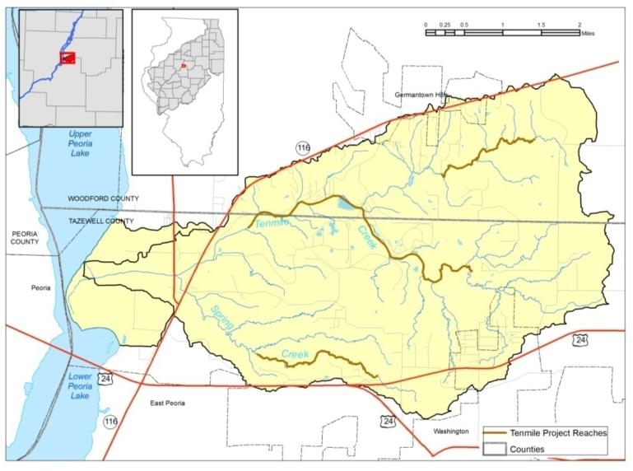
Figure 4000. Reaches identified for possible ecosystem restoration activities.

Based on this analysis, four reaches along the Creek mainstem are relatively unstable (Figures 37 and 51) and should be considered as priorities. Further investigations may improve upon predictive capabilities. Investigations initially focused on the Creek mainstem, but it became clear early on that tributaries such as Creek, Creek, and Creek (Figure 24) deliver considerable sediment to the mainstem. Additional work has shown that these tributaries also are high-priority candidates for restoration. Practices in the upper watershed and in sloping forested areas also require further consideration.

[Suggestion: Start general description of targeted reaches (though they’ve already been described above), such as total number of sites, length of reaches for additional study, how there are some long reaches with many problem sites but there are also problem sites outside of those reaches… Then break out Mainstem, Tributary Channels (lumped, unless you can think of a geological or process reason to separate them), Forested Lands, Agricultural Lands. Then continue the evaluation based on processes, e.g., Channel incision and widening (grade control, riffle/pool, Lunker…), Channel bank erosion (as part of intrinsic meandering…why do anything?), Mass Wasting of valley walls, etc. The relative costs and constraints of treating each process would be more easily discussed in that structure. The locations of particular sites or practices could then be identified on a figure. ]

1. Tenmile Creek Mainstem

Eight problem sites initially were identified from recent GPS tracked aerial flights along the assessed portion of the mainstem. An additional 49 potential problem areas were identified along the mainstem by carefully reviewing recently acquired aerial videotapes. Another 18 potential problem areas were identified from review of contemporary and historic panchromatic still aerial photos (Table 3). An additional four sites of concern were identified from in-channel field work and will require engineering surveys before proceeding further with project design.

The upper target reach is approximately a mile long (Figure 44). Only existing panchromatic still aerial photos were available for this area.

The next target reach is approximately 3.5 miles long. Recommended treatments primarily include grade control and habitat enhancement by constructing riffle and pool structures (Figure 51). Where the channelized segment ends in upper reaches of the mainstem, bedrock is exposed in the channel bed. The channel was less stable and stability and habitat indices were poor just below this point. Bedrock was considered to be a good place to anchor potential upper end multi-objective riffle and pool structures. Some severely eroded stream reaches may require installation of lunker structures and associated bioengineered techniques in combination with riffle and pool grade/habitat structures.

The third target reach is 3.9 miles long. Recommended treatments here also include grade control and habitat enhancement with riffle and pool structures, possibly combined with bioengineered techniques and lunker structures.

The fourth and lowest reach is 2.3 miles long, and 11 potential project sites were identified from aerial reconnaissance. This complex area is generally aggrading but exhibits channel degradation/incision in a few short segments where two gas pipeline segments are exposed. Riffle and pool structures may be useful to protect those gas pipelines, but relatively low bank elevations have led landowners to express concerns about flooding fields if water backs up too much.

Four sites with extensive mass wasting occur within the 3.5-mile project reach. Two more sites occur between the uppermost 1-mile and 3.5-mile project reaches, and five other sites occur near the bluff line between the 3.5-mile and lower 2.3-mile project reaches. Mass wasting occurs where the stream impinges on the base of the eastern valley walls.

Several more eroding streambanks occur at more isolated problem areas outside potential project reaches recommended in this report. Treatments within recommended reaches could have positive impacts on some of these other sites, but further research and assessment are necessary to clarify this. Appropriate stabilization of these outlier eroding streambanks also may be considered for potential individual projects, but project impacts must be considered within the context of the overall plan. Assessment of impacts to the stream channel from previously installed BMPs in uplands also needs to occur to identify additional opportunities for integrated system resource management (cf. Figure 3).

2. Spring Creek
Creek is 8.5 miles long and has 5-6 segments that may be suitable for projects (Figures 51 and 39). The uppermost reach defined here is about a mile long and exposed tree roots indicate ongoing incision. Various restoration practices could be considered, including riffle and pool structures for grade control, oxygenation of water, aesthetics, habitat, and energy dissipation in combination with bioengineering techniques or even “hard” structures such as stone toe protection.

The next channel segment downstream has two small segments that could be combined into one reach depending upon type of restoration practices considered for further assessment in a feasibility study. When combined, the two segments are about a mile long (Figures 51 and 39). Two mass wasting sites are located along this stream segment. Restoration of mass wasting sites requires considerable effort, financial commitment, and site access from a willing landowner. The remaining three channel segments are located in the lower third of the stream. The last stream channel segment has one mass wasting site, and three other mass wasting sites are just upstream (second to last channel segment). Therefore, the four mass wasting sites are located in lowermost 2 miles of the creek. These channel segments also would benefit from bioengineering, stone toe protection and riffle and pool structures.

3. Spring Creek Tributary S4
Creek is about 4.5 miles long, and assessment data indicated three particular reaches with channel stability problems, poor habitat, or both (Figure 40). The longest stream segment is in the middle area of Creek, the next longest is at the upper end of the channel, and the shortest segment is near the end of the channel about a quarter mile upstream of the channel mouth at the confluence with Creek. Typical restoration practices described above would also be suitable for consideration in these three reaches. No mass wasting sites were reported for this channel.

4. Wolf Creek
Creek is about 6 miles long, and preliminary field data indicated three reaches of concern (Figure 41). An exposed gas pipeline and a lower channel segment where the channel gradient is a little steeper than in the middle portion (Figure 28), requires considerable work. This pipeline may not be active since steps had not been taken to protect it from exposure for many years. In particular, the pipeline had not been physically covered with a protective emulsion and wrapped with a polyurethane sealant. If the gas pipeline is active, then relocation of the line or armoring are common approaches to address public safety and potential pollution concerns. The gas pipeline company must be contacted to be sure this issue is addressed. Forest management also would be a major consideration in middle and upper segments. Other potential restoration practices include those provided above for other stream segments.

5. Forest
Much of the southwestern part of the watershed, in particular, could benefit from woodland management. Forested ravines are habitat areas of interest in the Tenmile Creek watershed for management opportunities. They include forests on interfluves, slopes, terraces, and riparian areas. Elimination of invasive plant species is highly recommended. Removal of some understory biomaterial and less desirable short story trees should be considered with overall timber stand improvement practices. Connection and structural enhancement of fragmented vegetated areas, especially riparian zones, would be of great benefit, not only for water quality but to enhance habitat for many floral and faunal species, including birds.

Most existing forest is limited to ravines because slopes are too steep for agricultural or residential development. Steep slopes also are less valuable than gentle slopes for wildlife [citation]. Opportunities for restoring additional forest acreage in low sloping upland and floodplain areas should also be investigated.

6. Agricultural Land
Various agricultural BMPs have previously been implemented in the watershed, mainly outside channel areas (Figure 3). Traditional water management and erosion control projects (e.g. grassed waterways, terraces, ponds, WASCOBs, etc.) also have been constructed outside the channel in the Creek watershed. Those practices mainly focus on NPS sediment on agricultural lands. Agricultural BMPs are intended largely to maintain or improve productivity, but their effects on terrestrial habitat, aquatic habitat, fluvial hydrology and sediment delivery may be profound. These effects have not been well characterized in watersheds in Illinois and should be studied more thoroughly. These beyond-channel projects may alter water and sediment loadings to the Creek mainstem and can have either positive or negative effects immediately after construction. For example, without planning for compensation of flow regime changes or channel slope adjustments, sediment detention in upland areas can result in channel migration and/or channel incision, which would induce channel erosion with channel morphology changes (White et al., in review). By contrast, coordinated implementation of beyond-channel and in-channel BMPs should reduce peak discharge, increase base flow and provide a more balanced sediment regime.

G. Proposed Methods for Benefit Assessment
Monitoring stream hydrology can help determine if peak discharges have been ameliorated and if base flows have increased in summer months. “Normalizing” discharges can benefit habitat, plant and animal communities. Monitoring sediment and nutrient data combined with rainfall determinations would document changes in sediment delivery and transport in the watershed system. Continued monitoring of channel stability conditions and habitat indices as already initiated would help determine responses of the channel and habitat as long as other factors can be isolated and eliminated as causes.

VI. FEDERAL INTEREST
Potential project features will require resources from several federal, local, and state agencies. Integrated planning and management of these resources will be instrumental in achieving significant ecosystem restoration in the Tenmile Creek watershed and, in the larger sense, the ILRB. Federal interest exists and will be realized specifically when project plans, designs, and resources are integrated as seamlessly as possible with those of local and state organizations. This integrated effort and funding will foster ecosystem restoration most effectively and efficiently. The challenge to integrate efforts lies not only with federal agencies but also with local and state organizations. Potential project features and required federal interests are briefly outlined (Table 16).

Potential Project Feature | Appropriate Agency
Traditional Upland FarmTreatment  (Terraces, WASCOB’s, Grassed Waterways, No-till, etc… | USDA-NRCS USDA-FSA  IDOA  SWCD
In-Stream Naturalization  (Riffle/Pool Stuctures, Lunker Structures, Bioengineering for Streambank Stabilization, etc… | IDNR-ISWS  IDNR-ORC  USFWS  USDA-NRCS  USACOE
Priority Upland and Floodplain Wetland Restoration and Enhancement in Hydric Soil Areas | USDA-NRCS  USFWS  IDNR-ORC  USACOE
Forested Slope and Riparian Management | USFWS  USDA-NRCS  IDNR-ORC  IDNR-INHS
Stabilization of Select Mass Wasting Sites | USGS  USACOE  ISGS  ISWS

VII. RECOMMENDATIONS
Based on study results, it is evident that various strategies could improve ecological integrity of the Tenmile Creek watershed and thus address several goals within Alternative 6 of the Comprehensive Plan (USACE, 2007). Some goals of the Comprehensive Plan are applicable to restoration efforts in the Tenmile Creek watershed and are outlined in Section VE above.

Goals can be met by incorporating appropriate combinations of resource management options into a resource management plan for the entire watershed. These resource management options could include: 1) traditional erosion and sediment control BMPs outlined in standards developed for NRCS use; 2) bioengineering techniques (combined with placement of lunker structures or perhaps even “harder” structures, such as stone toe protection, stream barbs, etc. when necessary) to stabilize or naturalize streambanks and address channel equilibrium issues; 3) control of channel incision using riffle and pool structures (Newbury weirs, etc.); 4) channel re-meandering and reconnection of streams to parent floodplains; 5) wetland restoration or enhancement; 6) fish ladder placed at a large in-channel dam to promote fish passage and; 7) alternative futures planning and contemporary conservation designs for urban and rural stormwater infiltration and filtering, etc. Many of these options provide multiple benefits that enhance habitat while restoring or naturalizing flow regimes.

Traditional erosion and sediment control and water management practices and structures are recommended for additional design and construction. Innovative channel and near-channel restoration projects must be constructed to naturalize the fluvial environment and also managed to establish and sustain biologic diversity. Several unstable channel segments and near-channel areas on the mainstem identified for restoration are shown (Figure 51). Likewise, several areas were identified as potential sites for feasibility consideration. Because many factors may have contributed to these areas becoming unstable (e.g. glacial history of the watershed, surficial materials, combined dynamic processes including climate, drainage modifications, land-use changes, etc.) closer examination of causative factors and processes is recommended before implementing specific channel and slope stabilization projects. Initiating restoration projects that focus on stabilizing active degradation (e.g. knickpoints and headcuts) and regulating variability of water and sediment supply to the channel (reducing peak flow and increasing base flow) would rapidly improve habitats in the watershed, increase the likelihood of success of many other treatments, and possibly reduce long-term maintenance costs.

Application of the CEM shows that most stream reaches classified were post-Stage III. Moreover, the majority of these reaches were Stage V (Table 4), suggesting that general stability of the watershed is late-stage transitional, characterized by aggradation of the channel bed, mild mass wasting, heavy bank accretion, anastamosing channel thalweg, and diverse bank forms (Hupp, 1987). Within the CEM context, general stability of the physical habitat should trend toward improvement unless there are further extrinsic stimuli such as channel disturbances or modifications. What is not known, however, is how long observed conditions have existed. In west Tennessee where the CEM was developed, system recovery was on the order of 65 years (Hupp, 1992). Analysis in Illinois has been insufficient to document similar process-response rates, but continued data collection in this and other watersheds eventually will fill this data gap. Forest management techniques specifically must applied within wooded bluff areas and along riparian zones in the watershed. The IRVCG, as mentioned previously, encouraged R.O.D. advancement and strongly supported its development,bringing immediate acceptance and regional project support.

Channel and near-channel sources of sediment (particularly from streambed, streambanks, and riparian areas of the Tenmile Creek mainstem, Spring Creek, Wolf Creek and other tributaries to Tenmile Creek) must be controlled and habitats must be enhanced using in-stream and riparian naturalization techniques. These techniques include variations of bioengineering, rock weir establishment, thinning of some wooded bluff areas and intense understory management. Control of invasive species, protection of Threatened and Endangered species, concentrated management and expansion of terrestrial habitat types (such as forest, prairie, and savannah) and protection and enhancement of aquatic (fish and macroinvertebrate) habitats all must be considered in a comprehensive manner with systematic programs that appropriately address systemic problems.

Implementation of solutions that effectively and efficiently address problems must be coordinated with all local, state and federal agencies proficient at handling these problems from both technical and funding perspectives. The Tenmile Creek watershed assessment was modeled after the Special Area Management Plans (SAMPs) outlined in the USACE Comprehensive Plan (USACE, 2007), but adjustments were made to accommodate assessment scaling issues between the larger ILRB and subwatershed levels. The study attempted to conduct a comprehensive review of aquatic and terrestrial resources in the entire watershed. Assessment reports help define where SAMPs or resource management plans should be developed for key watershed areas in which considerable planning and restoration activities occur or where scientific information suggests a need to target restoration. The approach to build upon this SCWA effort with a more specific feasibility effort is more environmentally sensitive than the traditional project-by-project process. The traditional approach may lead to cumulative loss of resources over time. With the SAMPs approach, potential impacts are analyzed at a watershed scale to identify priority areas for preservation, identify potential critical restoration areas and determine not only the least environmentally damaging locations for proposed projects but also the most important target areas for restoration. The goal is to achieve balance between terrestrial and aquatic resource protection and reasonable economic development. These comprehensive and complex efforts require multi-agency participation at local, state and federal levels.

Potential partners include the USDA-NRCS (CREP, Environmental Quality Incentives Program, Conservation Reserve Program, Conservation Practices Program , etc.), USDA Farm Service Administration, local SWCDs, the Illinois Department of Agriculture Streambank Stabilization Program, IDNR (e.g., Illinois portion of CREP, Acres for Wildlife, Forestry Incentives Program, etc.), USEPA and IEPA (Section 319 of the Clean Water Act, etc.) and a host of other partners and funding sources.

Restoration in the Tenmile Creek watershed is complicated because public interests control very little of the watershed. Participation in ecosystem restoration efforts by private landowners is vital for achieving ecosystem goals. Recommendations include continuation of the traditional “sign-up” programs currently in place and further incentives to private landowners to participate in construction of restoration projects outlined and targeted as potential projects in this assessment report.

In summary, several BMPs have been applied in this watershed in the past, but more work is necessary. This report describes watershed conditions, both past and present, and recommends implementation of specific restoration techniques, many targeted to specific locations. Restoration of target areas would reduce water and sediment discharge variability in the watershed, expand management of riparian zones, increase upland and floodplain wetland restoration, enhance woodland structure and understory management (particularly in bluff areas), stabilize mass wasting sites and further install traditional upland conservation treatments. Various channel and streambank treatments that could be applied include bioengineered streambank erosion control, bioengineered low-intensity structural controls such as naturalized riffle and pool construction, lunker structures, longitudinal peak stone protection, stream barbs, etc. A renewed focus should be on restoration of target areas as described in the assessment report, continued focus and interest in capabilities and funding needs of local landowners, and increased landowner incentives would maximize restoration while providing more sustainable ecological diversity.

VIII: ACKNOWLEDGEMENTS

Acknowledgements

I thank Matt O’Hara, Kevin Irons, Thad Cook, Mike McClelland, Nerissa Michaels, Matt Stroub, Maurice Sisson III, Jared Woodcock, and Denim Perry for field assistance. Special thanks to Laura Sass, Tara Keininger, and Andrew Hulin of the Illinois Natural History Survey and Illinois Department of Natural Resources for creating the GAP data maps.
This material is based upon work supported by the IDNR under Contract No. G2006051

IX: DISCLAIMER

"Any opinions, findings, and conclusions or recommendations expressed in this publication are those of the author(s) and do not necessarily reflect the views of the IDNR"

X. REFERENCES CITED
References

From Greg
Lee, D.S., C.R. Gilbert, C.H. Hocutt, R.E. Jenkins, D.E. McAllister, and J.R. Stauffer, Jr.
1980. Atlas of North American freshwater fishes. Publication #1980-12 of the North Carolina Biological Survey.

Smith, P.W. 1979. The fishes of Illinois. University of Illinois Press, Urbana.

Tri-County Regional Planning Commission. 2004. Ten Mile Creek watershed
restoration plan. 241 pp.

(DREW insert)

New REFERENCES:

Brookes, A., 1988. Channelized Rivers: Perspectives for Environmental Management. John Wiley and Sons Ltd., Chichester , England. 326 p.

Herricks, E.E., P. Kumar, B. L. Rhoads, J.S. Schwartz. 2004. Developing A Multi- Scale Assessment Procedure To Evaluate Subwatersheds For Ecosystem Restoration For The Rock River Ecosystem Restoration Feasibility Study. Final Report prepared under U.S. Army Corps of Engineers Contract No. DACW25-03-P- 0045. Rock Island District, 171 p.

D.R. Montgomery and J.M. Buffington 1998. Channel processes, classification, and response potential. In: R.J. Naiman and R.E. Bilby, Editors, River Ecology and Management, Springer-Verlag, New York (1998), pp. 13–42.

Simon and Darby, 2002 A. Simon and S.E. Darby, Effectiveness of grade-control structures in reducing erosion along incised river channels: the case of Hotophia Creek, Mississippi, Geomorphology 42 (2002), pp. 229–254.

Soong, D.T., Ishii, A.L., Sharpe, J.B., and Avery, C.F., 2004, Estimating flood- peak discharge magnitudes and frequencies for rural streams in Illinois: U.S. Geological Survey Scientific Investigations Report 2004-5103, 147 p.

U.S. Geological Survey. 2009. Illinois Stream Stats. available online: http://water.usgs.gov/osw/streamstats/illinois.html
References
CH2MHill, 2001, City of Washington Comprehensive Plan, http://www.washington-illinois.org/.
Kramer, G.L., 1980, Prairie Studies at Caterpillar Tractor Co. Peoria Proving Ground, in Kucera, C.L., ed., Proceedings of the Seventh North American Prairie Conference, No.7, Springfield, Missouri: Southwest Missouri State University, p. 177–178.

Illinois Department of Transportation, 2008, Eastern Bypass Study Kickoff Meeting handout: http://www.easternbypass.com/

Illinois Natural History Survey, 2003a, Land Cover of Illinois in the Early 1800s, vector digital data, Champaign, Illinois: Illinois Natural History Survey.

Illinois Natural History Survey, 2003b, Illinois Natural History Survey's 1999-2000 1:100,000 Scale Illinois Gap Analysis Land Cover Classification, raster digital data, Version 2.0, Champaign, Illinois: Illinois Natural History Survey, http://www.isgs.illinois.edu/nsdihome/webdocs/landcover/gap.html.

Illinois NRCS, 2005, Key to Illinois soils: Natural Resources Conservation Service, U.S. Department of Agriculture, 59 p., http://www.illinoissoils.org/Links_Files/KeySoilsSept2006.xls

Omernik, J.M. 1995. Ecoregions: a spatial framework for environmental management: In Biological Assessment and Criteria: Tools for Water Resource Planning and Decision Making, W. Davis and T.P. Simon (eds.). Lewis Publishing, Boca Raton, FL. pp.. 49-62.

Tele Atlas North America, Inc., and ESRI, 2008, U.S. Census Block Centroid Populations, vector digital data, in ESRI Data & Maps, Redlands, California: ESRI.

Tri-County Regional Planning Commission, 1996, Woodford County Comprehensive Land Use Plan, http://www.woodford-county.org/index.php?section=30.

Tri-County Regional Planning Commission, 2004a, Tenmile Creek Watershed Restoration Plan, http://www.tricountyrpc.org/environment-page/watershed-planning.

Tri-County Regional Planning Commission, 2004b, Village of Germantown Hills, Illinois Comprehensive Plan, http://www.tricountyrpc.org/community-page/germantown-hills.

United States Department of Agriculture (USDA), National Agricultural Statistics Service (NASS), 2009, 2008 Illinois Cropland Data Layer, digital raster data, Washington D.C.: USDA, NASS, http://datagateway.nrcs.usda.gov/.

Woermann, J. W. 1902-1904. Map of the Illinois and DesPlains Rivers from Lockport, Illinois, to the mouth of the Illinois River. US Army Corps of Engineers

Woods, A.J., J.M. Omernick, C.L. Pederson, and B.C. Moran, 2006, Level III and IV Ecoregions of Illinois: U.S. Environmental Protection Agency, ftp://ftp.epa.gov/wed/ecoregions/il/il_eco.zip.
(end DREW insert)

Barbour, M. T., J. Gerritsen, B, D, Snyder, and J. B. Stribling. 1999. Rapid Bioassessment Protocols for Use in Wadeable Streams and Rivers, Periphyton, Benthic Macroinvertebrates, and Fish. Second Edition. U.S. Environmental Protection Agency, Office of Water, EPA 841-B-99-002, Washington, D.C.

Bhowmik, N.G., W.C. Bogner, J. Slowikowski, and J.R. Adams. 1993. Source Monitoring and Evaluation of Sediment Inputs for Peoria Lake. Illinois Department of Energy and Natural Resources Report No. IENR/RE-WR-93/01 and Illinois State Water Survey Contract Report 514, Champaign, IL.

Biological Stream Categorization Work Group. 1993. Biological Stream Categorization (BSC): Biological Assessment of Illinois Stream Quality through 1993. Edited by W.A. Bertrand, R. L. Hite, and D. M. Day with the Biological Stream Categorization Work Group (W. Ettinger, W. Matsunaga, S. Kohler, J. Mick, and R. Schanzle.). Illinois Environmental Protection Agency, Springfield, IL.

Changnon, S.A., J.R. Angel, K.E. Kunkel, and C.M.B. Lehmann. 2004. Climate Atlas of Illinois. Illinois State Water Survey, Informational/Educational Material 2004-02, Champaign, IL.

Demissie, M., R. Xia, L. Keefer, and N. Bhowmik. 2004. The Sediment Budget of the Illinois River. Illinois State Water Survey, Contract Report 2004-13, Champaign, IL.

Easterling, D.R., and T.R. Karl. 2001. Potential Consequences of Climate Variability and Change for the Midwestern United States. Climate Change Impacts on the United States The Potential Consequences of Climate Variability and Change. National Assessment Synthesis Team, U.S. Global Change Research Program, Chapter 6, pp. 167-188.

Evans, R.E., and D.H. Schnepper. 1977. Sources of Suspended Sediment: Spoon River, Illinois. Proceedings of the North-Central Section of the Geological Society of America, Peoria, IL, pp. 592-593.

Federal Interagency Working Group. 1998. “Stream Corridor Restoration: Principles, Processes, and Practices.” October 1998.

Greer, D., D. Szafoni, and L. Sulaway. 2002. Land Cover of Illinois in the Early 1800’s [Map]. Illinois Natural History Survey, Champaign, IL (http://www.inhs.uiuc.edu/cwe/maps/glo.html, accessed).

Grissinger, E.H., A.J. Bowie, and J.B. Murphey. 1991. Goodwin Creek Bank Instability and Sediment Yield. Proceedings of the Fifth Federal Interagency Sedimentation Conference. Subcommittee on Sedimentation of the Interagency Advisory Committee on Water Data, Las Vegas, NV, pp. 5-51 to 5-60.

Hansel, A.K., and W.H. Johnson. 1996. Wedron and Mason Groups: Lithostratigraphic Reclassification of Deposits of the Wisconsin Episode, Lake Michigan Lobe Area. Illinois State Geological Survey, Bulletin 104, Urbana, IL.

Herzog, B.L., B.J. Stiff, C.A. Chenoweth et al. 1994. Buried Bedrock Surface of Illinois [Map]. Illinois State Geological Survey and U.S. Geological Survey, Illinois Map 5, Urbana, IL.

Hilsenhoff, W.L. 1982. Using a Biotic Index to Evaluate Water Quality in Streams. Wisconsin Department of Natural Resources, Technical Bulletin 132, Madison, WI.

Hite, R. L., and W.A. Bertrand. 1989. Biological Stream Characterization (BSC): A Biological Assessment of Illinois Stream Quality. Special Report No. 13 of the State Water Plan Task Force. IEPA/AC/89-275.

Holtrop, A.M., and M. Pegg (eds.). 2004. Illinois River Ecosystem Restoration Monitoring and Watershed Assessment Framework. Final Report. U.S. Army Corps of Engineers, Rock Island District, 339 p.

Hupp, C.R. 1987. Determination of Bank Widening and Accretion Rates and Vegetation Recovery along Modified West Tennessee Streams. International Symposium on Ecological Aspects of Tree-Ring Analysis, Tarrytown, NY, pp. 224-233.

Hupp, C.R. 1992. Riparian Vegetation Recovery Patterns Following Stream Channelization: A Geomorphic Perspective. Ecology 73(4):1209-1226.

Illinois Department of Natural Resources. 1998a. The Illinois River Bluffs Area Assessment, Volume 1: Geology. Illinois Department of Natural Resources, Office of Scientific Research and Analysis, State Geological Survey Division, Springfield, IL.

Illinois Department of Natural Resources. 1998b. The Illinois River Bluffs Area Assessment, Volume 2: Water Resources. Illinois Department of Natural Resources, Office of Scientific Research and Analysis, Illinois State Water Survey Division, Springfield, IL.

Illinois Department of Natural Resources. 1998c. The Illinois River Bluffs Area Assessment, Volume 3: Living Resources. Illinois Department of Natural Resources, Office of Scientific Research and Analysis, Natural History Survey Division, Springfield, IL.

Illinois Department of Natural Resources. 1998d. The Illinois River Bluffs Area Assessment, Volume 4: Soci-Economic Profile, Environmental Quality, Archaeological Resources. Illinois Department of Natural Resources, Office of Scientific Research and Analysis, Division of Energy and Environmental Assessment, Illinois State Water Survey, Waste Management and Research Center, and Illinois State Museum Divisions, Springfield, IL.

Illinois Department of Natural Resources, 2006. Illinois Wildlife Action Plan. IDNR Office of Resource Conservation, Springfield, IL.

Illinois Environmental Protection Agency. 2000. Median Nutrient Concentrations by Watershed in Illinois: Source Water Assessment Program (SWAP) digital data: source: Short, M.B., 1999, Baseline Loadings of Nitrogen, Phosphorus and Sediments From Illinois Watersheds, IEPA BOW/99-020, Springfield, IL.

Illinois Environmental Protection Agency. 2004. Illinois Water Quality Report—2004, Clean Water Act Section 305(b), Water Resource Assessment Information. IEPA Bureau of Water,Appendix A-11, p. 2 (http://www.epa.state.il.us/water/water-quality/305b/305b-2004.pdf, accessed ).

Illinois Environmental Protection Agency. 2006a. Illinois Integrated Water Quality Report and Section 303(d) List—2006, Clean Water Act Sections 303(d), 305(b) and 314, Water Resource Assessment Information and Listing of Impaired Waters. IEPA Bureau of Water, Appendix A, 201 pp. and Listed waters maps, p. 40 (http://www.epa.state.il.us/water/tmdl/303d-list.html, accessed ).

Illinois Environmental Protection Agency. 2006b. State of Illinois Section 319 Biannual Report. IEPA Bureau of Water, p. 24 (http://www.epa.state.il.us/water/watershed/reports/biannual-319/2006/march.pdf, accessed ).

Illinois Gap Analysis Land Cover Grid in ArcMap: see also http://www.agr.state.il.us/gis/pass/gapdata/#mapping

Illinois Geospatial Data Clearinghouse. 1999. Illinois Digital Orthophoto Quarter Quadrangle (DOQ) Data 1998-1999 (http://www.isgs.uiuc.edu/nsdihome/webdocs/doqs, accessed ).

IL-GAP. 2001. Illinois GAP Analysis Program Land Cover Classification. Illinois Department of Agriculture (http://www.agr.state.il.us/gis/pass/gapdata/index.html, accessed December 2006).

Joseph, J., J. Ketter, and C. Carroll. 2003. Senachwine Creek Watershed Financial Assistance Agreement #3190014 Nonpoint Source Control Project—Phase II. Final Report, February, 2003. Prepared by: Illinois River Soil Conservation Task Force. Prepared for: Illinois Environmental Protection Agency; Division of Water Pollution Control, Springfield, IL

Karr, J.R., K.D. Fausch, P.L. Angermeier, P.R. Yant, and I.J. Schlosser. 1986. Assessing Biological Integrity in Running Waters: A Method and Its Rational. Illinois Natural History Survey, Special Publication 5, .

Keefer, L.L., White, W. P., Beardsley, J. D. 2/2009 DRAFT v.2, Illinois River Basin Ecosystem Restoration Geomorphic Watershed Assessment (IRBGWA) Protocols. Illinois State Water Survey, Institute of Natural Resource Sustainability, University of Illinois

Keefer, L.L. 2006, Multi-scale Geomorphic Assessment Approach for Streams in the Southern Illinois Region: Case Study, Big Creek Watershed, Pulaski and Union Counties, Illinois. Master of Science Thesis, University of Illinois, Urbana-Champaign, IL.

Killey, M. 1998. Illinois’ Ice Age Legacy. Illinois Department of Natural Resources, Illinois State Geological Survey, GeoScience Education Series 14, Champaign, IL.

Lee, M.T., P. Makowski, and W. Fitzpatrick. 1982. Assessment of Erosion, Sedimentation, and Water Quality in the Blue Creek Watershed, Pike County, Illinois. Illinois State Water Survey Contract Report 321, Champaign, IL.

Leedy, J.B. 1979. Observations on the Sources of Sediment in Illinois Streams. University of Illinois, Illinois Water Information System Group, Report of Investigation No. 18, Urbana, IL.

Lineback, J.A. (compiler). 1979. Quaternary Deposits of Illinois [Map]: Illinois State Geological Survey, 1:500,000 scale.

McKay, E.D., R.C. Berg, P.D. Johnstone, A.J. Stumpf, and C.P. Weibel. In review. Surficial Geology of the Middle Illinois River Valley – Portions of Bureau, Marshall, Peoria, Putnam, and Woodford Counties, Illinois – Including Chillicothe, Lacon, Putnam, and Rome, Illinois State Geological Survey, 7.5 Minute Quadrangles: Illinois Map Series, Champaign, IL. 1:62,500 scale.

Miller, T., C. Gill, and C. Carroll. 1997. Senachwine Creek Nonpoint Source Control Project. Final Report, December, 1997. Prepared by: Illinois River Soil Conservation Task Force. Prepared for: Illinois Environmental Protection Agency; Division of Water Pollution Control. Springfield, IL.

National Atlas. 2005. National Atlas of the United States and The National Atlas of the United States of America, Registered trademarks of the United States Department of Interior. http://www.nationalatlas.gov/ and http://www.nationalatlas.gov/printable/images/pdf/congdist/IL18_109.pdf.

Natural Resources Conservation Service. 2002. Watershed Boundary Data - 12 digit Hydrologic Units. U.S. Department of Agriculture, NRCS, Fort Worth, TX (http://datagateway.nrcs.usda.gov, accessed ).

Natural Resources Conservation Service. 2005. Data from on Landcover Statistics for the Senachwine Creek Watershed 1999-2000 (see IL-GAP, 2004).

Natural Resources Conservation Service. 1997. Soil Survey of Marshall County, Illinois. U.S. Department of Agriculture, NRCS.

Ohio Environmental Protection Agency. 1987. Biological Criteria for the Protection of Aquatic Life: Volume II: Users Manual for Biological Assessment of Ohio Surface Waters. OEPA Division of Water Quality, Monitoring, and Assessment, Columbus OH (http://www.epa.state.oh.us/dsw/bioassess/BioCriteriaProtAqLife.html, accessed).

Ohio Environmental Protection Agency. 2006a. 2006. Updates to Biological Criteria for the Protection of Aquatic Life: Volume II and Volume II Addendum: Users Manual for Biological Assessment of Ohio Surface Waters. OEPA Division of Surface Water, Ecol. Assessment Section, Columbus, OH

Ohio Environmental Protection Agency. 2006b. 2006. Updates to Biological Criteria for the Protection of Aquatic Life: Volume III: Standardized biological field sampling and laboratory methods for assessing fish and macroinvertebrate communities. OEPA Division of Surface Water, Ecol. Assessment Section, Columbus, OH

Ohio Environmental Protection Agency. 2006c. Methods for assessing habitat in flowing waters: Using the Qualitative Habitat Evaluation Index (QHEI). Ohio EPA Tech. Bull. EAS/2006-06-1. OEPA Division of Surface Water, Ecol. Assessment Section, Columbus, OH

O’Neal, M.R., M.A. Nearing, R.C. Vining, J. Southworth, and R.A. Pfeiferea. 2005. Climate Change Impacts on Soil Erosion in Midwest United States with Changes in Crop Management. Catena 61:165-184.

Page, L.M., K.S. Cummings, C.A. Mayer, S.L. Post, and M.E. Retzer. 1992. Biologically Significant Illinois Streams: An Evaluation of the Streams of Illinois Based on Aquatic Biodiversity. Illinois Department of Conservation and Illinois Department of Energy and Natural Resources, Project Completion Report: Enhancement of Biological Stream Characterization F-110-R, : 485 pages.

Phillips, A.C., B.L. Rhoads, T.J. McTighe, and C. Klaus. 2002. Stream Dynamics Assessment, Illinois River Basin. U.S. Army Corps of Engineers, Rock Island, Contract Report DACW25-98-D-0077, 65 p., 7 tbl., 46 figs.

Piskin, K., and R.E. Bergstrom. 1975. Glacial Drift in Illinois: Thickness and Character. Illinois State Geological Survey, Urbana, IL.

Rhoads, B.L., and M.A. Urban. 1997. A Human-induced Geomorphic Change in Low-energy Agricultural Stream: An Example from East-central Illinois. In S.S.Y.Wang, E.J. Langendoen, and F.D. Shields (eds.), Management of Landscapes Disturbed by Channel Incision, University of Mississippi, Oxford, MS, pp. 968-973.

Roseboom, D., and W.P. White. 1990. The Court Creek Restoration Project. Proceedings of Erosion Control: Technology in Transition. 21st International Erosion Control Association Conference, Washington D.C., pp. 14-17.

Soil Conservation Service. 1990. Draft Preliminary Investigation Report: Senachwine Creek Watershed, Peoria and Marshall Counties, Illinois. U.S. Department of Agriculture, SCS, 11 pages.

Soil Conservation Service. 1992. Soil Survey of Peoria County, Illinois. U.S. Department of Agriculture, SCS, Illinois Agricultural Experiment Station Report 132, 225 pages.

Schumm, S.A., M.D. Harvey, and C.C. Watson. 1984. Incised Channels: Morphology Dynamics and Control. Water Resources Publications, Littleton, CO.

Schwegman, J. 1973. Comprehensive Plan for the Illinois Nature Preserves System—Part 2—The Natural Divisions of Illinois. Prepared by the Illinois Nature Preserves Commission under guidance of the Framework Advisory Committee and in cooperation with the Illinois Department of Conservation.

Shields, F.D. Jr., S.S. Knight, and C.M. Cooper. 1997. Rehabilitation of Aquatic Habitats in Warmwater Streams Damaged by Channel Incision in Mississippi. Hydrobiologia 382:63–86.

Simon, A. 1989. A Model of Channel Response in Distributed Alluvial Channels. Earth Surface Processes and Landforms 14(1):11-26.

Simon, A. and P.W. Downs. 1995. An Interdisciplinary Approach to Evaluation of Potential Instability in Alluvial Channels. Geomorphology 12:215-232.

Simon, A., and M. Rinaldi. 2000. Channel Instability in the Loess Area of the Midwestern United States. Journal of American Water Resources Association 36(1):133-150.

Soil Survey Staff. 2005a. Soil Survey Geographic (SSURGO) Database for Marshall County, Illinois. U.S. Department of Agriculture, Natural Resources Conservation Service, Fort Worth, TX (http://SoilDataMart.nrcs.usda.gov/, accessed ).

Soil Survey Staff. 2005b. Soil Survey Geographic (SSURGO) Database for Peoria County, Illinois. U.S. Department of Agriculture, Natural Resources Conservation Service, Fort Worth, TX (http://SoilDataMart.nrcs.usda.gov/, accessed )

State of Illinois. 1997. Integrated Management Plan for the Illinois River Watershed. Office of the Lt. Governor, Technical Report, Springfield, IL.

Straub T.D., G.P. Johnson, D.P. Roseboom, and C.S. Sierra. 2006. Suspended-sediment Yields and Stream-channel Processes on Judy’s Branch Watershed in the St. Louis Metro East Region in Illinois. U.S. Geological Survey, Scientific Investigations Report 2006-5016, Reston, VA.

Stumpf, A.J. In Review. Surficial Geology of Rome Quadrangle: Illinois Preliminary Geologic Map, Illinois State Geological Survey

Suloway, L., M. Joselyn, and P. Brown. 1996. Critical Trends Assessment Phase II, Inventory of Resource Rich Areas in Illinois: An Evaluation of Ecological Resources. Illinois Department of Natural Resources, Center for Wildlife Ecology, Illinois Natural History Survey Division, IDNR/EEA-96/08 3M/1996 (http://www.inhs.uiuc.edu/cwe/rra/rra.html, accessed ).

Tri-County Regional Planning Commission. 2004. Tenmile Creek Watershed Restoration Plan. TCRPC, Peoria, IL

U.S. Army Corps of Engineers. 1990. Vicksburg District Systems Approach to Watershed Analysis for Demonstration Erosion Control Project, Appendix A. USACE, Vicksburg District, Demonstration Erosion Control Project Design Memorandum No. 54, Vicksburg, MS.

U.S. Army Corps of Engineers. 2004. Illinois River Basin and Tributaries Ecosystem Restoration Project Management Plan (PMP). USACE, Rock Island District.

U.S. Army Corps of Engineers. 2007. Illinois River Basin Restoration Comprehensive Plan with Integrated Environmental Assessment, Main Report; Public Review Draft. USACE, Rock Island District.

United States Department of Agriculture, Natural Resources Conservation Service in cooperation with the Illinois Agricultural Experiment Station. 1997. “Soil Survey of Marshall County, Illinois” by William M. Teater and Michael B. Walker. Soil Surveyed by K.D. Hanson, S.K. Higgins, W.M. Teater, M.B. Walker, and Z.E. Zwicker. Champaign, IL.

Urban, M.A. 2000. Conceptualizing Anthropogenic Change on the Upper Embarras River. Dissertation, University of Illinois, Champaign, IL.

Vagt, P.J. 1982. Vertical and Horizontal Stability of Streams in Northern Illinois. Masters Thesis, Geology Department, Northern Illinois University, DeKalb, IL.

White, W.P., M.Demissie, and L. Keefer. 2005. Illinois River Basin Assessment Framework. Proceedings of the Governor’s Conference on the Management of the Illinois River System. Peoria, IL (http://ilrdss.sws.uiuc.edu/, accessed ).

White, W.P., and L.L. Keefer. 2005. Rapid Stream Assessments of the Illinois River Watershed. Proceedings of the World Water & Environmental Resources Congress 2005: Impacts of Global Climate Change. Conference of the Environmental & Water Resources Institute of the American Society of Civil Engineers, Anchorage, AL, USA (accessible only with on-line subscription).

White, W.P., J. Beardsley, and S. Tomkins. 2008. “Lake Pittsfield (Blue Creek Watershed, Illinois) Section 319 National Monitoring Program Project”. National Water Quality Group Newsletter. North Carolina State University and the North Carolina State University Extension Service. With funding from the Illinois Environmental Protection Agency and the U. S. Environmental Protection Agency Section 319 Nonpoint Pollution Control Program of the Clean Water Act. Raleigh, NC.

Willman, H.B., E. Atherton, T.C. Buschback, C. Collinson, J. Fry, M.E. Hopkins, J. Linebeck, and J. Simon. 1975. Handbook of Illinois Stratigraphy. Illinois State Geological Society, Bulletin 95, Urbana, IL.

www.agr.state.il.us/gis/stats/landcover/mainpages/statistics_by_watershed.htm

Zielinski, J. 2002. Watershed Vulnerability Analysis: Center for Watershed Protection, Ellicott City, MD (http://www.cwp.org/Vulnerability_Analysis.pdf, accessed ).



Needs centered, corp logo?

